C5P1 v2

Iabalki

Thursday, November 19, 2015

## Part 1 - Loading and preprocessing the data

Task: Load the data (i.e. read.csv()); Process/transform the data (if necessary) into a format suitable for your analysis

activityFile <- download.file("http://d396qusza40orc.cloudfront.net/repdata%2Fdata%2Factivity.zip", "activity.zip")  
activity <- unzip("activity.zip")  
activity <- read.csv(activity, as.is = TRUE)

As a next step before I start doing anything, i would like to get a sense of what the data looks like:

str (activity)

## 'data.frame': 17568 obs. of 3 variables:  
## $ steps : int NA NA NA NA NA NA NA NA NA NA ...  
## $ date : chr "2012-10-01" "2012-10-01" "2012-10-01" "2012-10-01" ...  
## $ interval: int 0 5 10 15 20 25 30 35 40 45 ...

summary (activity)

## steps date interval   
## Min. : 0.00 Length:17568 Min. : 0.0   
## 1st Qu.: 0.00 Class :character 1st Qu.: 588.8   
## Median : 0.00 Mode :character Median :1177.5   
## Mean : 37.38 Mean :1177.5   
## 3rd Qu.: 12.00 3rd Qu.:1766.2   
## Max. :806.00 Max. :2355.0   
## NA's :2304

head (activity, 15)

## steps date interval  
## 1 NA 2012-10-01 0  
## 2 NA 2012-10-01 5  
## 3 NA 2012-10-01 10  
## 4 NA 2012-10-01 15  
## 5 NA 2012-10-01 20  
## 6 NA 2012-10-01 25  
## 7 NA 2012-10-01 30  
## 8 NA 2012-10-01 35  
## 9 NA 2012-10-01 40  
## 10 NA 2012-10-01 45  
## 11 NA 2012-10-01 50  
## 12 NA 2012-10-01 55  
## 13 NA 2012-10-01 100  
## 14 NA 2012-10-01 105  
## 15 NA 2012-10-01 110

tail (activity, 15)

## steps date interval  
## 17554 NA 2012-11-30 2245  
## 17555 NA 2012-11-30 2250  
## 17556 NA 2012-11-30 2255  
## 17557 NA 2012-11-30 2300  
## 17558 NA 2012-11-30 2305  
## 17559 NA 2012-11-30 2310  
## 17560 NA 2012-11-30 2315  
## 17561 NA 2012-11-30 2320  
## 17562 NA 2012-11-30 2325  
## 17563 NA 2012-11-30 2330  
## 17564 NA 2012-11-30 2335  
## 17565 NA 2012-11-30 2340  
## 17566 NA 2012-11-30 2345  
## 17567 NA 2012-11-30 2350  
## 17568 NA 2012-11-30 2355

Got it!

The fields were originally described as - steps: Number of steps taking in a 5-minute interval (missing values are coded as NA) - date: The date on which the measurement was taken in YYYY-MM-DD format - interval: Identifier for the 5-minute interval in which measurement was taken

Now, that we loaded them though .. Let's convert date to a date and interval to a factor

activity$date <- as.Date(activity$date, format = "%Y-%m-%d")  
activity$interval <- factor(activity$interval)  
str (activity)

## 'data.frame': 17568 obs. of 3 variables:  
## $ steps : int NA NA NA NA NA NA NA NA NA NA ...  
## $ date : Date, format: "2012-10-01" "2012-10-01" ...  
## $ interval: Factor w/ 288 levels "0","5","10","15",..: 1 2 3 4 5 6 7 8 9 10 ...

summary (activity)

## steps date interval   
## Min. : 0.00 Min. :2012-10-01 0 : 61   
## 1st Qu.: 0.00 1st Qu.:2012-10-16 5 : 61   
## Median : 0.00 Median :2012-10-31 10 : 61   
## Mean : 37.38 Mean :2012-10-31 15 : 61   
## 3rd Qu.: 12.00 3rd Qu.:2012-11-15 20 : 61   
## Max. :806.00 Max. :2012-11-30 25 : 61   
## NA's :2304 (Other):17202

## Part 2 - What is mean total number of steps taken per day?

For this part of the assignment, you can ignore the missing values in the dataset.

For that purpose we create a subset of the non-NA activities and we will use it in this section

activity_noNAs <-subset(activity, activity$steps!="NA")

Calculate the total number of steps taken per day

totalPerDay_noNAs <- aggregate (steps ~ date, data=activity_noNAs, sum)  
print (totalPerDay_noNAs)

## date steps  
## 1 2012-10-02 126  
## 2 2012-10-03 11352  
## 3 2012-10-04 12116  
## 4 2012-10-05 13294  
## 5 2012-10-06 15420  
## 6 2012-10-07 11015  
## 7 2012-10-09 12811  
## 8 2012-10-10 9900  
## 9 2012-10-11 10304  
## 10 2012-10-12 17382  
## 11 2012-10-13 12426  
## 12 2012-10-14 15098  
## 13 2012-10-15 10139  
## 14 2012-10-16 15084  
## 15 2012-10-17 13452  
## 16 2012-10-18 10056  
## 17 2012-10-19 11829  
## 18 2012-10-20 10395  
## 19 2012-10-21 8821  
## 20 2012-10-22 13460  
## 21 2012-10-23 8918  
## 22 2012-10-24 8355  
## 23 2012-10-25 2492  
## 24 2012-10-26 6778  
## 25 2012-10-27 10119  
## 26 2012-10-28 11458  
## 27 2012-10-29 5018  
## 28 2012-10-30 9819  
## 29 2012-10-31 15414  
## 30 2012-11-02 10600  
## 31 2012-11-03 10571  
## 32 2012-11-05 10439  
## 33 2012-11-06 8334  
## 34 2012-11-07 12883  
## 35 2012-11-08 3219  
## 36 2012-11-11 12608  
## 37 2012-11-12 10765  
## 38 2012-11-13 7336  
## 39 2012-11-15 41  
## 40 2012-11-16 5441  
## 41 2012-11-17 14339  
## 42 2012-11-18 15110  
## 43 2012-11-19 8841  
## 44 2012-11-20 4472  
## 45 2012-11-21 12787  
## 46 2012-11-22 20427  
## 47 2012-11-23 21194  
## 48 2012-11-24 14478  
## 49 2012-11-25 11834  
## 50 2012-11-26 11162  
## 51 2012-11-27 13646  
## 52 2012-11-28 10183  
## 53 2012-11-29 7047

If you do not understand the difference between a histogram and a barplot, research the difference between them. Make a histogram of the total number of steps taken each day

library ("ggplot2")  
hist (totalPerDay_noNAs$steps, breaks = round(nrow (totalPerDay_noNAs)/3,0))  
lines( c(mean(totalPerDay_noNAs$steps),mean(totalPerDay_noNAs$steps)), c(0,max(totalPerDay_noNAs$steps)), col = "red", lwd = 2)

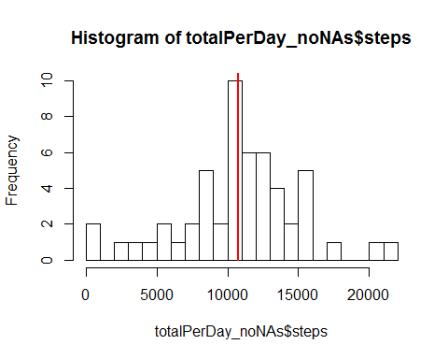

Calculate and report the mean and median of the total number of steps taken per day

mean (totalPerDay_noNAs$steps)

## [1] 10766.19

median (totalPerDay_noNAs$steps)

## [1] 10765

## Part 3 -- What is the average daily activity pattern?

Make a time series plot (i.e. type = "l") of the 5-minute interval (x-axis) and the average number of steps taken, averaged across all days (y-axis)

avgPerInterval_noNAs <- aggregate (steps ~ interval, data=activity_noNAs, mean)  
plot (avgPerInterval_noNAs$steps, type = "l")

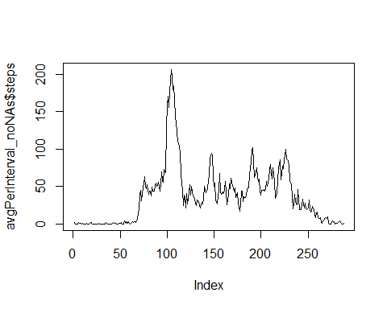

Which 5-minute interval, on average across all the days in the dataset, contains the maximum number of steps?

subset (avgPerInterval_noNAs, avgPerInterval_noNAs$steps == max(avgPerInterval_noNAs$steps))

## interval steps  
## 104 835 206.1698

## note: there could be more than one...

# Part 4 -- Inputing missing values

Note that there are a number of days/intervals where there are missing values (coded as NA). The presence of missing days may introduce bias into some calculations or summaries of the data.

Calculate and report the total number of missing values in the dataset (i.e. the total number of rows with NAs)

Note: We already have the answer from the exploratory function we ran earlier (see summary) but in case we want to embed the exact number will be ..

nrow (subset(activity, is.na(activity$steps)==TRUE))

## [1] 2304

Devise a strategy for filling in all of the missing values in the dataset. The strategy does not need to be sophisticated. For example, you could use the mean/median for that day, or the mean for that 5-minute interval, etc.

The approach I decided on is to use the mean for that 5 min interval (excluding all unknown values). Note: this approach will only work if there is at least one non-NA value for each interval. (We will otherwise have to define a rule of what happens if there all NAs in the respecitve period)

So we check .. Given that when we sum or mean up an NA and a value - the result is NA

temp <- aggregate(steps ~ interval, data = activity, sum)   
nrow (temp$steps[is.na (temp$steps)==TRUE])

## NULL

rm (temp)

NULL -- Nothing to worry about.. we may proceed with filling in the NA data with mean for the interval

Create a new dataset that is equal to the original dataset but with the missing data filled in.

temp<-as.data.frame(cbind(  
 is.na(activity$steps)*avgPerInterval_noNAs$steps,  
 (!(is.na(activity$steps)))*activity$steps))  
   
# two columns -- one will only have the mean value if the original value was NA and the second one will only have a value of the actual steps if the original value is not NA  
  
temp[is.na(temp)] <- 0  
#replace all NAs with zeroes  
temp <- temp [,1]+temp [,2]  
# now sum them up..   
activity$adjustedSteps<-temp  
# append that new value to our activity dataframe under adjustedSteps column  
rm (temp)

Make a histogram of the total number of steps taken each day and calculate and report the mean and median total number of steps taken per day. Do these values differ from the estimates from the first part of the assignment? What is the impact of imputing missing data on the estimates of the total daily number of steps?

totalPerDay_Adj <- aggregate (adjustedSteps ~ date, data=activity, sum)  
  
cat ("Mean\n",  
 "After Adjustment:", mean (totalPerDay_Adj$adjustedSteps),"\n",  
 "Before Adjustment:", mean (totalPerDay_noNAs$steps))

## Mean  
## After Adjustment: 10766.19   
## Before Adjustment: 10766.19

cat ("Median\n",  
 "After Adjustment:", median (totalPerDay_Adj$adjustedSteps),"\n",  
 "Before Adjustment:", median (totalPerDay_noNAs$steps))

## Median  
## After Adjustment: 10766.19   
## Before Adjustment: 10765

hist (totalPerDay_Adj$adjustedSteps, breaks = round(nrow (totalPerDay_Adj)/3,0))

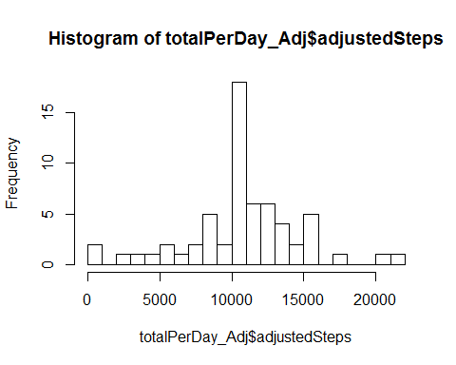

The mean is expected to stay the same (we did fill in the values with mean values). The median shifted slightly, almost ignorable.

## Part 5 - Are there differences in activity patterns between weekdays and weekends?

Create a new factor variable in the dataset with two levels - "weekday" and "weekend" indicating whether a given date is a weekday or weekend day.

For this part the weekdays() function may be of some help here. Use the dataset with the filled-in missing values for this part.

library(plyr)  
  
activity$isWeekend <- mapvalues(as.factor(as.numeric(grepl("Sat|Sun", weekdays(as.Date(activity$date),abbreviate=TRUE)))), from = c(0, 1), to = c("weekday", "weekend"))

Make a panel plot containing a time series plot (i.e. type = "l") of the 5-minute interval (x-axis) and the average number of steps taken, averaged across all weekday days or weekend days (y-axis). See the README file in the GitHub repository to see an example of what this plot should look like using simulated data.

avgPerIntervalandDayType<- aggregate (adjustedSteps ~ interval + isWeekend, data = activity, mean)  
   
library (lattice)  
xyplot (adjustedSteps ~ interval|factor(isWeekend),   
 data = avgPerIntervalandDayType,  
 layout = c (1,2), type ="l",  
 main=list(label="Avg # of steps (01Oct-30Nov12)"))

