
Comsats University Islamabad
Attock Campus

Department Of Computer Science
Course | SQE (Lab)
Instructor | Ma’am Munazza Mushtaq
Project Title | Semester Project

SUBMITTED BY:
Registration  No | Name
FA23-BSE-019 | Mian Abdullah Jan
FA23-BSE-060 | Hamad Khan Momand
FA23-BSE-058 | Mohsin Hayat
FA23-BSE-041 | Khubaib Hussain
FA23-BSE-048 | Mesum Abbas

Table of Contents
TOPIC: Library Management System 3
1. FUNCTIONALITIES AND EXECUTION: 3
CODE: 3
Main.py: 3
OUTPUT: 5
ADD BOOK: 5
VIEW BOOK: 5
SEARCH BOOK: 6
DELETE BOOK: 6
2. MANUAL TESTING: 7
3. BUG REPORTING: 9
4. CODE QUALITY ANALYSIS: 10
SONARQUBE: 10
5. SNYK 11
DASHBOARD: 11
PROJECTS: 11

TOPIC: Library Management System

FUNCTIONALITIES AND EXECUTION:

CODE:

Main.py:
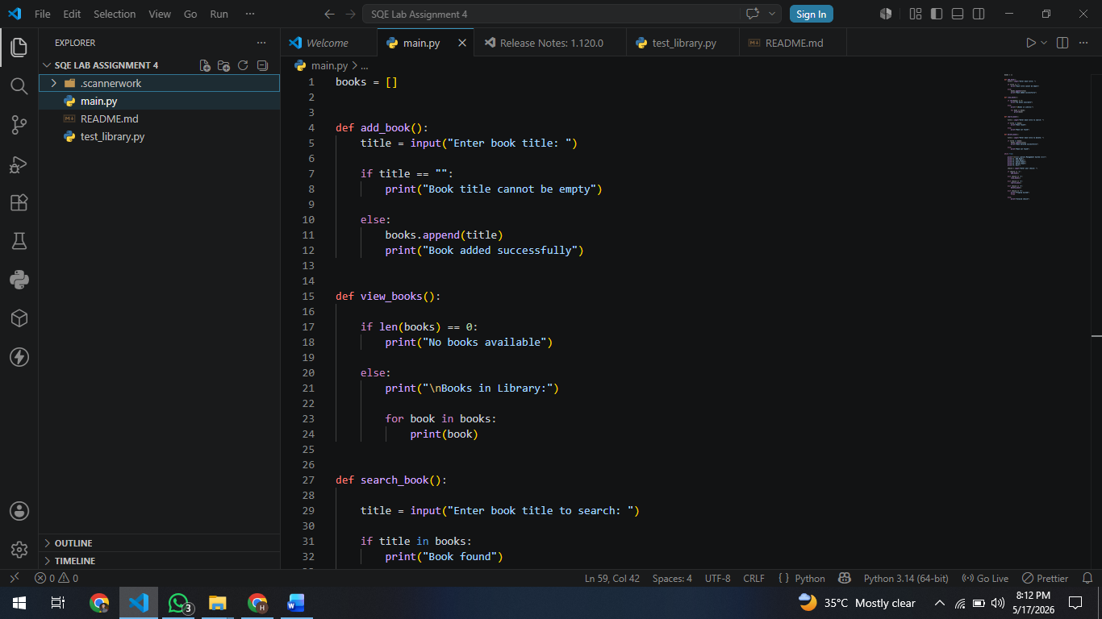
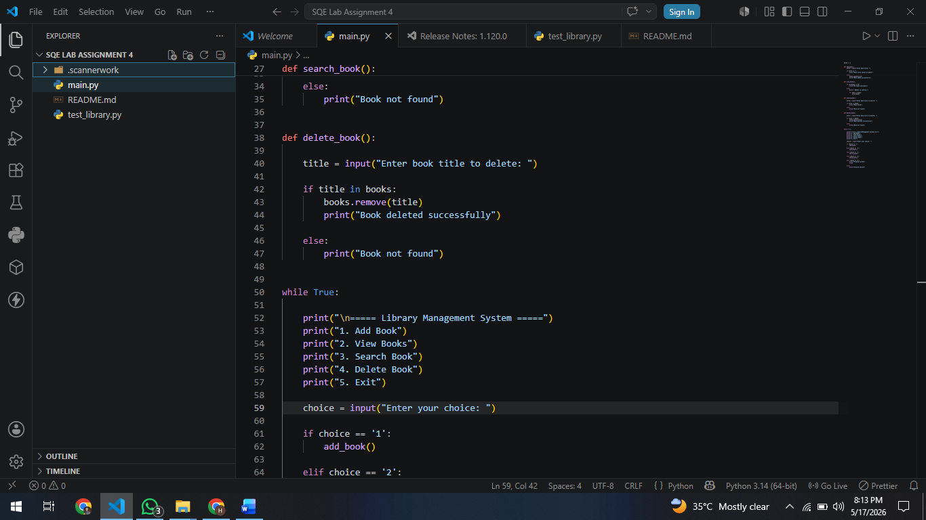
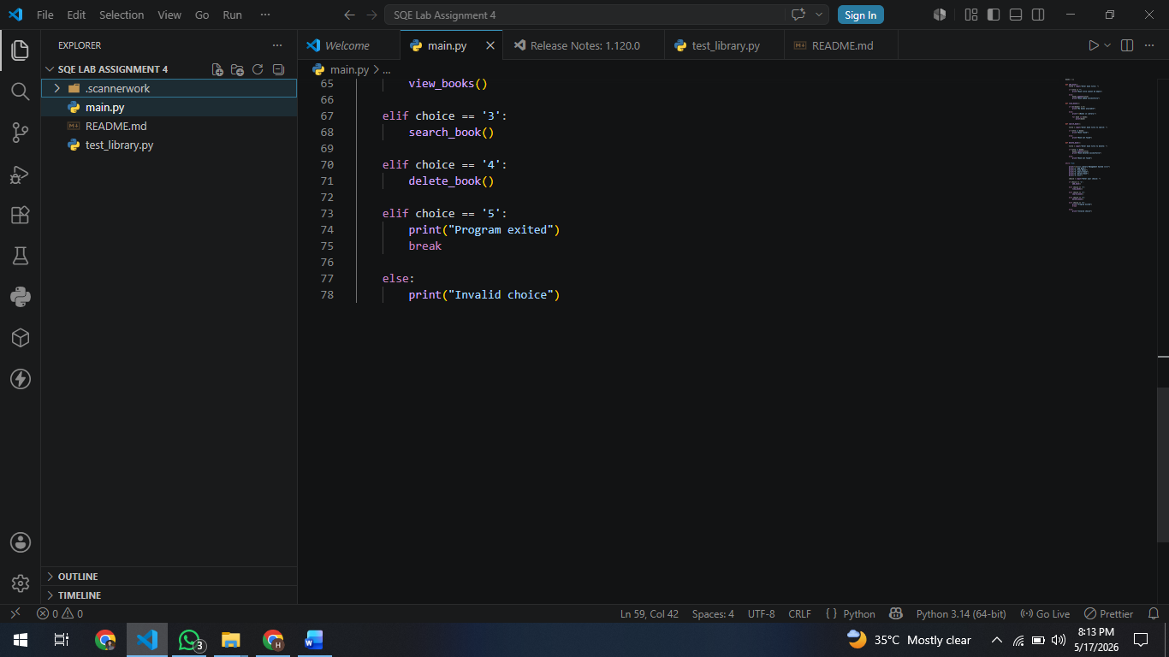

OUTPUT:

ADD BOOK:
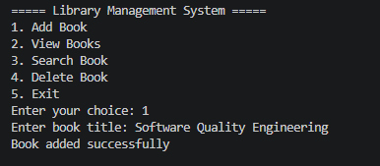

VIEW BOOK:
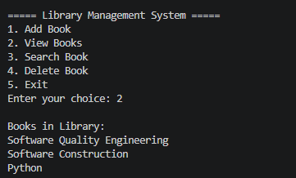

SEARCH BOOK:
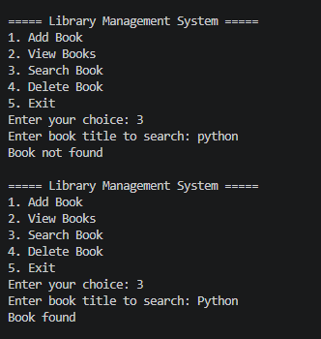

DELETE BOOK:
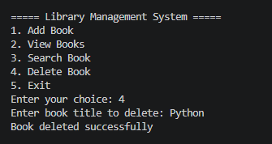

MANUAL TESTING:
Test Case ID | Functionality | Test Scenario | Input | Expected Result | Actual Result | Status
TC-01 | Add Book | Add valid book | Python | Book added successfully | Book added successfully | Pass
TC-02 | Add Book | Add empty book title | Empty Input | Error message displayed | Error message displayed | Pass
TC-03 | Add Book | Add duplicate book | Python twice | Duplicate should not be allowed | Duplicate accepted | Fail
TC-04 | Add Book | Add book with spaces only | " " | Invalid input message | Book added | Fail
TC-05 | Add Book | Add special characters | @@@ | Invalid input | Book added | Fail
TC-06 | View Books | View when books exist | View Books | Display all books | Books displayed | Pass
TC-07 | View Books | View when no books exist | Empty library | No books available | No books available | Pass
TC-08 | Search Book | Search existing book | Python | Book found | Book found | Pass
TC-09 | Search Book | Search non-existing book | Java | Book not found | Book not found | Pass
TC-10 | Search Book | Search with lowercase | python | Book found | Book not found | Fail
TC-11 | Search Book | Search empty input | Empty Input | Error message | Book not found | Fail
TC-12 | Search Book | Search special characters | ### | Invalid input | Book not found | Fail
TC-13 | Delete Book | Delete existing book | Python | Book deleted successfully | Book deleted successfully | Pass
TC-14 | Delete Book | Delete non-existing book | Java | Book not found | Book not found | Pass
TC-15 | Delete Book | Delete with lowercase title | python | Book deleted | Book not found | Fail
TC-16 | Delete Book | Delete empty input | Empty Input | Error message | Book not found | Fail
TC-17 | Delete Book | Delete special characters | ### | Invalid input | Book not found | Fail
TC-18 | Exit | Exit application | 5 | Program closes | Program closed | Pass
TC-19 | Menu | Invalid menu choice | 9 | Invalid choice message | Invalid choice message | Pass
TC-20 | Menu | Enter alphabet in menu | abc | Invalid choice message | Invalid choice message | Pass

Bug ID | Bug Name | Description | Steps to Reproduce | Expected Result | Actual Result | Severity | Status
LIB_BUG_01 | Duplicate Book Allowed | System allows adding same book multiple times | 1. Add book “Python”  2. Add “Python” again | Duplicate books should not be accepted | Duplicate book added successfully | Medium | Fail
LIB_BUG_02 | Case-Sensitive Search | Search fails when lowercase letters are used | 1. Add “Python”  2. Search “python” | Book should be found | System shows “Book not found” | Low | Fail
LIB_BUG_03 | Spaces Accepted as Book Title | Empty spaces are accepted as valid title | 1. Select Add Book 2. Enter spaces only | System should reject spaces | Book added successfully | Medium | Fail
LIB_BUG_04 | No Permanent Data Storage | Data is lost after program restart | 1. Add books  2. Exit program  3. Run again | Previously added books should remain saved | All books removed after restart | High | Fail
LIB_BUG_05 | No Delete Confirmation | Books are deleted immediately without confirmation | 1. Add book  2. Delete book | System should ask for confirmation | Book deleted immediately | Low | Fail

BUG REPORTING:

CODE QUALITY ANALYSIS:

SONARQUBE:
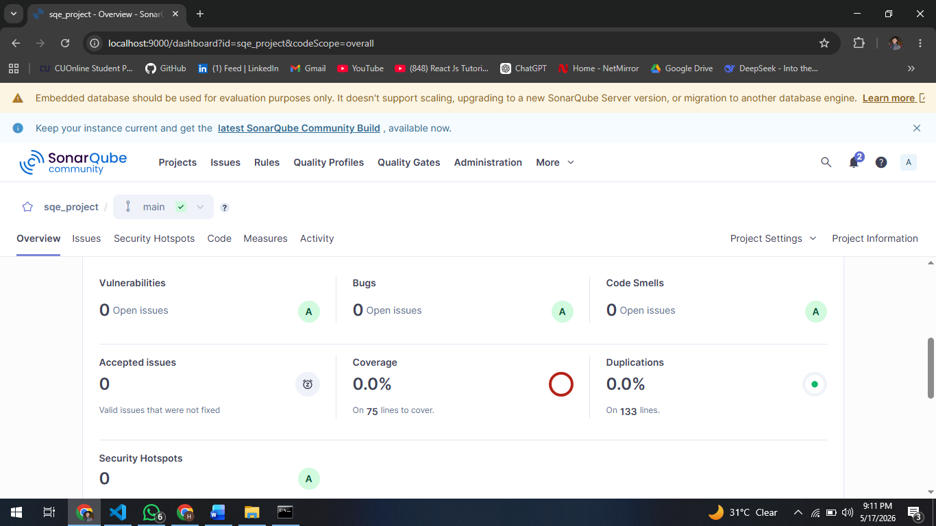

SNYK

DASHBOARD:
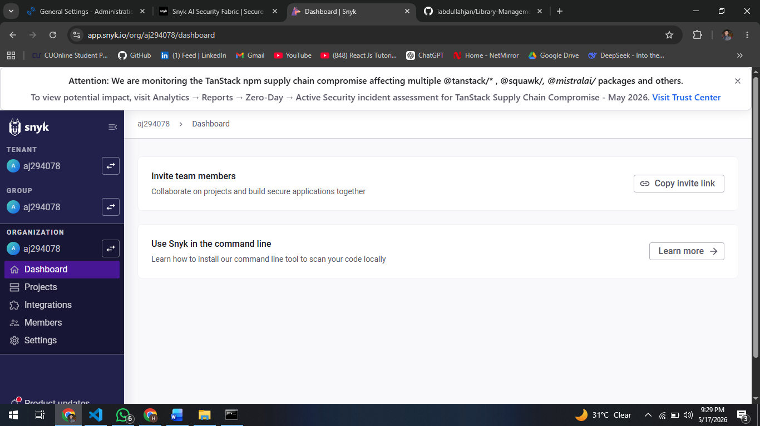

PROJECTS:
