**COMSATS UNIVERSITY ISLAMABAD**

**ATTOCK CAMPUS**

**DEPARTMENT OF COMPUTER SCIENCE**

|  |  |
| --- | --- |
| **Course** | AICT (CSC101) Lab |
| **Instructor** | Mam Maryam |
| **Assignment No** | 01 |
| **Project Title** | Resume |
| **Name** | Mian Abdullah Jan |
| **Reg** | CIIT/FA23- BSE019/ATK |

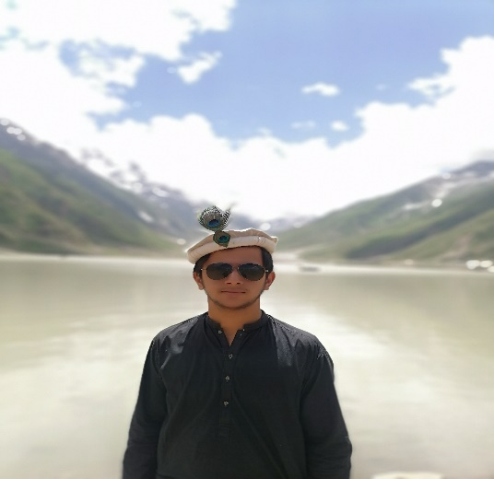

A problem solving software engineer completing projects around the globe. I provide a high quality service to the client with in the limited passage of time with a outstanding scripting.

***SUMMARY***

***Mian Abdullah Jan***

***EXPERIENCE***

* **Software Engineer**
* **WordPress**
* **HTML**
* **CSS**
* **Java Script**

***LANGUAGES***

***HOBBIES***

* Pushto
* Urdu
* English
* **Sports**
* **Reading**
* **Travelling**

***SKILLS***



03121993962

aj294078@gmail.com

Peshawar, Pakistan

***FREELANCING***

* Works as a WordPress developer on Fiverr, Upwork, freelancer, guru and etc.

***SOFTWARE ENGINEERING***

* I work as a software engineer beginner at a software house.
* My future plan is to present my country in the field of Computer Science in the world.

My future goals and objectives is to become a full stake web developer.

I want to establish my own software house to give more opportunities to the youth of my country.

***OBJECTIVES***

**Comsats university Islamabad, Attock Campus**

Bachelor of science in Software Engineering (2023-2027)

**Peshawar Model degree college, Dalazak raod**

F.SC in Computer Science with 80% marks.

***EDUCATION***