# Data Preprocessing

Removed:

* Punctuation
* Words in caps and words with numbers

# Model

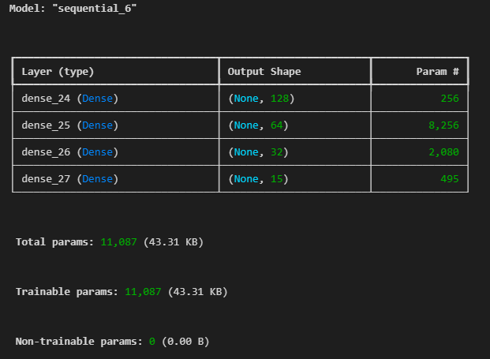

* Random Forest
* Naïve Bayes

# Training procedure

Train – Test split 80:20

Label encoded both input and output.

# API

# Testing Results

Randomforest:

Nn:

Naïve Bayes:

