## ER Diagram

The ER diagram of this news portal is shown in figure 2.4. The ER diagram contains six entities namely: Allarticles, category, pages, navigation and users.

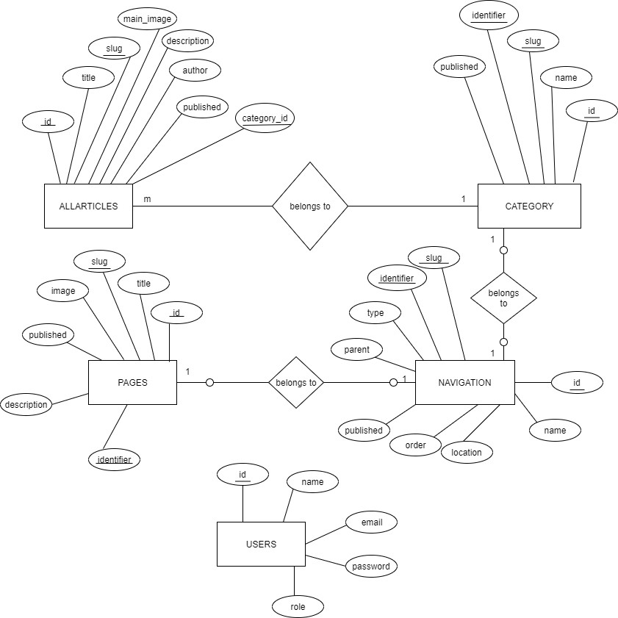

* + 1. **Context Diagram (Level-0 Data flow Diagram)**

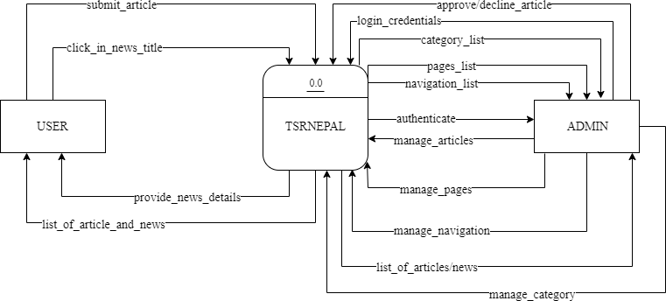

*Fig 2.5.1: Context diagram*

* + 1. **Level-1 Data Flow Diagram**

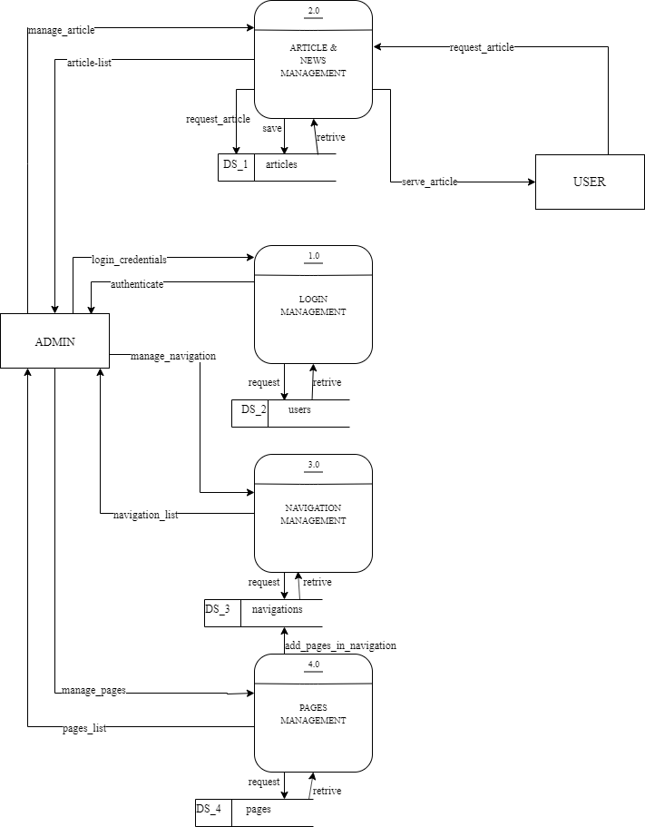

*Fig 2.5.2: Level-1 DFD*

This is hello world

This is abhiyan shrestha