

## Tribhuvan University

### Institute of Science and Technology

**A Final Year Internship Report On**

# Web Development at

**Web House Nepal**

### Submitted to

**Department of Computer Science and Information Technology St Lawrence College**

### Chabahil, Kathmandu, Nepal

**In partial fulfilment of the requirements**

### for the Bachelors of Science in Computer Science and Information Technology

**Submitted by**

Abhiyan Shrestha (Roll no.: 10361/073)

### Under the supervision of

Mr. Ramesh Chaudhary

**December, 2021**

# RECOMMENDATION

I hereby recommend that the internship report prepared under my supervision by Abhiyan Shrestha on **“Web Development”** be accepted as in fulfilling partial requirements for the degree of Bachelors of Science in Computer Science and Information Technology.

### Mr. Ramesh Chaudhary Supervisor

Department of Computer Science and Information Technology, St Lawrence College, Chabahil, Kathmandu



**Tribhuvan University**

### Institute of Science and Technology ST LAWRENCE COLLEGE

Chabahil, Kathmandu

## LETTER OF APPROVAL

We certify that we have read this dissertation work and, in our opinion, it is satisfactory in the scope and quality as a dissertation in the partial fulfilment of requirement of Bachelors of Science in Computer Science and Information Technology.

### Evaluation Committee

**……………………………… Mr. Ramesh Chaudhary** Head of Department

Department of Computer Science and Information Technology

St Lawrence College Chabahil, Kathmandu (Supervisor)

### ……………………………..

**External Examiner**

# ACKNOWLEDGEMENT

The internship opportunity I had in Web House Nepal was a great chance for learning and professional development. My overall intern experience was really great. I consider myself very lucky as I became part of wonderful company. I am also grateful for having chance to meet so many wonderful people and professionals who led me through this internship period.

I convey my sincere gratitude to my Academic Supervisor **Mr. Ramesh Chaudhary** without his kind direction and proper guidance this study would not have been a little success. In every phase of this project his supervision and guidance shaped this report to be complete perfectly and I am thankful towards St Lawrence College for supporting me to do the project.

I am so grateful to **Mr. Dhan Bahadur Ghala** for giving me opportunity and inspiring me to do internship on Web Development without his support and encouragement, it would be really difficult to work and complete my report.

I would like to express my special gratitude and thanks to **Mr. Ananta Koirala, Mr. Binod Thapa, Mr. Ramesh Dhakal** for guiding me to complete my task during my tenure in the company. Because of their proper guidance I had completed many projects.

Finally, I would like to express my gratitude to all the people who helped me by providing their valuable assistance and time during this internship program.

# ABSTRACT

This report will provide what and how I complete Web Development internship at Web House Nepal. This report will begin with the brief introduction of the company and my role as intern.

This report provides complete details of how backend of tsrnepal in created. Tsrnepal is a news portal to address article related economy and finance. Backend of the system provides all control to admin. Admin can perform all CRUD operation in navigation table. So that, navigation item of site can be change without need to developer. Item from category and pages table can be added in navigation table. Navigation item can be dragged to change their position in navigation bar. Sortable Js is used to make it in action.

System provides platform to write article for user. Any people who is interested in writing article can use this system. Any article written by users will be reviewed by admin of website and after approval the article will be published in the site.

***Keywords:*** *News Portal, National Affair, International Affair, Economy*

# TABLE OF CONTENTS

ACKNOWLEDGEMENT i

ABSTRACT ii

TABLE OF CONTENTS iii

CHAPTER 1 1

INTRODUCTION 1

* 1. Introduction 1
  2. Problem Statement 1
  3. Objective 2
  4. Organization Introduction 2
     1. Assigned Role (Responsibilities assigned) 3
  5. Scope of the Report 3
  6. Report Organization 3

CHAPTER 2 5

SYSTEM ANALYSIS 5

* 1. Requirements Collection 5
  2. System Requirements 5
     1. Functional Requirements 5
     2. Non-Functional Requirements 6
  3. Feasibility Analysis 7
     1. Economic Feasibility 7
     2. Operational Feasibility 7
     3. Technical Feasibility 7
     4. Schedule Feasibility 8
  4. ER Diagram 9
  5. Process Model 10
     1. Context Diagram (Level-0 Data flow Diagram) 10
     2. Level-1 Data Flow Diagram 10

CHAPTER 3 12

SYSTEM DESIGN 12

* 1. Database Design 12
     1. Allarticles Table 12
     2. Categories Table 13
     3. Commodities Table 13
     4. Navigations Table 13
     5. Pages Table 14

CHAPTER 4 15

SYSTEM IMPLEMENTATION 15

* 1. Front End Tools 15
     1. HTML 15
     2. CSS 15
     3. Bootstrap 16

4.2.5 JavaScript 16

* 1. Back End Tools 16
     1. PHP 16
     2. Laravel 17
     3. MySQL 17
  2. Module Implementation 17
     1. Manage Article Module 17

4.3.1 HomeController Module 18

CHAPTER 5 20

TESTING 20

* 1. Unit Test 20
     1. Unit Test Cases 20
     2. Test Execution 21

CHAPTER 6 24

CONCLUSION 24

6.1 Conclusion 24

BIBLIOGRAPHY 25

Appendix 1: Screenshots 26

**LIST OF FIGURES**

Fig 2.2.1: Use Case Diagram… 6

Fig 2.4: ER Diagram… 9

Fig 2.5.1: Context Diagram… 10

Fig 2.5.2: Level 1 DFD 11

Fig 4.3.1: Flow Chart of dynamicNavigation method… 19

# LIST OF TABLES

Table 3.1.1: Allarticles Table… 12

Table 3.1.2: Categories Table… 13

Table 3.1.3: Commodities Table… 13

Table 3.1.4: Navigation Table… 14

Table 3.1.5: Pages Table 14

**LIST OF ABBREVIATION**

|  |  |  |
| --- | --- | --- |
| NEPSE | = | Nepal Stock Exchange |
| HTML | = | Hyper Text Markup Language |
| CSS | = | Cascading Style Sheets |
| PHP | = | Hypertext Preprocessor |
| CRUD | = | Create, Read, Update and Delete |
| SQL | = | Structured Query Language |
| DFD | = | Data-flow Diagram |
| ER | = | Entity Relationship |
| RDBMS | = | Relational Database Management System |
| GNU | = | General Public License |
| MVC | = | Model View Controller |
| SDLC | = | Software Development Life Cycle |

* 1. **Introduction**

# CHAPTER 1

## INTRODUCTION

An internship is an opportunity offered by the employer to students or trainees, called interns, to give them the knowledge of real world works as well as the work experience. Internship is a lifetime experience for anyone, for me it was awesome. I take internship as an opportunity to validate knowledge and explore new things. During my bachelor, I was always keen to learn new every day. When we read anything exciting in our class, I always wanted to apply it to solve problem as far as possible. Finally, I got the chance to apply it to solve commercial problem through my intern period.

I was responsible to develop and maintain backend of website in the company. Because of prior experience of working in PHP/Laravel, company had given me huge responsibility. It was tough for me but I take it as a challenge and tried to complete every task perfectly, assigned to me. During my tenure, I had created more than ten projects in diverse category. Travel site, School website, News Portal are some of the project in which I was closely involved.

The Southen Rock ([www.tsrnepal.com](http://www.tsrnepal.com/)) is the latest project in which I was involved and I am going to explain about this project further more in this intern report of mine. It is portal where article related to economy, stocks market, Fintech, international affairs will be posted. Any people who want to write article for tsrnepal can do it by using open press feature of the site.

News portal is a web-based application where wide range of people can get information and update them self with latest news. Traditional paper-based newspaper takes time to reach with people and it is expensive in terms of budget. With the help of internet and using World Wide Web now we can see news in matter of seconds. Admin of news portal will publish news and we can see that news in any corner of world in another second.

## Problem Statement

It is really difficult to keep update with national and international economic news in the bizarre internet with overloaded information. The Southen Rock is trying to make difference in community by providing quality content. To keep update with latest fintech, stock market, economy national and international affairs is really time consuming. Either

all these category’s articles are not available in one website or article are overloaded with lots of information.

People are showing keen interest in stock market from past few years. They are searching more content about finance, economy and stock news in internet. To supply this demand and enlighten people about stock market status and current business news tsrnepal is working actively in the community. There are many people who wants to share their experience and learning about stock trades. Despite, people are interested to write there is not platform specifically for those people. Tsrnepal can be a platform for those people.

## Objective

The major objective of this project is to develop the web application to collect and organize articles related to economy. Some of the key objectives to develop the system are as follows:

* + - To make easy web surfing for people who wants to keep update themselves about economy related news and articles.
    - To share finding and experience with each other by using open press.
    - To provide commodity price, stocks price, articles and news at one place.
    - To educate people about finance and economy.

## Organization Introduction

Web House Nepal is IT company which is providing service like Web Designing and Development, SEO, Graphic Designing, Mobile Application Development and many more according to client demand. It is moving forward by carrying mission to decrease digital divide from small/medium business. It had created Web Based POS Application, Online Bus Reservation System (Easy Bus), Office Management System in its mainstream product line. POS is used by many coffee shop and restaurants in Kathmandu valley. These kinds of product will help to organize, operate and automate the business.

Apart from web application, we develop website as per the requirement of client. SEO, Mobile Application, Logo Design are some others services to mention. Company have established good command in web application and web site in the market.

People working here are flexible and professional. They help each other and provide excellent service to the client. Company culture is awesome, all people are friendly and

helpful. Company do care about its employee; company take us to various refreshment program.

### Assigned Role (Responsibilities assigned)

I was assigned to develop backend of blogging site. It has multiple functionality like dynamic navigation bar, dynamic pages, flexibility to create new pages, displaying NEPSE index and many more. In brief, this site is share market, finance and economy related blogging site. Responsibility assigned to me during my internship are given below:

* + - * Creating fully functional Controllers
      * Designing Models
      * Creating migration file for table
      * Integrating views in blade

According to project assigned to me I need to make required controller, mode and views. Making perfect communication between them is also my responsibility.

The main responsibility was to develop the certain module in time with better efficiency and to follow the different development conventions.

## Scope of the Report

This report is based on the experience I had on Web House Nepal. This report focuses the project that I have completed recently, including detail description of the task I have done and overall learning experience of my tenure in the company. This report also includes detailed description about my role as a web developer and my collaboration with this organization to achieve my success. It also clarifies my performance during this period to gain detailed knowledge about web development in real world.

## Report Organization

Report organization is an important part of a report formation. It gives the overall pattern of the report, which contains summary information of the overall document. This document is categorized into several chapters and further is divided into sub chapters including all details of project.

* + - First chapter is about the introduction of the whole report. It includes short introduction of the organization, introduction of the system, objectives, problem statement.
    - The second chapter includes the system analysis. The topic of this chapter includes: system requirements, feasibility analysis and data model.
    - Third chapter is about the system design. It contains database design, interface design etc.
    - The fourth chapter is about the implementation. It contains the details about the tools that are required to design the system.
    - The fifth chapter contains testing which includes different testing processes.
    - The last chapter includes conclusion of the whole project. It also provides information about what further can be achieved from the project.

# CHAPTER 2

## SYSTEM ANALYSIS

## Requirements Collection

The requirement collection is first step in software development life cycle. During the development of tsrnepal website initial requirement collection is done by client relation officer. According to report generated by client relation officer, web designer designs the layout. After the few iterations of creating design and showing design to the client, finally design was approved.

With the finalized design I started developing site to make it dynamic. As we used agile methodology in development, we had to get feedback from client after complete of each functionality.

## System Requirements

While developing a system and before implementing it, it is necessary to analyse the whole system requirements. It is categorized into mainly two parts, namely: functional and non- functional requirements.

### Functional Requirements

Functional requirements describe what a software should do when it is given input. The functional requirements of the news portal are given below:

* + - * Admin should be able to create, update, delete the news.
      * Only Published news can display in website.
      * Admin must be able to select category while adding news/articles.
      * Items in navigation bar should be customizable, sortable from admin panel.
      * New pages should be creatable from admin panel.
      * User submit article for review and after approval it should be displayed in website.

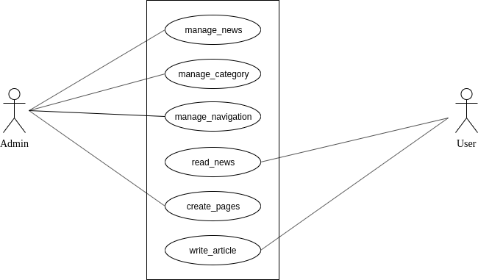

*Fig 2.2.1: Use Case diagram*

### Non-Functional Requirements

Non-functional requirements describe characteristics and behaviour of any functionality of system. Non-functional requirements generally give more details about how system will perform certain functionality. The non-functionality requirements for this system include:

### Efficiency:

When admin perform any CRUD operation in system, system should give response within 7 seconds.

### Reliable:

After changing name of navigation item, it should be changed after next reload of the website.

### User Experience:

System should give response in appropriate text format what it had done, after user action.

## Feasibility Analysis

Feasibility analysis determines whether the proposed system is feasible to develop or not. Feasibility analysis is a part of system analysis carried to confirm that the system being developing is actually feasible or not. This is the phase where any system designers are able to know whether to start the project or not.

We performed some analysis on different aspects of the system to gain the better understanding of whether to start this project or not. After the completion of feasibility analysis, it is determined that the proposed system can be developed. Mainly four type of feasibility, Technical feasibility and Schedule Feasibility.

### Economic Feasibility

To develop the proposed system, minimum resources are required. We did not need any special hardware or software to develop the system. Laravel Framework which we are going to use to create platform, is open source. And all other packages which we will use is system is also open source. In case of hardware, any modern personal computer is enough to setup environment.

Any operating system can be used and the php framework, Laravel is used which is free. MySQL database is used to store data which is also free too use. All software used in development environment is free and open source. To deploy the site, we need to pay for server but which falls on our budget so that the project is economically feasible.

### Operational Feasibility

Proposed project is really easy to use. Lots of article and news will be displayed and if used want to read any one of then they just need to click the image or title of the news. News and articles are filtered using category so the by selecting category user can go through category wise content. Hence, this system is operationally feasible too.

### Technical Feasibility

We can say that this project is technically feasible because there is not any functionality which is not implemented before. After all this is web-based application and can run on every latest web browser independent of the platform used. Users can access this system from any device which is connected to the internet and have web browser.

### Schedule Feasibility

We are using framework to develop this system. Framework is really helpful for rapid application development. Maybe the deadline cannot be meet if we had to develop it with core PHP Language. Though, we are using framework where most of the core part of the project is already bundled up. Security, Routing, Session, Authentication and many more features are available in the framework. If we work based on the milestones, this project will be completed on time.

## ER Diagram

The ER diagram of this news portal is shown in figure 2.4. The ER diagram contains six entities namely: Allarticles, category, pages, navigation and users.

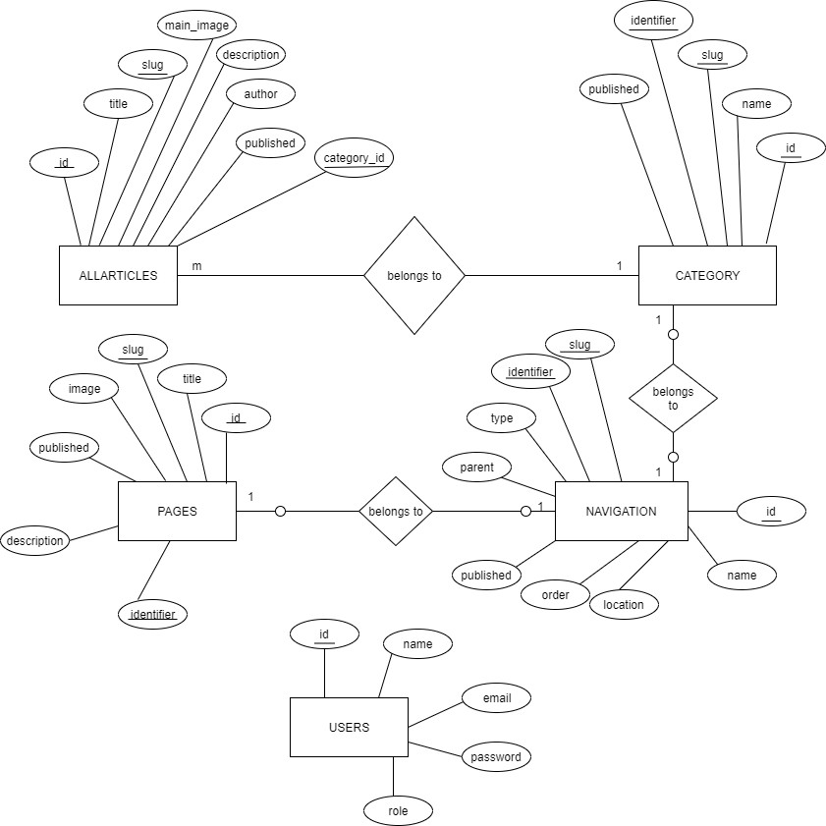

*Fig 2.4: ER diagram*

## Process Model

Process Modelling is a part of structuring the requirement in the simplified representation. Each model represents a process from a specific perspective. Process model are abstract visualization of system.

### Context Diagram (Level-0 Data flow Diagram)

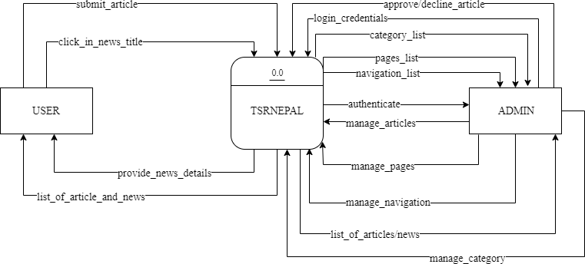

*Fig 2.5.1: Context diagram*

### Level-1 Data Flow Diagram

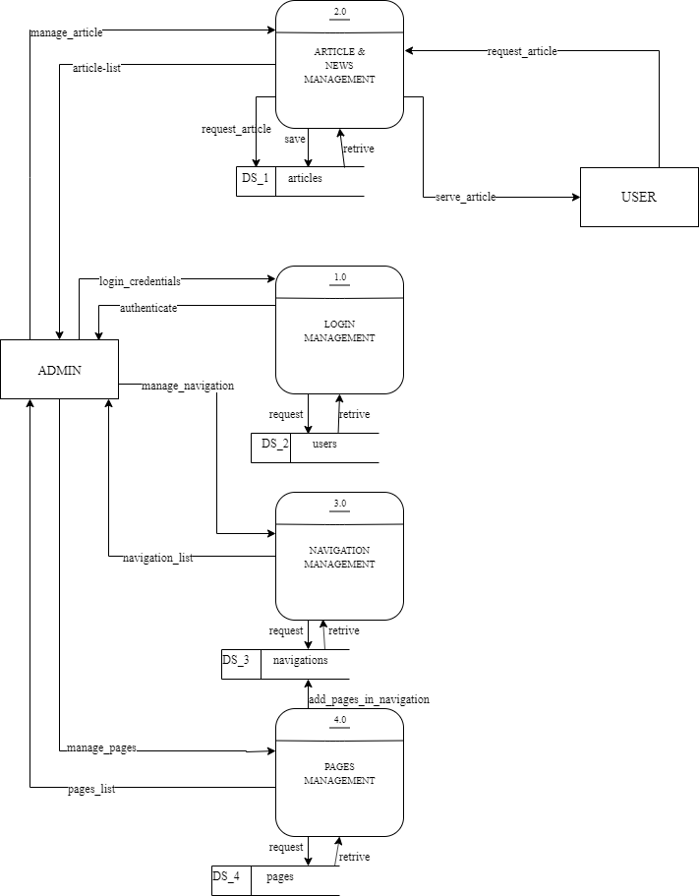

*Fig 2.5.2: Level-1 DFD*

* 1. **Database Design**

# CHAPTER 3

## SYSTEM DESIGN

Database Schema is the overall representation of the database tables in a way that represents all the co-relations between them.

The database schema design of the project is given below:

### Allarticles Table

This table keeps information about articles. There is one foreign key on this table, category_id which is reference to categories table.

Table 3.1.1: Allarticles Table

|  |  |
| --- | --- |
| **Attributes** | **Data Type** |
| id (pk) | Bigint(20) unsigned |
| category_id (fk) | Bigint(20) unsigned |
| page_title | Varchar (255) |
| meta_title | Varchar (255) |
| meta_description | text |
| keyword | Varchar (255) |
| title | Varchar (255) |
| slug | Varchar (255) |
| short_description | Varchar (255) |
| main_image | Varchar (255) |
| description | longtext |
| author | Varchar (255) |
| published | Tinyint(4) |
| homepage | Tinyint(4) |
| exclusive | Tinyint(4) |

## Categories Table

Categories table is used to store type of articles. Some standard article types are already seeded during creation. But if admin want to add more category then he/she can add new category.

Table 3.1.2: Categories Table

|  |  |
| --- | --- |
| **Attributes** | **Data Type** |
| id | Bigint(20) unsigned |
| name | Varchar (255) |
| identifier | Varchar (255) |
| slug | Varchar (255) |
| published | Enum (‘Yes’, ‘No) |

## Commodities Table

Commodities table is used to store current price of particular commodities. Table 3.1.3: Commodities Table

|  |  |
| --- | --- |
| **Attributes** | **Data Type** |
| id | Bigint(20) unsigned |
| name | Varchar (255) |
| unit | double (8, 2) |
| published | Enum (‘Yes’, ‘No) |
| order | Int(11) |

## Navigations Table

Navigations table is used to store all navigation item. Parent and child all navigation items are stored and managed in this table. Published status of this table is deciding factor whether or not to show navigation item in navigation bar of the web site. We can add item in navigations table from categories table and pages table.

Table 3.1.4: Navigations Table

|  |  |
| --- | --- |
| **Attributes** | **Data Type** |
| id | Bigint(20) unsigned |
| name | Varchar (255) |
| slug | Varchar (255) |
| identifier | Varchar (255) |
| type | Varchar (255) |
| parent | Tinyint(4) |
| published | Tinyint(4) |
| order | Tinyint(4) |
| location | Varchar (255) |

## Pages Table

Pages table is used to store information about single pages. Pages like terms and conditions, Privacy policy and other single’s pages data are stored in this table. Admin can create any other single page and store it in this table. Pages created here can also be added in navigation table.

Table 3.1.5: Pages Table

|  |  |
| --- | --- |
| **Attributes** | **Data Type** |
| id | Int(10) unsigned |
| title | Varchar (255) |
| slug | Varchar (255) |
| image | Varchar (255) |
| published | Tinyint(4) |
| description | longtext |
| identifier | Varchar (255) |
| type | Varchar (255) |
| page_title | Varchar (255) |
| meta_title | Varchar (255) |
| meta_description | text |
| keywords | text |

# CHAPTER 4

## SYSTEM IMPLEMENTATION

## Front End Tools

Front end tools are used to design the user interface and to develop the front end. These tools are used to make the system more interactive with users. HTML, CSS, Javascript, Bootstrap are the front-end technologies which are used to develop the front end. We have used HTML, bootstrap – css framework and jquery – javascript library to develop the front end. These technologies are described below.

### HTML

HTML (HyperText Markup Language) is the standard markup language used to create web pages.

Since this project is web application, HTML is used as markup language to create different pages which is displayed to the user. Some of the HTML tags used in the project are given below.

Paragraph Tag: <p> This is paragraph tag </p>. This tag is used to display short description of article while listing articles.

Image Tags: <img src=”/uploads/news/protest.jpg” alt=”people protesting”>. This tag is used to display image related to news and articles publish in the site.

### CSS

Cascading Style Sheets (CSS) is a style sheet language used for describing the presentation semantics (the look and formatting) of a document written in a markup language. To make the system more user friendly, CSS is used to design the HTML page. CSS is used in every pages of the application. Some of the CSS attribute used in this project are given below.

Padding: Padding is inside space between content and container. It can have different value. In this project padding is used in multiple element, one of them are body element where we have used padding 0.

Margin, Position, font-size, color, background-color are some mostly used CSS attributes to adjust look and feel of website and we have used excessively those attributes in this site too.

### Bootstrap

Bootstrap is a free and open-source collection of tools for creating websites and web applications. We have used Admin Cast template, which is bootstrap based template, to develop the layout of the system. Bootstrap have many ready to use class to get desired output in layout and design of website. Mainly we have used bootstrap to make responsive design. Some class of bootstrap we have used in our project are given below.

Col-lg-8, col-md-12, col-sm-12 are some responsive related class we have used in our peoject.

### 4.2.5 JavaScript

JavaScript (sometimes abbreviated JS) is a prototype-based scripting language that is dynamic, weakly typed. JavaScript is a client-side scripting language meaning that JavaScript code is written into an HTML page. When a user requests an HTML page with JavaScript in it, the script is sent to the browser and it's up to the browser to do something with it. It is used to make webpage more interactive, check or modify the contents of forms, change images, open new windows and write dynamic page content.

JavaScript is used to make interactive and to generate instant response in the website. It is event-based language. We can hook different action on different event occurred in the website either is system generated event or action done by user. Like when user hover cursor in the certain button then change the colour of it.

There are different frameworks created in JavaScript we had used framework in our project more than JavaScript itself.

## Back End Tools

I was involved in web development using PHP framework Laravel as a back-end tool and MySql as a database.

### PHP

PHP is a server-side scripting language designed for web development but also used as a general-purpose programming language. We have used Laravel as a PHP framework.

We used PHP to make Controller class. HomeController which has multiple methods to feed data to the respective view according to user’s request. How we have implemented PHP to create HomeController somehow look like this.

<?php

class HomeController { public function index()

{

$data = getNeededDataFromModel(); return view(‘front.index’, $data);

}

}

?>

### Laravel

Laravel is a free, open-source PHP web framework, created by Taylor Otwell and intended for the development of web applications following the model–view–controller (MVC) architectural pattern.

Laravel provides awesome folder structure to manage codebase. We need to follow convention to work in Laravel. There are separate places for all components of project like, controller need to be inside app/http/Controllers inside this we can have folder and keep controller classes inside this or just create controller class file.

### MySQL

MySQL is an open-source relational database management system (RDBMS). Our all data are stored and retrieved by MySQL database. Creating required table in database is done by Laravel. We create migration file in Laravel and fill it with required field and their respective datatype. After creating migration file for each table, we want to create and fire ‘php artisan migrate’ command in terminal. This will create table in database made ready to populate table with data.

## Module Implementation

This project is combination of lots of modules. Some of the module of this projects are: Manage Article module, HomeController Module, Navigation Manager Module, Pages Manager Module.

### Manage Article Module

This module consists of AllarticlesController, Allarticle Model, Create, Edit, Listing page for article. AllarticlesController have six methods which serves working html pages to the user. There are other methods which are called by those six methods and get data processed by them.

* + - * Index method

This method is used to display all data stored in allarticles table. This method gets all articles from along with their belonging category and those data send to list view of all article.

* + - * Create method

Create method is used to display create form of article. This method gets categories name with their id with that data this method displays allarticles form. Category name is used to select the category of allarticles.

* + - * Store method

Store method have multiple responsibility. When user fills the allarticle form and click submit button, system keep all those data in object of Request class. We can access those data using $request object in this system. First, we validate the content filled by user. If content passed the validation then only system go forward otherwise appropriate error message will displayed to user. After getting validated data we create an array and put values provided by user, files/image are uploaded and their name are added in array, after completing that we pass that array to create method of allarticles.

* + - * Edit method

Edit method used to display edit form populated with previous value in appropriate field.

* + - * Update method

This method is invoked when user click the update button in the edit form. If anything is changed in the form then system will update that field in the database.

* + - * Destroy method

Destroy method have parameter id of the article which user want to delete. We search articles according to the id. If system find the article then we will fire delete method to delete it from the database.

### 4.3.1 HomeController Module

HomeController have many methods but one of the most important and entry point for many request is dynamicNavigation.

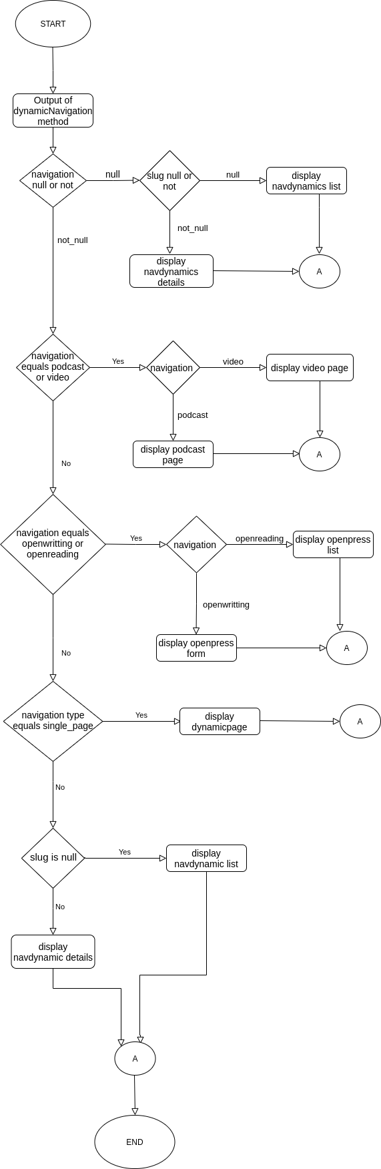

*Fig 4.3.1: Flow Chart of dynamicNavigation method*

* 1. **Unit Test**

# CHAPTER 5

## TESTING

We have tested each module of this system in order to check the correctness of the output. Firstly, we found many errors and then it was resolved stepwise. Some of the test case are listed below. Testcase for login, adding article in article table and adding pages in navigation table are listed below. Hence, this test was successful.

### Unit Test Cases

* + - * **Test case for login**

|  |  |  |
| --- | --- | --- |
| **SN** | **Input** | **Expected Output** |
| 1 | Email: [info@tsr.com](mailto:info@tsr.com)  Password: testing | Successful Login |
| 2 | Username: [info@ts.com](mailto:info@ts.com) Password: testing | Unsuccessful Login These credentials do not  match our records. |
| 3 | Username: [info@tsr.com](mailto:info@tsr.com) Password: adfasdfsd | Unsuccessful Login  These credentials do not match our records. |

### Test case for adding article

|  |  |  |
| --- | --- | --- |
| **SN** | **Input** | **Expected Output** |
| 1 | Title: Left Blank | The title field is required |
| 2 | Select_category: Left Blank | The category id field is  required. |

|  |  |  |
| --- | --- | --- |
| 3 | Title: Testing Article Posting Select_category: Dividents Short_description: This is testing Description: Description of article goes here  Main_image: Image uploaded Publish: checked | Allarticle created Successfully. |

* + - * **Test case for adding pages in navigation**

|  |  |  |
| --- | --- | --- |
| **SN** | **Input** | **Expected Output** |
| 1 | Click on ‘+’ icon in pages table | Display, Add into  navigation bar form |
| 2 | Without selecting navigation type, click  submit button. | The parent field is  required. |
| 3 | Select navigation item from displayed  dropdown and click submit button. | Pages added in navigation  table. |

### Test Execution

* + - * **Test result for login**

|  |  |  |  |
| --- | --- | --- | --- |
| **SN** | **Input** | **Actual Output** | **Remarks** |
| 1 | Email: [info@tsr.com](mailto:info@tsr.com) Password: testing | Admin page displayed. | Test Succeed |
| 2 | Email: [info@test.com](mailto:info@test.com) Password: testing | These credentials do not match our  records. | Test Succeed |

|  |  |  |  |
| --- | --- | --- | --- |
| 3 | Email: [info@tsr.com](mailto:info@tsr.com) Password:random | These credentials  do not match our records. | Test Succeed |

### Test result for adding article

|  |  |  |  |
| --- | --- | --- | --- |
| **SN** | **Input** | **Actual Output** | **Remarks** |
| 1 | Title: left blank | Failed to add  article | Test succeed |
| 2 | Select_category: left blank | Article added. | Test Failed. category_id field made ‘required’  on server side. |
| 3 | Title: Testing Article Posting  Select_category: Dividents Short_description: This is testing  Description: Description of article goes here Main_image: Image uploaded  Publish: checked | Article added. | Test Succeed. |

* + - * **Test result for adding pages in navigation**

|  |  |  |  |
| --- | --- | --- | --- |
| **SN** | **Input** | **Actual Output** | **Remarks** |
| 1 | Click on ‘+’ icon in pages table | Display, Add into  navigation bar form | Test Succeed. |

|  |  |  |  |
| --- | --- | --- | --- |
| 2 | Without selecting  navigation type, click submit button. | Added page into navigation. | Test Failed. Problem fixed |
| 3 | Select navigation item from displayed dropdown and click  submit button. | Pages added in navigation table. | Test Succeed. |

**6.1 Conclusion**

# CHAPTER 6

## CONCLUSION

This internship period become the turning point of my life. I got an experience as a software developer. I got a chance to intact with other software developer. In this report, I have tried to include overall finding of internship and knowledge that I have gained during my internship.

I got hands on experience of how software development life cycle works in software companies. I felt little different on this particular note that how we have studied SDLC in our course book, is not exactly how they operate in the company. However, overall journey of my internship was really fruitful.

I have learned various types of technologies required for web development. My main focus had been on back end development, but I got a chance to work on some front-end frameworks too. With the help of this internship I have gained significant amount knowledge which will be helpful for my future carrier.

The team of Web House Nepal have been really helpful and supportive to grow, sharpen knowledge and to acquire new skills.

# BIBLIOGRAPHY

PHP. PHP documents. Retrieved from php.net/docs.php

Laravel Screencast. Laravel 5.2 from Scratch. Retrieved from https://laracasts.com/lar avel-5-from-scratch

Bootstrap. Bootstrap documents. Retrieved from <http://getbootstrap.com/docs/3.3/> Laravel framework. Laravel 5.2 documents. Retrieved from https://laracasts.com/lara

vel.com/docs/5.2

# Appendix 1: Screenshots

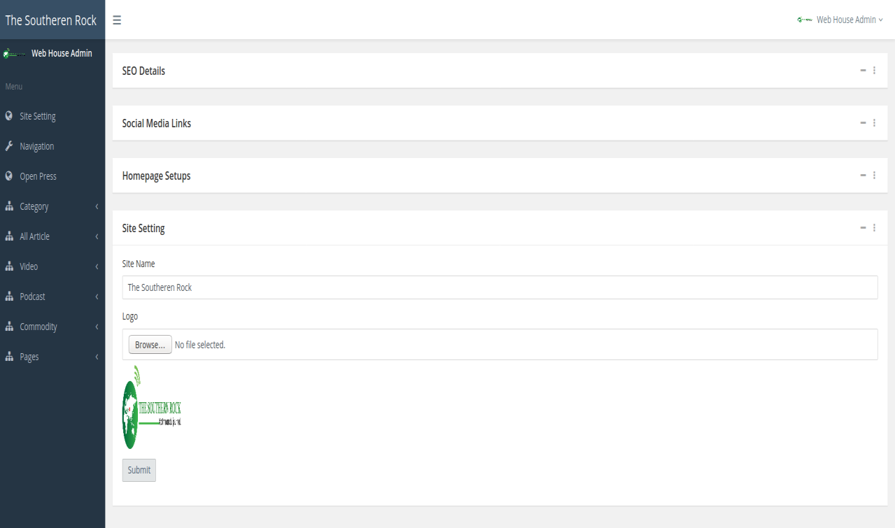

*Fig: Screenshot of Dashboard*

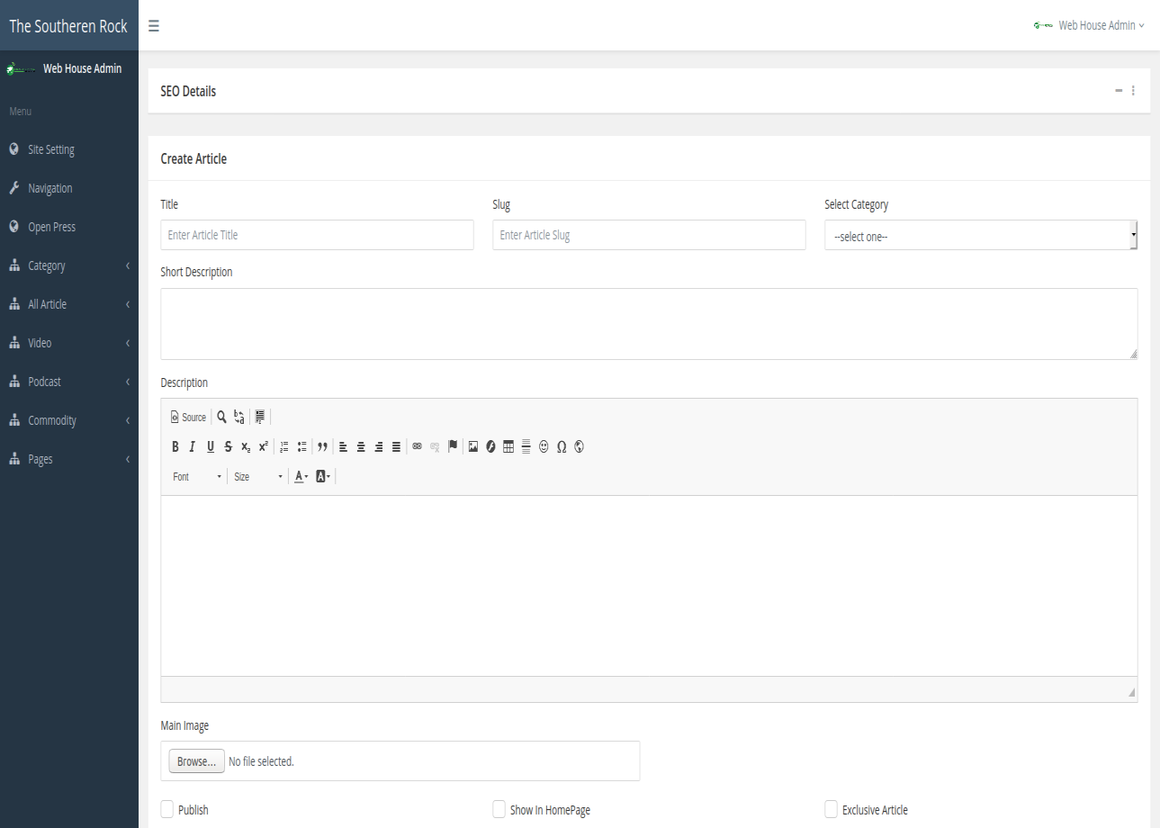

*Fig: Screenshot of adding article details*

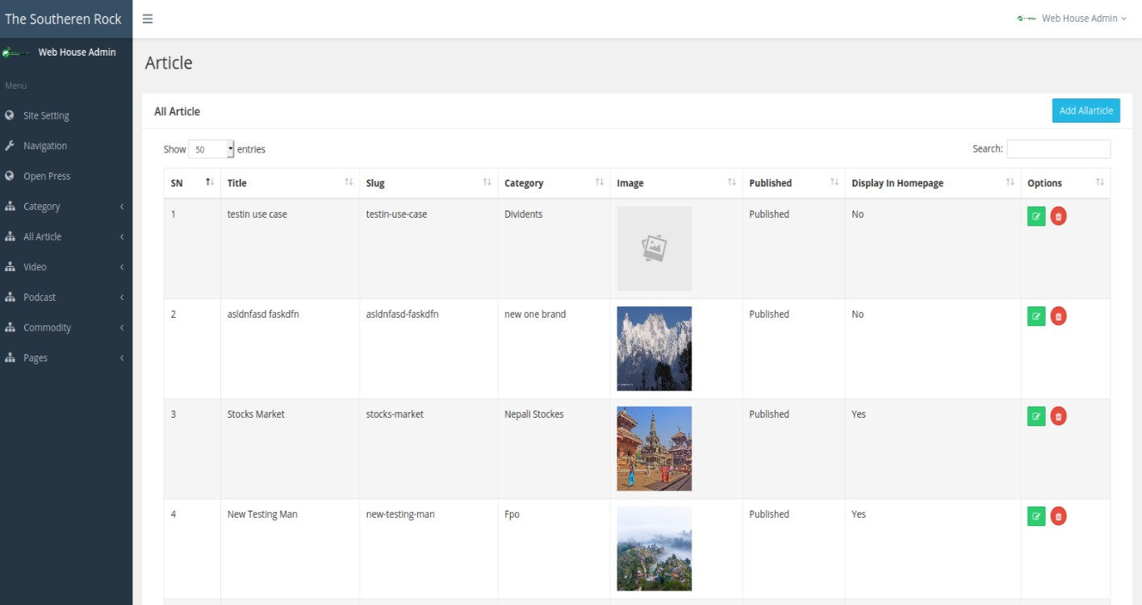

*Fig: Screenshot of Article List*

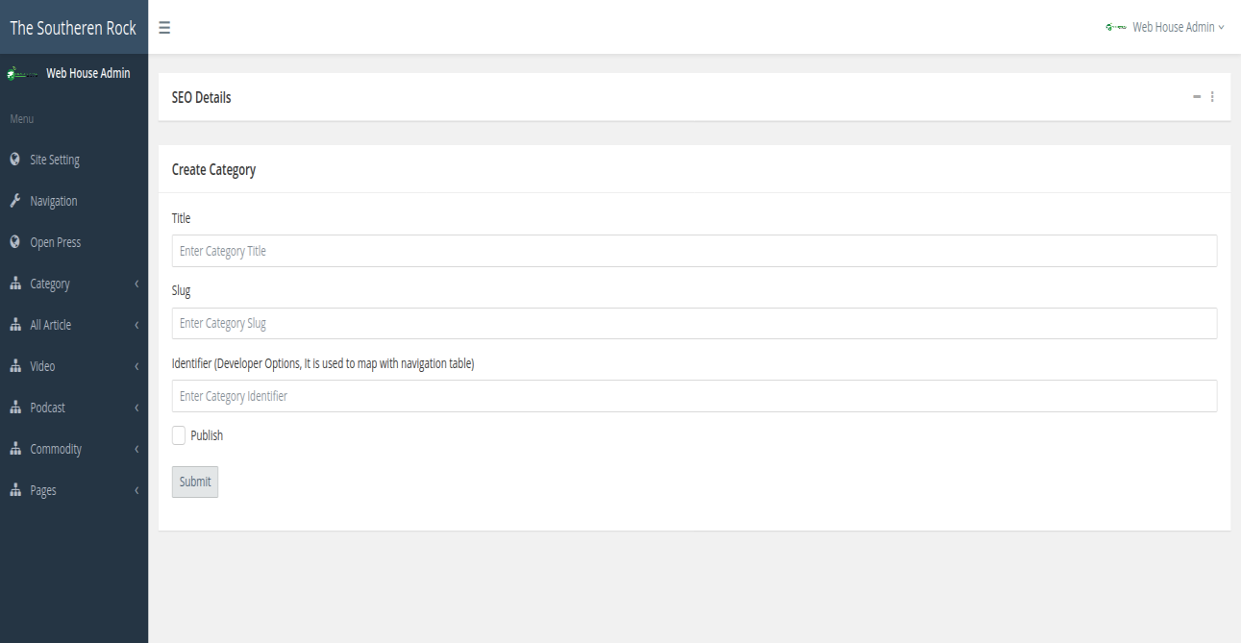

*Fig: Screenshot of adding category*

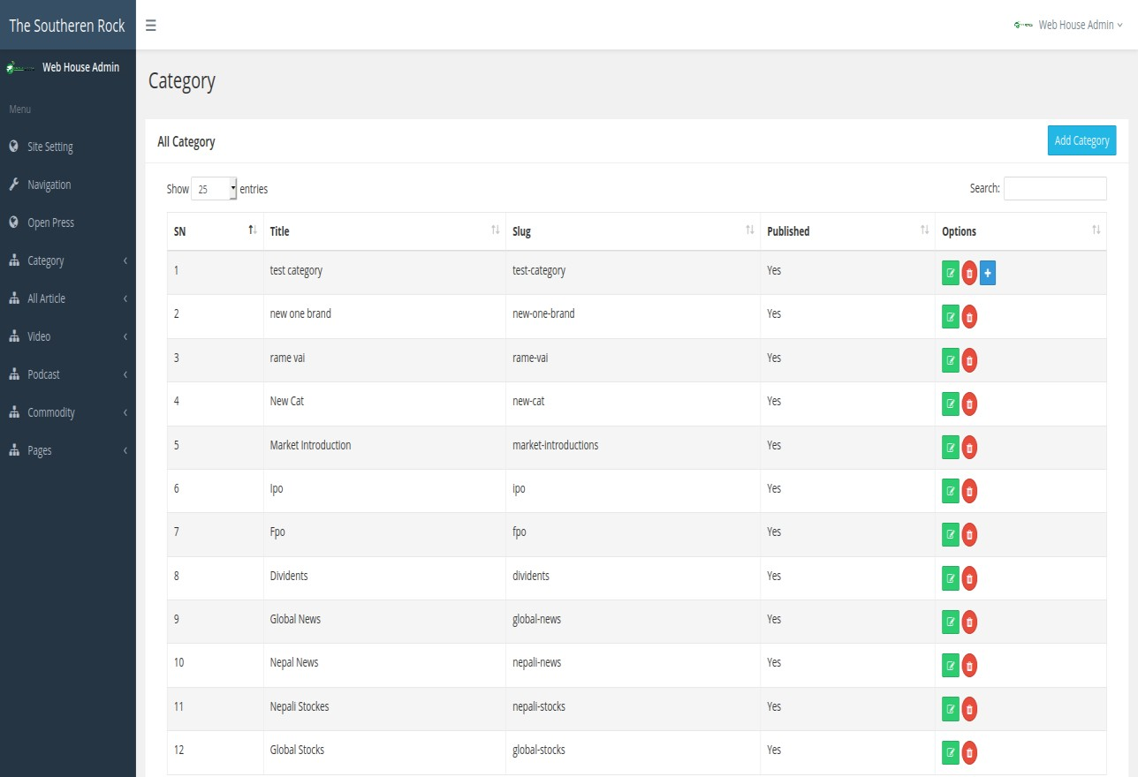

*Fig: Screenshot of Category List*

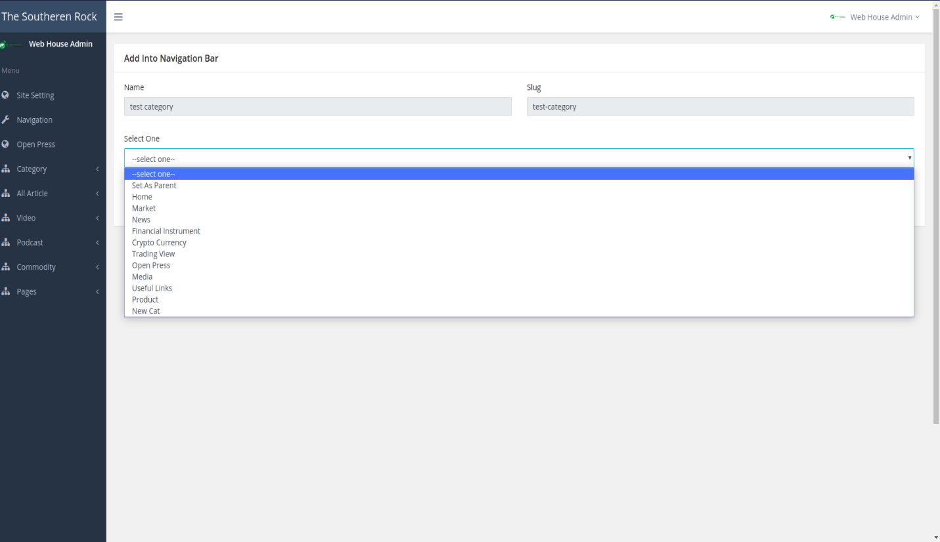

*Fig: Screenshot of adding category in navigation bar*

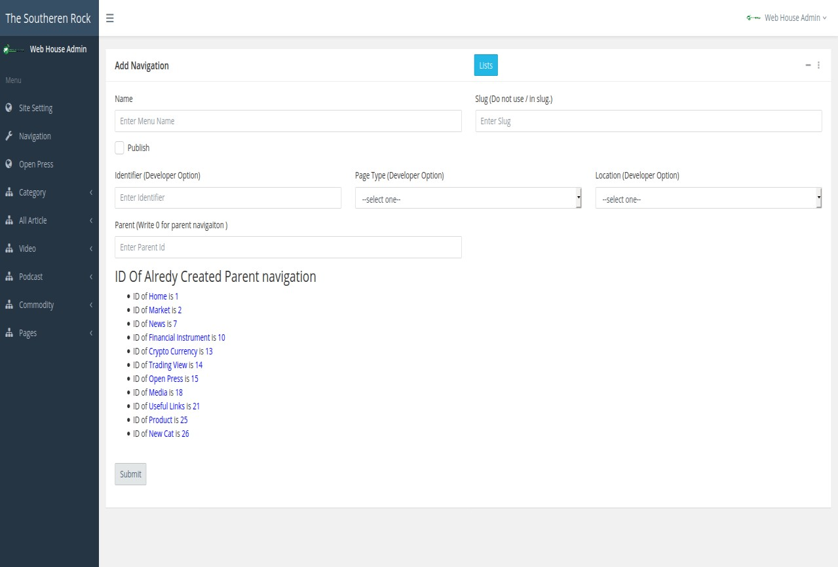

*Fig: Screenshot of adding item in navigation bar*

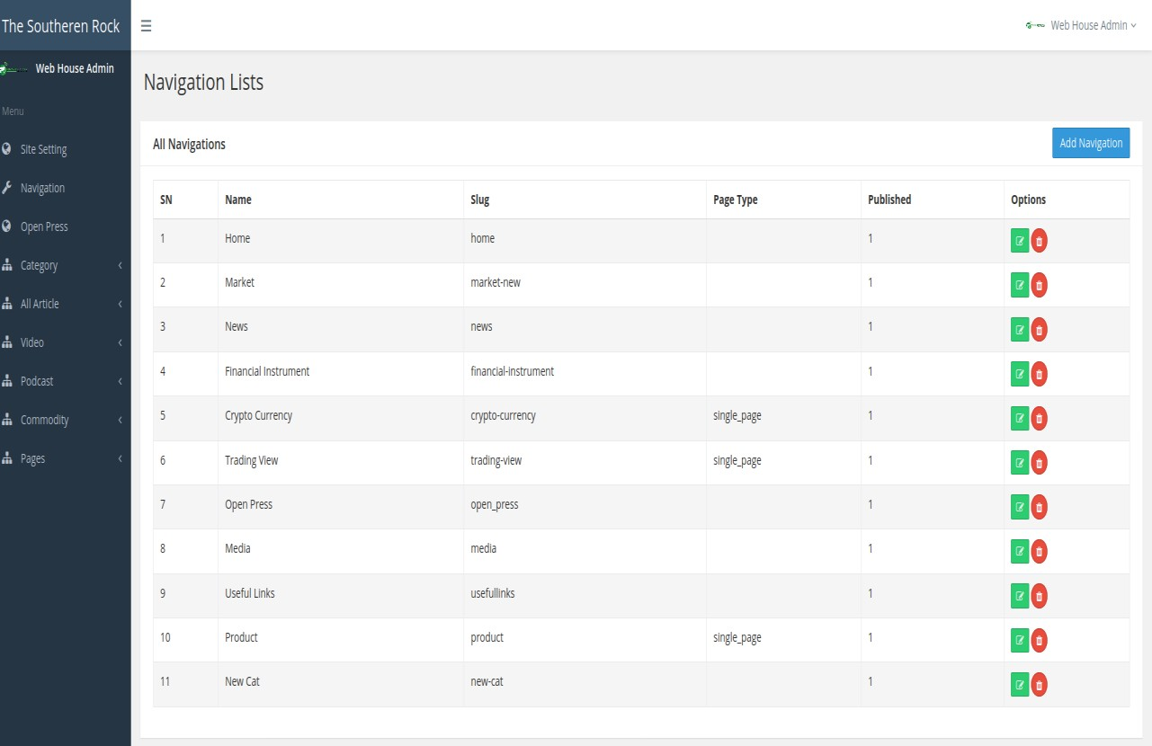

*Fig: Screenshot of navigation list*

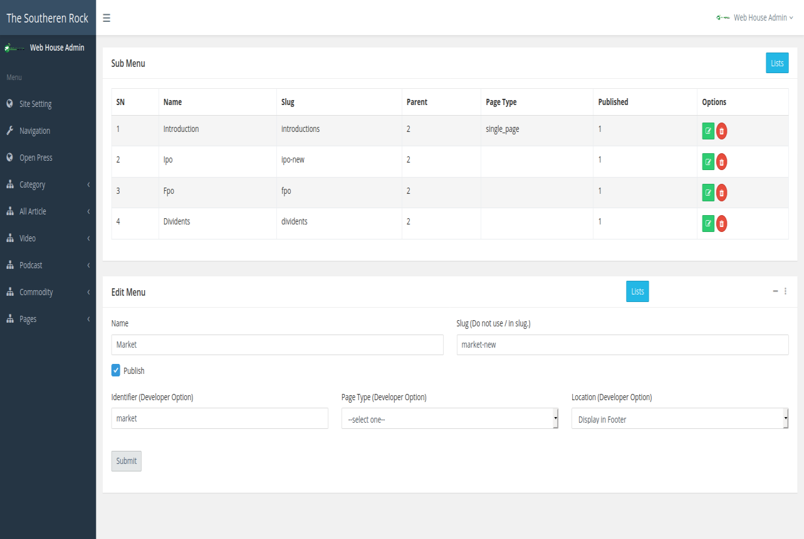

*Fig: Screenshot of edit and child of navigation item*

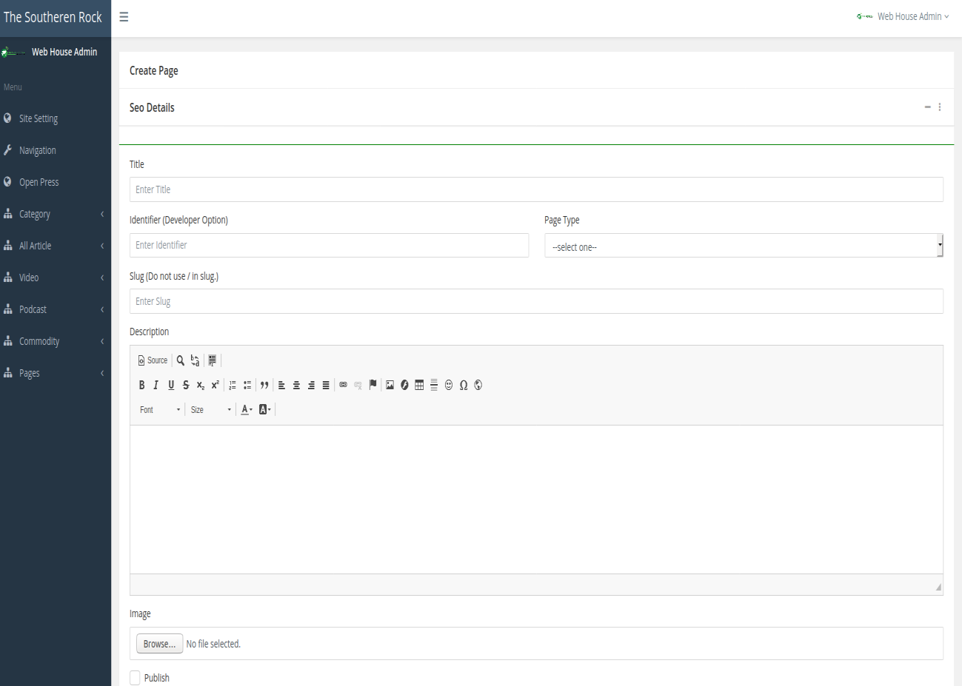

*Fig: Screenshot of adding pages*

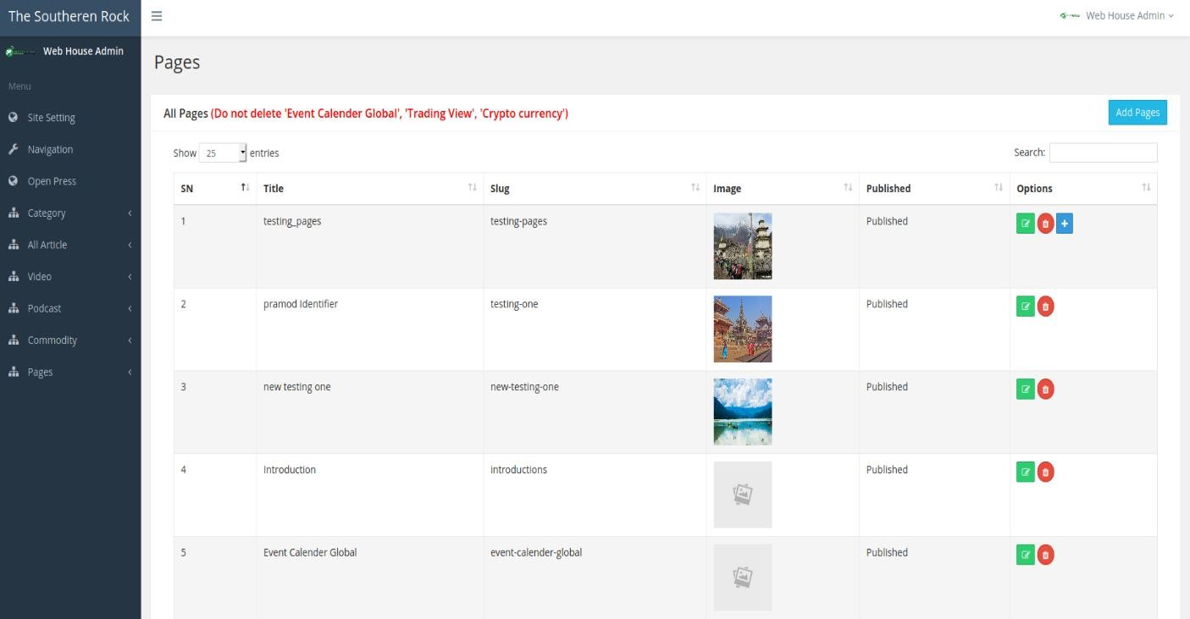

*Fig: Screenshot of pages list*