questionnaires for new enrollees
milo checkmate YEAR-ROUND REGULAR/ONLINE PROGRAM

Name: _________________________________ Date: _________________________

Read the instructions carefully. Answer Y, if yes. N, if no. Write your answer at the opposite blank space.

A. Do you know how the pieces and pawns move and capture? _____
B. Do you know the values of the pieces and pawns? _____ Which are the major pieces? ___________ the minor pieces? ___________
C. Do you know how to record the moves? _____
D. Do you know how to castle? _____kingside castling? ____ queenside castling? _____

E. Do you know the following chess terms?

1) Chess notation ____ 2) check ____ 3) checkmate ___ 4) Stalemate____ 5) Pawn promotion ____ 6) En passant capture ____

7) Win the Exchange ____8) Lose the Exchange ____ 9) Threat _____ 10) Attack and Defense ____ 11) Back rank ____ 12) Tactics ____

F. Encircle your answer. Which combination of pieces can checkmate? K-king; Q-queen; R-rook; B-bishop; N-knight
a) R d) R + Q g) K + B k) 2Ns n) B + N
b) K + R e) Q h) K + 2 Bs l) K + N o) 2Bs + N
c) 2 Rs f) K + Q i) 2 Bs m) K + 2Ns p) K + B + N

G. Among the combination of pieces given above, which are you very familiar with?
_______________________________________________________________________________________________________________

H. Do you know the opening principles? If yes, write at least three principles.

__________________________________________________________________________________________________________________

I. Do you know the principles applied in the K and pawn endgame? If yes, write at least three principles.

___________________________________________________________________________________________________________________

J. Do you know the basic tactics? If yes, enumerate them?

______________________________________________________

K. Do you know the good pawn structure? If yes, can you give at least three. ______________________________________________________

L. Do you know the bad pawn structure? If yes, can you give at least three. _______________________________________________________

M. Do you know what a good bishop is? ____ Do you know where the rook is better placed? ____

N. Do you know the Philidor’s Defense? _____ Do you know about the so-called “Lucena position”? ______

Please email this questionnaire with your indicated answers. Thank you.

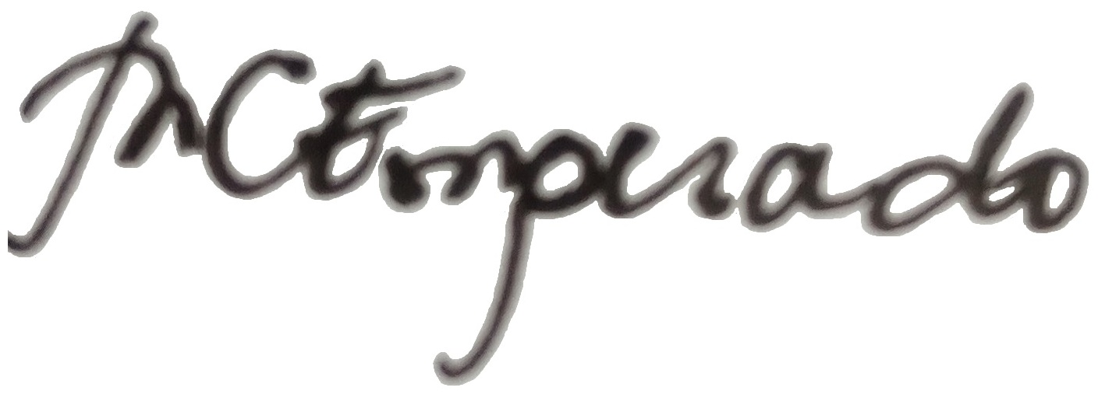

By: WNM Milagros C. Emperado
President/Founder Metropolitan Chess Club (Center) & Checkmate Phils. Inc.

