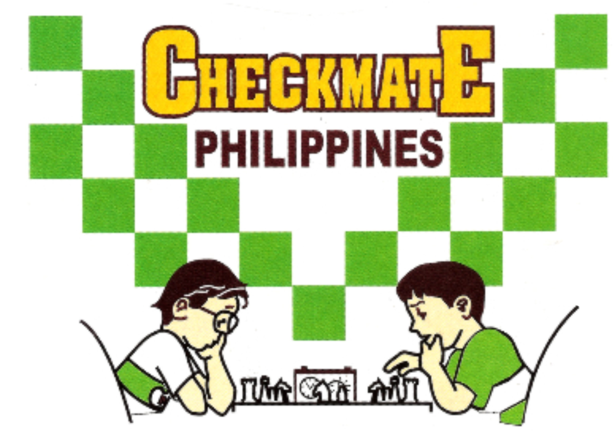 |  | PSA LIFETIME ACHIEVEMENT AWARDEE: SCOOP AWARDEE METROPOLITAN CHESS CENTER  Office: 834 Marquez St., Ph. 5 Gatchalian Subd., Las Piñas City  Landline: (02)-8826-8560 Mobile no. 0922-822-6319  email: mccchess@yahoo.com website: mccchess.com  fb: milo checkmate chess clinic and sports academy

MILO CHECKMATE ONLINE REGISTRATION FORM

Please fill-up the form completely.

SCHEDULE ___________________________________________________________________________________________________

FULL NAME: BIRTHDATE AGE GENDER

_______________________________________________________________________________________________________________
ADDRESS

CONTACT NO. EMAIL FB

_______________________________________________________________________________________________________________
SCHOOL AND SCHOOL ADDRESS

_______________________________________________________________________________________________________________
CHESS AWARDS

Declaration:

By joining this chess activity, I hereby certify that the organizer(s) and its staff are not responsible for any damages, loss, or injury which may be sustained by the player during the course of the event or may arise from any cause in connection with the event.

_______________________________________________________________________________________________________________
STUDENT’S SIGNATURE PARENT/GUIDANCE SIGNATURE
(OVER PRINTED NAME)

Details/Requirements for 2023 Milo Checkmate Online Program:
- Schedules: Tuesday 2pm and 3:15pm; Thursday 1:45pm and 3pm. First-come, first-serve basis.
- Fees: one-on-one P4800 for eight sessions; group class P5500 for ten sessions. (One hr./session)
- Advance payment is required and can pay thru gcash 0922-822-6319 or any branch of Banco de Oro (BDO) account # 001480 1353 70 both under Milagros C. Emperado
- Email the filled-up form together with the enrollee’s answer sheet and the deposit slip.
- Required to have a notebook and pen during the session.

