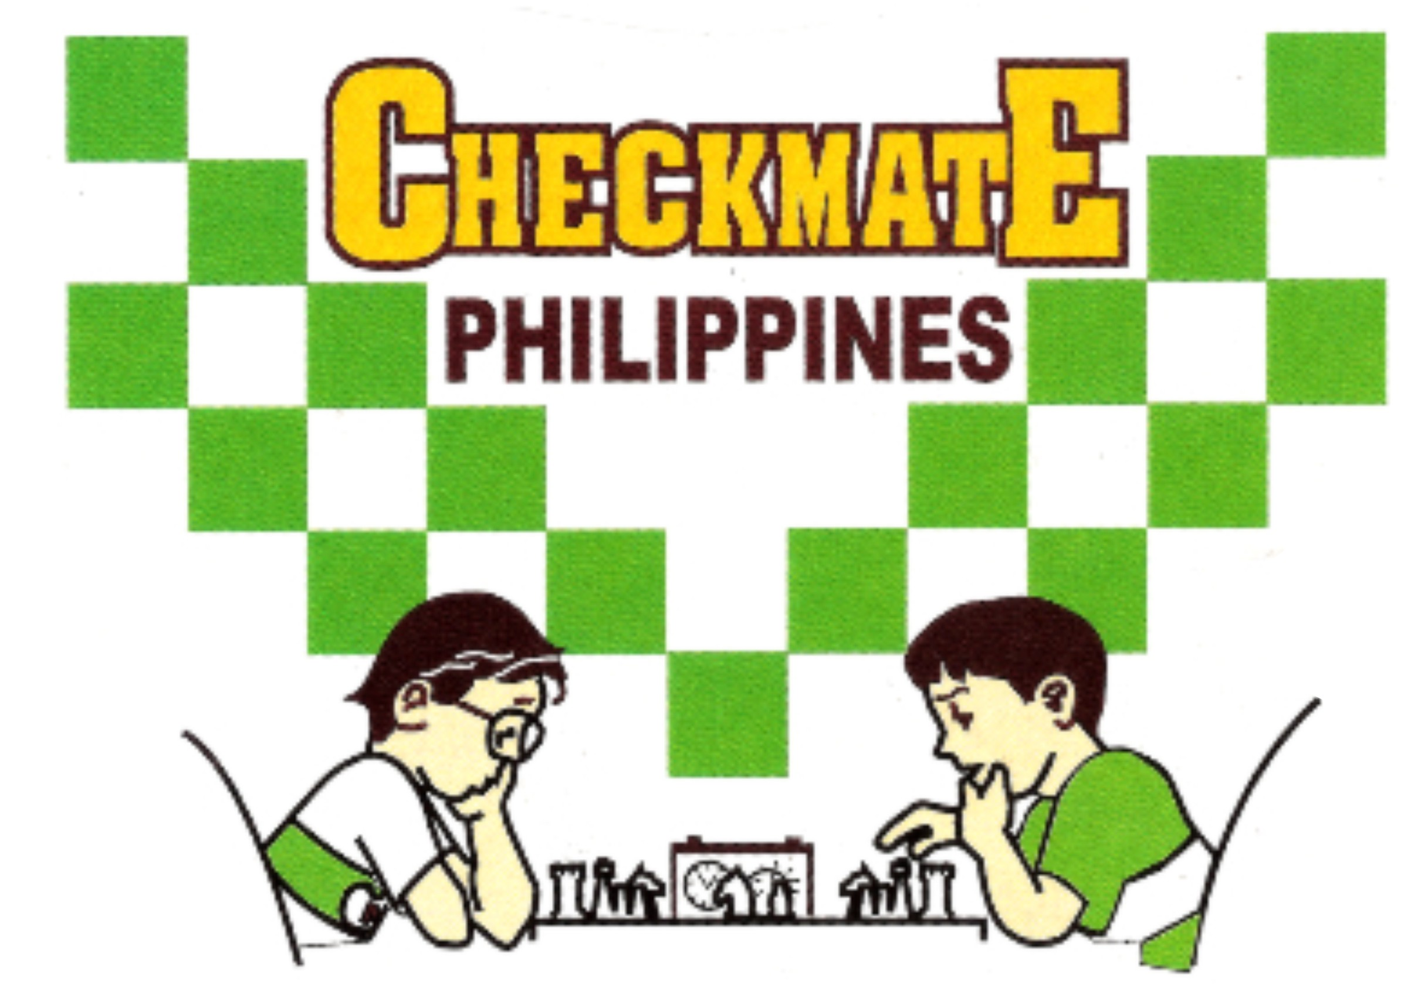 |  | PSA LIFETIME ACHIEVEMENT AWARDEE: SCOOP AWARDEE  METROPOLITAN CHESS CENTER  Office: 834 Marquez St., Ph. 5 Gatchalian Subd., Las Piñas City  Landline: 02-8826-8560 Mobile nos. 0922-822-6319  email: mccchess@yahoo.com website: mccchess.com  fb: milo checkmate chess clinic and sports academy

MILO Checkmate Online Enrollment Form
Fill-up the form and email it at mccchess@yahoo.com

SCHEDULE ___________________________________________________ Number of sessions _______________________________

FULL NAME: BIRTHDATE AGE SEX

_______________________________________________________________________________________________________________
CONTACT NO. EMAIL

_______________________________________________________________________________________________________________
CHESS AWARDS (if any)

Declaration:

We confirm that the agreed schedules will be strictly followed. In case of unavoidable circumstances, an early notification will be sent accordingly to request that the session be cancelled and to resume on the next schedule instead. Without such prior notification, the organizer(s) and his/her coach reserves the right to have the involved session be officially counted.

_______________________________________________________________________________________________________________
STUDENT’S SIGNATURE PARENT/GUIDANCE SIGNATURE
(OVER PRINTED NAME)

Instructions for Online registrations:
- Fill-up the form.
- Can pay thru gcash 0922-822-6319 or at BDO account Number: 001480 -1353-70
Both account Name: Milagros C. Emperado

- If using a deposit slip/gcash, indicate the name of the enrollee on the payor’s name to make sure the payment would be acknowledged rightfully.

- Email the filled-up form together with the deposit slip at mccchess@yahoo.com.

- Requirements if joining the final evaluation tournament. (Date will be provided in advance).
  - Bring your own chess sets, notebook and pen.
  - Wear or bring your face mask.
  - Wear your Milo uniform. (Available onsite, cost P250).

Thank you.
WNM Milagros C. Emperado

