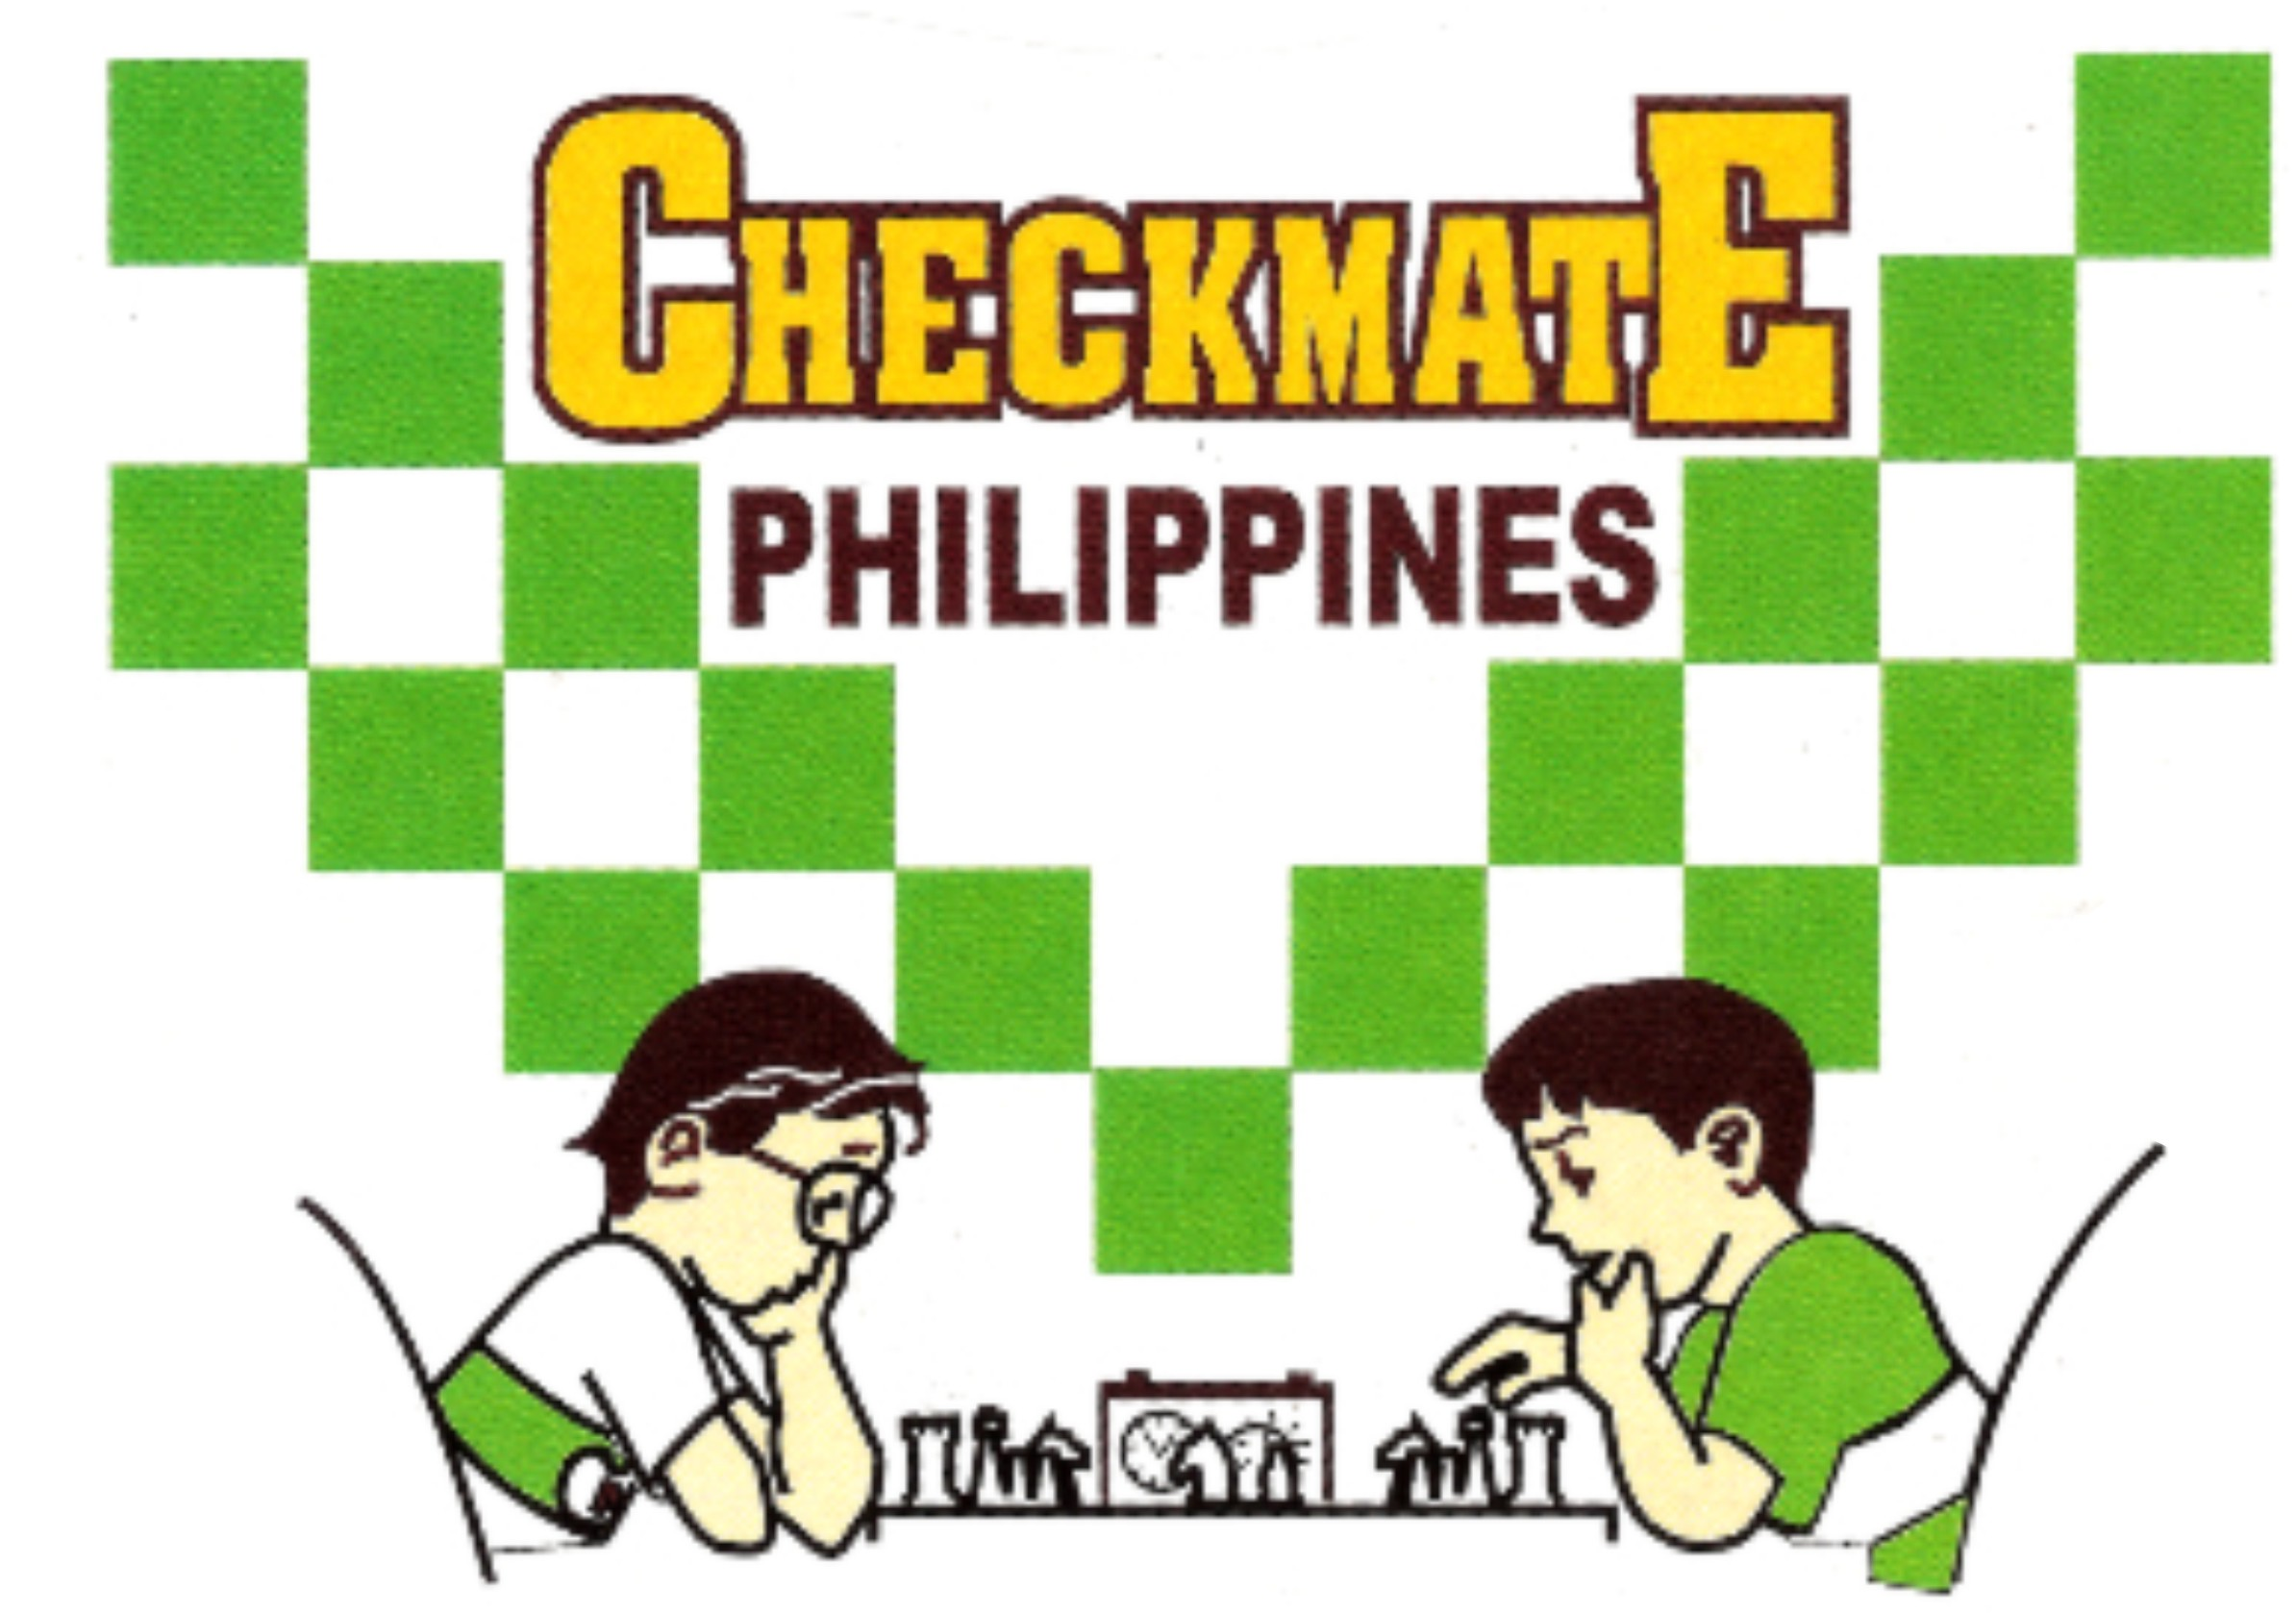 |  | PSA LIFETIME ACHIEVEMENT AWARDEE: SCOOP AWARDEE METROPOLITAN CHESS CENTER  Office: 834 Marquez St., Ph. 5 Gatchalian Subd., Las Piñas City  Landline: (02)-8826-8560 Mobile no. 0922-822-6319  email: mccchess@yahoo.com website: mccchess.com  fb: milo checkmate chess clinic and sports academy

MILO CHECKMATE (FACE-TO-FACE) PRE-ENROLLMENT FORM

Please fill-up the form completely.

SCHEDULE _____________________________________________ VENUE_______________________________________________

FULL NAME: BIRTHDATE AGE GENDER

_______________________________________________________________________________________________________________
ADDRESS

CONTACT NO. EMAIL FB

_______________________________________________________________________________________________________________
SCHOOL AND SCHOOL ADDRESS

_______________________________________________________________________________________________________________
CHESS AWARDS

Declaration:

By joining this chess activity, I hereby certify that the organizer(s) and its staff are not responsible for any damages, loss, or injury which may be sustained by the player during the course of the event or may arise from any cause in connection with the event.

_______________________________________________________________________________________________________________
STUDENT’S SIGNATURE PARENT/GUIDANCE SIGNATURE
(OVER PRINTED NAME)

Details:
- Program is for kids who are seven (7) years old and above.
- One batch/series of the Milo Checkmate clinics (Saturdays- or Sundays- or Summer) consists of six sessions for the lessons and one for the tournament. (Two hours/session for the lesson and five hours for the tournament).
- The tournament can be held on a Saturday or Sunday depending on the availability of the venue.
- All enrollees (of same batch) from different venues are assembled together in the tournament and mandatory to participate. They compete according to their levels. Winners are awarded medals, courtesy of the supporting Milo, the No.1 energy drink in the country.
- Fee: P5950/batch. Advance payment is required. Can pay thru gcash 0922-822-6319 or any branch of Banco de Oro (BDO) account # 001480 1353 70 both under Milagros C. Emperado
- An acknowledgement will be forwarded thru messages or email once payment is received.
- A test questionnaire will be emailed for prior assessment of the enrollee.
- Must bring own chess set, notebook and pen during the session. Wear/bring face mask
- For onsite registration, please bring the copy of the pre-enrollment form and pay to the designated coach/MCC office staff and ask for a receipt.

