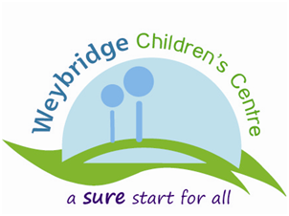

**Weybridge Children’s Centre Newsletter**

**Autumn 2010**



**‘Caring for each other, Sharing with each other, Learning together’**

**Bits and Bobs**

The Parenting Puzzle is fully booked for September, so we are now taking bookings for January

Our Saturday drop in session is up and running, so please drop by and see us.

If you interested in gardening and would like to get involved with helping us develop our garden please get in touch.

Do you want to give up smoking? We can put you in touch with ‘Surrey’s Stop Smoking Service’. It’s a free service run by professionals and you can be supported through evening groups or one-to-one day time telephone sessions. Talk to us for more details or call the Stop Smoking Service directly on 0845 602 3608

C:\Documents and Settings\hwright\My Documents\My Pictures\images1.jpg

**Our Centre**

Following our extremely successful opening celebration on 10th July we are delighted to be offering a huge range of services from our centre, based at the converted bowls pavilion.

There is a marvellous multi-sensory room, which provides an interesting and stimulating experience for all children, however has particular benefits for children with additional needs. This room is available to be booked for half hour slots, simply ring the centre advisers, Yvette and Helena, to book your session.

Yvette and Helena are also on hand to answer any questions you may have regarding local childcare, early years education or starting school. They have well established links with local agencies and services and a wide variety of leaflets for you.

If they can’t help you, they’ll know who can!

Welcome to our new look newsletter, I hope you have all had a lovely summer.

Attached you will find our new programme, which is full of activities to support families with young children in the Weybridge area. Please have a read as we aim to offer something for everyone and each activity has been planned in response to families’ requests. Your feedback is extremely important to us and we are now setting up our forum; ‘Friends of Weybridge Children’s Centre’. This forum is an opportunity to meet together and to consult further about our services, please contact me for more details or if you would like to get involved.

We look forward to seeing you in our centre soon.

* Daphne