- Calcolare la frequenza cardiaca di riserva (formula di Karvonen)

K% = ((HR - HRrest)*100) / (HRmax - HRrest)
HR = Heart Rate – Frequenza cardiaca
HRrest = Frequenza cardiaca a riposo
HRmax = Massima frequenza cardiaca

Dati presi dall’ultimo allenamento:


K% = ( ( 168 – 55 ) * 100 ) / ( 195 – 55 )
K% = ( 113 * 100 ) / 140
K% = 11300 / 140
K% = 80,71

- Trasformare Karvonen % in Vo2Max %
Tabella di conversione
Karvonen % | Vo2Max %
50 | 35
65 | 50
72 | 60
79 | 70
83 | 75
87 | 80
91 | 85
94 | 90

Giova’s formula (fuck Cartesio)
Vo2Max% = y0 + ( ( ( y1 – y0 ) / ( x1 – x0 ) ) * ( x - x0 ) )
Vo2Max% = 70 + ( ( ( 75 – 70 ) / ( 83 – 79 ) ) * ( 80,71 – 79 ) )
Vo2Max% = 70 + ( 5 / 4 ) * 1,71
Vo2Max% = 70 + 2,13
V02Max% = 72,13

- Trasformare Vo2Max % in Vo2Max ml/kg/min
Tabella di conversione
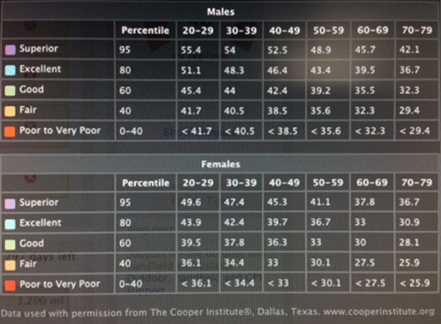
Creo una colonna specifica per i 28 anni:
Giova’s formula (fuck Cartesio again)
row95 = y0 + ( ( ( y1 – y0 ) / ( x1 – x0 ) ) * ( x - x0 ) )
row95 = 55,4 + ( ( ( 54 – 55,4 ) / ( 30 – 20 ) ) * ( 28 – 20 ) )
row95 = 55,4 + ( -1,4 / 10 ) * 8
row95 = 55,4 – 0,14 * 8
row95 = 55,4 – 1,12
row95 = 54,28
row80 = y0 + ( ( ( y1 – y0 ) / ( x1 – x0 ) ) * ( x - x0 ) )
row80 = 51,1 + ( ( ( 48,3 – 51,1 ) / ( 30 – 20 ) ) * ( 28 – 20 ) )
row80 = 51,1 + ( -2,8 / 10 ) * 8
row80 = 51,1 -0,28 * 8
row80 = 51,1 – 2,24
row80 = 48,86

row60 = y0 + ( ( ( y1 – y0 ) / ( x1 – x0 ) ) * ( x - x0 ) )
row60 = 45,4 + ( ( ( 44 – 45,4 ) / ( 30 – 20 ) ) * ( 28 – 20 ) )
row60 = 45,4 + ( -1,4 / 10 ) * 8
row60 = 45,4 – 0,14 * 8
row60 = 45,4 – 1,12
row60 = 44,28
row40 = y0 + ( ( ( y1 – y0 ) / ( x1 – x0 ) ) * ( x - x0 ) )
row40 = 41,7 + ( ( ( 40,5 – 41,7 ) / ( 30 – 20 ) ) * ( 28 – 20 ) )
row40 = 41,7 + ( -1,2 / 10 ) * 8
row40 = 41,7 – 0,12 * 8
row40 = 41,7 – 0,96
row40 = 40,74

Nuova tabella di conversione
Percentile | Age 28
95 | 54,28
80 | 48,86
60 | 44,28
40 | 40,74

Vo2Max = y0 + ( ( ( y1 – y0 ) / ( x1 – x0 ) ) * ( x - x0 ) )
Vo2Max = 48,86 + ( ( ( 44,28 – 48,86 ) / ( 60 – 80 ) ) * ( 72,13 - 80 ) )
Vo2Max = 48,86 + ( -4,58 / -20 ) * - 7,87
Vo2Max = 48,86 + 0,229 * - 7,87
Vo2Max = 48,86 - 1,8
Vo2Max = 47,06

Risultato finale 47,06

