Overview of Historical GPR Human Audit

Dario Caldara, Matteo Iacoviello, Patrick Molligo and Charlotte Singer

Contents

Dates 2

Priority Dates 2

Second Priority Dates 2

Third Priority Dates 2

Current Assignments 2

Human algorithm 3

Notes 3

Examples 4

Example 1: Photo as a main article 4

Example 2: Photo associated with article 5

Example 3: Photo as tie breaker 6

Example 4: Article under photo 7

Example 5: Standard 1 8

Example 6: Standard 2 9

Example 7: Standard 3 10

# Dates

### Priority Dates

* November 1941 – January 1942
* September – November 1962
* April - June 1972

### Second Priority Dates

* September 1938
* August 1939 – January 1940
* June 1940
* February – September 1942
* January 1980
* November – December 1981
* March – June 1982
* November 1983
* April 1986
* August 1990 – January 1991
* August – October 2001
* September – October 2002
* January – April 2003
* February – April 2014
* September 2014
* August 2017
* March 2018
* May – October 2019

### Third Priority Dates

1985 – Present chronologically

### Current Assignments

Patrick 1985-1996

Charlotte 1997-2002

Dario 2003-2011

Matteo 2012-2019

# Human algorithm

* **Is the article missing?**
  + **Yes: Code an m**
  + **No: Is there a GPR banner?**
    - **Yes:** **Code a 3**
    - **No:** **Is there a GPR main article**?
      * 1. Width/number of columns is most important
      * 2. Check largest font size to break ties
      * 3. Check associated picture to break ties
      * 4. Check centrality of article to break ties
      * **Yes: Code a 2**
      * **No: Is there a GPR front page article?**
        + **Yes: Code a 1**
        + **No: Code a 0**

# Notes

* Assume GPR = 1, unless the article is convincingly rejecting that. Easing tensions - not GPR
  + E.g., “peace talks resume, but road ahead is complicated” means GPR = 1
  + “peace signed, big party” means GPR = 0
* Article Banner, main, and front articles are distinct, not subsets/supersets of each other
* All hits are indicators, not counts
  + Banner = 3; and include keyword or event
  + Main = 2
  + Front = 1
  + Missing article = “m”
* A Non-GPR article should be coded as a GPR article if context tells us it is directly caused by GPR
  + For example, see Sep 18th, 2001
* If number of columns, font, and centrality are equal, we consider there to be multiple main articles
* A feature picture with clear title either above or directly below can count as a main article
  + A picture without a title doesn’t count
* Adjacent pictures do not count towards column width
* An article is only considered a front page article if it is at the top of the page
* One column articles can be main articles

# Examples

### Example 1: Photo as a main article

In this example, because we can read the title associated with the photograph and the photograph takes up the greatest number of columns, it becomes the main article. The other two articles on the top row are front page articles, and any articles below the top row are disregarded.

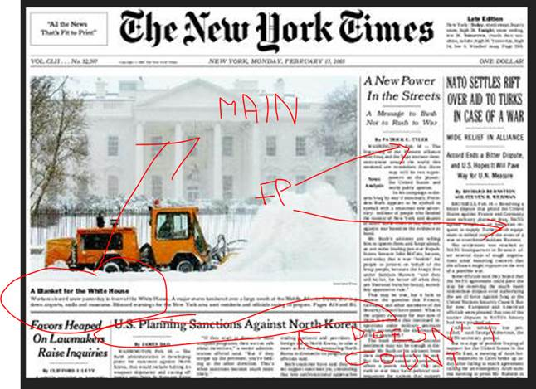

### Example 2: Photo associated with article

In this example, the photograph is associated with the article to the right. While together they take up the greatest number of columns, in determining the main article we only take into account the number of columns the title spans. In this case, the main article becomes the one on the left, and the other two articles on the top row become front page articles.

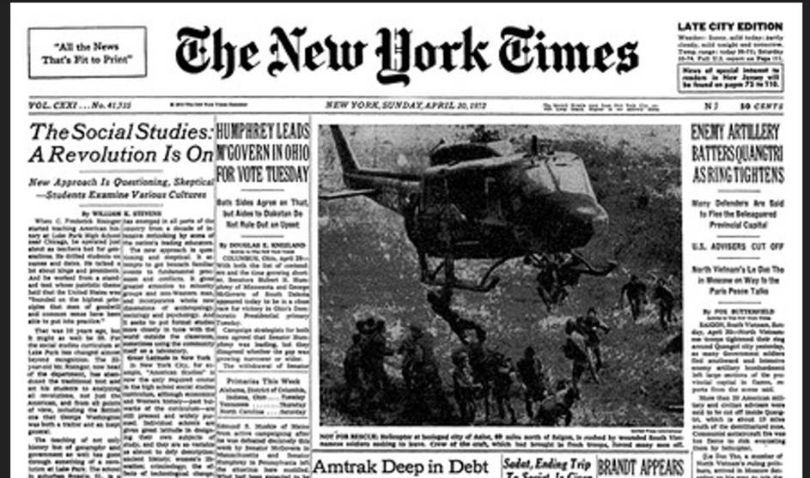

### Example 3: Photo as tie breaker

In this example, the photo in the center seems to be associated with the article “Cahill’s Top Aide Indicted in Alleged Kickback Plot”. That article and the article “South Vietnamese Launch Push to Retake Quangtri” both span the most columns and both have equal font size. Without the photo there, they would have both been coded as main articles, but with the photo there, it acts as a tie breaker, making “Cahill’s Top Aide Indicted in Alleged Kickback Plot” the main article. The other articles on the top row become front page articles.

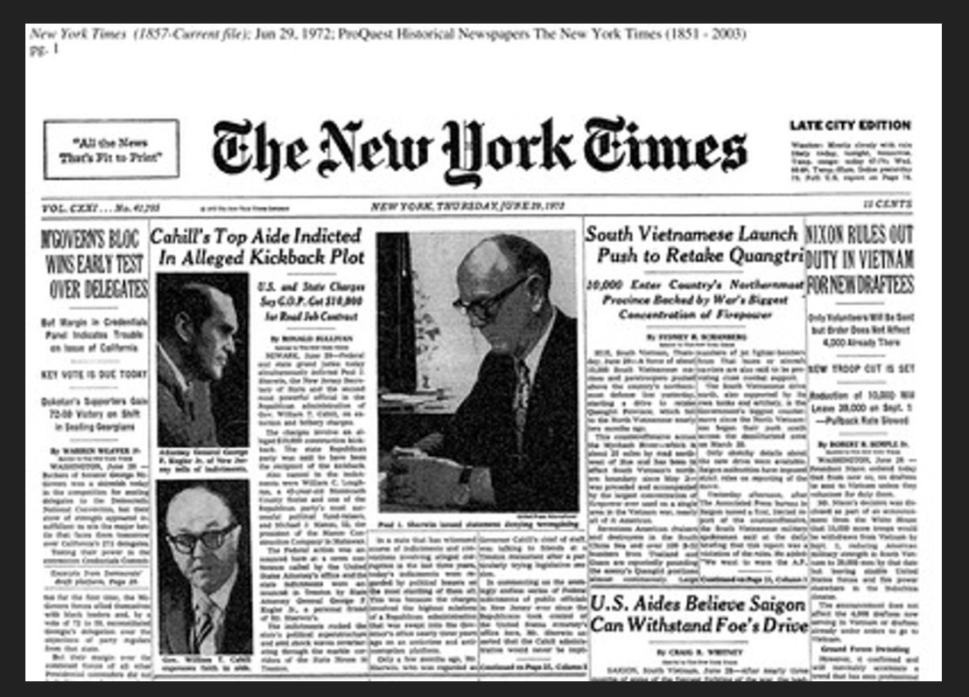

### Example 4: Article under photo

In this example, the article “Frontier Insurgency Spills Into a Pakistani City” is associated with the large photo, making it at least a front page article, potentially a main article, despite not being in the top row. Since its title takes up more columns than the that of the article “Fed Chief’s Reassurance Fails to Halt Stock Plunge”, it is the main article.

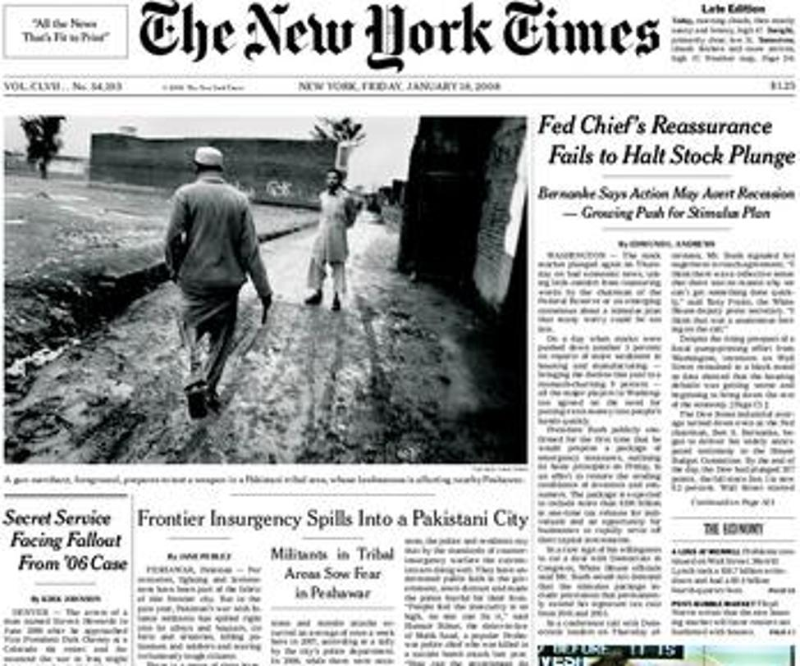

### Example 5: Standard 1

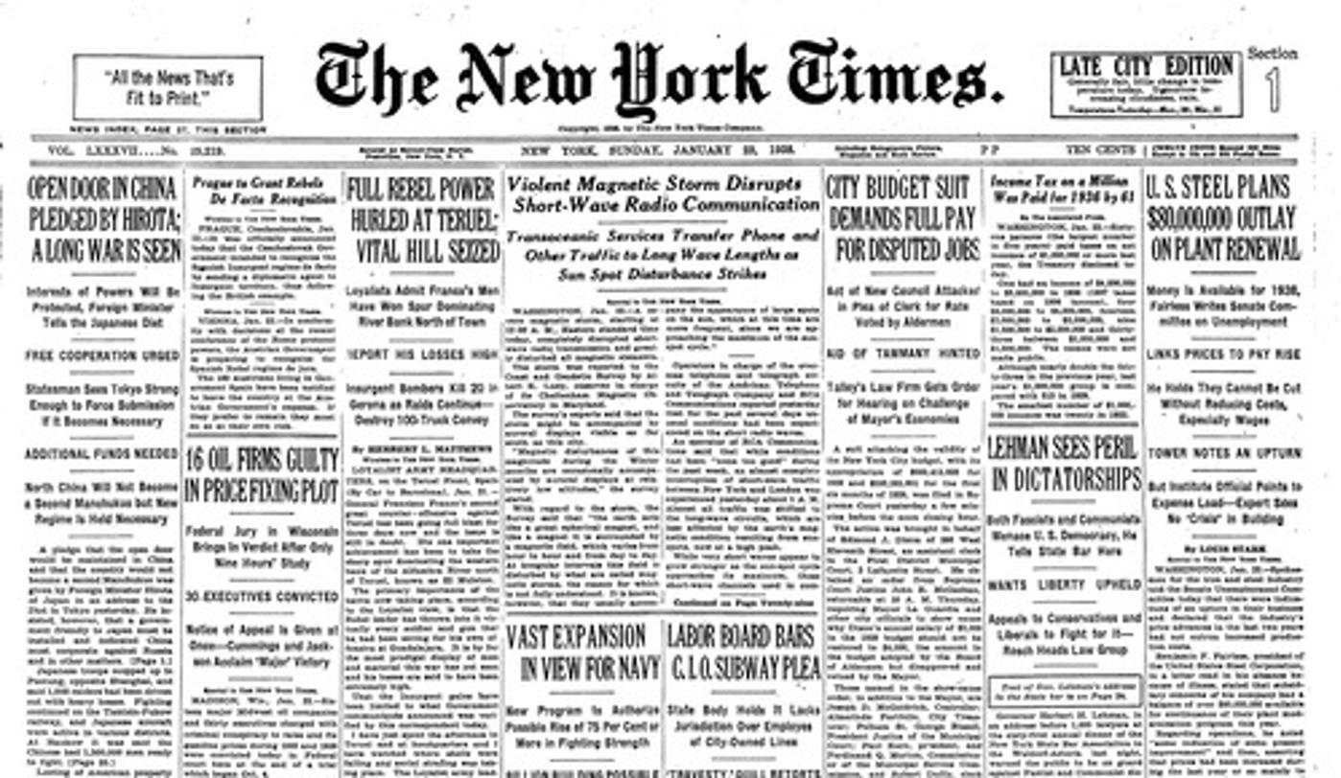

### Example 6: Standard 2

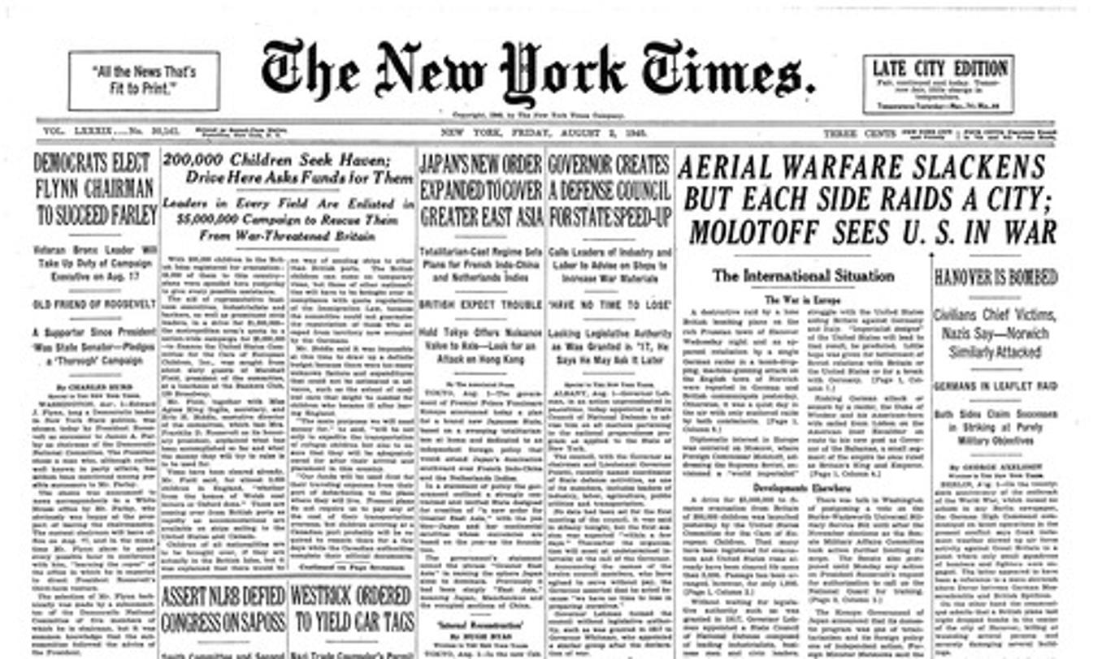

### Example 7: Standard 3

