Sport Informatics in support of Olympic and Paralympic Sports (IACSS Olympic Workshop)
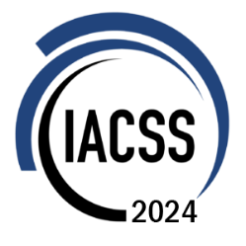
Conference Application Form
Application instructions
We look forward to receiving your application.
Make sure to submit this application form to organizer email zhang_hui@zju.edu.cn
Please complete the following form carefully. You will be required to complete all boxes marked with an asterisk (*).
All other boxes may be completed to provide additional details.
Personal Details (*required)
*First Name
*Last Name
*Email
Affiliation/
Organization
Institute/
Department
*Title
*Country / Region
Mobile
Social event | Please select if you want to participate:  Conference Dinner
Special dietary | Diabetic Vegetarian Halal Food Other  Please specify
Special requirements
(if any)

In order to present the information of your talk, we need a photo of the participant (width: height≈3:4), a brief biography of the individual, and an abstract of your talk. More details please refer to the conference page.
* All participants will have a standardized participation fee of €100 €150, please watch for the response email to the application for details on how to pay the fee.
IACSS 2024 Organizing Committee

