Title
Author(s)
Institution(s)

Abstract
Write your abstract here, under the “Abstract_Text_IJCSS” style sheet. The abstract must not exceed 500 words. It should contain introduction, methods, results, discussion and conclusion. Abstract before introduction is not necessary. It must be inserted in the article after the authors’ addresses, indented by 1 cm from both sides of the normal text. One figure and 1 table are allowed. Tables must be clearly and simply laid out with clear row and column legends, units where appropriate, no vertical lines and horizontal lines only between the table title (“Table_Text_IJCSS” style sheet) and column headings, between the column headings and the main body of the table, and after the main body of the table. Table should be referred to as 'Table 1.', and should be placed below the keywords. Figure should be referred to as 'Figure 1.' and should be placed below Table 1. Keywords categorize your article and are placed after the abstract. You can use up to five keywords written in capital letters. Use the APA Style Sixth Edition (short: “APA 6th ed.”) and the style sheet “References_IJCSS” to quote your literature. An example for a journal article is listed below. For further details refer to the IJCSS guidelines for authors, which you can find accessing https://sciendo-parsed-data-feed.s3.eu-central-1.amazonaws.com/IJCSS/Guidelines_for_Authors.pdf .
Keywords: IJCSS, Template, Guidelines (Up to 5)

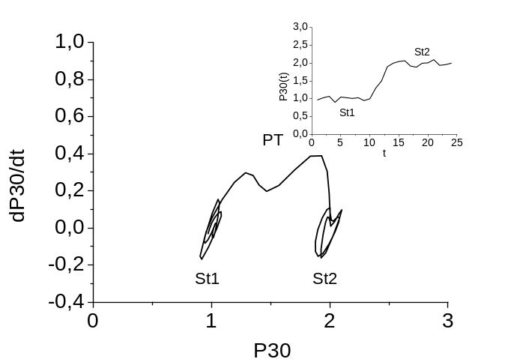
Figure 1. This is an example of how to caption figures for the conference abstract. Refere to “Figure_Text_IJCSS” and “Table_Text_IJCSS” style sheet for the formatting.
Table 1. Mean comparison test between the assessments of the single tests for the male subjects, Wilcoxon signed-rank Test, r.l. – rear leg, f.l. – front leg.
Technique | Practice-Test vs. PCR-Test |  | Practice-Test vs. PCSM-Test |  | PCR-Test vs. PCSM-Test
Gyaku-Zuki |  | 0.94 |  | 0.26 |  | 0.012
Gyaku-Zuki over run |  | 0.81 |  | 0.98 |  | 1.00
Gyaku-Zuki (left) |  | 0.03 |  | 0.0010 |  | 0.002
Ura-Mawashi (rear leg) |  | 0.03 |  | 0.023 |  | 0.452

References
Lees, A., Graham-Smith, P., & Fowler, N. (1994). A biomechanical analysis of the last stride, touchdown, and takeoff characteristics of the mens long jump. Journal of applied biomechanics, 10(1), 61–78.

