|  |
| --- |
| **Sport Informatics in support of Olympic and Paralympic Sports (IACSS Olympic Workshop)** |

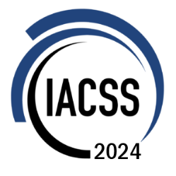Conference Application Form

**Application instructions**

We look forward to receiving your application.

Make sure to submit this application form to organizer email [zhang_hui@zju.edu.cn](mailto:zhang_hui@zju.edu.cn)

Please complete the following form carefully. You will be required to complete all boxes marked with an asterisk (*).

All other boxes may be completed to provide additional details.

|  |  |
| --- | --- |
| Personal Details (*required) | |
|  | |
| *First Name |  |
| *Last Name |  |
| *Email |  |
| Affiliation/  Organization |  |
| Institute/  Department |  |
| *Title |  |
| *Country / Region |  |
| Mobile |  |
| Social event | Please select if you want to participate: Conference Dinner 🞏 |
| Special dietary | Diabetic 🞏 Vegetarian 🞏 Halal Food 🞏 Other 🞏  Please specify |
| Special requirements (if any) |  |

In order to present the information of your talk, we need **a photo** of the participant (width: height≈3:4), **a brief biography** of the individual, and **an abstract of your talk**. More details please refer to the [conference page](https://iacssconference.org/#/2024/speaker).

* All participants will have a standardized participation fee of ~~€100~~ €100, please watch for the response email to the application for details on how to pay the fee.

IACSS 2024 Organizing Committee