|  |  |
| --- | --- |
|  | **Machine**  **Fault Finder** |

User’s Manual

Demo Module

|  |  |
| --- | --- |
| Iadept Marketing |  |
| iAdept Marketing |
| D-998, 1st Floor, Palam Extension  Sec-7, Dwarka, New Delhi – 110077 | |
| Mobile: +91 9810010218  Fax: +91 11 45613132  Email: info@iadeptmarketing.com | |

Table of Contents

Overview 3

Installation 4

Licensing 4

Using the tool 5

Manual data entry 5

Automatic data reading. 6

Diagnosis 7

Basic Diagnosis 7

Advanced Diagnosis 7

# Overview

Machine Fault Finder is a diagnostic tool to find the faults of a machine using FFT analysis. This tool is not dependent on device rather it is dependent on the FFT spectrum.

This product contains Bearing database for most commonly used of around 30000 bearings.

Concept of this tool is to provide user the understanding of current situation about the machine defect and knowledge of about how to improve that situation using the required resources so that user can perform the suggested action, which will result in improved and efficient machine.

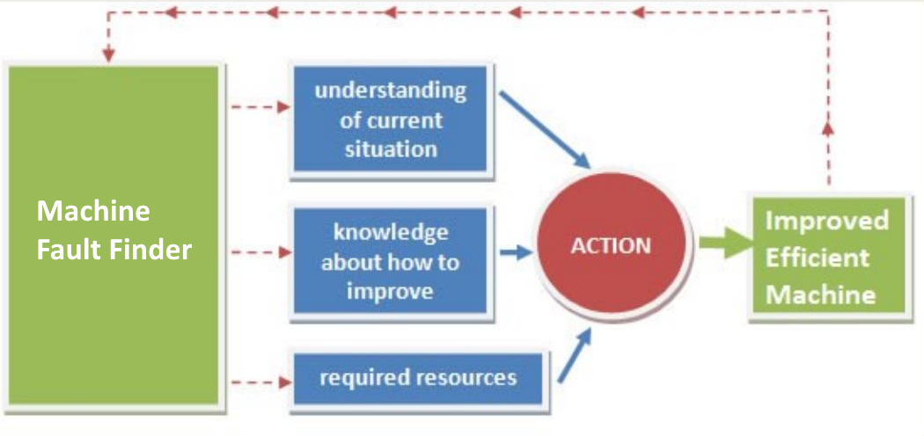

Faults that can be detected using the tool are:

–

Misalignment

–

Belt Drive Problems

–

Rotor Rub

–

Hydraulic and Aerodynamic forces

–

Mass Unbalance

–

Mechanical Looseness

–

Gear Faults

–

Bent Shafts

–

Motor Current Faults

–

Bearing Damages

–

Cavitation

–

Many Others

Faults that can be detected using the tool are:

* Misalignment
* Belt Drive Problems
* Rotor Rub
* Hydraulic and Aerodynamic forces
* Mass Unbalance
* Mechanical Looseness
* Gear Faults
* Bent Shafts
* Motor Current Faults
* Bearing Damages
* Cavitation
* Many Others

This manual explains how to setup and operate Machine Fault Finder.

# Installation

Installation is from a single executable file either provided on USB flashdrive or downloaded from the internet.

Either way run the application called setup.exe.

Upon the successful installation a shortcut is created on the desktop with name Machine Fault Finder.

# Licensing

When application is started it checks for the license and in case of not finding a license it will display a message that this application is not activated.

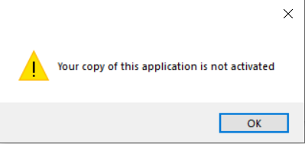

On click of “OK” button it will show a new screen displaying a string, which is specific to each computer. A License is generated based on this string which will be provided to user once this UID is provided to us.

For Demo application this license is valid for 15 days from the date License is generated.

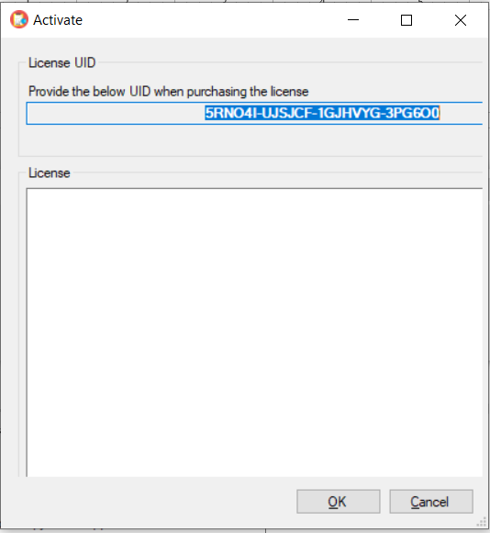

User has to place the license string in the license section and click OK. License will be activated and user will need to restart the application.

# Using the tool

User has the option of Manual data entry and automated data collection. For demo application, user is restricted to use automated data collection from the instruments directly, and UNV/UFF data files other than FFT data.

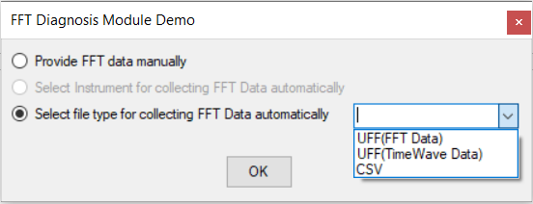

## Manual data entry

In case user selects manual data entry option, user has to provide the X-data and Y-Data for FFT calculation along with RPM, X label and Pulse.

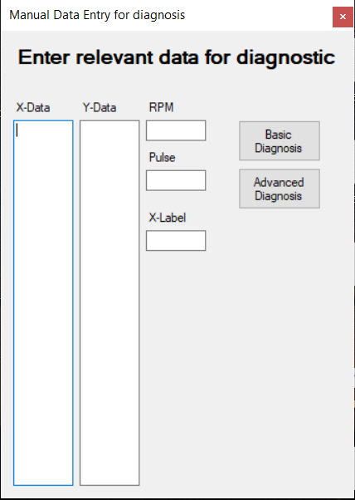

User has option of Basic Diagnosis and Advanced Diagnosis for manual data entry.

## Automatic data reading.

User has an option to select automatic data reading either directly from the Hardware devices or from the data file placed locally on the computer system. Benstone’s Impaq Elite and IMXA-460 are some of the instrument from which this application can fetch data directly. We are in process of streamlining more instruments in this section.

Other option which is to select data file stored locally on the computer system. The type of files for this arrangement are UNV/UFF, CSV, FD2.

Time wave data can also be selected and will be converted to FFT on the go for diagnostic in this case.

For demo application, only option available in automatic section is for selection of locally stored data file of UNV/UFF for FFT data. Other options are not available for demo user.

The data file provided if contains data for more than 1 FFT, analysis will be done on all FFT and user will be prompted with the detail about the data provided beforehand.

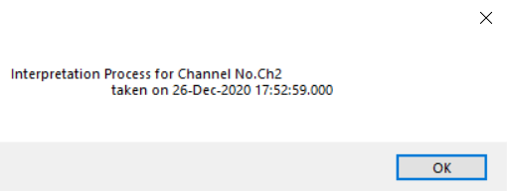

# Diagnosis

Diagnosis in this tool is divided in two parts - Basic Diagnosis and Advanced Diagnosis. In manual data entry user have the option of both the diagnosis. However, for automated data selection user is forced to use advanced diagnosis only.

## Basic Diagnosis

This option provides user about the basic diagnosis of the data, based on the peaks irrespective of the machine type and settings with setting them as default.

User can get an overview about the prominent faults here.

## Advanced Diagnosis

This option is about providing a filter based diagnosis based on the type of machine point, its settings, RPM margins, direction, etc.

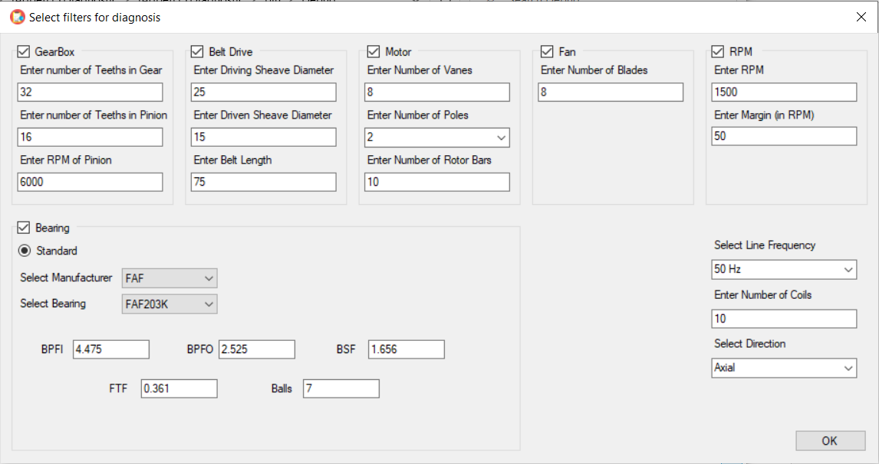

User can specifically select the type of point, bearing settings (if any), machine settings, RPM variation and margins, direction, etc. for filtering out the specific result. Based on the selection, user can filter out the most specific fault.

