Reviews /Change Request
Principal / Dean / Administrator
- In the same page, ask for – real industry-based AI Infrastructure projects, Cloud Projects, Generative AI/LLM projects, IOT projects

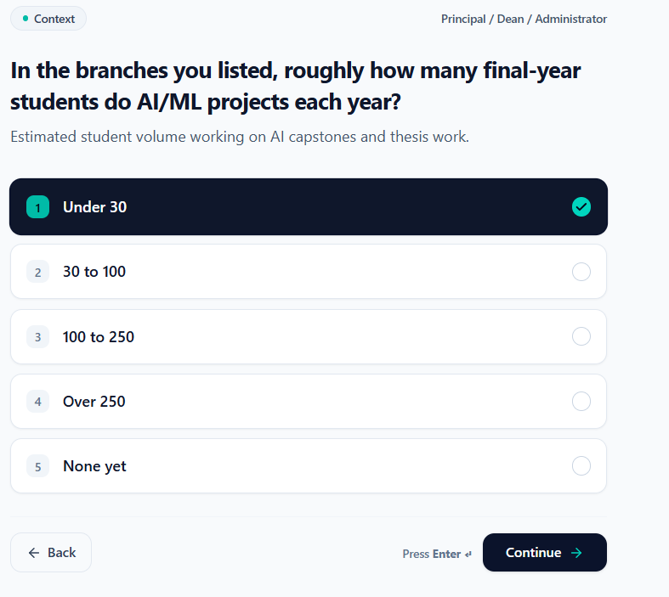

- Also, ask what cloud infrastructure they use, Storage option for projects and data workflows in the same page. In every option provided, at last provide a text box to write their observation/requirement
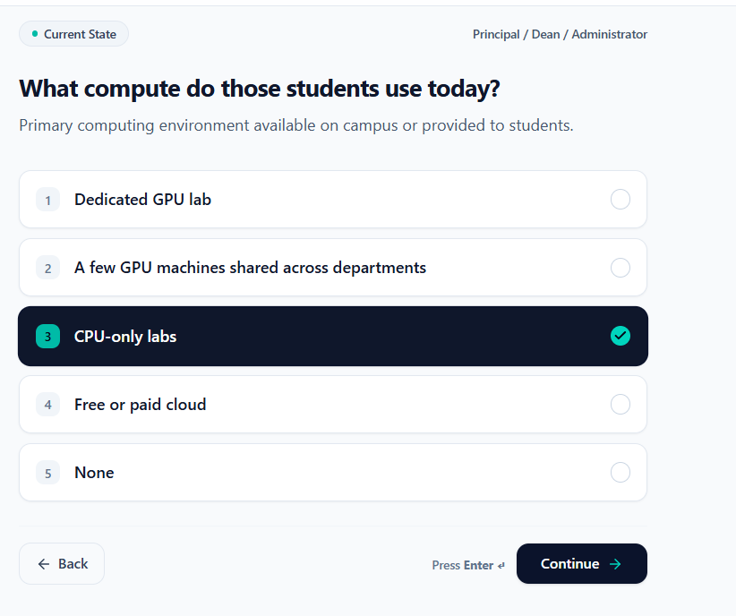
- Instead of the word partnership – use responsibility / solution. At last – provide a text box option to mention their observation
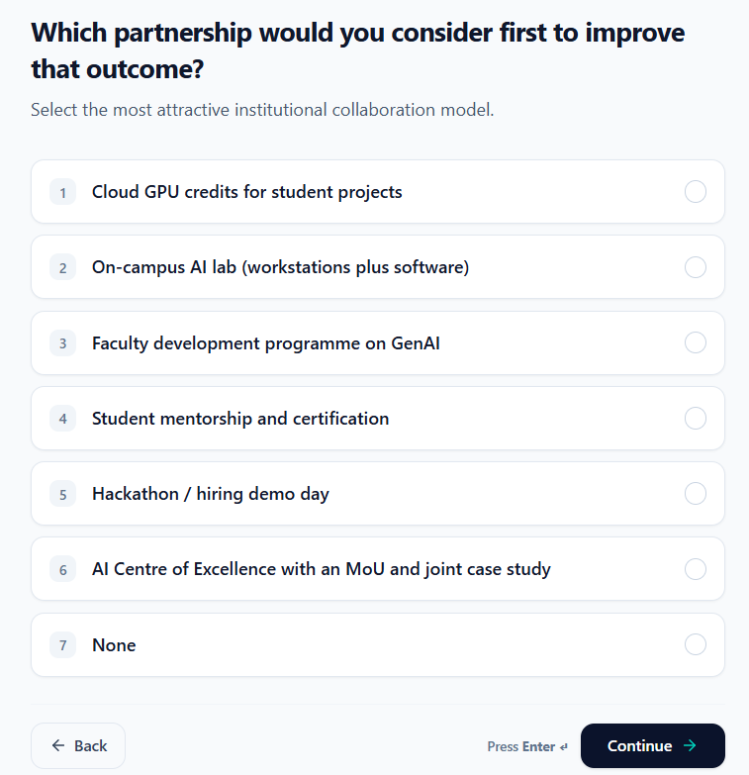

Training/Placement officer

- Ask the question specific to our tech requirement like – Provide the options as mentioned below
- Lack of knowledge on AI infrastructure, Cloud technologies, IOT projects
- Lack of hands of experience into real world industry project samples / internship
- Lack practice and access to GPU infra / Gen AI LLM exposure / IOT full stack development
- Mention if others {text box}
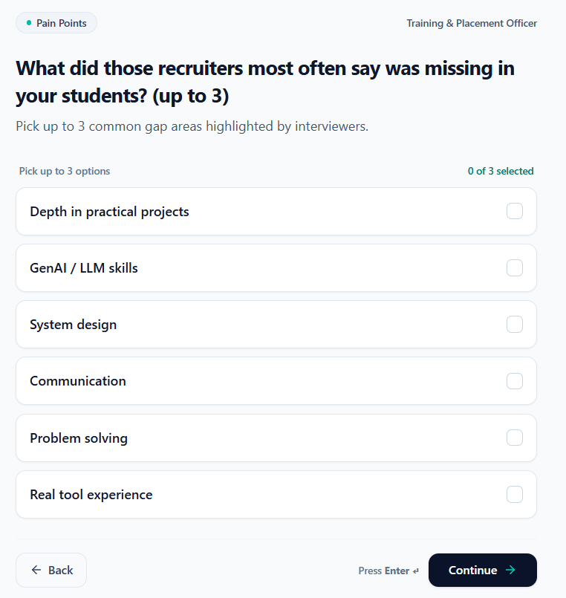
Remove these options
HOD /Faculty
- In the question – Along with GenAI include, AI infrastructure, Cloud and IOT projects
