**Quantification of climate impact for breeding and decision support at dairy farms**

*Torsten Pook1, István Fodor1, and Ines Adriaens1,2*

1Animal Breeding and Genomics, Wageningen Livestock Research

2Department of Biosystems, Livestock Technology, KU Leuven, Leuven, Belgium

# Background

## Climate change and its projected effects in Europe

Climate change is a long-term change in the state of the climate, and this can be defined using different variables such as air temperature, or precipitation (IPCC, 2007).

The frequency or intensity of extreme weather events, e.g., heat waves and droughts, are expected to increase as a consequence of the changing climate, which trend is projected to persist throughout the century (Kharin and Zwiers, 2000). The impact of climate change is more noticeable on the extremes, e.g., in maxima or minima, or the 10th and 90th percentiles of the climatic variables (Moghim et al., 2022).

Temperature increase has also accelerated in Europe (van der Schrier et al., 2013). For example, Moghim et al. (2022) showed that all regions in Europe have experienced an increase in annual mean temperatures during the period of 2006-2016 compared to 1976-2005 as a baseline. With respect to the climatic extremes, Cardell et al. (2020) estimated that warm extremes will increase in all seasons over the entire Europe, with summer projected to be the most affected, although warm extremes are also projected to rise in spring and autumn and shoulder seasons. Cold spells are projected to be less frequent and severe across Europe. The number of heavy precipitation days and their amplitude will likely increase, but also the dry periods will become longer (Cardell et al., 2020).

The implications of such changes to humans and society are manifold. Among other things, negative impacts of extreme heat include health risks and human discomfort. Economies will experience a decrease in labour productivity, and direct monetary costs will also incur for governments (Smid et al., 2019).

## The impact of climate change on dairy herds

The impact of climate change on dairy cows is also diverse, as it compromises cow health and welfare, reduces the efficiency of breeding, and leads to production and economic losses (Rojas-Downing et al., 2017). High-producing dairy cows are metabolically very active, and during hot environmental conditions can become unable to efficiently dissipate excess heat. Hence, the impact of climate change on dairy cows is mostly seen in the form of heat stress (Cheng et al., 2022; West, 2003).

### Effects of heat stress on the health and welfare of dairy cows

Climate change can affect the health of dairy cows directly and indirectly. Direct effects include the increased risk of disease (e.g., mastitis, lameness) and mortality due to the increased frequency and intensity of heat waves (Lacetera, 2019). Depending on the duration and intensity of heat, heat stress can lead to metabolic disorders, oxidative stress, immunosuppression, and even death (Lacetera, 2019). Indirect effects of climate change include changes in the microbial communities (e.g. pathogens), spread of vector-borne diseases, and the growth of mycotoxin-producing fungi, among others (Lacetera, 2019; Rojas-Downing et al., 2017; Thornton et al., 2009).

Heat stress also reduces dry matter intake and rumination time, both being important drivers of health, welfare, production and reproduction (Leliveld et al., 2023). Therefore, behavioural measurements (using Precision Livestock Farming [PLF] technologies) are important to assess the timing and impact of heat stress on the welfare of cows, and these technologies may gain even more importance for individual monitoring of welfare with the changing climate.

### Effects of heat stress on reproduction

Fertility is also affected by heat stress, although the effects of heat waves on reproduction appear with a time lag, therefore, they are more difficult to detect (Herbut et al., 2018). Hot conditions reduce the dry matter intake of dairy cows, which prolongs the postpartum negative energy balance, contributing to a longer calving to conception interval. Oestrus expression becomes less intense, follicles and oocytes are negatively impacted, and the uterine environment becomes less suitable for embryo implantation, all of which effects worsen reproductive results as a consequence of heat stress (De Rensis and Scaramuzzi, 2003; Roth, 2017).

### Breeding and the genetics of heat stress

The efficiency of dairy cattle breeding programs is also impacted by heat stress. Genotypes may respond in different ways to the environmental variation (which is termed genotype-by-environment interaction, or GxE), and this effect is especially important in dairy cattle, where offspring of the same sire produce in a wide range of environments around the globe. Certain genotypes may be more sensitive to the climatic environment than others, and sires with best performance in a thermoneutral environment can perform poorly under hot conditions (Calus, 2006; Lynch and Walsh, 1998). A wide range of traits can be affected by GxE, including milk production, fertility, health, and even survival (Calus, 2006), therefore, accounting for the role of climatic parameters in breeding programs is crucial. As the demand of animals suitable for altered conditions is expected to rise with climate change, GxE is also expected to gain more emphasis in animal breeding in the near future (Strandén et al., 2022).

### Economic effects of heat stress

Twenty years ago, the livestock industry of the US was estimated to incur 1.7-2.4 bn USD loss annually due to heat stress, half of which was estimated to occur in the dairy industry (St-Pierre et al., 2003). About a decade later, 63.9% of the total economic loss experienced by the US livestock sector (dairy, beef, poultry, and swine combined) originated from dairy cattle, and amounted to 1.5 bn USD/year (Key et al., 2014). In addition to the health, welfare, and reproductive consequences for dairy cows, economic estimates also highlight the importance of proper management interventions, early heat stress detection, and breeding in the context of climate change.

## Aim

The aim of this study was to develop novel modelling techniques to investigate heat stress sensitivity of individual cows, using a wide range of weather features, high-frequency behavioural sensor data, and milk production information. Domain knowledge was incorporated into the method development, by defining weather features that are known or suspected to affect cow behaviour and physiology. Also, activity was not only used as a dependent variable to describe heat stress sensitivity, but also as an explanatory variable to estimate its relationship with milk losses.

# Materials and Methods

## Data

Records from 13 farms with a total of 4,912 cows were used for the analysis. In total, 16 years of milk production data (2006-2021), comprising 3,572,290 daily milk records from 11,650 lactations were analysed. The number of first, second, third, and fourth or higher lactations was 2,618, 3,623, 2,459, and 2,950, respectively. Daily activity data (from accelerometers) were available between 2007 and 2021, corresponding to 2,759,981 lactation days (77.3% of total).

Hourly weather data were collected from nearby weather stations. The weather parameters on a particular farm were estimated as a weighted average of the distance between the three closest weather stations and the respective farm. Temperature humidity index (THI) was calculated as follows:

THI = (1.8 × T + 32) − [(0.55 − 0.0055 × RH) × (1.8 × T − 26)],

where T was the ambient temperature (°C) and RH was relative humidity (%).

Hourly data were aggregated to daily values (e.g., daily mean, minimum, maximum). In addition to THI, minimum, average and maximum temperature, and minimum and maximum relative humidity were used in the analyses, e.g., to quantify the temperature range within a day or the maximum THI during a day. Additionally, the number of hours with THI above 68, 72, 80 were considered. In addition to the daily values, mean THI over the previous three days (as suggested by Vandenplas et al. (2023), among others), and relative change of temperature and THI to the previous day were used in the analyses.

The number of daily milk records and the proportion of records with activity data are shown in **Figure 1**.

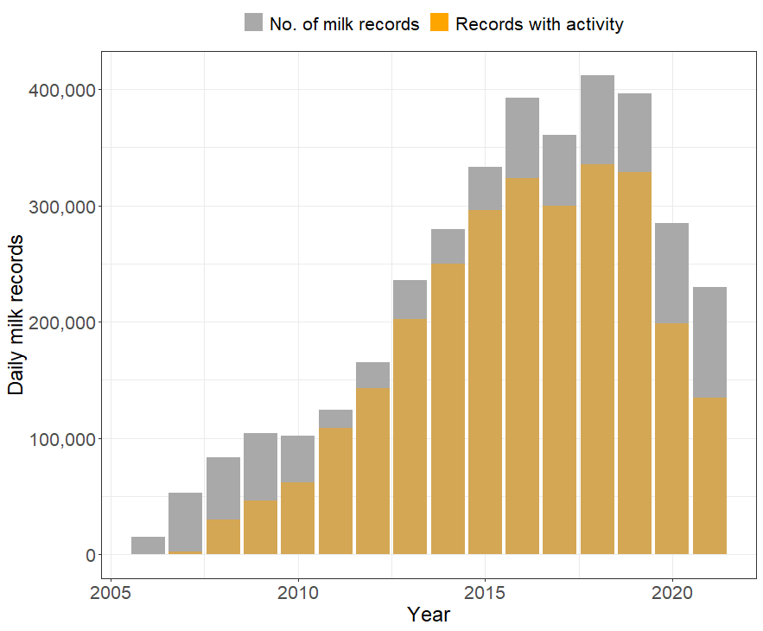

Figure 1. Number of daily milk records overall and with activity data

## Statistical analysis

As described above, the goal of the modelling was to assess the impact of weather on individual cows, based on changes in activity and milk production. As a proxy of heat stress effect, we defined a phenotype based on daily milk yield. For this, we first fitted a lactation curve, using a Nadaraya-Watson estimator with Gaussian kernel and a bandwidth of 25 days. The first 7 days and the last 5% of the lactation were excluded from the analysis, as these days showed substantially higher variance, and did not seem to reflect the rest of the lactation. This approach can be viewed as an extension of the moving average method proposed by Poppe et al. (2020) to express the expected lactation curve *l* at time point *t*, by adding an additional weighting factor:

$$l\left(t\right)= \frac{\sum_{i}{y_{i} K\left(t-t_{i}\right)}}{\sum_{i}{K}(t-t_{i})},$$

With $y_{i}$ being the observed milk yield at time point $t_{i}$ and K as the used kernel function.

Next, the daily performance $l_{daily}$ was compared to the expected lactation curve $l_{lac}$. Again, local smoothing was applied, using a kernel function with a much smaller bandwidth (3 compared to 25), and no weighting on the days before the actual date of the milking:

$$K_{lac}\left(x\right)=ϕ_{0,25}(x)$$

$$K_{daily}\left(x\right)=ϕ_{0,3}\left(x\right)⋅1_{x>0}$$

where $ϕ_{μ,σ }$ was the density of a Gaussian distribution with mean $μ$ and standard deviation $σ$.

We constructed two performance indicators using the expected and the realized milk production. First, the relative performance was calculated as the ratio between the expected and the realized production. Secondly, each cow-day record where the realized production was at least 10% lower than the expected production was classified as cow-days with low performance, defined as a binary trait. The occurrence of low performance can be regarded as in indicator for the cow being under stress.

In order to evaluate the weather effects, we need to adjust for other factors that impact the response variable. For daily activity, models included seasonality, farm, year, days in milk (DIM), and parity. Additionally, the interaction between DIM and THI was included. For the milk-yield related traits, activity was also used as an explanatory variable. In the model for activity, an animal effect was added, as in contrast to the milk yield related traits, activity was not relative to the lactation curve of the specific individual on an overall scale with substantial differences between animals.

Instead of a joint estimation of all parameters simultaneously, an iterative procedure was performed. After the effect of the first predictor (daily mean THI) was estimated, the fitted values were subtracted from the response variable, and the residuals were used as the new response variable to fit the second predictor (seasonality) in the next iteration. This procedure was iteratively repeated until each parameter was fitted 5 times.

Predictors were fitted in the following order:

1. Daily mean THI
2. Seasonality
3. Farm-year-parity
4. Days in milk (DIM)
5. DIM x daily mean THI
6. Further weather parameters
   1. Daily maximum temperature
   2. Mean average THI of the last 3 days
   3. Daily maximum THI
   4. Mean daily maximum THI of the last 3 days
   5. Daily temperature range (difference of maximum and minimum)
   6. Difference of mean temperature with the mean of the previous day
   7. Daily number of hours with high THI (>68, 68-72,72-80,>80)
7. Seasonality x Farm
8. Activity (of the same day/of 1 day prior/of 2 days prior/of 3 days prior) – only in the models of milk yield traits
9. Animal effect – only in the models of activity

Farm, year and parity were accounted for as fixed class effects. Seasonality was estimated as a day-of-the-year effect that was estimated using the Nadaraya-Watson estimator with Gaussian kernel and a bandwidth of 15 days. DIL was also estimated using a Nadaraya-Watson estimator with Gaussian kernel and bandwidth of 5 days.

All remaining weather parameters, the interaction between seasonality and farm, and the activity effect were estimated using Nadaraya-Watson estimators, with appropriately chosen bandwidths.

# Results and Discussion

## Descriptive statistics of milk yield and activity

Mean relative milk yield was 100%, with a standard deviation of 5.7% (**Figure 2**). The frequency of cow-days with low performance was 4.3%.

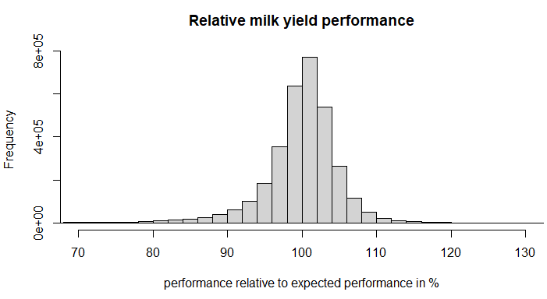

Figure 2. Histogram of relative daily milk yield of a cow relative to the expectation from the individual lactation curves

Daily activity (step counts) was expressed as a daily activity score. Mean daily activity score was 0.21, with a standard deviation of 3.39 (**Figure 3**).

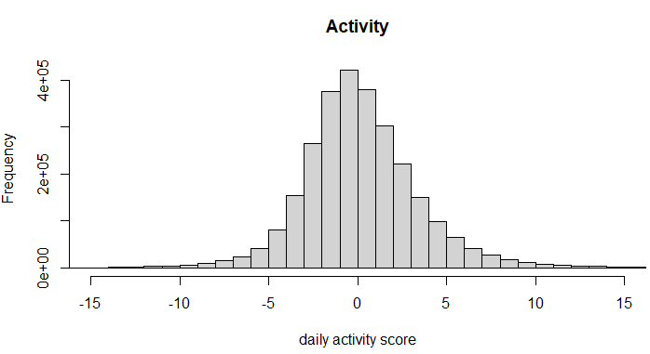

Figure 3. Histogram of daily activity scores

## Heat stress under temperate climate

The annual number of hours of heat stress by severity, farm, season, and month are shown in **Figures 4-6**. Every farm experienced heat stress of all severities during the study period, but the number of heat stress hours depended on the year. Severe heat stress only occurred during the summer, but mild and moderate heat stress was also observed during the shoulder seasons, mostly between April and October.

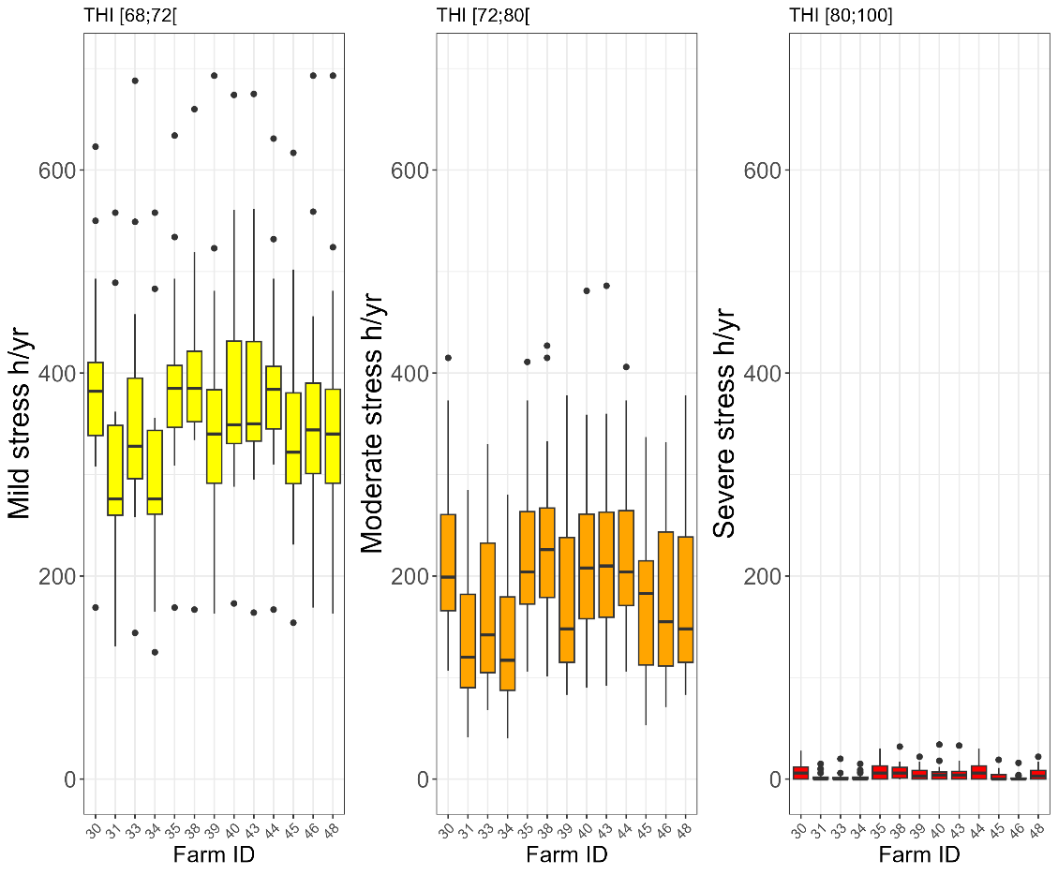

Figure 4. Boxplot of annual heat stress hours by farm and heat stress severity

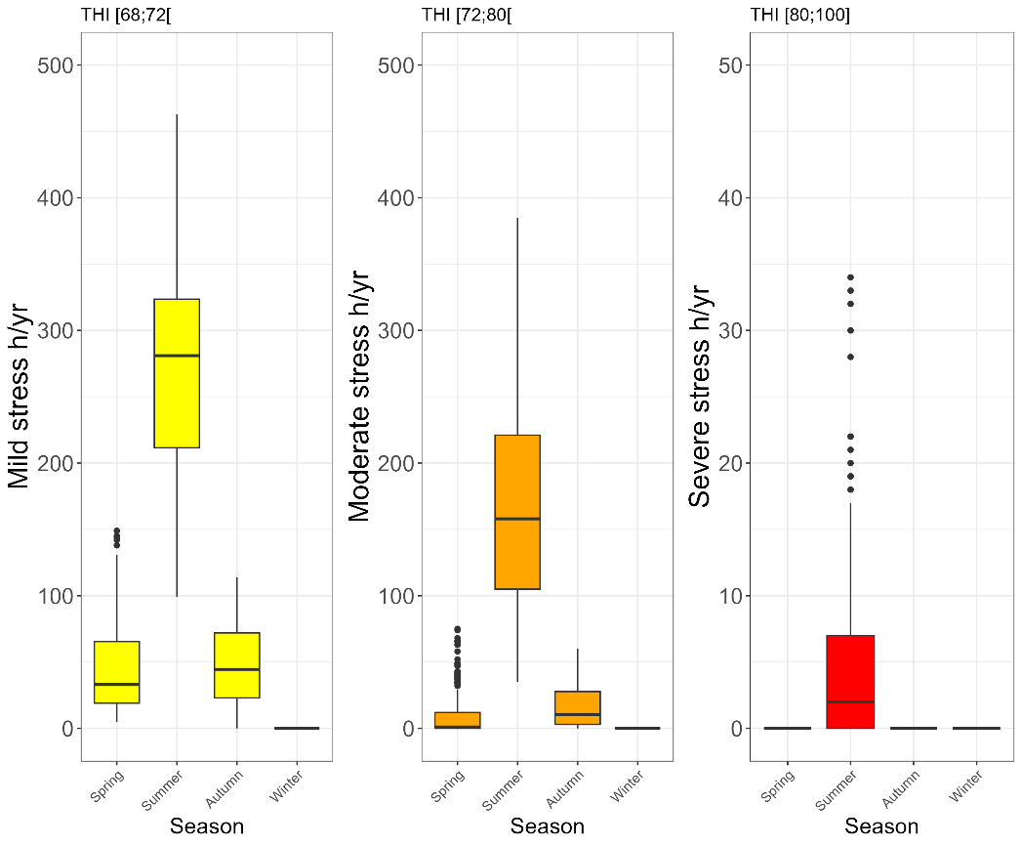

Figure 5. Boxplot of heat stress hours by season and heat stress severity

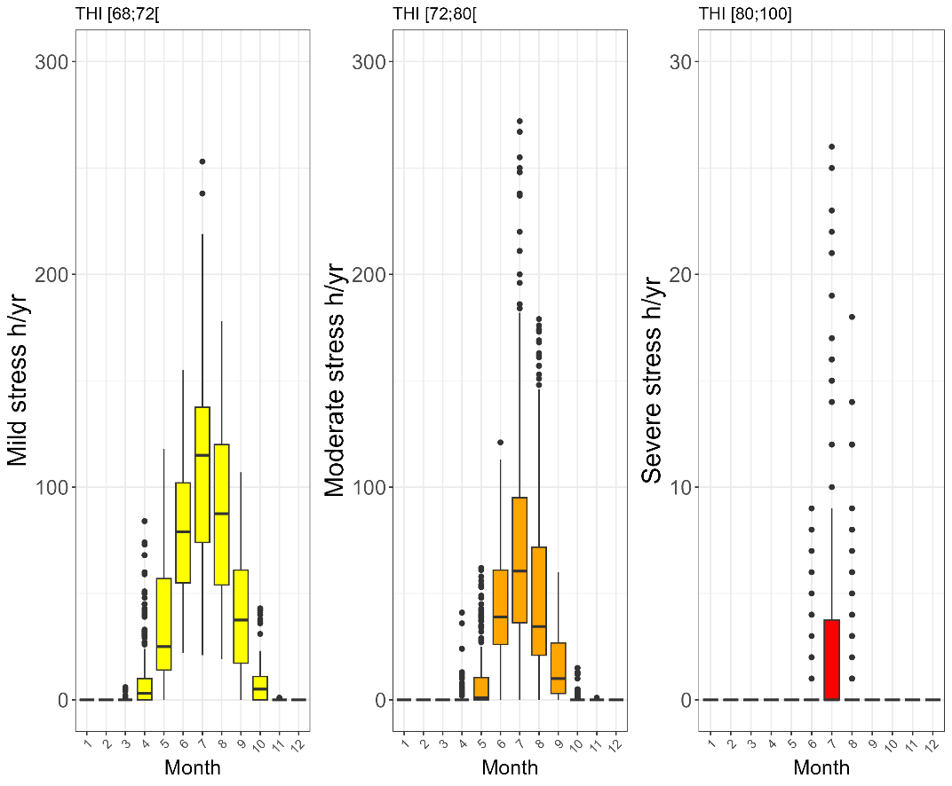

Figure 6. Boxplot of heat stress hours by month and heat stress severity

## Relationship of milk yield with weather and other explanatory variables

In the following, we first focus on individual weather parameters. Up to a daily mean THI of 65 we observed only a mild impact of THI on milk yield. However, milk yield started to decrease substantially above THI 65. For example, milk yield was, on average, 1.0% and 2.1% lower at THI 70 and 75, respectively, compared to THI 65. Cows in lower parities were less affected by heat stress based on changes in milk production. Milk yield of cows in first lactation was reduced by 0.9% and 1.3%, whereas cows in fourth or higher lactation lost 1.4% and 2.3% of milk, at THI 70 and 75, respectively, compared to THI 65 (**Figure 7**). We observed similar effects for the mean THI over the previous three days, indicating the importance of time-lagged heat stress impact on milk production. The duration of high THI conditions within a day was also found important. Substantial milk yield losses were observed when THI was high for a longer period over the day, which also reduced the period for recovering from heat stress effects (**Figure 8**).

When aggregating all individual weather parameters, the biggest overall effect was observed on on the 4th July 2015 on Farm 38, when temperature peaked at 34.7°C, the mean THI of the day was 75.6, the maximum THI was 82.1, and cows experienced 22 hours of THI 68 or higher. At herd level, Farm 38 is expected to have a 4.9% milk yield loss on this day and the probability of an individual cow being under stress (i.e., producing at least 10% below expected) was 19.2%. During the entire study period, the proportion of days with a 0.5%, 1%, and 2% reduction in milk yield was 4.2%, 1.9%, and 0.3% of all days, respectively. This might seem like only a minor difference at first glance, however, the proportion of cows under stress was at least 1%, 2%, 3%, and 5% on 6.9%, 2.1%, 1.2%, and 0.3% of all days, respectively.

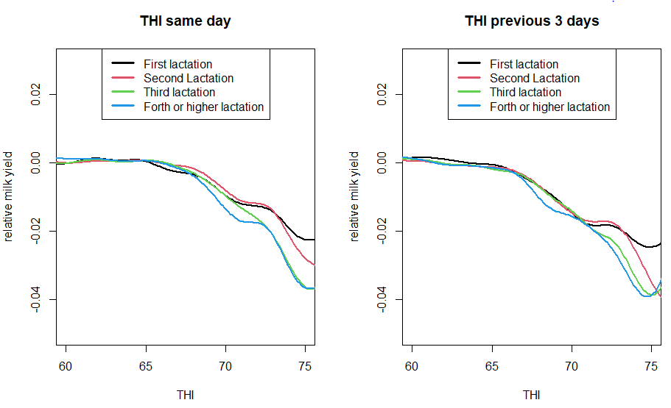

Figure 7. Relative milk yield as a function of THI of the same day and THI over the previous 3 days

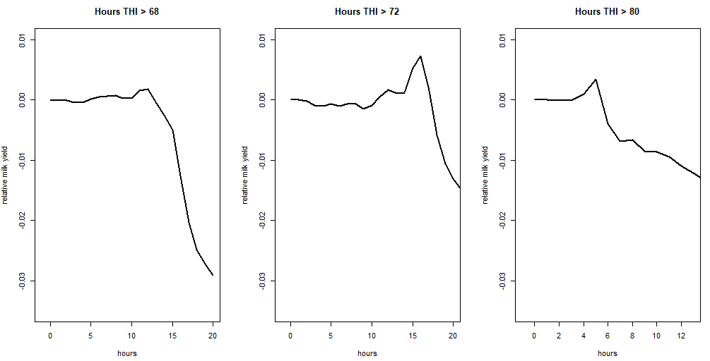

Figure 8. The relationship of high THI duration within a day with relative milk yield

Lactation stage also had a substantial impact on resilience to heat, with cows in late lactation (301-400 DIM) experiencing approx. twice as high production losses relative to the expected production than cows in peak lactation (31-100 DIM). We observed even lower relative milk losses in early lactation (1-30 DIM, **Figures 9 and 10**). Although the apparent effect of heat was lower during peak lactation, the proportion of cows with at least 10% short-term decrease in milk yield was high (up to 8%). Compared to the 4.3% frequency observed in the entire study population, this is a high occurrence.

However, the observations made for early lactation (1-30 DIM) should be treated with caution, because of the relatively poor model fit in the first few days of milk production. The relative losses during late lactation (301-400 DIM) might be inflated due to the lower milk production compared to peak lactation (31-100 DIM), reducing the denominator.

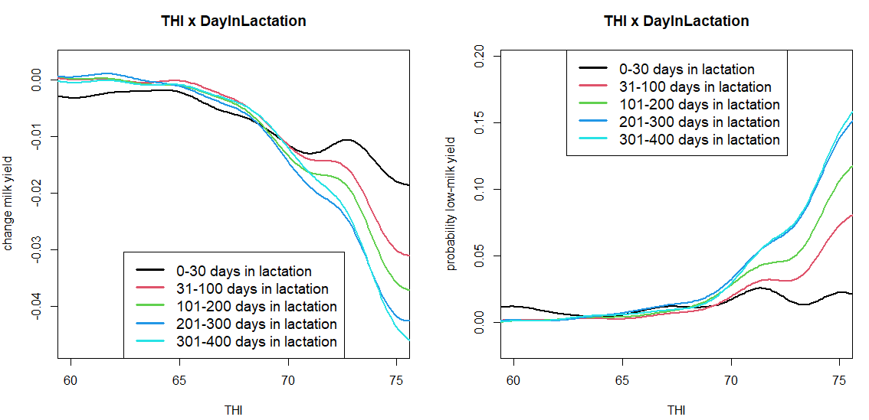

Figure 9. The relationship of relative milk yield and the probability of having low (i.e., at least 10% below expected) milk production with THI by stage of lactation

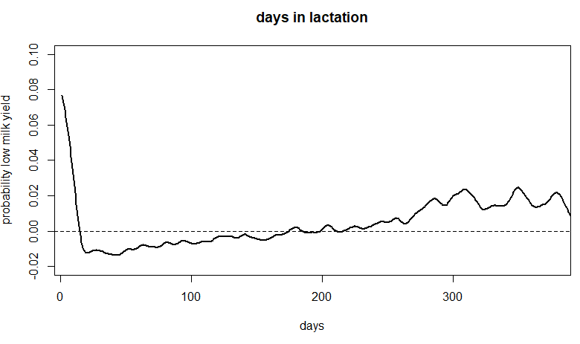

Figure 10. The probability of having low (i.e., at least 10% below expected) production  
by days in milk

Seasonality had a relatively low impact in our study, with the highest expected milk yields in summer (+0.4%), and a slightly higher proportion (+1.2%) of cows experiencing milk yield losses in autumn (**Figure 11**). That is, the same weather conditions in summer might affect cows less severely than in autumn, suggesting that cows (and management) might be better adapted to hot conditions in summer. Note that the fitted seasonality effect also indirectly accounts for nutritional changes over the years. The models fitted initially also included a season-by-farm effect to capture this even better, however, as variance of the fit was high this was excluded from the final model.

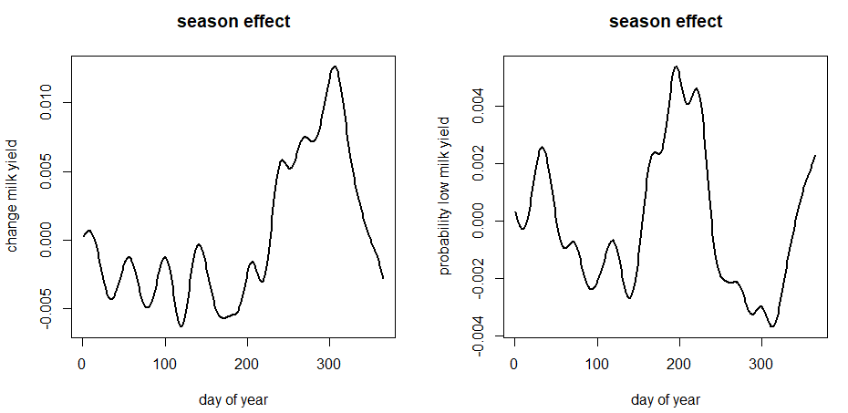

Figure 11. The relationship of seasonality with relative milk yield and milk yield losses

## Relationship of activity with weather

In contrast to milk yield, which was heavily impacted by weather conditions of the previous three days, we observed a much stronger relationship of activity with weather conditions on the same day, with cows in different parities affected very similarly. Activity scores increased more than linearly with increasing THI. The increase in activity scores was 0.40 between THI 60 and 65, 0.68 between THI 65 and 70, and 0.77 between THI 70 and 75 (**Figure 12**).

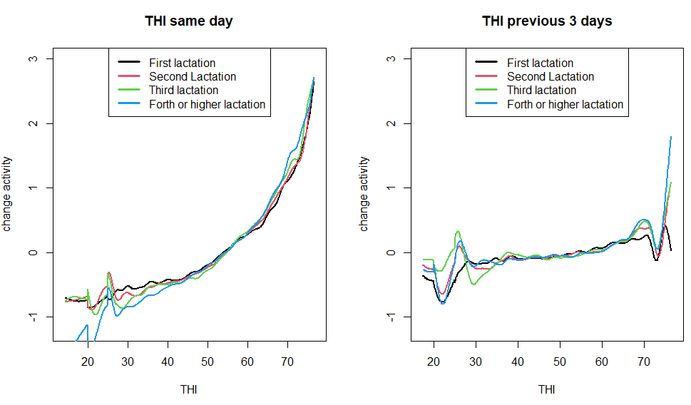

Figure 12. Changes in activity by THI

Over the lactation, a gradual decrease in activity was observed, however, cows showed a substantially increased activity in the first 50 days of their first lactation (**Figure 13**).

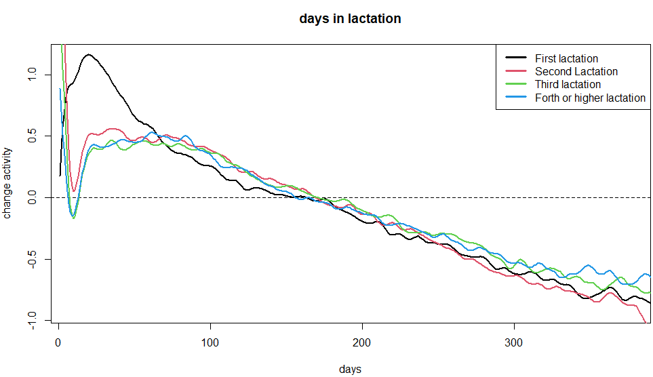

Figure 13. Changes in activity during lactation by parity

Other weather parameters only had a minor impact on activity. The highest overall impact on activity was observed on 9th August 2020 on Farm 31, with a maximum temperature of 34°C, mean THI of 75.5, maximum THI of 80.2, and 24 hours of THI 68 or higher. On this day on this farm, the estimated increase of the activity score was 2.80 (which is almost one standard deviation of the activity scores).

## Activity as a predictor of milk yield changes

Activity as a predictor for milk yield showed by far the largest effect when activity was substantially reduced. Activity scores around -15 (the lowest score possible) were related to a 20% reduction in milk yield on average (**Figure 14**). Such a dramatic reduction in activity is usually an indicator of severe disease. Medium to slightly above expected activity scores (0 to 2) were related to the highest milk yield. Reduced activity only had a negative impact on the day of milk production and one day before.

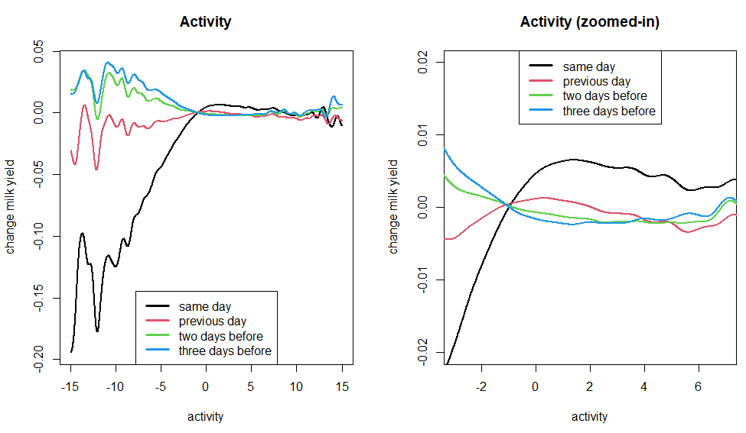

Figure 14. Relationship of activity scores with relative milk yield

## Methodology

We used kernels of different bandwidths for the continuous variables in the model, which preserves more information compared to creating categorical bins, e.g. of values along the THI gradient. When assessing daily milk production relative to the expected lactation curve, no weight was put on the days preceding the date of the milk record, because a heat stress effect on a particular day does not impact the milk yield of the previous day. Our method to estimate an expected lactation curve can be replaced by any other method used for fitting lactation curves, for example, the quantile regression method applied by Poppe et al. (2020).

In our approach, explanatory variables (including the weather features) were fitted iteratively. The reason for this was that different input parameters, in particular those of the same type, are often highly correlated. For example, the correlation of the activity of a cow was 0.76, 0.68, and 0.64, between subsequent days, two days apart, and three days apart, respectively. This would compromise model robustness, and would require parameter selection in a joint estimation. However, in our model, the order of fitting explanatory variables could affect their estimated effect, therefore, parameter estimates should be taken with caution. The overall impact of weather conditions as an aggregated value over all these correlated parameters should however still be reliable.

# References

Calus, M.P.L. 2006. Estimation of genotype × environment interaction for yield, health, and fertility in dairy cattle. PhD thesis, Wageningen University.

Cardell, M.F., Amengual, A., Romero, R., and Ramis, C. 2020. Future extremes of temperature and precipitation in Europe derived from a combination of dynamical and statistical approaches. Int J Climatol. 40:4800–4827.

Cheng, M., McCarl, B., Fei, C. 2022. Climate Change and Livestock Production: A Literature Review. Atmosphere 13.

De Rensis, F., and Scaramuzzi, R.J. 2003. Heat stress and seasonal effects on reproduction in the dairy cow – a review. Theriogenology 60:1139– 1151.

Herbut, P., Angrecka, S., and Walczak, J. 2018. Environmental parameters to assessing of heat stress in dairy cattle – a review. International Journal of Biometeorology. 62:2089–2097.

IPCC. 2007. The Physical Science Basis. Contribution of Working Group I to the Fourth Assessment Report of the Intergovernmental Panel on Climate Change [Solomon, S., D. Qin, M. Manning, M. Marquis, K. Averyt, M.M.B. Tignor, H.L. Miller Jr., and Z. Chen (eds)]. Cambridge, UK and New York, NY, USA: Cambridge University Press.

Key, N., Sneeringer, S., and Marquardt, D. (2014). Climate change, heat stress, and U.S. dairy production. United States Department of Agriculture. Available at: https://www.ers.usda.gov/webdocs/publications/45279/49164_err175.pdf?v=0#:~:text=Depending%20on%20the%20climate%20model,for%20dairies%20in%20the%20South

Kharin, V.V., and Zwiers, F.W. 2000. Changes in the extremes in an ensemble of transient climate simulations with a coupled atmosphere–ocean GCM. Journal of Climate, 13(21), 3760–3788.

Lacetera, N. 2019. Impact of climate change on animal health and welfare. Animal Frontiers. 9:26-31.

Leliveld, L.M.C., Lovarelli, D., Finzi, A., Riva, E., and· Provolo, G. 2023. Efects of cow reproductive status, parity and lactation stage on behaviour and heavy breathing indications of a commercial accelerometer during hot weather conditions. International Journal of Biometeorology. 67:1263–1272.

Lynch, M., Walsh, B. 1998. Genetics and analysis of quantitative traits, 1st. Sinauer Associates, Sunderland.

Moghim, S., Teuling, A. J., and Uijlenhoet, R. 2022. A probabilistic climate change assessment for Europe. International Journal of Climatology, 42(13), 6699–6715.

Poppe, M., Veerkamp, R.F., van Pelt, M.L., and Mulder, H.A. 2019. Exploration of variance, autocorrelation, and skewness of deviations from lactation curves as resilience indicators for breeding. Journal of Dairy Science, 103:1667-1684.

Rojas-Downing, M.M., Nejadhashemi, A.P., Harrigan, T., and Woznicki, S.A. 2017. Climate change and livestock: Impacts, adaptation, and mitigation. Climate Risk Management. 16:145-163.

Roth, Z. 2017. Effect of heat stress on reproduction in dairy cows: insights into the cellular and molecular responses of the oocyte. Annu. Rev. Anim. Biosci. 5:151–170.

Smid, M., Russo, S., Costa, A.C., Granell, C., and Pebesma, E. 2019. Ranking European capitals by exposure to heat waves and cold waves. Urban Climate. 27:388-402.

St-Pierre, N.R., Cobanov, B., and Schnitkey, G. 2003. Economic losses from heat stress by U.S. livestock industries. J. Dairy Sci. 86, E52–E77.

Strandén, I., Kantanen, J., Lidauer, M.H., Mehtiö, T., and Negussie, E. 2022. Animal board invited review: Genomic-based improvement of cattle in response to climate change. Animal 16, 100673.

Thornton, P.K., Van de Steeg, J., Notenbaert, A., and Herrrero, M. 2009. The impacts of climate change on livestock and livestock systems in developing countries: A review of what we know and what we need to know. Agric. Syst. 101:113–127.

van der Schrier, G., Besselaar, E.J.M., Klein Tank, A.M.G. and Verver, G. 2013. Monitoring European average temperature based on the E-OBS gridded data set. Journal of Geophysical Research, 118, 5120–5135.

Vandenplas, J., Aguerre, S., Mattalia, S., Promp, J., Vallee, R., Boichard, D., Castro-Dias-Cuyabano, B., Vinet, A., Carabano, M.J., Diaz, C., Ramon, M., Calus, M., Mulder, H. 2023. Report on the effect of heat stress on production and fertility traits in dairy cattle. Available at: [RUMIGEN-D3.1-Report-on-the-effect-of-heat-stress-on-production-and-fertility-traits_v1.pdf](https://rumigen.eu/wp-content/uploads/2023/11/RUMIGEN-D3.1-Report-on-the-effect-of-heat-stress-on-production-and-fertility-traits_v1.pdf)

West, J.W. 2003. Efects of heat-stress on production in dairy cattle. J Dairy Sci 86:2131–2144.

# Appendix

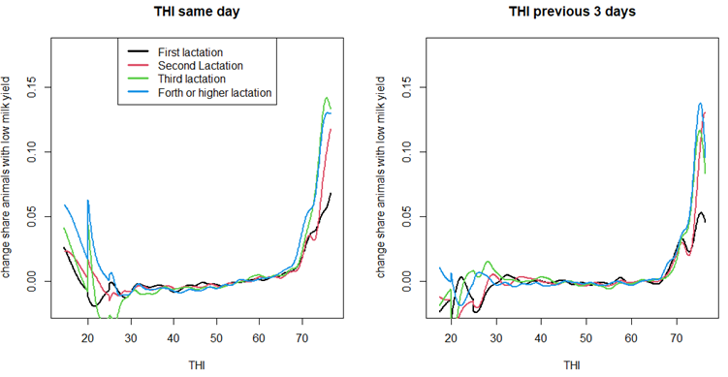

Figure S1. Relative proportion of cows with low milk yield (i.e., at least 10% below expected) along the entire THI scale

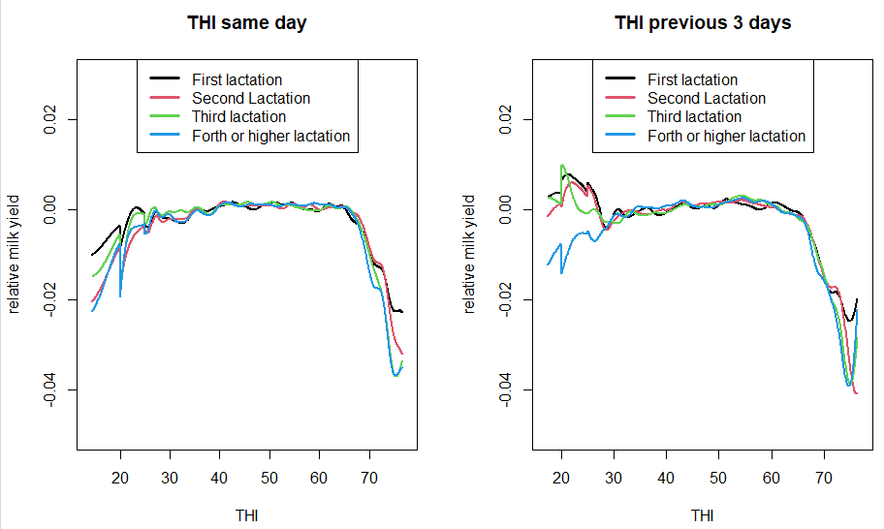

Figure S2. Relative milk yield along the entire THI scale by parity

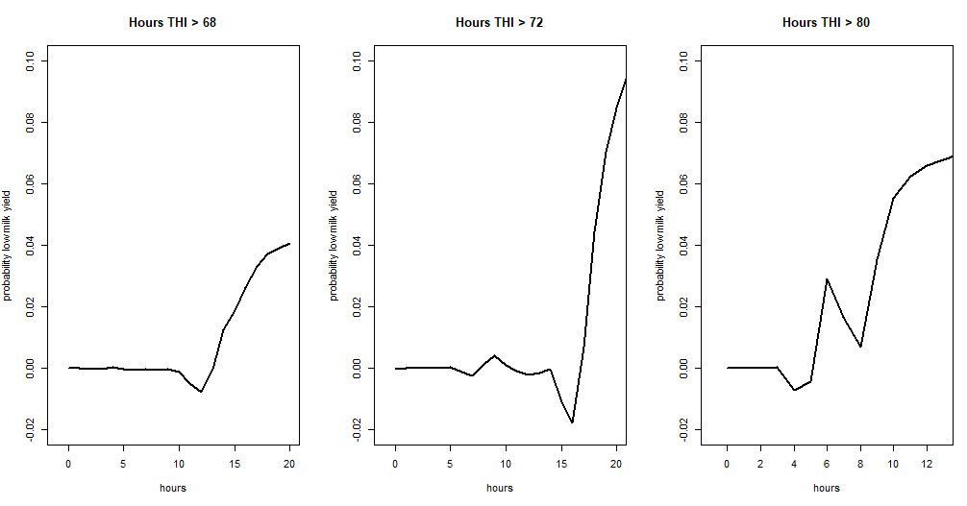

Figure S3. Probability of low milk yield by the number of high THI hours within a day