<https://www.jstage.jst.go.jp/article/indhealth/44/3/44_3_388/_pdf/-char/ja>

in humans, ambient temperature seldom cause of heat stress. Rather result from 6 fundamental factors:

* Environmental = ambient temperature, radiant temp, humidity and air movement
* Behavioural = metabolic rate, clothing

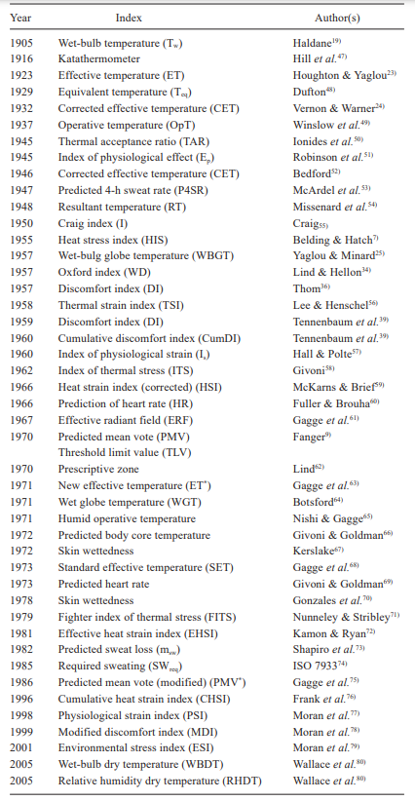10% change in rel hum = 0.3°C in ambient temperature