Problem 1

1. List all the files in the Shakespeare folder in HDFS

$hadoop fs -ls Shakespeare

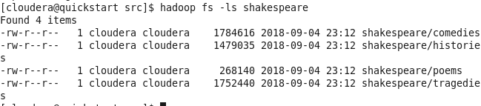

Display the first 16 lines of the poems data in HDFS

$hadoop fs -cat Shakespeare/poems | head -n 16

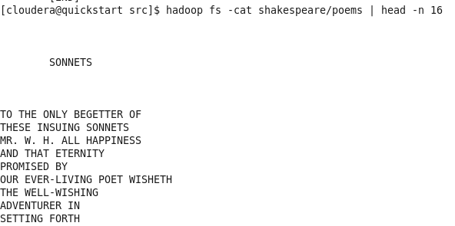

1. Large replication factor means more replicated files. These duplicated will occupy more memory space on the data node, which is of limited capacity. Therefore one downside of large replication factor is that it will exploit the data nodes’ memory capacities.

Additionally, too much of files will lead to the generation of too much meta-data and storing these meta-data in the name node will become a challenge since name node has limited memory capacity as well.

1. One benefit of large block size is that this will result in less meta-data files and hence requires smaller capacity name node. Otherwise, name node will be overflowed with meta-data of huge amounts of small blocks.

One disadvantage is that for small number of tasks, large block size will result in too much time spent on transferring and hence the job will run slower than they could.

1. Because $128×5<642<128×6$, we will have the file stored in six blocks

RA RB RC

N1 Part 1, Part 4 N3 Part 3, Part 1 N5 Part 5, Part 2

N2 Part 2, Part 5 N4 Part 4, Part 6 N6 Part 6, Part 3

Meta-Data

File-Part 1: RA-N1, RB-N3

File-Part 2: RA-N2, RC-N5

File-Part 3: RB-N3, RC-N6

File-Part 4: RB-N4, R1-N1

File-Part 5: RC-N5, RA-N2

File-Part 6: RC-N6, RB-N4

1. Two disadvantages of HDFS
2. Low-latency data access

HDFS is designed to deliver a high throughput of data and this may be at the expense of latency. Therefore applications that require low-latency access to data will not work well with HDFS.

1. Because the name node holds file system metadata in memory, the limit to the number of files in a file system is governed by the amount of memory on the name node. Therefore HDFS cannot store too many small files because they will produce way too much metadata that will overflows name node’ memory.
2. Download from HDFS to local file. For example, download the Shakespeare file to a new local directory downloadedfile

$hadoop fs –get Shakespeare downloadedfile

The transferring process begin with the computer communicating with the name node to look up the metadata for the file. Once the name node send back metadata, the computer can directly access the data nodes and begin the data transferring process.

Problem 2

Mapper Input Mapper Output Reducer Input Reducer Output

15 (3, 15), (5,15) 2, [24, 30] 2, 54

21 (3, 21), (7,21) 3, [15, 21, 24, 30] 3, 90

24 (2, 24), (3, 24) 5, [15, 30] 5, 45

30 (2, 30), (3, 30), (5, 30) 7, [21, 49] 7, 70

49 (7, 49)

Problem 3

1. Mapper output Reducer input Reducer output

gif, 1200 gif, [1200, 1900] gif, 1550

html, 900 html, [900, 1100] html, 1000

gif, 1900 jpg, [4000] jpg, 4000

jpg, 4000

html, 1100

1. The keys are represented by string and the values are presented by integers.