# Notes from Homework 2

Make a copy of this document, rename it to “hw2-notes” and move it to your CSE 523 Google Docs collection. Maintain your notes in this document. Do not forget that anyone should be able to accomplish the same task by following your notes. You may find it helpful to include screenshots.

## Understand the purpose of ONL

Read the article at <https://onl.wustl.edu/>

Answer the following questions

1. In your own words, what does ONL provide to end users?

The Open Network Laboratory provides such a setting (realistic), allowing systems researchers to evaluate and refine their ideas, and then to demonstrate them to those interested in moving the technology into new products and services. ONL also includes multi-core servers which support Virtual Machines (VMs) for end user use.

1. What tool do users work with to create a new topology?

Routers can be linked together using a central *Virtual Network Switch* (VNS). We can create topologies in RLI interface.

1. User configurations are sent to what entity in ONL for processing?

New configurations can be built by instantiating routers and hosts and connecting them together graphically. Once a configuration has been created, it can be saved to a file for later use. When a user is conducting an experiment, the configuration is submitted to the ONL management server, which generates the low level control messages to configure the various system components to realize the specified configuration.

1. In your own words, why might monitoring traffic counters be useful?

Real-time remote traffic counter displays allows users to develop the insights needed to understand the behavior of new capabilities within a complex operating environment.

## Sign up for an ONL account

Applying for an account by clicking “get an account” on the left hand side of the page <https://onl.wustl.edu/>. Below is the screen shot of the request confirmation.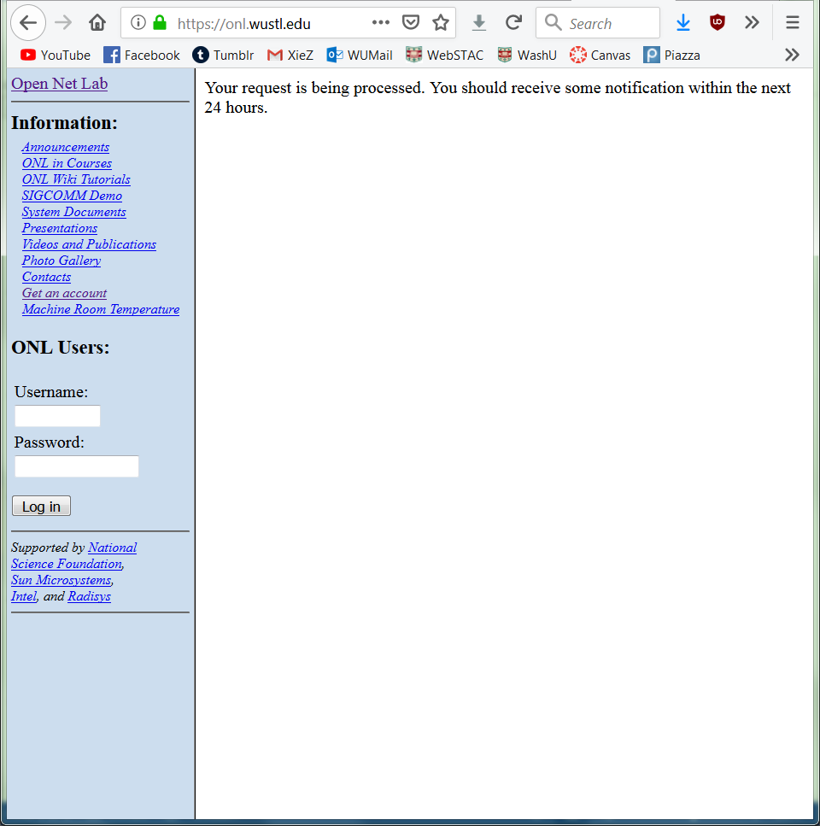

Figure 2. Account Request Confirmation

## Ensure the proper working environment

1. Download the RLI.jar from the “Getting Started” section

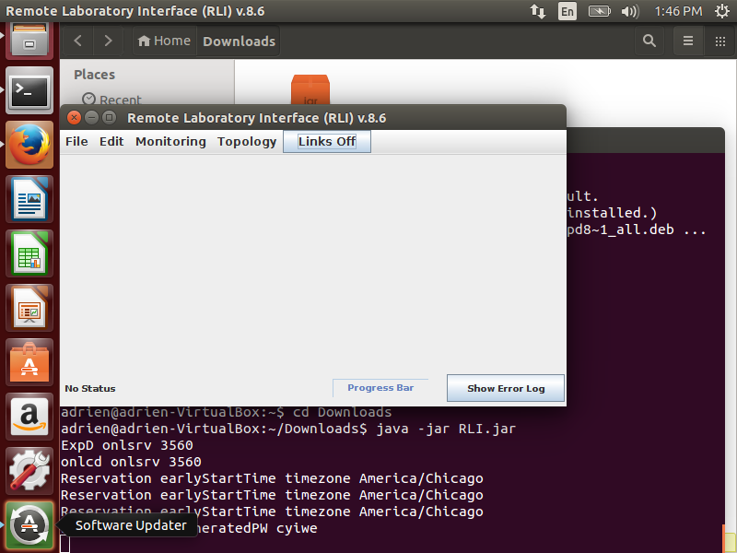

Figure 3. Running the jar file

1. Download the Java Runtime Environment
   1. Open terminal and run the commands
   2. sudo add-apt-repository ppa:webupd8team/java
   3. sudo apt-get update
   4. sudo apt-get install oracle-java8-installer

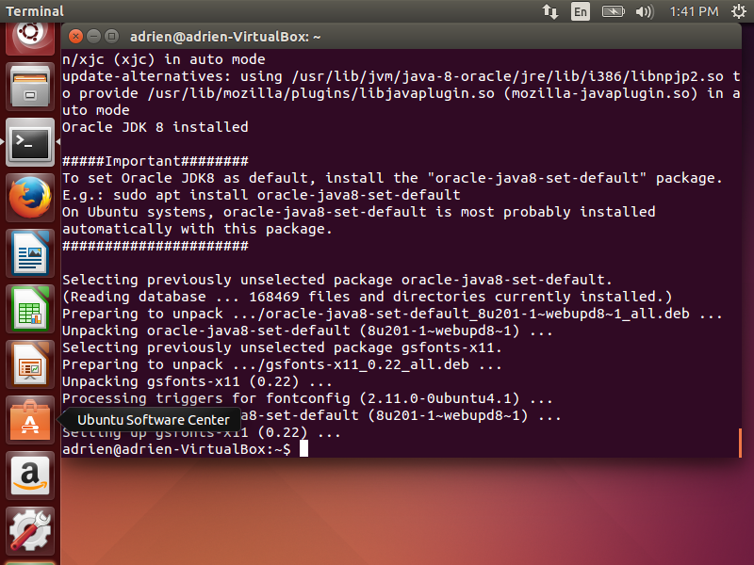

Figure 4. Installed oracle jdk8

1. Accessing the ONL directory through ssh
   1. Display the directory by ls

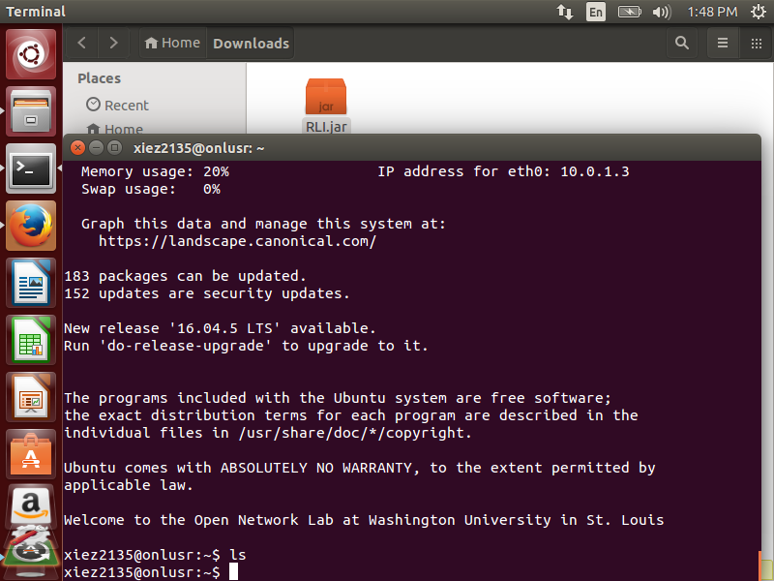

Figure 5. SSH

## Set up the experiment

1. Create three terminals
   1. Ssh –L 7070:onlsrv:7070 [xiez@onl.wustl.edu](mailto:xiez@onl.wustl.edu)
   2. Ssh [xiez@onl.wustl.edu](mailto:xiez@onl.wustl.edu)
   3. Java –jar RLI.jar

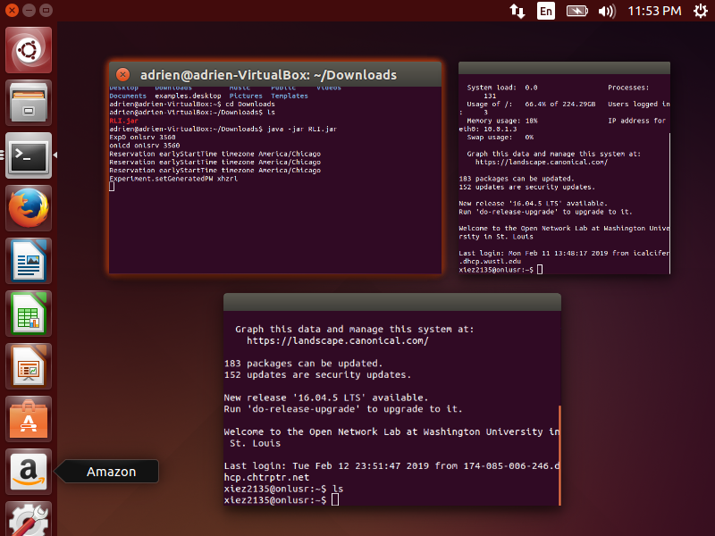

Figure 5. Three terminal

1. Commit topology
   1. In RLI, add 2 host core instance
   2. Add GigE switch and connect them with the instances
   3. Make a reservation
   4. Commit

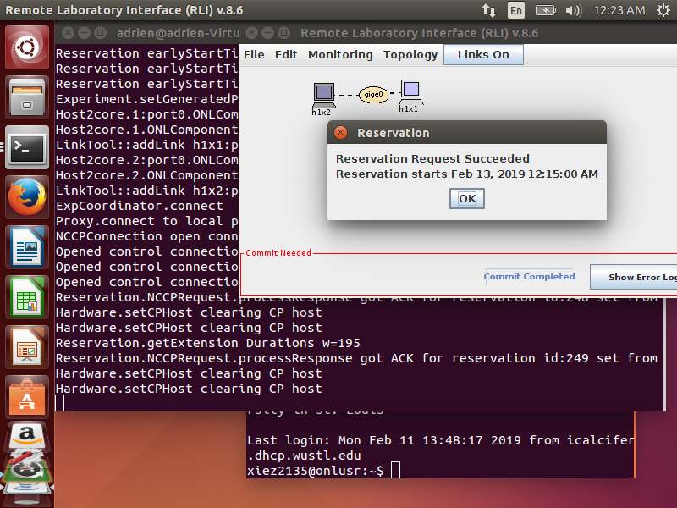

Figure 6. Topology created and reservation made

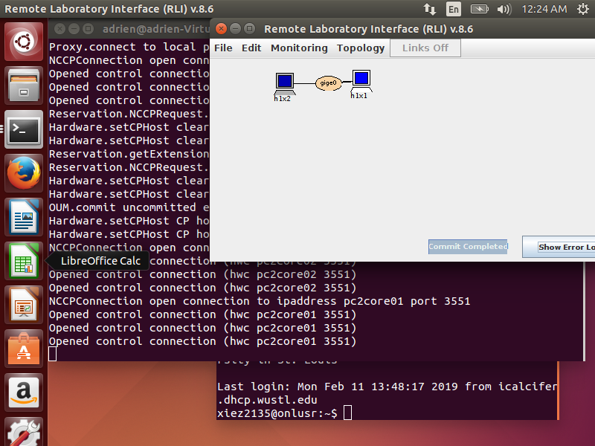

Figure 6. Commit

## Do the experiment

1. SSH into the ONL base server
   1. Source /users/onl/.topology
   2. SSH into h1x1 by ssh $h1x1
   3. Type uname –a and report the result (screenshot attached below)

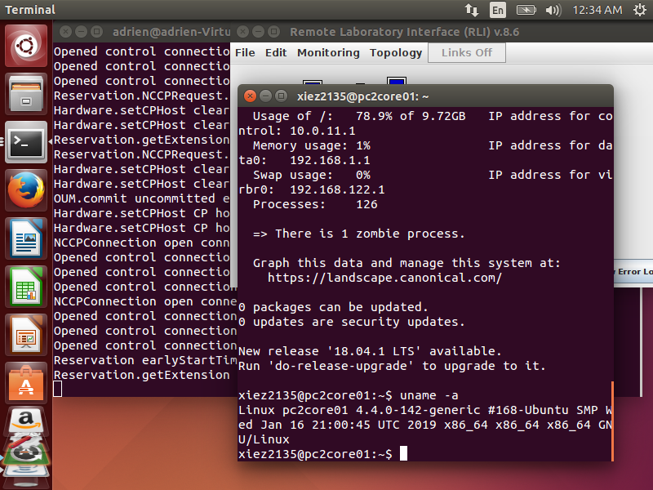

Figure 8. uname –a reuslt

* 1. Type ping –c 10 h1x2 (results attached below as screenshot)

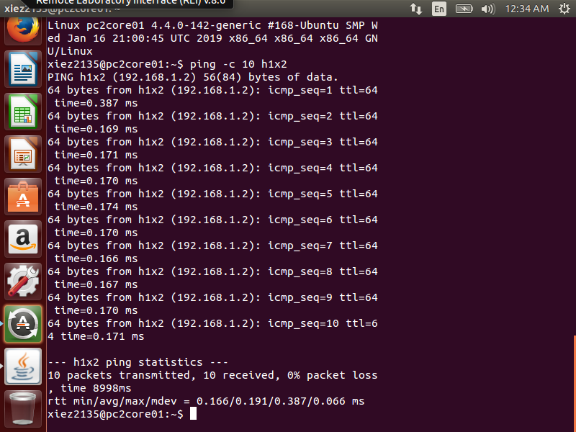

Figure 9. ping –c 10 h1x2 result.

1. While still in h1x1, type iperf3 –s –d
2. Exit h1x1 by ctr + D and log into h1x2 by ssh $h1x2
3. Type iperf3 –c h1x1 and the results are attached below as screenshot

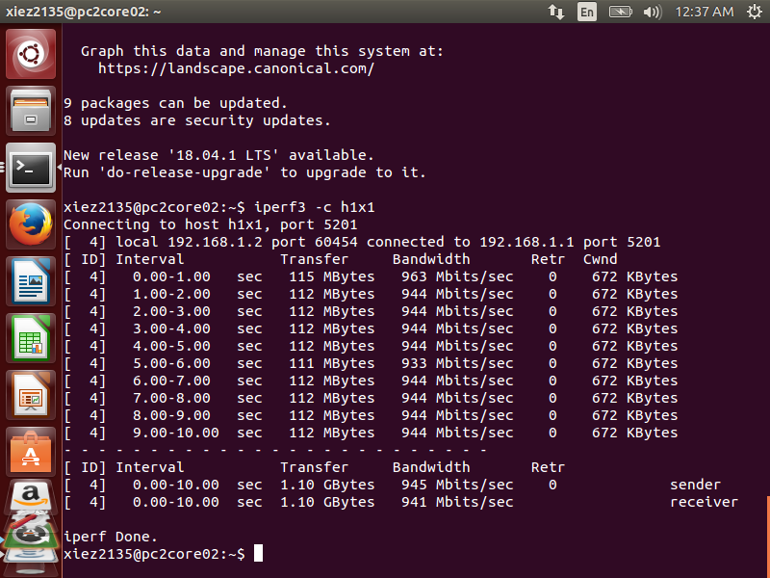

Figure 10. Result of iperf3 –c h1x1 on h1x2

1. Exit.

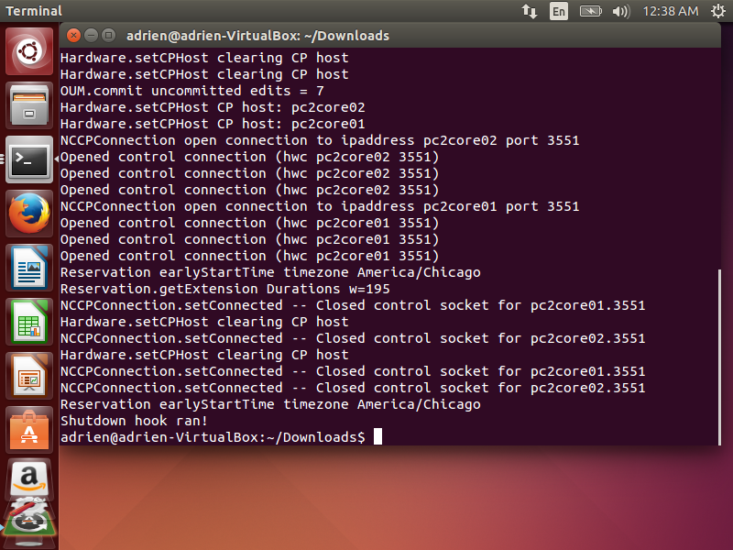

Figure 11. Terminal message after exit RLI.jar

## Finalize this file in Google Docs.

Make all of your final edits; make sure your work is neat and easy to follow. Remove the “cross-out” from the following drawing.

Finished!