Adrian John Antonio BSIT-MI181

Ismael Ebrada

***Wireframe***

Our Android Application is Flappy Bird. As you can see on the firsts picture that has start button and rankings button, if the user taps the start button, the interface will transfer to the gaming field where the user can play the game.

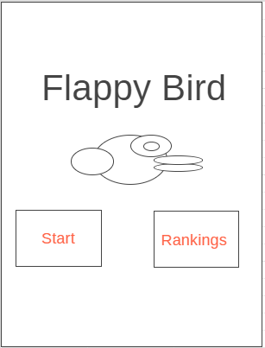 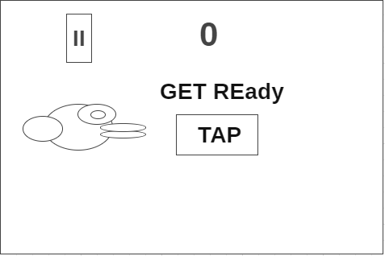

This is the gameplay interface of the application. The rules of this game is simple, you just have to tap the phone to prevent the bird from falling and also to avoid green tunnels by going in between them. Everytime the user goes through the green tunnel they will get one point.

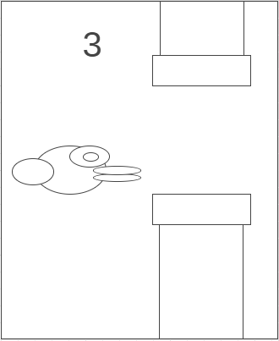 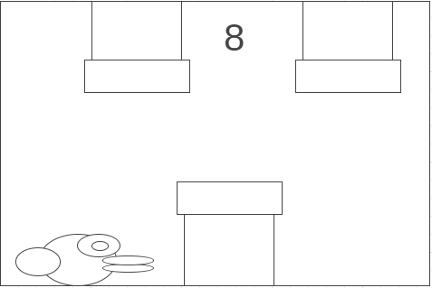

If the bird fall or stumbled to the green tunnel, the result will be game over.

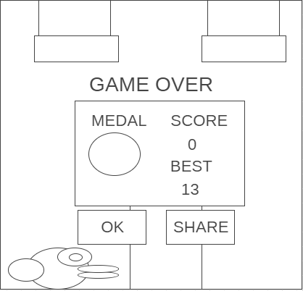 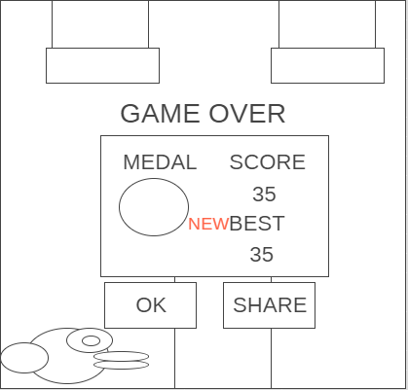

the score the user got will be recorded, but, if the user tries to play again by first tapping the ok button then the start button, the score will start from 0 and the user can play the game again.

**Mockups and Prototype:**

What you’re seeing below is the mockups and prototype of the application.

If the user taps the play button. The user will proceed to the gameplay of the application *(See Figure 1.0)*. If, however, user taps the ranking button (The one that has 1, 2, 3 button), they will be transferred to the ranking interface *(See Figure 1.5)*

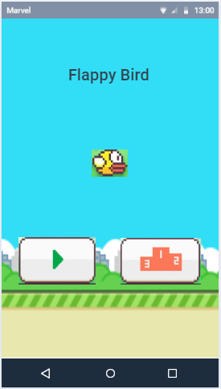

Figure 1.0

This is the gameplay of the application (with colors). Like what I said before, the rules of this game is to prevent the bird from falling by tapping the screen of your phone, you will also need to cross between the green tunnels to get a score and survive.

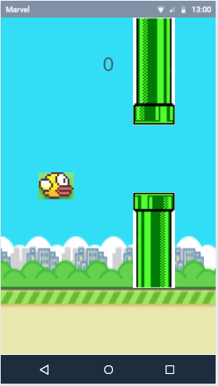 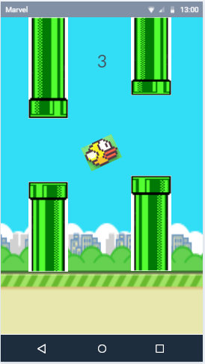

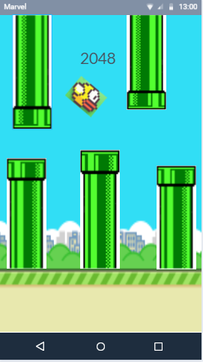

Figure 1.1

This is the interface of the bird getting bumped to one of the green tunnels *(See Figure 1.2)*.

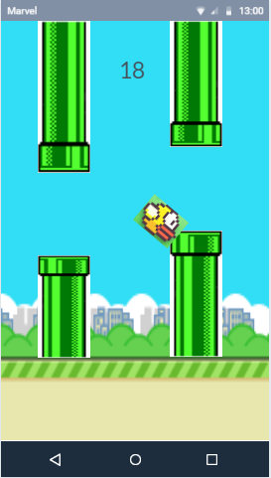

Figure 1.2

Despite the user lost, he/she can still play by clicking the play button, however, their score will start from zero *(See Figure 1.3)*. They can also click the rankings button to see who got the highest score and the lowest score.

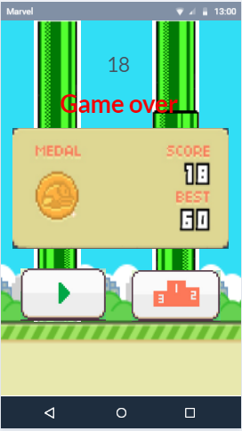

Figure 1.3

This is the ranking interface of the Flappy Bird. The user can tap the back button to go back to the game.

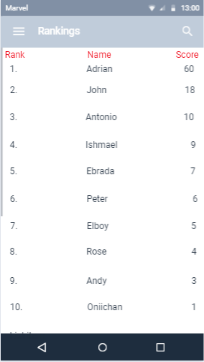

Figure 1.4

Used tools to make this happen:

[https://wireframe.cc](https://wireframe.cc/)

[https://marvelapp.com](https://marvelapp.com/)