REQUIREMENTS ANALYSIS DOCUMENT
for
Smart Personal Task Manager (SPTM)

Issue Number: 1.0
Issue Date: 30 October 2026

Prepared by
Zeynep Etik - 220104004035
Sümeyye Dalga - 220104004091
İbrahim Agah Arslan - 220104004077

TABLE OF CONTENTS
1 Introduction 4
1.1 Purpose of the system 4
1.2 Scope of the system 4
1.3 Objectives and success criteria of the project 4
1.4 Definitions, acronyms, and abbreviations 5
1.5 References 6
1.6 Overview 6
2 Current system 6
3 Proposed system 7
3.1 Overview 7
3.2 Functional requirements 7
3.2.1 Account and Profile Management 8
3.2.2 Mission Statement Management 8
3.2.3 Task Management 8
3.2.4 Prioritization (Covey Matrix and GTD Contexts) 9
3.2.5 GTD Workflow (Inbox, Next Actions, Weekly Review) 9
3.2.6 Appointments and Calendar Integration 9
3.2.7 Progress and Achievement Tracking 9
3.2.8 Reminders and Notifications 10
3.2.9 Data Synchronization and Offline Use 10
3.3 Nonfunctional requirements 10
3.3.1 Usability 10
3.3.2 Reliability 10
3.3.3 Performance 11
3.3.4 Supportability 11
3.3.5 Implementation 11
3.3.6 Interface 11
3.3.7 Packaging 11
3.3.8 Legal 12
3.4 System models 12
3.4.1 Scenarios 12
3.4.2 Use case model 14
3.4.3 Object model 19
3.4.4 Dynamic model 21
3.4.5 User interfaces and Mock-ups 26
4 Glossary of Terms 28
5 Priority 29
6 Traceability 31

Introduction
This document is the Requirements Analysis Document (RAD) of the Smart Personal Task Manager (SPTM). It defines what the system will do and gives the analysis model of the system using object-oriented, UML-based modeling. It is written for the development team, the course instructor (acting as the client) and future maintainers of the system.

Purpose of the system
People use many tools to manage tasks, appointments and reminders, but these tools rarely connect daily actions to a person's long-term purpose. As a result, users often feel busy but not effective: their focus is fragmented, they procrastinate on important but non-urgent work, and their daily activities are disconnected from their values.
The purpose of SPTM is to help an individual plan and carry out daily work in line with a personal mission. SPTM combines two proven methods:
- Stephen Covey's "7 Habits": a personal Mission Statement acts as a compass, and tasks are prioritized with the Time Management Matrix (urgent/important quadrants).
- David Allen's "Getting Things Done" (GTD): ideas are captured in an Inbox, clarified into Next Actions, grouped by Contexts and reviewed in a Weekly Review.
Every Task in SPTM is linked to the Mission Statement or one of its Sub-missions. Together with calendar integration, progress tracking and achievement reports, this turns task management from a simple checklist into a purposeful, reflective habit.

Scope of the system
In scope. SPTM is a single-user personal productivity system with desktop and mobile clients and a cloud backend for synchronization. It covers:
- User accounts and Preferences;
- Mission Statement creation, versioning and Sub-mission hierarchy;
- Task management (create, view, update, archive/delete), task hierarchy and Checklist Items;
- Prioritization with the Covey Matrix and GTD Contexts, Next Actions and Inbox processing;
- Bidirectional synchronization with external calendars (Google Calendar, Apple Calendar, Outlook);
- Progress tracking, time tracking, achievement log, Progress Reports and the guided Weekly Review;
- Reminders and notifications, offline use and synchronization between the User's devices.
Out of scope. Team or shared task lists, delegation of Tasks to other people, e-mail integration, payments, and AI-generated advice are not part of this release.
Development status. At the time of this issue the frontend (user interface screens of the client) has been implemented, and the backend (application logic, persistence, synchronization and calendar integration) has not been started. Therefore this document also serves as the specification that the backend must fulfil and against which the existing screens are checked.

Objectives and success criteria of the project
The objectives are taken from the problem statement [1]. Each objective has a measurable success criterion that will be checked in the acceptance tests.
Table 1: Project objectives and success criteria
ID | Objective | Success criterion
OBJ-1 | Formulate and maintain an evolving personal Mission Statement. | A first-time user writes a Mission Statement and first linked Task in under 10 minutes (NFR-1); all earlier versions can be viewed (FR-8).
OBJ-2 | Link daily Tasks and Appointments hierarchically to missions. | 100% of stored Tasks have a related Mission Statement or Sub-mission (FR-13); Task hierarchies of at least 3 levels are supported (FR-15).
OBJ-3 | Prioritize with Covey's Time Management Matrix. | Every Task is shown in exactly one Quadrant (FR-24); the User can override the suggestion (FR-26).
OBJ-4 | Support GTD: Inbox, Next Actions, Contexts, Weekly Review. | An Inbox Item can be captured in at most 2 interactions (NFR-2); a full Weekly Review can be completed inside the application (FR-34).
OBJ-5 | Integrate with local calendar applications. | An event created in a connected calendar appears in SPTM after the next synchronization, and vice versa, without duplicates (FR-37, NFR-7).
OBJ-6 | Support desktop and mobile with synchronization. | Desktop and mobile clients run on the platforms in NFR-22/23; a change is visible on another online device within 10 s (NFR-10).
OBJ-7 | Track achievements and visualize progress. | Daily, weekly and monthly Progress Reports are generated within 3 s (FR-46, NFR-11).

Definitions, acronyms, and abbreviations
The acronyms used in this document are listed below. Domain terms (Mission Statement, Task, Quadrant, Next Action, etc.) are defined in Section 4, Glossary of Terms.
Table 2: Acronyms and abbreviations
Acronym | Meaning
SPTM | Smart Personal Task Manager
RAD | Requirements Analysis Document
FR / NFR | Functional Requirement / Non-functional Requirement
UC | Use Case
PS | Problem Statement (section reference, see Section 6)
EARS | Easy Approach to Requirements Syntax
GTD | Getting Things Done (David Allen)
UML | Unified Modeling Language
UI | User Interface
API / REST | Application Programming Interface / Representational State Transfer
OAuth | Open standard for delegated authorization, used for calendar access
KVKK | Kişisel Verilerin Korunması Kanunu (Turkish Personal Data Protection Law No. 6698)
GDPR | EU General Data Protection Regulation
WCAG | Web Content Accessibility Guidelines
MoSCoW | Must have, Should have, Could have, Won't have (prioritization scheme)

Requirement sentence structure. Functional and non-functional requirements are written with the EARS templates [6]:
- Ubiquitous: "The system shall <response>."
- Event-driven: "When <trigger>, the system shall <response>."
- State-driven: "While <state>, the system shall <response>."
- Unwanted behaviour: "If <condition>, then the system shall <response>."
- Optional feature: "Where <feature is included>, the system shall <response>."

References
[1] Smart Personal Task Manager - Problem Statement, CSE443 Object-Oriented Analysis and Design, 2026.
[2] CSE443 Project Deliverable #1 - Requirements Analysis Document, assignment description, 2026.
[3] B. Bruegge, A. H. Dutoit, Object-Oriented Software Engineering Using UML, Patterns, and Java, 3rd ed., Pearson, 2010.
[4] S. R. Covey, The 7 Habits of Highly Effective People, Free Press, 1989.
[5] D. Allen, Getting Things Done: The Art of Stress-Free Productivity, Penguin, 2001 (rev. 2015).
[6] A. Mavin, P. Wilkinson, A. Harwood, M. Novak, "Easy Approach to Requirements Syntax (EARS)", Proc. 17th IEEE Int. Requirements Engineering Conf., 2009.
[7] ISO/IEC/IEEE 29148:2018, Systems and software engineering - Life cycle processes - Requirements engineering.
[8] Object Management Group, Unified Modeling Language (UML) Specification, Version 2.5.1, 2017.
[9] Google Calendar API, Microsoft Graph Calendar API, Apple EventKit and Android Calendar Provider developer documentation.
[10] Law No. 6698 on the Protection of Personal Data (KVKK), Republic of Türkiye; Regulation (EU) 2016/679 (GDPR).

Overview
Section 2 describes how personal tasks are managed today and the problems of current solutions. Section 3 presents the proposed system: a functional overview, the functional requirements (FR-1 to FR-52, grouped by modules), the non-functional requirements (NFR-1 to NFR-29) and the system models - scenarios, use case model, object (domain) model, dynamic models and user interface mock-ups. Section 4 is the glossary, Section 5 gives the priority of every requirement and Section 6 traces requirements to the problem statement, use cases and domain classes.

Current system
SPTM does not replace a single existing system. Today the target users accomplish the same tasks with a combination of separate tools:
Table 3: How the tasks supported by SPTM are accomplished today
Activity | How it is done now | Problems
Defining personal purpose | Mission or vision statements written in a notebook, journal or a note-taking app (if at all). | The mission is not visible when tasks are chosen; earlier versions are lost; no link to daily work.
Recording tasks | Generic to-do apps (e.g., Microsoft To Do, Google Tasks, Todoist), sticky notes, paper planners. | Flat lists or projects with no relation to values or long-term goals; urgent tasks crowd out important ones.
Prioritizing | Due dates, star/flag markers or manual numbering; the Covey Matrix drawn on paper. | No systematic urgent/important classification; matrix on paper is not kept up to date.
GTD workflow | Inbox and contexts built manually with labels in a to-do app or in paper folders. | Weekly Review depends on self-discipline; no guidance, no reminders, no statistics.
Appointments | Google Calendar, Apple Calendar or Outlook, separate from the task list. | Tasks and meetings are seen in different places; follow-up actions from meetings are forgotten.
Tracking progress | Ticking items off; occasionally spreadsheets or habit-tracker apps. | No history of achievements, no view of time spent per life area, little motivation from visible progress.

In summary, the current way of working is fragmented across several tools, does not keep the Mission Statement in view, does not support prioritization by importance and does not provide a structured review. Data must be copied between tools by hand and is often not available offline on all devices. SPTM addresses these problems by bringing mission, tasks, calendar and reflection into one synchronized system.

Proposed system
This section documents the functional and non-functional requirements elicited from the problem statement [1] and the analysis model of SPTM.

Overview
SPTM consists of clients (desktop and mobile, the frontend of which is already implemented), a cloud backend, a local database on each device and adapters to external calendar services. Functionally the system is organized into nine modules:
Table 4: Functional modules of SPTM
Module | Functionality | FRs
Account and Profile | Registration, login, Preferences. | FR-1 – FR-4
Mission Statement | Guided creation, editing, versioning, Sub-mission hierarchy, mission visibility. | FR-5 – FR-11
Task Management | Task CRUD, task hierarchy, Checklist Items, archive, list and matrix views, filtering. | FR-12 – FR-23
Prioritization | Covey Quadrants, suggestions, overrides, GTD Contexts. | FR-24 – FR-28
GTD Workflow | Inbox capture and processing, Next Actions, Weekly Review. | FR-29 – FR-35
Calendar Integration | Calendar accounts, bidirectional sync, conflicts, follow-up Tasks. | FR-36 – FR-41
Progress and Achievements | Task Status, progress ratios, time tracking, achievement log, reports. | FR-42 – FR-46
Reminders | Reminders and notifications. | FR-47 – FR-49
Synchronization and Offline | Offline use, multi-device sync, data export. | FR-50 – FR-52

A typical day with SPTM looks as follows: the User opens the Dashboard and sees the Mission Statement, today's Next Actions and Appointments. New ideas are captured into the Inbox in seconds and processed later into Tasks linked to a Sub-mission. Tasks are prioritized in the Covey Matrix, Reminders notify the User of deadlines, and time spent and completed Tasks are logged. Once a week, the system guides the User through a Weekly Review in which progress is reviewed and the Mission Statement may be refined.

Functional requirements
Functional requirements are numbered FR-1 to FR-52 and grouped by module. Each requirement is written with an EARS sentence pattern. The priority of each requirement (MoSCoW) is listed in Section 5 and its source and related use cases in Section 6. Terms written with initial capitals (e.g., Task, Sub-mission) are the same terms used in the use cases, the domain model and the glossary.

Account and Profile Management
ID | Requirement
FR-1 | The system shall allow a person to register a User account with a name, an e-mail address and a password.
FR-2 | When the User submits valid credentials, the system shall authenticate the User and display the Dashboard.
FR-3 | If the User submits invalid credentials, then the system shall reject the login and display an error message that does not reveal which credential was wrong.
FR-4 | The system shall allow the User to edit Preferences, namely language, theme, default task view, weekly review day/time and notification settings.

Mission Statement Management
ID | Requirement
FR-5 | When the User creates a Mission Statement for the first time, the system shall provide a guided interface that asks reflection questions about values, roles and long-term goals.
FR-6 | The system shall allow the User to edit the text of the Mission Statement at any time.
FR-7 | When the User saves a modified Mission Statement, the system shall store the previous text as a Mission Version with a version number and a timestamp.
FR-8 | The system shall allow the User to view all Mission Versions of the Mission Statement in chronological order.
FR-9 | The system shall allow the User to create, edit and remove Sub-missions linked to the Mission Statement, including Sub-missions nested under other Sub-missions.
FR-10 | While the User is creating a Task or viewing a task list, the system shall display the Mission Statement or the related Sub-mission.
FR-11 | If the User tries to remove a Sub-mission that still has linked Tasks, then the system shall require the User to reassign or archive those Tasks before the removal.

Task Management
ID | Requirement
FR-12 | The system shall allow the User to create a Task with a title, description, due date/time, location, estimated effort, Contexts and a related Mission Statement or Sub-mission.
FR-13 | If the User submits a Task without a title or without a related Mission Statement or Sub-mission, then the system shall reject the Task and indicate the missing fields.
FR-14 | Where voice input is available on the device, the system shall allow the User to dictate the title and description of a Task or the content of an Inbox Item.
FR-15 | The system shall allow the User to create subtasks under a parent Task to form a task hierarchy of at least three levels.
FR-16 | The system shall allow the User to modify any attribute of a Task, including its parent Task and its related Mission Statement or Sub-mission.
FR-17 | The system shall allow the User to add, check, uncheck and remove Checklist Items within a Task.
FR-18 | When the User archives a Task, the system shall remove the Task from active views and keep it retrievable in the archive.
FR-19 | When the User requests the permanent deletion of a Task, the system shall ask for confirmation before deleting it.
FR-20 | If a Task that is being archived or deleted has subtasks, then the system shall ask the User whether the operation also applies to the subtasks.
FR-21 | The system shall display Tasks both in a list view and in a Covey Matrix view.
FR-22 | The system shall allow the User to filter Tasks by Mission Statement/Sub-mission, Context, due date range and Task Status.
FR-23 | The system shall allow the User to sort the task list by due date, Quadrant and creation date.

Prioritization (Covey Matrix and GTD Contexts)
ID | Requirement
FR-24 | The system shall classify every Task into exactly one of the four Quadrants of the Covey Matrix according to its importance and urgency.
FR-25 | When the User creates or updates a Task that has a due date and an estimated effort, the system shall suggest an urgency value and a Quadrant for the Task.
FR-26 | The system shall allow the User to override the suggested Quadrant of a Task.
FR-27 | When the User moves a Task to another Quadrant in the Covey Matrix view, the system shall update the importance and urgency of the Task accordingly.
FR-28 | The system shall allow the User to create, rename and delete Contexts (e.g., @home, @work, @phone) and to assign one or more Contexts to a Task.

GTD Workflow (Inbox, Next Actions, Weekly Review)
ID | Requirement
FR-29 | The system shall allow the User to capture an Inbox Item containing only free text from any main screen.
FR-30 | The system shall display the number of unprocessed Inbox Items on the Dashboard.
FR-31 | When the User processes an Inbox Item, the system shall allow the User to convert it into a Task, store it as a deferred (someday/maybe) Task, or discard it.
FR-32 | The system shall allow the User to mark a Task as a Next Action and shall list all Next Actions grouped by Context.
FR-33 | When the weekly review day and time configured in Preferences is reached, the system shall prompt the User to start a Weekly Review.
FR-34 | While a Weekly Review is in progress, the system shall guide the User through processing the Inbox, reviewing overdue, upcoming and deferred Tasks, viewing the weekly Progress Report and reflecting on the Mission Statement.
FR-35 | When the User completes a Weekly Review, the system shall store the Weekly Review with its completion time and the User's notes.

Appointments and Calendar Integration
ID | Requirement
FR-36 | The system shall allow the User to connect one or more external calendar accounts (Google Calendar, Apple Calendar, Microsoft Outlook).
FR-37 | While a Calendar Account is connected and synchronization is enabled, the system shall synchronize Appointments bidirectionally with the external calendar.
FR-38 | Where deadline export is enabled by the User, the system shall create or update an event in the connected calendar for each Task that has a due date.
FR-39 | If an Appointment was changed both locally and in the external calendar since the last synchronization, then the system shall show both versions and let the User choose the version to keep.
FR-40 | The system shall allow the User to create a follow-up Task from an Appointment, pre-filling its title and date and keeping a link to the Appointment.
FR-41 | The system shall display the Appointments of the current day on the Dashboard together with the User's Next Actions.

Progress and Achievement Tracking
ID | Requirement
FR-42 | The system shall maintain for every Task and every Sub-mission a status that is one of Not Started, In Progress, Completed or Deferred.
FR-43 | The system shall compute the progress of a Mission Statement, Sub-mission or parent Task as the ratio of completed linked Tasks to all non-archived linked Tasks.
FR-44 | The system shall allow the User to start and stop a timer on a Task and to enter the time spent manually.
FR-45 | When the User marks a Task or Sub-mission as completed, the system shall record an Achievement with the completion date in the achievement log.
FR-46 | The system shall generate Progress Reports with charts showing completed Tasks, time allocation per Sub-mission and Context, and completion trends for a selected day, week or month.

Reminders and Notifications
ID | Requirement
FR-47 | The system shall allow the User to define one or more Reminders for a Task, either relative to its due date or at an absolute time.
FR-48 | When the time of a Reminder is reached, the system shall send a notification to all devices on which the User is signed in.
FR-49 | If notifications are disabled in Preferences, then the system shall show due Reminders only inside the application.

Data Synchronization and Offline Use
ID | Requirement
FR-50 | While the device has no network connection, the system shall allow the User to create, edit and process Tasks, Inbox Items and the Mission Statement using local storage.
FR-51 | When network connectivity is restored, the system shall synchronize local changes with the cloud and with the User's other devices.
FR-52 | The system shall allow the User to export his or her Tasks, Mission Statement, Mission Versions and Achievements in JSON or CSV format.

Nonfunctional requirements
Non-functional requirements are numbered NFR-1 to NFR-29 and grouped by the categories of the template.

Usability
ID | Requirement
NFR-1 | The system shall allow a first-time User to write a Mission Statement and create the first linked Task within 10 minutes without external help.
NFR-2 | The system shall allow the User to capture an Inbox Item with at most two interactions from any main screen.
NFR-3 | The system shall conform to WCAG 2.1 level AA, including screen-reader labels for all controls and full keyboard navigation on desktop.
NFR-4 | The system shall provide its user interface in English and Turkish.
NFR-5 | The system shall use the same terms (Mission Statement, Sub-mission, Task, Inbox, Context, Quadrant, Next Action, Weekly Review) on every screen and in this document.

Reliability
ID | Requirement
NFR-6 | The system shall not lose any change that the User has saved locally if the application or the device crashes.
NFR-7 | If a synchronization is interrupted, then the system shall resume it later without creating duplicate Tasks, Inbox Items or Appointments.
NFR-8 | The cloud synchronization service shall be available at least 99.5% of each calendar month, excluding announced maintenance.

Performance
ID | Requirement
NFR-9 | The system shall respond to user interface actions (open, save, filter, switch view) within 1 second for 95% of actions, for a User with up to 5,000 Tasks.
NFR-10 | When a change is saved on one online device, the system shall make it visible on the User's other online devices within 10 seconds.
NFR-11 | The system shall generate a Progress Report covering one month within 3 seconds.

Supportability
ID | Requirement
NFR-12 | The backend shall be organized in layers (API, application logic, persistence) so that a new calendar provider can be added by implementing a single adapter interface.
NFR-13 | The backend shall expose a versioned RESTful API documented with the OpenAPI specification.
NFR-14 | Automated unit and integration tests shall cover at least 70% of the backend business logic.
NFR-15 | The system shall log synchronization errors with timestamps so that problems can be diagnosed without access to the User's private content.

Implementation
ID | Requirement
NFR-16 | The backend shall integrate with the already implemented frontend through JSON over REST, without requiring a redesign of the existing screens.
NFR-17 | The backend shall be implemented in Java (Spring Boot) with PostgreSQL as the cloud database; the client frontend (implemented in React and TypeScript and packaged for desktop and mobile) shall use SQLite for local storage.
NFR-18 | All source code and documentation shall be kept in the team's GitHub repository.

Interface
ID | Requirement
NFR-19 | The system shall access external calendars through the providers' official interfaces: Google Calendar API, Microsoft Graph (Outlook), Apple EventKit / CalDAV and the Android Calendar Provider.
NFR-20 | All communication between clients and the backend shall use HTTPS with TLS 1.2 or later.
NFR-21 | The system shall import and export calendar data in iCalendar (.ics) format and task data in JSON/CSV format.

Packaging
ID | Requirement
NFR-22 | The desktop client shall be delivered as installable packages for Windows, macOS and Linux.
NFR-23 | The mobile client shall be delivered for Android 10 or later and iOS 16 or later.
NFR-24 | The backend shall be delivered as a container image (Docker) together with a configuration file for deployment.

Legal
ID | Requirement
NFR-25 | The system shall comply with the Turkish Personal Data Protection Law (KVKK, Law No. 6698) and the EU GDPR, including explicit consent and deletion of all personal data on the User's request.
NFR-26 | The system shall encrypt personal data at rest (AES-256) and store passwords only as salted hashes (bcrypt or Argon2).
NFR-27 | The system shall apply role-based access control so that a User can access only his or her own data and administrators cannot read Mission Statement or Task contents.
NFR-28 | The system shall request only the minimum OAuth scopes needed from calendar providers and shall respect the providers' terms of use.
NFR-29 | All third-party libraries used shall have licenses compatible with the distribution of the system.

System models
This section presents the analysis model of SPTM: scenarios, the use case model, the object (domain) model, dynamic models and user interface mock-ups with the navigational paths between screens. All diagrams follow UML 2.5 notation [8]. The domain model is conceptual: it contains classes, attributes and associations only, without operations or database elements.

Scenarios
The following scenarios describe concrete uses of the system with named actor instances. They were used to discover and validate the use cases.
Scenario name | setUpMissionAndFirstTask
Participating actor instances | ayse: User
Flow of events | 1. Ayse installs SPTM on her laptop, registers with her e-mail address and logs in.  2. Because she has no Mission Statement yet, the system shows the guided questions. She answers "integrity, family, learning" for values and "student, daughter, team member" for roles, then writes: "To live with integrity, keep learning and support my family."  3. She adds three Sub-missions: "Career / Education", "Health" and "Family".  4. She selects "+ New Task". The Task Form shows her mission at the top. She enters "Prepare CSE443 RAD", due 30 October 23:59, effort 6 hours, Sub-mission "Career / Education", Context @work.  5. The system suggests Quadrant Q1 (urgent and important) because the deadline is two days away. Ayse accepts it, adds a reminder one day before and marks the Task as a Next Action.  6. The Task appears in Q1 of the Covey Matrix and in today's Next Actions on the Dashboard.

Scenario name | captureAndProcessIdea
Participating actor instances | mehmet: User
Flow of events | 1. While riding the bus, Mehmet remembers that he must renew his passport. He taps "Capture" on his phone and dictates "renew passport". The Inbox counter on the Dashboard shows 1.  2. In the evening he opens the Inbox, selects the item and chooses "Make Task".  3. The Task Form opens pre-filled with "renew passport". He links it to Sub-mission "Family", adds Context @errands, marks it as a Next Action and saves.  4. The Inbox is now empty and the Task appears under @errands in the Next Actions list.

Scenario name | syncMeetingAndFollowUp
Participating actor instances | ayse: User, googleCalendar: Calendar Service
Flow of events | 1. Ayse's project advisor adds a meeting "RAD review" on Thursday 14:30 to Ayse's Google Calendar.  2. At the next periodic synchronization the system fetches the event and shows it in today's Appointments on the Dashboard.  3. After the meeting Ayse opens the Appointment and selects "Follow-up task". The system creates a Task "Follow-up: RAD review" linked to the Appointment; she adds the checklist items "fix use case diagram" and "add glossary".  4. Ayse changes the meeting time in SPTM to 15:00 while her advisor changes it to 16:00 in Google Calendar. At the next synchronization the system shows both versions and Ayse keeps 16:00.

Scenario name | sundayWeeklyReview
Participating actor instances | mehmet: User, clock: System Clock
Flow of events | 1. Mehmet set the weekly review to Sunday 20:00. At that time the system sends a notification "Time for your Weekly Review".  2. He opens the review. The system shows his Mission Statement and processes two remaining Inbox Items with him.  3. The system lists one overdue Task; he reschedules it. Among the deferred Tasks he reactivates "start running twice a week".  4. The weekly Progress Report shows 14 completed Tasks and that 70% of his time went to "Career / Education". He writes a note that Health was neglected and adds a sentence about his health to his Mission Statement.  5. He completes the review; the system saves it with his notes and creates a new Mission Version.

Scenario name | offlineUpdate
Participating actor instances | ayse: User
Flow of events | 1. On a flight without internet, Ayse marks two Tasks as Completed and captures three Inbox Items on her phone.  2. The system saves all changes locally and records two Achievements.  3. After landing, the phone reconnects; the system synchronizes the changes, and when Ayse opens her laptop the same Tasks are completed and the Inbox counter shows 3.

Use case model
Actors. The User is the person who manages his or her own missions and Tasks (the only human actor). The Calendar Service is an external system (Google Calendar, Apple Calendar or Outlook) that stores the User's Appointments. The System Clock is a timer actor that initiates time-triggered use cases (Reminders, periodic synchronization).
The use case diagram is divided into three parts by functional area for readability.
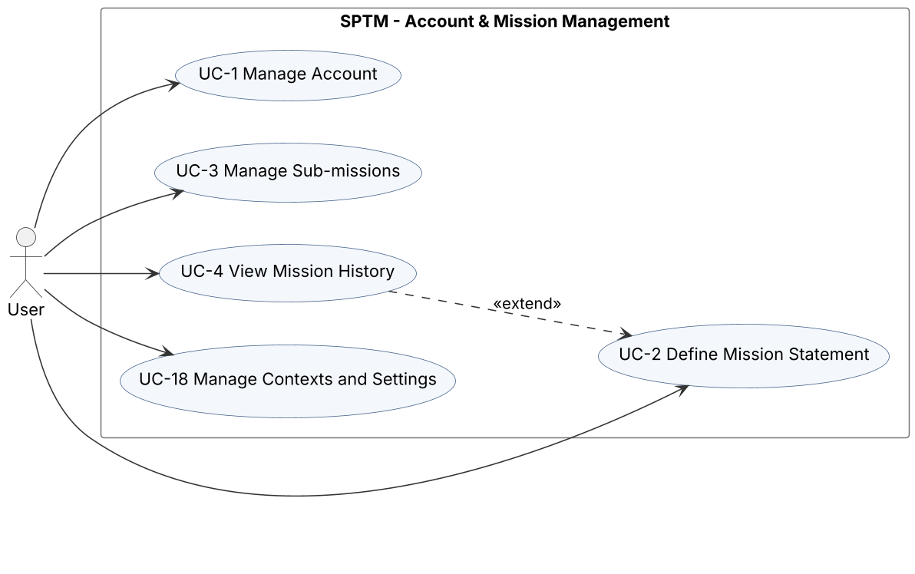
Figure 1: Use case diagram - Account and Mission Management
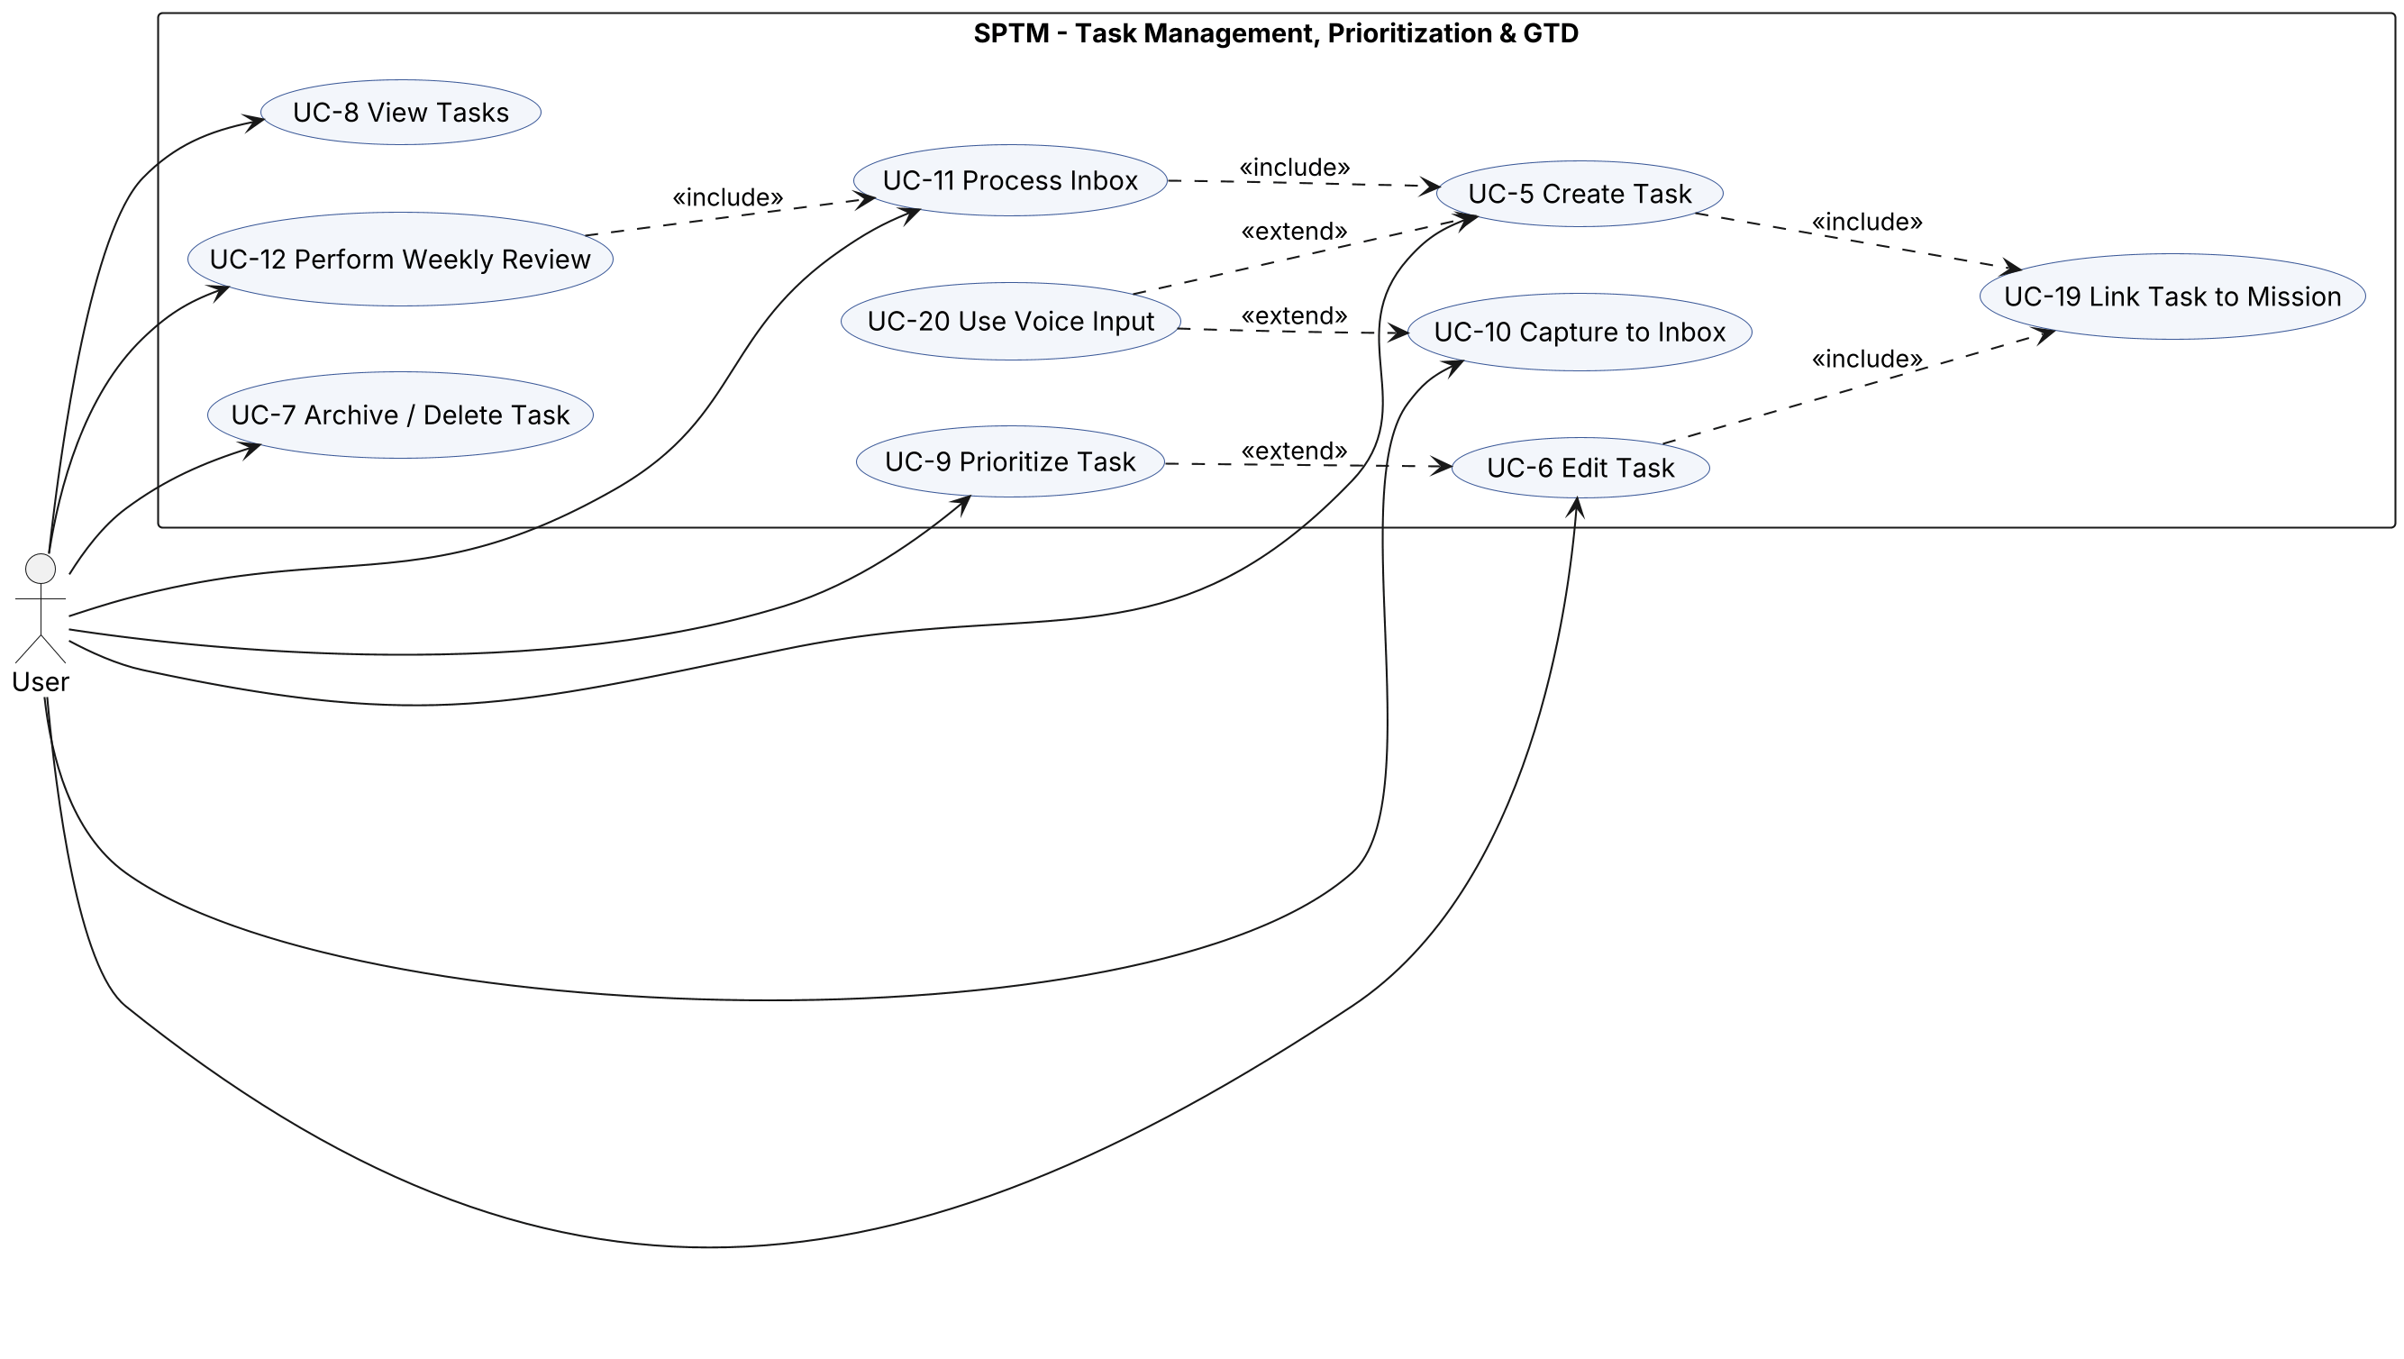
Figure 2: Use case diagram - Task Management, Prioritization and GTD
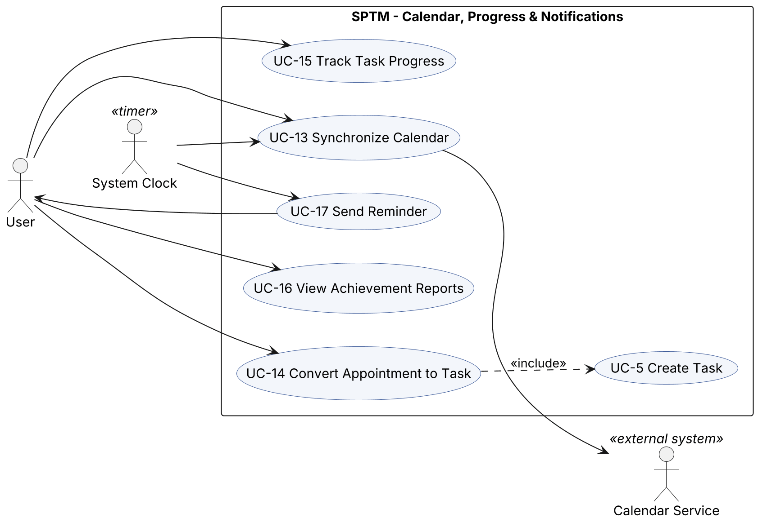
Figure 3: Use case diagram - Calendar, Progress and Notifications
Table 5: Use case summary and links to functional requirements
ID | Use case | Actors | Description | Related FRs
UC-1 | Manage Account | User | Register, log in, log out and update account data. | FR-1, FR-2, FR-3
UC-2 | Define Mission Statement | User | Write or refine the personal Mission Statement through a guided interface; each save creates a Mission Version. | FR-5, FR-6, FR-7
UC-3 | Manage Sub-missions | User | Create, edit, nest and remove Sub-missions (focus areas) under the Mission Statement. | FR-9, FR-11
UC-4 | View Mission History | User | Browse earlier Mission Versions for reflection. | FR-8
UC-5 | Create Task | User | Create a Task linked to the Mission Statement or a Sub-mission, with Contexts, due date and Reminders. | FR-10, FR-12, FR-13, FR-14, FR-15, FR-25, FR-28, FR-47, FR-50, FR-51
UC-6 | Edit Task | User | Change Task attributes, hierarchy, mission link and Checklist Items. | FR-15, FR-16, FR-17, FR-47, FR-50, FR-51
UC-7 | Archive / Delete Task | User | Archive a Task or delete it permanently after confirmation. | FR-18, FR-19, FR-20
UC-8 | View Tasks | User | See Tasks in list, Covey Matrix or Dashboard views with filters and sorting. | FR-10, FR-21, FR-22, FR-23, FR-32, FR-41
UC-9 | Prioritize Task | User | Accept or override the suggested Quadrant of a Task. | FR-24, FR-25, FR-26, FR-27
UC-10 | Capture to Inbox | User | Quickly record an idea or commitment as an Inbox Item. | FR-14, FR-29, FR-30, FR-50, FR-51
UC-11 | Process Inbox | User | Decide for each Inbox Item: make it a Task, defer it, or discard it. | FR-31, FR-32, FR-50, FR-51
UC-12 | Perform Weekly Review | User | Follow the guided GTD Weekly Review. | FR-33, FR-34, FR-35
UC-13 | Synchronize Calendar | User, Calendar Service, System Clock | Exchange Appointments and deadlines with an external calendar. | FR-36, FR-37, FR-38, FR-39
UC-14 | Convert Appointment to Task | User | Create a follow-up Task from an Appointment. | FR-40
UC-15 | Track Task Progress | User | Change Task Status, record time spent, complete Checklist Items, log Achievements. | FR-17, FR-42, FR-43, FR-44, FR-45
UC-16 | View Achievement Reports | User | See Progress Reports and the achievement log for a period. | FR-43, FR-46
UC-17 | Send Reminder | System Clock (initiator), User | Notify the User when a Reminder or the weekly review time is reached. | FR-33, FR-48, FR-49
UC-18 | Manage Contexts and Settings | User | Manage Contexts, Preferences, notification settings and data export. | FR-4, FR-28, FR-49, FR-52
UC-19 | Link Task to Mission | User | Select the Mission Statement or a Sub-mission for a Task; included in UC-5 and UC-6. | FR-10, FR-13, FR-16
UC-20 | Use Voice Input | User | Dictate the content of a Task or an Inbox Item; extends UC-5 and UC-10. | FR-14

Use case descriptions. The most important use cases are described in detail below.
Use case name | Define Mission Statement (UC-2)
Participating actors | Initiated by User
Flow of events | [User] 1. The User selects "My Mission" on the Dashboard.  [System] 2. The system shows the Mission Editor. If no Mission Statement exists, it shows the guided reflection questions (values, roles, 10-year vision).  [User] 3. The User answers the questions and writes or edits the mission text, then selects "Save Version".  [System] 4. The system stores the previous text as a new Mission Version (version number, timestamp), saves the new text and shows a confirmation.
Alternative flows | 3a. The mission text is empty: the system does not save and asks the User to write at least one sentence.
Entry condition | The User is logged in.
Exit condition | The Mission Statement is saved and its previous text (if any) is kept as a Mission Version, OR the User cancelled and nothing changed.
Quality requirements | Saving shall take less than 1 second (NFR-9). Mission text is encrypted at rest (NFR-26).
Related requirements | FR-5, FR-6, FR-7

Use case name | Create Task (UC-5)
Participating actors | Initiated by User
Flow of events | [User] 1. The User selects "+ New Task" (or speaks a voice command, FR-14).  [System] 2. The system shows the Task Form together with the Mission Statement, the list of Sub-missions and Contexts.  [User] 3. The User enters the title, description, due date, estimated effort, selects a Sub-mission, Contexts and optionally a parent Task and Reminders.  [System] 4. The system suggests urgency and a Quadrant based on the due date and effort (FR-25).  [User] 5. The User accepts or changes the Quadrant and selects "Save".  [System] 6. The system validates the data, creates the Task with status Not Started, creates the Reminders, and shows the Task in the list and Covey Matrix views.
Alternative flows | 6a. Title or mission link is missing: the system highlights the missing fields and keeps the entered data (FR-13).
Entry condition | The User is logged in and a Mission Statement exists.
Exit condition | A new Task linked to the Mission Statement or a Sub-mission is stored, OR the User cancelled.
Quality requirements | The Task is saved locally even when offline (FR-50) and synchronized later (FR-51).
Related requirements | FR-10, FR-12, FR-13, FR-14, FR-15, FR-25, FR-28, FR-47, FR-50, FR-51

Use case name | Process Inbox (UC-11)
Participating actors | Initiated by User
Flow of events | [User] 1. The User opens the Inbox (from the Dashboard counter or during a Weekly Review).  [System] 2. The system lists the unprocessed Inbox Items, oldest first.  [User] 3. The User selects an item and chooses one decision: "Make Task", "Someday / Maybe" or "Trash".  [System] 4. For "Make Task" the system opens the Task Form pre-filled with the item text (include UC-5) and marks the new Task as a Next Action if the User selects so. For "Someday / Maybe" it creates a Task with status Deferred. For "Trash" it discards the item.  [System] 5. The system marks the item as processed and refreshes the list. Steps 3-5 are repeated until the Inbox is empty or the User leaves.
Alternative flows | 4a. The User cancels the Task Form: the Inbox Item stays unprocessed.
Entry condition | At least one unprocessed Inbox Item exists.
Exit condition | Every chosen item is processed; the Dashboard counter shows the remaining number.
Quality requirements | Processing one item shall take at most three interactions.
Related requirements | FR-31, FR-32, FR-50, FR-51

Use case name | Perform Weekly Review (UC-12)
Participating actors | Initiated by User; System Clock (reminder)
Flow of events | [System] 1. At the weekly review time set in Preferences, the system sends a Weekly Review reminder (UC-17).  [User] 2. The User starts the Weekly Review.  [System] 3. The system shows the Mission Statement and Sub-missions, then the unprocessed Inbox Items (include UC-11).  [System] 4. The system lists overdue, upcoming (next 7 days) and Deferred Tasks; the User reschedules, reactivates or archives them.  [System] 5. The system shows the Progress Report of the past week (completed Tasks, time per Sub-mission).  [User] 6. The User writes reflection notes and, if needed, edits the Mission Statement (UC-2).  [System] 7. The system stores the Weekly Review as completed with the notes.
Alternative flows | 2a. The User selects "Later": the system postpones the reminder by 24 hours.
Entry condition | The User is logged in.
Exit condition | A completed Weekly Review is stored, OR the User postponed it (the reminder is repeated next day).
Quality requirements | The User can leave and continue later without losing the progress of the review.
Related requirements | FR-33, FR-34, FR-35

Use case name | Synchronize Calendar (UC-13)
Participating actors | Initiated by User or System Clock; communicates with Calendar Service
Flow of events | [User] 1. The User selects "Sync now", or the periodic synchronization time is reached.  [System] 2. The system requests from the Calendar Service all events changed since the last synchronization.  [Calendar Service] 3. The Calendar Service returns the changed events.  [System] 4. The system creates, updates or removes the corresponding Appointments and sends local changes (and Task deadlines if enabled) to the Calendar Service.  [System] 5. The system updates the last synchronization time and refreshes the Dashboard and Calendar views.
Alternative flows | 4a. The same Appointment was changed on both sides: the system shows both versions and the User chooses one (FR-39). 2a. The Calendar Service is unreachable: the system keeps local data and retries later.
Entry condition | At least one Calendar Account is connected and synchronization is enabled.
Exit condition | Local Appointments and the external calendar contain the same events.
Quality requirements | No duplicate Appointments after interrupted synchronization (NFR-7). Only minimum OAuth scopes are used (NFR-28).
Related requirements | FR-36, FR-37, FR-38, FR-39

Use case name | Send Reminder (UC-17)
Participating actors | Initiated by System Clock; communicates with User
Flow of events | [System Clock] 1. The time of a Reminder (or the weekly review time) is reached.  [System] 2. The system checks the User's notification Preferences.  [System] 3. The system sends a notification with the Task title and due date to the User's devices and marks the Reminder as delivered.  [User] 4. The User opens the notification; the system shows the related Task (or starts UC-12).
Alternative flows | 2a. Notifications are disabled: the system shows the Reminder only inside the application (FR-49).
Entry condition | A Reminder with a time in the past and not yet delivered exists.
Exit condition | The Reminder is marked as delivered.
Quality requirements | A notification is sent within 1 minute of the Reminder time when the device is online.
Related requirements | FR-33, FR-48, FR-49

Object model
Figure 4 shows the analysis-level domain model (entity objects) of SPTM. It contains the main concepts, their attributes and associations; operations and database details are intentionally left out. The central concept is the Task, which must always be linked to the MissionStatement or a SubMission. Both Task and SubMission have reflexive associations that form hierarchies.
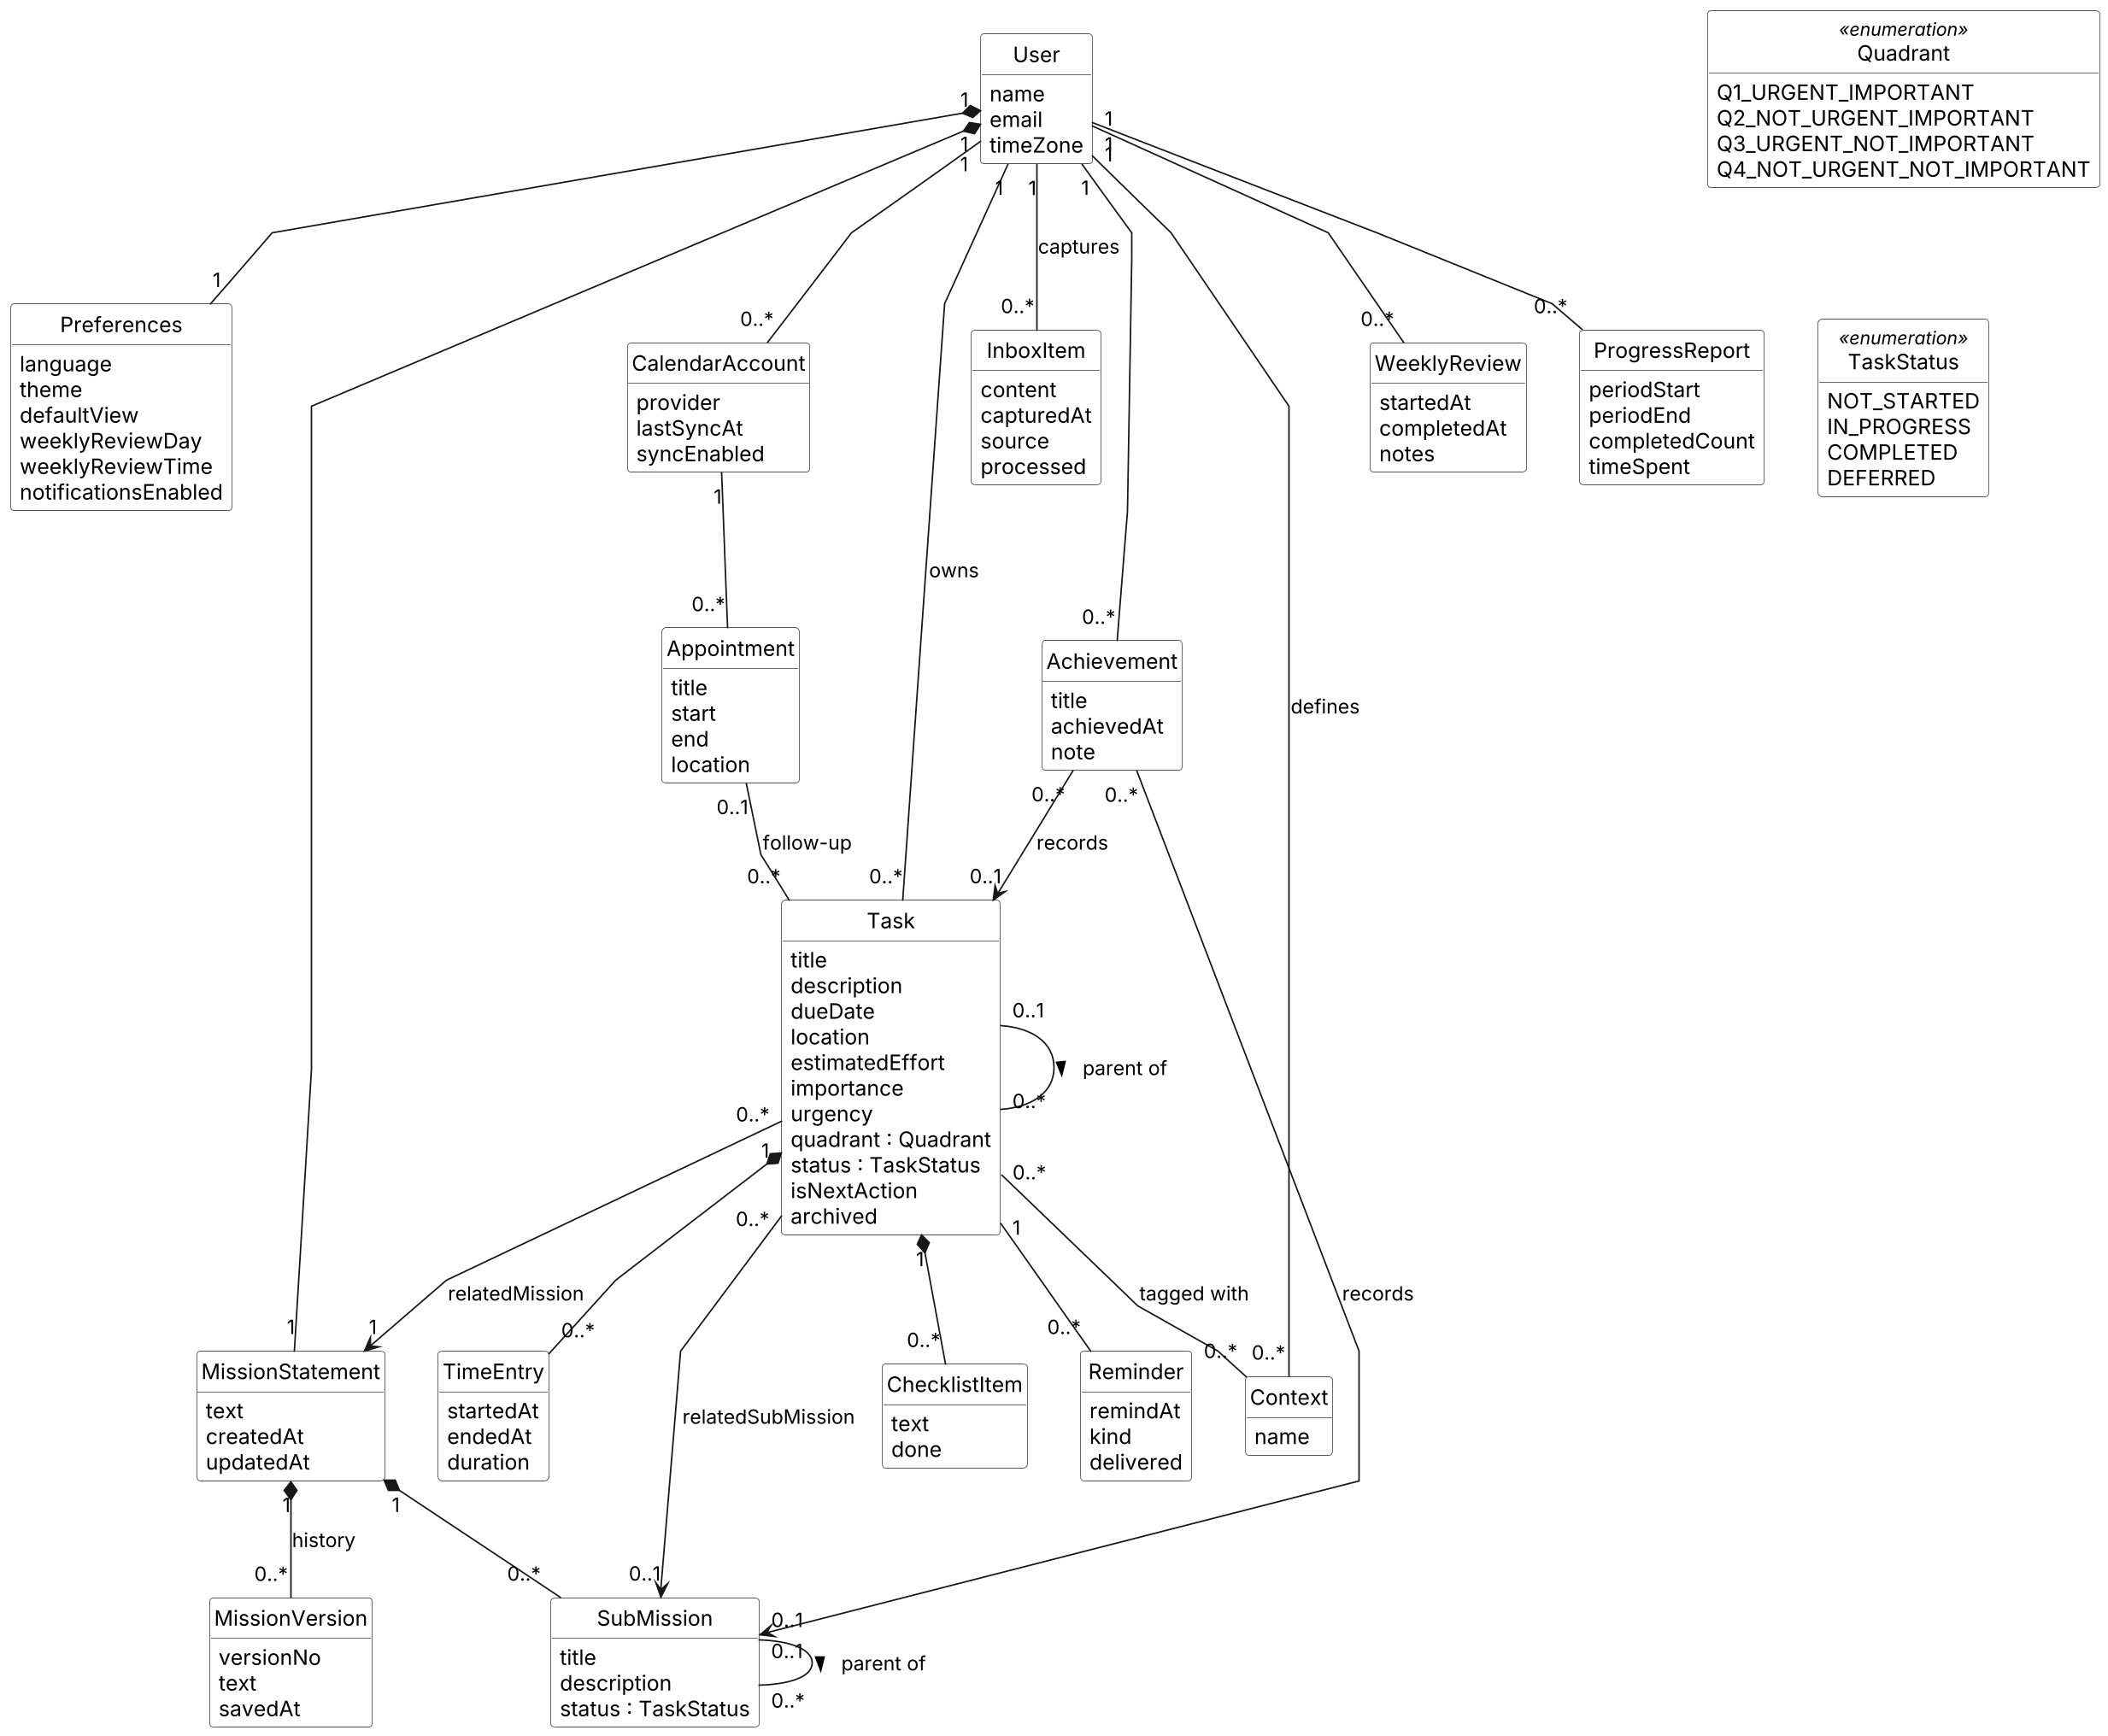
Figure 4: Domain model (UML class diagram, analysis level)
Table 6 lists the analysis objects. Following the Bruegge & Dutoit approach [3], they are classified as entity, boundary and control objects. Boundary objects correspond to the screens of the already implemented frontend; control objects coordinate one use case each.
Table 6: Analysis object dictionary
Class | Type | Description
User | Entity | A person who uses SPTM; owns all other data.
Preferences | Entity | User settings: language, theme, default view, weekly review day/time, notifications.
MissionStatement | Entity | The User's personal mission text that guides task selection.
MissionVersion | Entity | A stored earlier text of the Mission Statement with version number and date.
SubMission | Entity | A focus area or sub-goal under the Mission Statement; may be nested.
Task | Entity | An actionable item linked to the Mission Statement or a Sub-mission; may have subtasks.
ChecklistItem | Entity | A small step inside a Task.
Context | Entity | GTD context tag such as @home, @work, @phone.
InboxItem | Entity | Raw captured idea or commitment that has not yet been processed.
CalendarAccount | Entity | Connection to an external calendar provider.
Appointment | Entity | A calendar event (meeting, appointment) synchronized with an external calendar.
Reminder | Entity | A notification time for a Task or the Weekly Review.
TimeEntry | Entity | A recorded period of time spent on a Task.
Achievement | Entity | A logged completion of a Task, Sub-mission or milestone.
WeeklyReview | Entity | A performed GTD Weekly Review with notes.
ProgressReport | Entity | Calculated statistics of a period (completed Tasks, time spent).
Quadrant / TaskStatus | Enumeration | Possible Covey quadrants and Task Status values.
LoginView, DashboardView, MissionEditorView, MissionHistoryView, TaskForm, TaskListView, CoveyMatrixView, InboxView, CalendarView, ReportView, WeeklyReviewView, SettingsView | Boundary | Screens of the (already implemented) frontend through which the User interacts with the system.
CalendarServiceAdapter, NotificationService | Boundary | Interfaces to external calendar providers and to platform notification services.
CreateTaskControl, ProcessInboxControl, CalendarSyncControl, WeeklyReviewControl, ReminderControl, ReportControl | Control | Objects that coordinate a single use case (UC-5, UC-11, UC-13, UC-12, UC-17, UC-16).

Main constraints of the domain model:
- A Task belongs to exactly one User and is related to exactly one MissionStatement and at most one SubMission (FR-12, FR-13).
- A Task has exactly one Quadrant and one TaskStatus at any time (FR-24, FR-42).
- A Task may have at most one parent Task; cycles in the task hierarchy are not allowed (FR-15).
- A SubMission with linked Tasks cannot be removed until its Tasks are reassigned or archived (FR-11).
- Each User has exactly one MissionStatement and one Preferences object; MissionVersions are never modified after creation (FR-7).
- An Achievement records the completion of exactly one Task or one SubMission (FR-45).

Dynamic model
The dynamic model describes the behaviour of the system with sequence diagrams for the most important use cases, a state machine diagram for Task and an activity diagram for the Weekly Review. Sequence diagrams use the boundary/control/entity stereotypes of the analysis objects in Table 6.
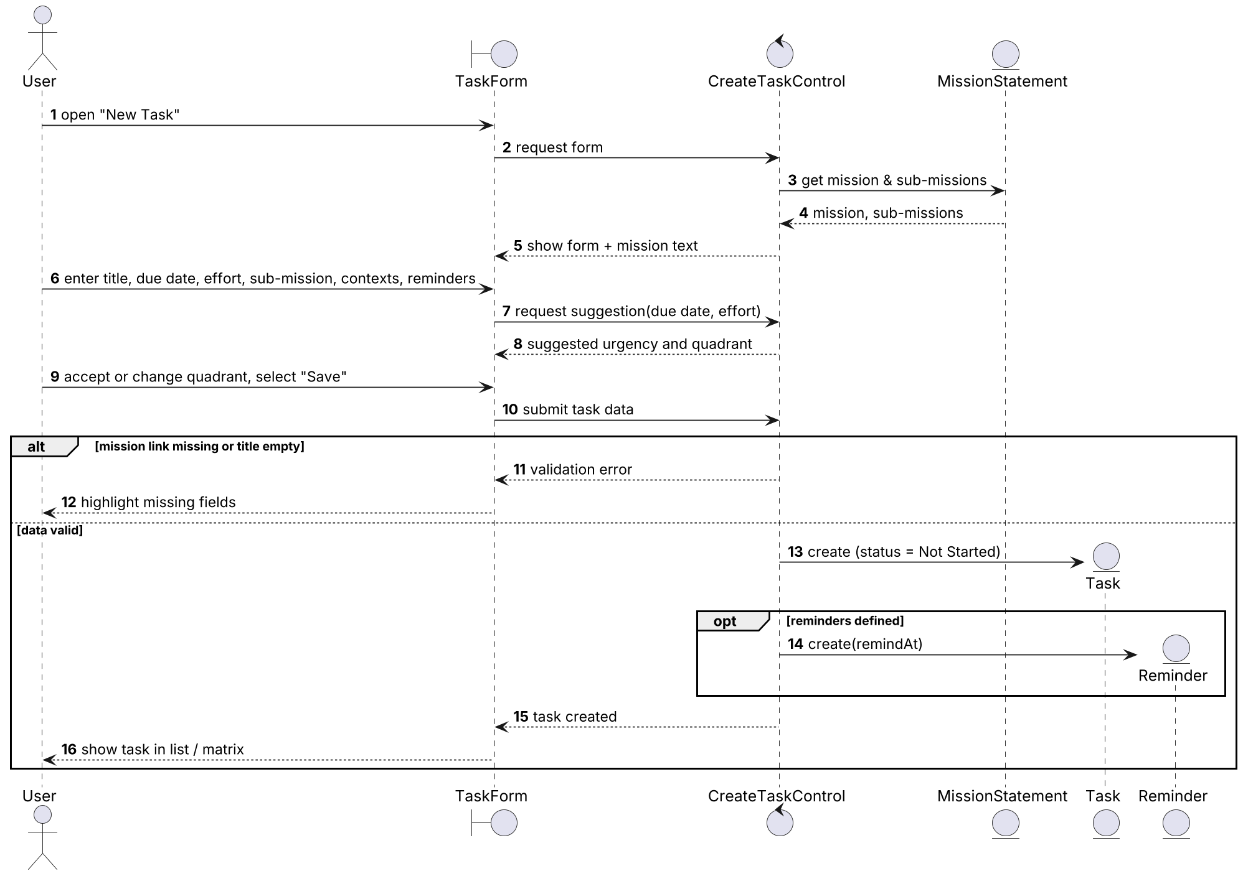
Figure 5: Sequence diagram - UC-5 Create Task
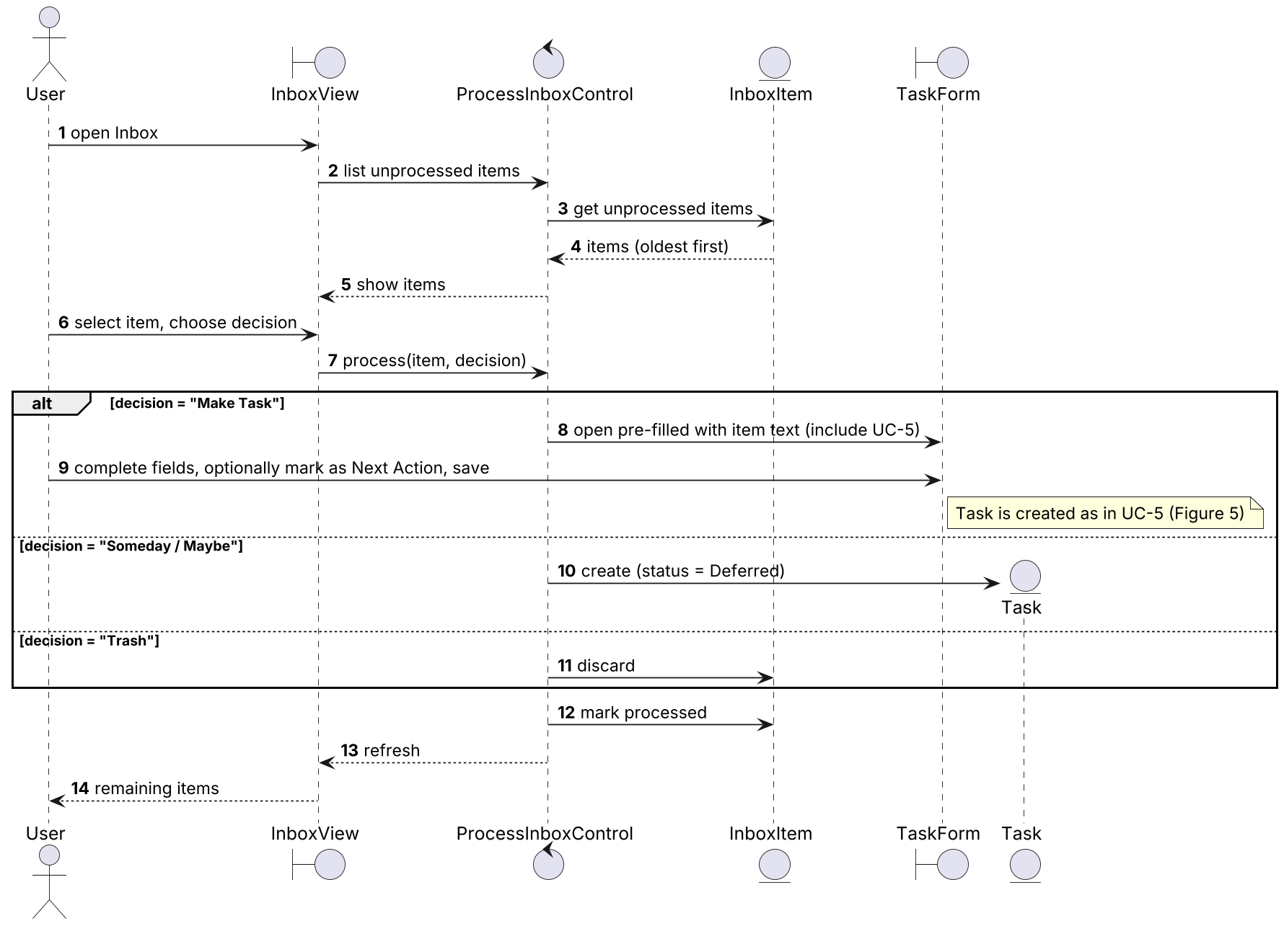
Figure 6: Sequence diagram - UC-11 Process Inbox
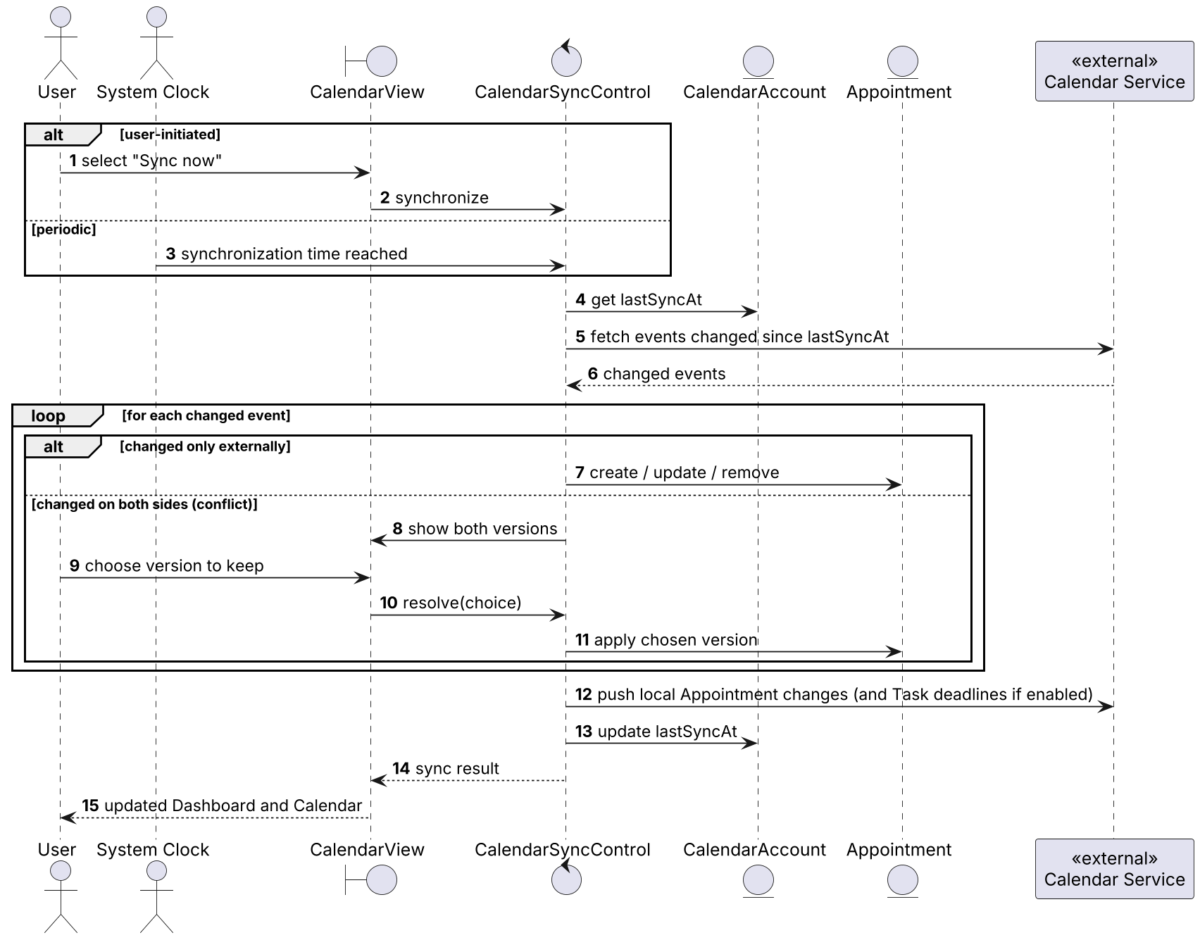
Figure 7: Sequence diagram - UC-13 Synchronize Calendar
A Task moves through the states below. The states correspond to the TaskStatus values (FR-42); "Archived" represents the archived flag (FR-18).
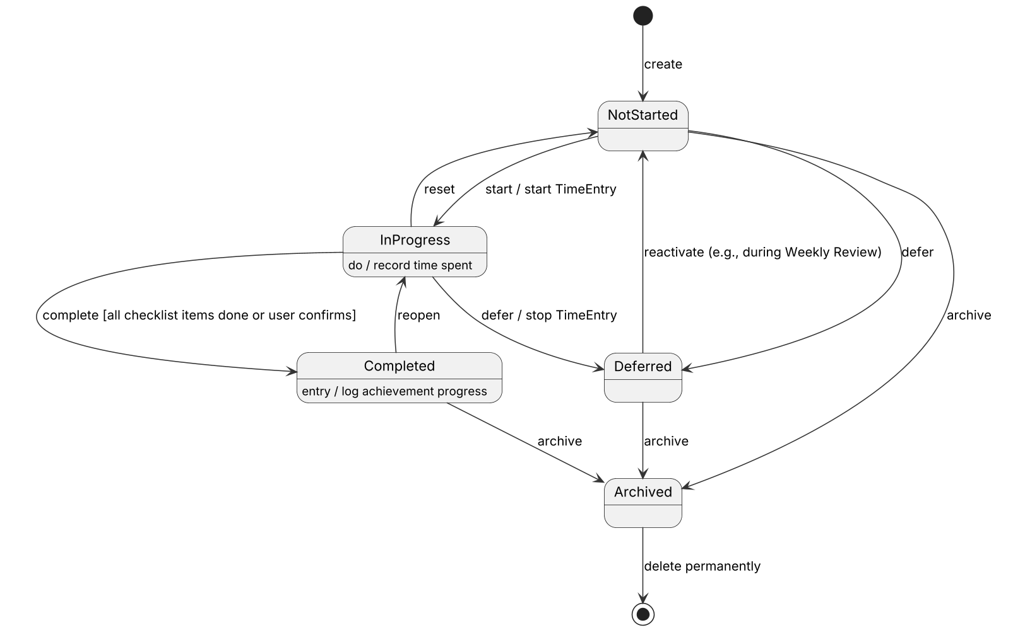
Figure 8: State machine diagram - Task
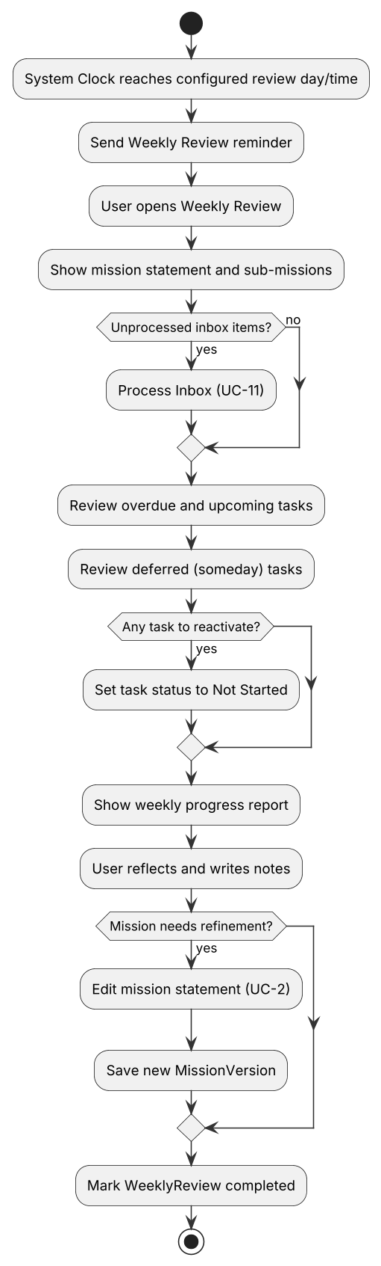
Figure 9: Activity diagram - UC-12 Perform Weekly Review

User interfaces and Mock-ups
The frontend of SPTM has already been implemented. Figure 10 shows the navigational paths between the screens, and Figures 11-14 show low-fidelity mock-ups of the main screens that describe their required content. Screen names are the boundary objects of the object model.
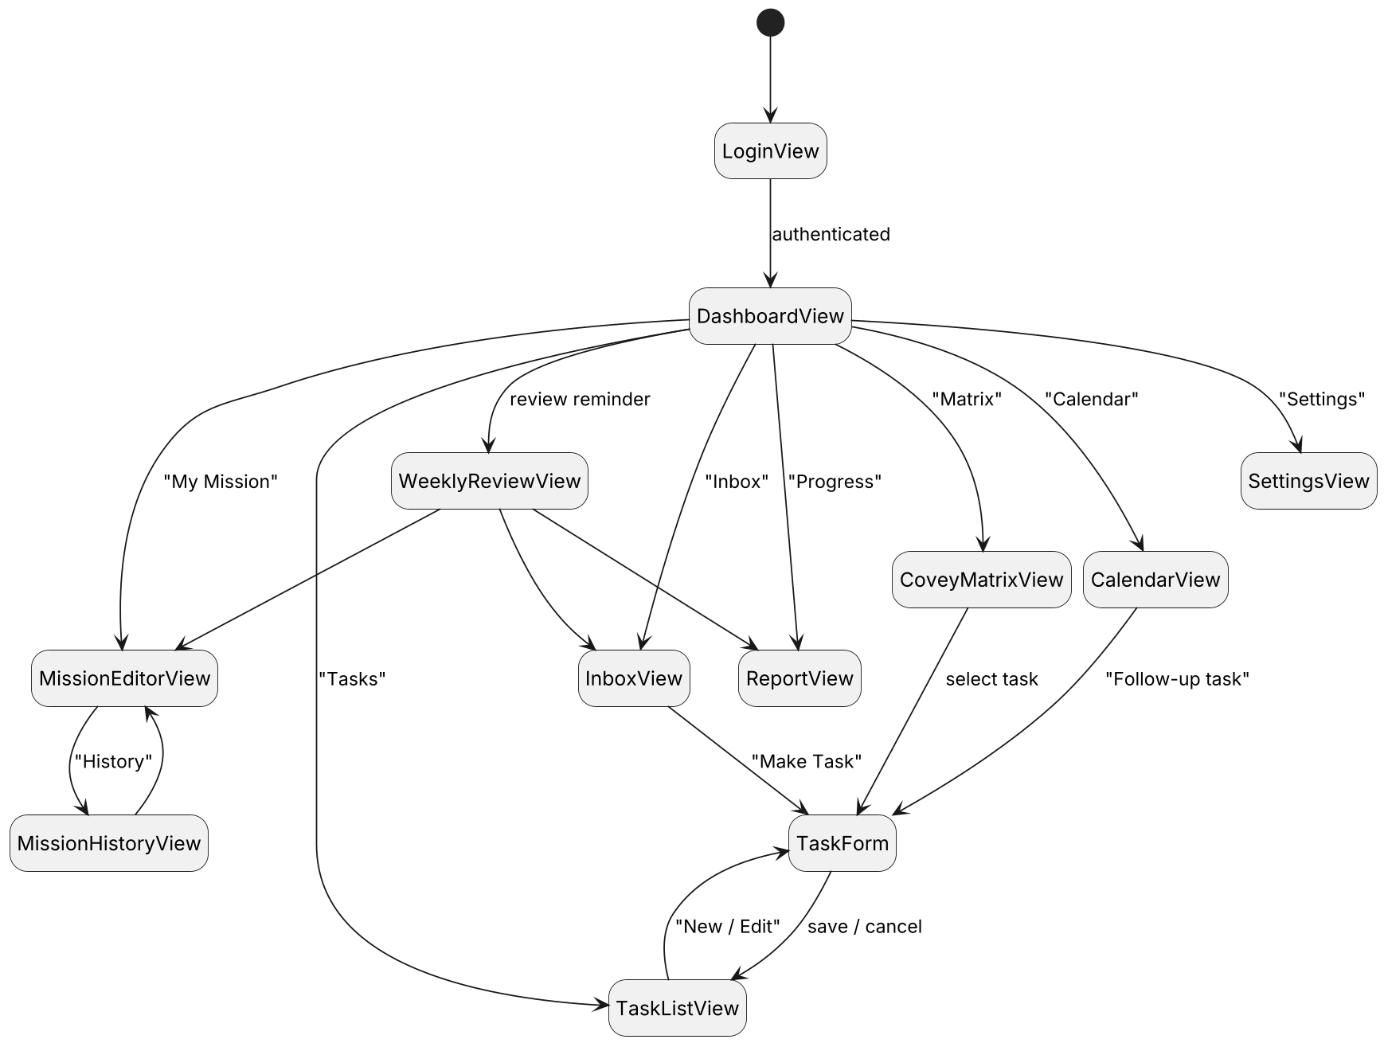
Figure 10: Navigational paths between screens
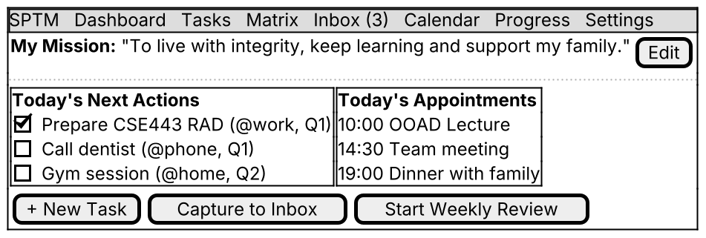
Figure 11: Mock-up - Dashboard (FR-10, FR-30, FR-41)
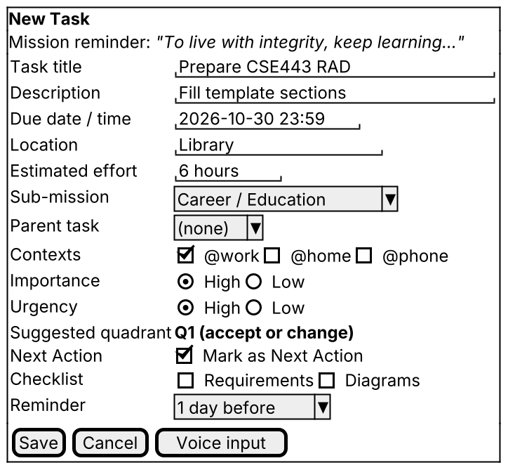
Figure 12: Mock-up - Task Form (FR-12, FR-15, FR-25, FR-28, FR-32, FR-47)
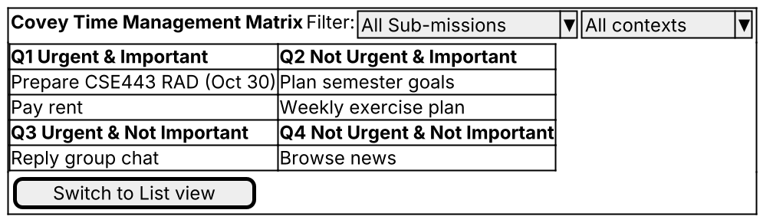
Figure 13: Mock-up - Covey Matrix view (FR-21, FR-24, FR-27)
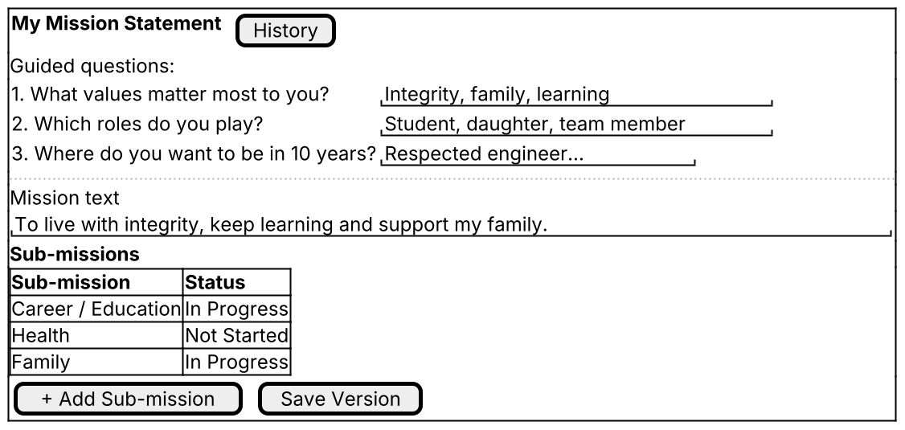
Figure 14: Mock-up - Mission Statement editor (FR-5 - FR-9)

Glossary of Terms
The following terms are used consistently in the requirements, use cases, domain model and user interface.
Table 7: Glossary of terms
Term | Definition
Mission Statement | A short personal text describing the User's values, roles and long-term aspirations; the "personal compass" in Covey's terms.
Mission Version | A saved earlier text of the Mission Statement, kept for reflection.
Sub-mission | A focus area or sub-goal of the Mission Statement (e.g., Health, Career). Called "sub-mission" or "focus area" in the problem statement.
Task | A single actionable item the User wants to do. A Task is always linked to the Mission Statement or a Sub-mission and may have subtasks.
Parent Task / Subtask | A larger Task (objective) and the smaller Tasks nested under it.
Checklist Item | A small step inside one Task that can be checked off.
Appointment | A time-bound event such as a meeting, stored in or synchronized with a calendar.
Covey Matrix | Time Management Matrix of Stephen Covey with four Quadrants based on urgency and importance.
Quadrant | One of Q1 Urgent & Important, Q2 Not Urgent & Important, Q3 Urgent & Not Important, Q4 Not Urgent & Not Important.
GTD | Getting Things Done, the productivity method of David Allen: capture, clarify, organize, reflect, engage.
Inbox / Inbox Item | The place where raw ideas are captured quickly before they are processed; an entry in it.
Next Action | The next physical, visible step that moves a Task forward (GTD).
Context | A GTD tag describing where or with what a Task can be done (e.g., @home, @work, @phone).
Someday / Maybe | GTD list of ideas not committed to now; represented by Tasks with status Deferred.
Weekly Review | A guided weekly session to process the Inbox, review Tasks and progress, and reflect on the Mission Statement.
Task Status | The status of a Task or Sub-mission: Not Started, In Progress, Completed or Deferred.
Achievement | A logged completion of a Task, Sub-mission or milestone.
Progress Report | Charts and statistics of completed Tasks and time spent over a period.
Reminder | A scheduled notification for a Task or the Weekly Review.
Synchronization | Keeping data identical between devices, the cloud and external calendars.
Dashboard | The start screen showing the Mission Statement, today's Next Actions, today's Appointments and the Inbox counter.
Preferences | The User’s settings: language, theme, default task view, weekly review day and time, and notification settings.
Time Entry | A recorded period of time spent on a Task, measured with the timer or entered manually.
Calendar Account | The User’s connection to one external calendar provider (Google Calendar, Apple Calendar or Outlook).
Calendar Service | The external calendar system that stores the User’s Appointments; an actor of the use case model.
System Clock | The timer actor that starts time-triggered use cases such as Reminders and periodic synchronization.

Priority
Requirements are prioritized with the MoSCoW scheme. Priorities were set according to how directly a requirement supports the core objective of the problem statement (linking daily Tasks to the Mission Statement and prioritizing them) and its dependency on other requirements.
Table 8: Priority levels
Priority | Meaning | Planned release
Must | Essential for the core purpose; the system is not acceptable without it. | Release 1 (course demo)
Should | Important and expected by the client, but the system is still usable without it for a short time. | Release 1 if time allows, otherwise Release 2
Could | Desirable improvement; implemented only if resources allow. | Release 2

Table 9: Priority of functional requirements (Must: 26, Should: 20, Could: 6)
ID | Priority | Requirement
FR-1 | Must | The system shall allow a person to register a User account with a name, an e-mail address and a password.
FR-2 | Must | When the User submits valid credentials, the system shall authenticate the User and display the Dashboard.
FR-3 | Must | If the User submits invalid credentials, then the system shall reject the login and display an error message that does not reveal which credential was wrong.
FR-4 | Should | The system shall allow the User to edit Preferences, namely language, theme, default task view, weekly review day/time and notification settings.
FR-5 | Must | When the User creates a Mission Statement for the first time, the system shall provide a guided interface that asks reflection questions about values, roles and long-term goals.
FR-6 | Must | The system shall allow the User to edit the text of the Mission Statement at any time.
FR-7 | Should | When the User saves a modified Mission Statement, the system shall store the previous text as a Mission Version with a version number and a timestamp.
FR-8 | Should | The system shall allow the User to view all Mission Versions of the Mission Statement in chronological order.
FR-9 | Must | The system shall allow the User to create, edit and remove Sub-missions linked to the Mission Statement, including Sub-missions nested under other Sub-missions.
FR-10 | Must | While the User is creating a Task or viewing a task list, the system shall display the Mission Statement or the related Sub-mission.
FR-11 | Should | If the User tries to remove a Sub-mission that still has linked Tasks, then the system shall require the User to reassign or archive those Tasks before the removal.
FR-12 | Must | The system shall allow the User to create a Task with a title, description, due date/time, location, estimated effort, Contexts and a related Mission Statement or Sub-mission.
FR-13 | Must | If the User submits a Task without a title or without a related Mission Statement or Sub-mission, then the system shall reject the Task and indicate the missing fields.
FR-14 | Could | Where voice input is available on the device, the system shall allow the User to dictate the title and description of a Task or the content of an Inbox Item.
FR-15 | Must | The system shall allow the User to create subtasks under a parent Task to form a task hierarchy of at least three levels.
FR-16 | Must | The system shall allow the User to modify any attribute of a Task, including its parent Task and its related Mission Statement or Sub-mission.
FR-17 | Should | The system shall allow the User to add, check, uncheck and remove Checklist Items within a Task.
FR-18 | Must | When the User archives a Task, the system shall remove the Task from active views and keep it retrievable in the archive.
FR-19 | Must | When the User requests the permanent deletion of a Task, the system shall ask for confirmation before deleting it.
FR-20 | Should | If a Task that is being archived or deleted has subtasks, then the system shall ask the User whether the operation also applies to the subtasks.
FR-21 | Must | The system shall display Tasks both in a list view and in a Covey Matrix view.
FR-22 | Must | The system shall allow the User to filter Tasks by Mission Statement/Sub-mission, Context, due date range and Task Status.
FR-23 | Should | The system shall allow the User to sort the task list by due date, Quadrant and creation date.
FR-24 | Must | The system shall classify every Task into exactly one of the four Quadrants of the Covey Matrix according to its importance and urgency.
FR-25 | Should | When the User creates or updates a Task that has a due date and an estimated effort, the system shall suggest an urgency value and a Quadrant for the Task.
FR-26 | Must | The system shall allow the User to override the suggested Quadrant of a Task.
FR-27 | Could | When the User moves a Task to another Quadrant in the Covey Matrix view, the system shall update the importance and urgency of the Task accordingly.
FR-28 | Must | The system shall allow the User to create, rename and delete Contexts (e.g., @home, @work, @phone) and to assign one or more Contexts to a Task.
FR-29 | Must | The system shall allow the User to capture an Inbox Item containing only free text from any main screen.
FR-30 | Should | The system shall display the number of unprocessed Inbox Items on the Dashboard.
FR-31 | Must | When the User processes an Inbox Item, the system shall allow the User to convert it into a Task, store it as a deferred (someday/maybe) Task, or discard it.
FR-32 | Should | The system shall allow the User to mark a Task as a Next Action and shall list all Next Actions grouped by Context.
FR-33 | Should | When the weekly review day and time configured in Preferences is reached, the system shall prompt the User to start a Weekly Review.
FR-34 | Should | While a Weekly Review is in progress, the system shall guide the User through processing the Inbox, reviewing overdue, upcoming and deferred Tasks, viewing the weekly Progress Report and reflecting on the Mission Statement.
FR-35 | Could | When the User completes a Weekly Review, the system shall store the Weekly Review with its completion time and the User's notes.
FR-36 | Must | The system shall allow the User to connect one or more external calendar accounts (Google Calendar, Apple Calendar, Microsoft Outlook).
FR-37 | Must | While a Calendar Account is connected and synchronization is enabled, the system shall synchronize Appointments bidirectionally with the external calendar.
FR-38 | Could | Where deadline export is enabled by the User, the system shall create or update an event in the connected calendar for each Task that has a due date.
FR-39 | Should | If an Appointment was changed both locally and in the external calendar since the last synchronization, then the system shall show both versions and let the User choose the version to keep.
FR-40 | Should | The system shall allow the User to create a follow-up Task from an Appointment, pre-filling its title and date and keeping a link to the Appointment.
FR-41 | Must | The system shall display the Appointments of the current day on the Dashboard together with the User's Next Actions.
FR-42 | Must | The system shall maintain for every Task and every Sub-mission a status that is one of Not Started, In Progress, Completed or Deferred.
FR-43 | Should | The system shall compute the progress of a Mission Statement, Sub-mission or parent Task as the ratio of completed linked Tasks to all non-archived linked Tasks.
FR-44 | Should | The system shall allow the User to start and stop a timer on a Task and to enter the time spent manually.
FR-45 | Should | When the User marks a Task or Sub-mission as completed, the system shall record an Achievement with the completion date in the achievement log.
FR-46 | Should | The system shall generate Progress Reports with charts showing completed Tasks, time allocation per Sub-mission and Context, and completion trends for a selected day, week or month.
FR-47 | Must | The system shall allow the User to define one or more Reminders for a Task, either relative to its due date or at an absolute time.
FR-48 | Must | When the time of a Reminder is reached, the system shall send a notification to all devices on which the User is signed in.
FR-49 | Could | If notifications are disabled in Preferences, then the system shall show due Reminders only inside the application.
FR-50 | Should | While the device has no network connection, the system shall allow the User to create, edit and process Tasks, Inbox Items and the Mission Statement using local storage.
FR-51 | Should | When network connectivity is restored, the system shall synchronize local changes with the cloud and with the User's other devices.
FR-52 | Could | The system shall allow the User to export his or her Tasks, Mission Statement, Mission Versions and Achievements in JSON or CSV format.

Non-functional requirements. NFR-3, NFR-6, NFR-7, NFR-9, NFR-16, NFR-20, NFR-25, NFR-26 and NFR-27 are Must; NFR-1, NFR-2, NFR-4, NFR-5, NFR-10, NFR-11, NFR-12, NFR-13, NFR-14, NFR-17, NFR-18, NFR-19, NFR-22, NFR-23, NFR-28 and NFR-29 are Should; NFR-8, NFR-15, NFR-21 and NFR-24 are Could.

Traceability
Each requirement is traced backward to the problem statement [1] and forward to use cases and domain classes. The problem statement sections are labelled as follows:
Table 10: Problem statement section labels
Label | Problem statement section (§ = section number in [1])
PS-O | §2 Objective Overview (mission compass, Covey grid, GTD Inbox / Next Actions / Contexts / Review, calendar, multi-platform, achievements)
PS-1.1 | §3.1 Mission Statement Management - Creation and Editing
PS-1.2 | §3.1 Mission Statement Management - Versioning and History
PS-1.3 | §3.1 Mission Statement Management - Mission Hierarchy
PS-1.4 | §3.1 Mission Statement Management - Visibility and Integration
PS-2.1 | §3.2 Task Operations (Create / Read / Update / Delete)
PS-2.2 | §3.2 Task Hierarchy and Mission Linkage
PS-2.3 | §3.2 Prioritization Methodologies (Covey matrix, suggestions, GTD contexts)
PS-2.4 | §3.2 Reminders and Alerts
PS-3.1 | §3.3 Calendar Sync
PS-3.2 | §3.3 View Integration
PS-4.1 | §3.4 Progress Tracking (status, time spent, checklists)
PS-4.2 | §3.4 Achievement Logs
PS-4.3 | §3.4 Reflection and Review (GTD Weekly Review)
PS-5.1 | §4.1 Database Design (core data, integrity rules)
PS-5.2 | §4.2 Connectivity and Synchronization - API Integrations
PS-5.3 | §4.2 Offline Functionality
PS-5.4 | §4.2 Security Considerations
PS-5.5 | §4.2 Cross-Platform Compatibility
PS-5.6 | §4.2 User Interface and Experience (dashboard, accessibility, voice)
PS-6 | §5 Challenges and Constraints

Table 11: Requirements traceability matrix (FR → problem statement, use cases, classes)
FR | Source (PS) | Use cases | Domain classes
FR-1 | PS-5.4 | UC-1 | User
FR-2 | PS-5.4 | UC-1 | User
FR-3 | PS-5.4 | UC-1 | User
FR-4 | PS-5.1 | UC-18 | Preferences
FR-5 | PS-1.1 | UC-2 | MissionStatement
FR-6 | PS-1.1 | UC-2 | MissionStatement
FR-7 | PS-1.2 | UC-2 | MissionStatement, MissionVersion
FR-8 | PS-1.2 | UC-4 | MissionVersion
FR-9 | PS-1.3 | UC-3 | SubMission
FR-10 | PS-1.4 | UC-5, UC-8, UC-19 | MissionStatement, SubMission
FR-11 | PS-5.1 | UC-3 | SubMission, Task
FR-12 | PS-2.1 | UC-5 | Task, Context
FR-13 | PS-2.2 | UC-5, UC-19 | Task, MissionStatement, SubMission
FR-14 | PS-2.1, PS-5.6 | UC-5, UC-10, UC-20 | Task, InboxItem
FR-15 | PS-2.2 | UC-5, UC-6 | Task
FR-16 | PS-2.1, PS-2.2 | UC-6, UC-19 | Task
FR-17 | PS-4.1 | UC-6, UC-15 | ChecklistItem
FR-18 | PS-2.1 | UC-7 | Task
FR-19 | PS-2.1 | UC-7 | Task
FR-20 | PS-5.1 | UC-7 | Task
FR-21 | PS-2.1 | UC-8 | Task
FR-22 | PS-2.1 | UC-8 | Task, Context, SubMission
FR-23 | PS-2.1 | UC-8 | Task
FR-24 | PS-2.3 | UC-9 | Task, Quadrant
FR-25 | PS-2.3, PS-6 | UC-5, UC-9 | Task
FR-26 | PS-2.3, PS-6 | UC-9 | Task
FR-27 | PS-2.3, PS-5.6 | UC-9 | Task
FR-28 | PS-2.3 | UC-5, UC-18 | Context, Task
FR-29 | PS-O | UC-10 | InboxItem
FR-30 | PS-O | UC-10 | InboxItem
FR-31 | PS-O | UC-11 | InboxItem, Task
FR-32 | PS-O, PS-2.3 | UC-8, UC-11 | Task, Context
FR-33 | PS-4.3 | UC-12, UC-17 | WeeklyReview, Reminder, Preferences
FR-34 | PS-4.3 | UC-12 | WeeklyReview, ProgressReport
FR-35 | PS-4.3 | UC-12 | WeeklyReview
FR-36 | PS-3.1, PS-5.2 | UC-13 | CalendarAccount
FR-37 | PS-3.1 | UC-13 | CalendarAccount, Appointment
FR-38 | PS-3.1 | UC-13 | Task, Appointment
FR-39 | PS-3.1, PS-6 | UC-13 | Appointment
FR-40 | PS-3.1 | UC-14 | Appointment, Task
FR-41 | PS-3.2 | UC-8 | Appointment, Task
FR-42 | PS-4.1 | UC-15 | Task, SubMission, TaskStatus
FR-43 | PS-2.2, PS-4.1 | UC-15, UC-16 | Task, SubMission, MissionStatement
FR-44 | PS-4.1 | UC-15 | TimeEntry
FR-45 | PS-4.2 | UC-15 | Achievement, Task, SubMission
FR-46 | PS-4.2 | UC-16 | ProgressReport
FR-47 | PS-2.4 | UC-5, UC-6 | Reminder
FR-48 | PS-2.4 | UC-17 | Reminder
FR-49 | PS-2.4 | UC-17, UC-18 | Reminder, Preferences
FR-50 | PS-5.3 | UC-5, UC-6, UC-10, UC-11 | Task, InboxItem, MissionStatement
FR-51 | PS-5.2, PS-5.3, PS-5.5 | UC-5, UC-6, UC-10, UC-11 | User
FR-52 | PS-5.4 | UC-18 | User

Table 12: Coverage of problem statement sections
PS | Functional requirements | Non-functional requirements
PS-O | FR-29, FR-30, FR-31, FR-32 | –
PS-1.1 | FR-5, FR-6 | –
PS-1.2 | FR-7, FR-8 | –
PS-1.3 | FR-9 | –
PS-1.4 | FR-10 | –
PS-2.1 | FR-12, FR-14, FR-16, FR-18, FR-19, FR-21, FR-22, FR-23 | –
PS-2.2 | FR-13, FR-15, FR-16, FR-43 | –
PS-2.3 | FR-24, FR-25, FR-26, FR-27, FR-28, FR-32 | –
PS-2.4 | FR-47, FR-48, FR-49 | –
PS-3.1 | FR-36, FR-37, FR-38, FR-39, FR-40 | –
PS-3.2 | FR-41 | –
PS-4.1 | FR-17, FR-42, FR-43, FR-44 | –
PS-4.2 | FR-45, FR-46 | –
PS-4.3 | FR-33, FR-34, FR-35 | –
PS-5.1 | FR-4, FR-11, FR-20 | NFR-17
PS-5.2 | FR-36, FR-51 | NFR-12, NFR-13, NFR-19
PS-5.3 | FR-50, FR-51 | NFR-6, NFR-7
PS-5.4 | FR-1, FR-2, FR-3, FR-52 | NFR-20, NFR-25 – NFR-28
PS-5.5 | FR-51 | NFR-22, NFR-23
PS-5.6 | FR-14, FR-27 | NFR-1 – NFR-5
PS-6 | FR-25, FR-26, FR-39 | NFR-1, NFR-5, NFR-7, NFR-25

Every problem statement section is covered by at least one requirement, every functional requirement is traced to at least one use case, and every use case (UC-1 to UC-20) is linked to one or more functional requirements (Table 5).

