Aluno: Matrícula:

**Teste: Como está seu inglês?**

Agora vamos ver como estão seus conhecimentos da língua inglesa. Leiam atentamente o texto abaixo e assinale a opção correta para cada questão.

**TEXTO 1**

A computer is a programmable machine that stores and retrieves data and performs high-speed logical and mathematical operations. However, it is not able to think. It accepts data and instructions as input, and after processing them, it outputs the results.

When we talk about computers, we have to consider the hardware and the software. The hardware consists of all the electronic and mechanical parts that make up a computer system, and the software is the collection of data and programs needed to solve problems with computers.

1. O melhor título para este Texto 1 seria:

a) The History of Computers

b) What is a Computer?

c) Hardware X Software

2. É uma ideia presente no texto:

a) o computador resolve problemas através do seu próprio raciocínio.

b) o *hardware* é mais importante para o computador do que o *software*.

c) o processamento de dados é composto de três etapas.

3. Do Texto 1, podemos inferir que:

a) o computador se presta a diversas aplicações por causa da sua versatilidade.

b) o computador está se tornando cada dia menor e mais barato.

c) o computador é a invenção humana que mais evoluiu nas últimas décadas.

4. “(...) the software is the collection of data and programs needed to solve problems with a computer.” (l. 6-7) A ideia contida na oração acima está associada a:

a) It basically consists of the system analysts, the programmers, the operators and the technical managers.

b) It is the collection of man-written solutions, as well as all documents to guide the operation of a computer.

c) It consists of several units: the CPU, the main memory, and the peripherals known as input and output devices.

5. No trecho selecionado para a questão 4, a palavra “programs” pode ser entendida como:

a) canais

b) jogos

c) instruções

6. A pergunta que pode ser respondida com base nas informações contidas no Texto 1 é:

a) Quem inventou o computador?

b) O que significa software?

c) O que é um dispositivo de entrada?

7. Existe equivalência de **classe gramatical** entre as palavras do par em:

a) programmable (l. 1) high-speed (l. 1)

b) however (l. 2) after (l. 3)

c) input (l. 3) outputs (l. 3)

8. A palavra de referência (à esquerda) corresponde à palavra a direita em:

a) that (l. 1) computer (l. 1)

b) them (l. 3) data and instructions (l. 2)

c) it (l. 3) mathematical operations (l. 2)

9. A opção na qual a palavra *computer* exerce a função de modificador é:

a) computer (l. 1)

b) computers (l. 4)

c) computer (l. 5)

10. **Não** existe oposição de sentido entre as palavras do par em:

a) logical (l. 2) mathematical (l. 2)

b) accepts (l. 2) outputs (l. 3)

c) input (l. 3) results (l. 3)

11. O melhor parágrafo para finalizar o Texto 1 seria:

a) Fourth-generation computers are rather faster than third-generation computers and can complete thousands of instructions at a time.

b) On the backside of the computer, there are several slots into which we can connect a wide range of peripherals.

c) In only a short time, the computer has changed the way in which many jobs are done and has become part of our everyday lives.

12. De acordo com o Texto 1 e com as informações abaixo, faça a correspondência entre as palavras (à esquerda) e as definições (à direita).

(01) computer game ( ) The study and development of computer systems, hardware and software

(02) computer graphics ( ) All of the hardware and software that can interact with a particular computer.

(03) computer science ( ) Charts, graphs, diagrams, or pictures produced with the aid of a computer.

(04) computer security ( ) A computer program designed for amusement or instruction.

(05) computer system ( ) The process of protecting a computer system from access by virus or unauthorized person.

13. Os fatos abaixo estão relacionados com a história do computador. Numere-os de 1 a 5, partindo do mais antigo para o mais recente.

( ) In the 17th and 18th centuries, many ways of calculating were invented.

( ) The first analog computer was used in World War II.

( ) The primitive calculating device was the fingers of a man’s hands.

( ) Howard Aiken invented the first digital computer, called Mark I.

( ) The first real calculating machine appeared in 1820.

14. Identifique as partes e componentes do computador abaixo:

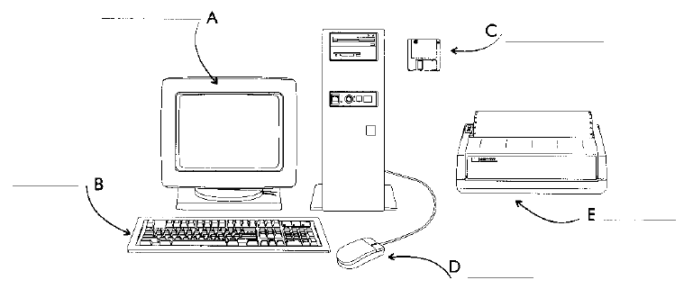

15. Complete a coluna de exemplos da tabela abaixo com as partes identificadas na da questão anterior.

|  |  |  |
| --- | --- | --- |
| TYPE | DESCRIPTION | EXAMPLE |
| Storage devices | Provide permanent storage for data and programs | a) |
| Input devices | Enable data to go into the computer’s memory | b)  c) |
| Output devices | Enable users to extract information from the system | d)  e) |

16. A oração que melhor resume as ideias contidas no Texto 1, na Figura e na Tabela é:

a) Most computers are equipped with data communication facilities.

b) Computers are also used in education and business.

c) A computer is not only a machine but also a system.