MascoTier

* Background: #2f3243
* Title (MascoTier): #fdfdfb
* Slogan: #749dd0
* Owner button: #75a8f2
* Carer button: #caebb3
* Navbar: transparent
* Navbar content: #fdfdfb
* a: hover: #75a8f2

SIGN UP

* form div: #fdfdfb

* letter color: #3f434a

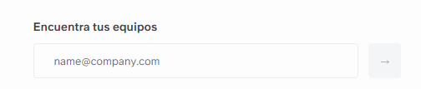

* Already have account: transparent background / #fdfdfb
* Footer: transparent/ same design as the navbar

Log In

Same design as the sign up

Add Pet

Same design as the sign up but

* Different background(optional)

Profile edit

Same design as the sign up

Carer List

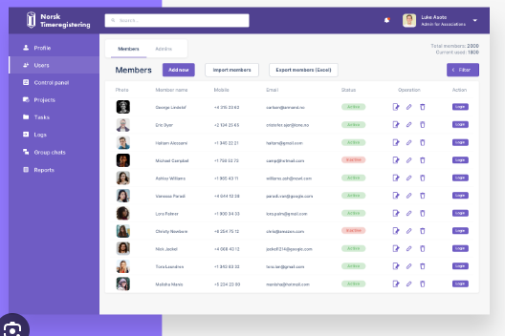

* letter color: #3f434a
* filter button: #75a8f2
* filter background: #fdfdfb

Carers History

Same design as the carer list

Imbox

* Div container: background transparent / #1f1f1f
* Letter: #fdfdfb
* Row: hover : background #B4B4B8
* Row: click: background: #0B60B0
* Sidebar: backgound : #B4B4B8
* Sidebar element: click: background #EFECEC
* Mail div : transparent
* Button: #75a8f2

Open requests

* Div container: background transparent / #1f1f1f
* Letter: #fdfdfb
* Row: hover : background #B4B4B8
* Row: click: background: #0B60B0
* Chat Button: #75A8F2

CHATS

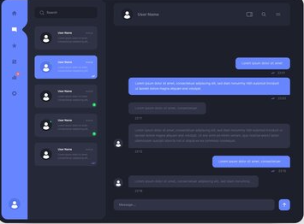

* Elemet:click : : #75A8F2
* Letter Color of the sender’s: #75A8F2
* Letter color of the recipient: #B4B4B8