SCRS/09/ 187

An Example of the use of Management Strategy Evaluation for North Atlantic Albacore, using Multifan-CL and FLR.

Laurence T. Kell, Paul De Bruyn Maria Soto Ruiz and Haritz Arrizabalaga²

SUMMARY

An example of undertaking a Management Strategy Approach based upon MULTIFAN-CL is presented for North Atlantic albacore.

KEYWORDS

Albacore, FLR, Harvest Control Rules, Precautionary Approach , Management Strategy Evaluation MultiFan-CL

- Introduction
The conventional process for providing scientific management advice is the selection of a current “best” assessment and then to recommend a management measure such as a Total Allowable Catch (TAC) based upon biological reference points, e.g. the maximum sustainable yield (MSY) or associated spawning stock biomass (B_{MSY}) and fishing- mortality (F_{MSY}). However, scientific advice and management is often performed in a fairly ad-hoc manner and does not account for all the uncertainty involved. Also stock assessment often requires a time-consuming re-evaluation of data to produce advice that may deviate considerably from one year to the next. Therefore the FAO Technical Consultation on the Precautionary Approach to Capture Fisheries (FAO 1996) recommended the use of decision (or harvest control) rules as one of the elements of the precautionary approach to fishery management. These rules should “specify in advance what actions should be taken when specified deviation from the operational targets and constraints are observed” and should be able to “[respond] to unexpected or unpredictable events with minimum delay”. Although harvest control rules have been widely used to provide fisheries management advice, and may include several precautionary elements, it does not necessarily follow that they will be precautionary in practice (Kirkwood and Smith 1996). This is because most harvest control rules are not evaluated formally to determine the extent to which they achieve the goals for which they were designed, given the uncertainty inherent in the system being managed (Punt 2006). Simulation is increasingly being used as a means to perform these evaluations (Kirkwood and Smith 1996, Cooke 1999, McAllister et al. 1999, Sainsbury et al. 2000) since management regulations can then be formally evaluated, given the uncertainty inherent in the system being managed, to determine the extent to which they achieve the goals for which they were designed (Punt, 2006).
Therefore the development of management procedures (MPs) (Butterworth and Punt, 1999) and the use of management strategy evaluation (MSE) (Smith et al., 1999) are becoming more widely used in fishery management because they provide formalisations of longterm, robust strategies that are designed to satisfy multiple conflicting objectives (Rademeyer et al. 2007). In a Management Strategy Evaluation (MSE) complex models are used primarily to test the robustness of simpler assessment–management rules before implementation, by conducting computer-based experiments that embody how the whole system reacts to a variety of possible management actions. Population and fleet dynamics are deduced from a range of plausible hypotheses and available data sets, rather than being based on a singular set of assumptions, because the objective is to develop strategies that are robust to our uncertainty about the “true” dynamics and, hence, to meet the requirements of the precautionary approach to fisheries management adopted by FAO (1996).
Therefore in this paper we provide an example of using the Management Strategy Approach based upon MULTIFAN-CL. The Management Strategy Evaluation (MSE) for albacore is developed from a Multifan-CL assessment (ref) using the FLR open source software framework (Fisheries Library for R, http://www.flr-project.org, Kell et al. 2007). using FLR (Fisheries Library for R, http://www.flr-project.org Kell et al. 2007). A benefit of using FLR is that it is designed to conduct Management Strategy Evaluation (MSE) and can be used to evaluate alternative measures with respect to a range of management objectives, regulations and stock assessment methods under a variety of assumptions about resource and fishery dynamics (Fromentin and Kell, 2007, Tserpes et al. 2009). All code is available at the google code project http://code.google.com/p/mse4mfcl/ . The intention is to show the advantages of the approach rather than to provide management advice. Although after agreeing appropriate stock hypotheses and management measures to be evaluated management advice could be provided.

- Material and methods
  - Data
The 2009 assessment of North Atlantic albacore was conducted using Multifan-CL, four scenarios were agreed by the species group to be plausible, these were runs 4B, 4G, 4H and 4N. 4B was identical to the base case assessment in the last assessment (SCRS-09-108); 4G was a variant on 4B where catchability was constrained to be constant over time (although still allowing for seasonal variability); 4H included an age-specific vector of natural mortality calculated using the method of Chen and Watanabe (1988) and the Von Bertalanffy parameters of Bard (1981); while 4N allowed selectivity to be calculated independently for each fishery.
The effect of the robustness of advice was also evaluated by comparing 2007 assessment to 2009. There is also lack of knowledge on biology and while the maturity vector used by the species group assumed 50 % mature at age 5 and 100% from age 6 onwards papers on maturity from other oceans, Indian and Pacific show 50% maturity at age 4 and 100% at 5 and onwards. Therefore an additional scenario was considered that assumed the later maturity ogive.
  - Methods
The three main elements of a MSE are:
i) Operating Model (OM), that represents alternative plausible hypotheses about stock and fishery dynamics, allowing integration of a higher level of complexity and knowledge than is generally used within stock assessment models;
ii) The Management Procedure (MP) or management strategy which is the combination of the available pseudo-data, the stock assessment used to derive estimates of stock status and the management model or Harvest Control Rule (HCR) that generates the management outcomes, such as a target fishing mortality rate or Total Allowable Catch; and
iii) Observation Error Model (OEM) that describes how simulated fisheries data, or pseudo-data, are sampled from the Operating Model.
All terminology employed here is based upon that of Rademeyer et al. (2007).
An important aspect of MSE is that the management outcomes from the HCR are fed back into the operating model so that their influence on the simulated stock and hence on the future simulated fisheries data is propagated through the stock dynamics (Figure 1).
The success of the MSE approach depends on the extent to which the true range of uncertainty can be identified and represented in operating models. Several authors (e.g. Rosenberg and Restrepo 1994, Francis and Shotton 1997, Kell et al. 2007) have attempted to identify and categorize the uncertainties that can hinder attempts to manage fisheries (and other natural resources) successfully. These uncertainties include the following:

- process error – natural variation in dynamic processes such as recruitment, somatic growth, natural mortality, and the selectivity of the fishery;
- observation error – related to collecting data from a system (e.g. age sampling, catches, surveys);
- estimation error – related to estimating parameters, both in the operating model, and, if a model-based management procedure is used, in the assessment model within the management procedure that leads to the perception of current resource status;
- model error – related to uncertainty about model structure (e.g. causal assumptions of the models), both in the operating model and in the management procedure; and
- implementation error – because management actions are never implemented perfectly and may result in realized catches that differ from those intended.

  - Operating model
A main objective of this study is to use MULTIFAN-CL to explore alternative plausible hypotheses about stock and fishery dynamics using a simulation framework to evaluate the robustness of alternative management advice based upon stock assessment as provided by ICCAT. The OM was constructed on the basis of the age-structured equation:
The MULTIFAN-CL stock assessment was used to construct a simulation model on the basis of the age-structured equation:
N_{a,t} = N_{a-1,,t-1} e^{-Za-1,t-1}
where N_{a,t} is the number of fish of age a at time t, and Z_{a,t} is the total mortality from age a–1 to age a. Z_{a,t} = M_{a} + F_{a,t}, where M_{a} is the natural mortality at age a and F_{a,t} is the fishing mortality at age a in year t. A Beverton and Holt stock recruitment relationship (Beverton and Holt, 1956) was assumed to close the life cycle, parameters were taken from the MULTIFAN-CL assessments.
Uncertainty was incorporated in the OM, by assuming historic uncertainty in the recruitment deviates estimated by Multifan-CL based upon the correlation matrix Figure 2. In addition it was assumed that historically the fishery had been effort limited and that fishing mortality was a product of effort, catchability and selection pattern, uncertainty was modelled by assuming catchability had a log normal distribution with a CV of 30%.
The resulting uncertainty in historical stock trends are presented in figure 3.
    - Management Procedure
The Management Procedure (MP) is the specific combination of: (i) the sampling regime, (ii) the stock assessment method, (iii) the biological reference points and (iv) the management strategies. Here a simple HCR was consider, each year an assessment, based upon Virtual Population Analysis (VPA), was conducted and the current stock status and biological reference points estimated. Then the catch that would be equivalent to a fishing mortality of F_{0.1} in the quota year was calculated and set as next year´s TAC.
    - Observation error model
The sampling regime, modelled by the Observation Error Model, corresponds to the collection of commercial catch data, the derivation of catch numbers-at-age and catch per unit effort (CPUE) and the estimation of biological parameters such as which growth, maturity and natural mortality-at-age. These data are generated by
In this example a single index of abundance covering ages 1 to 14 was modelled sampling, sampling error was modelled by assuming a lognormal distribution with a CV of 30%. Catch and biological parameters were assumed to be know exactly.
    - Software
Modelling was performed using the open source R statistical environment available from cran.r-project.org. The actual code, data and this manuscript used are all available as part of a google project at http://code.google.com/p/mse4mfcl/. The project can be accessed by non members who may check out read-only working copies or by project members to allow changes to be made, see http://code.google.com/p/glmscrs/source/checkout for more details. The project is managed using subversion and under windows TottoiseSVN provides an easy to use user interface; see http://code.google.com/p/mseflr/wiki/UsingTortoiseSVN for a guide on how to use tortoise.
Routines in R to read, manipulate, write, analyze, and plot the MFCL input and output files are available at http://code.google.com/p/r4mfcl/ which is based on original work by Pierre Kleiber of the US National Marine Fisheries Service, and Adam Langley and John Hampton of the SPC. The FLR framework is available to www.flr-project.org.

- Results
Results are presented for deterministic runs for the six scenarios in figure 5, this shows historic stock estimates (prior to 2008) and projections based upon a fishing mortality of F_{MSY} subsequently. Historically the biggest difference is due to the 2007 (blue) and 2009 assessment.

Time series of recruitment, SSB, yield and fishing mortality for each of the assumed future recruitment scenarios, TAC levels correspond to 20,000 tonnes to 36,000 tonnes in increments of 2000 tonnes are presented in, Figure 6a & b. The same results are then presented in the form of Kobe plots in Figures 7a & b, the axes correspond to fishing mortality relative to F_{MSY} and SSB relative to B_{MSY} The green quadrant corresponds to the stock being above B_{MSY} and harvesting at less than F_{MSY.} While the red quadrant to the stock being below B_{MSY} and harvesting at greater than F_{MSY} and the yellow quadrants to the stock being either below B_{MSY} or harvesting at greater than F_{MSY}. The black line corresponds to the median of historical estimates, the grey to the median of projected estimates and the points to individual realisations at the end of the projection period (2020), white correspond to the 50th bi-variate percentile. Individual panels correspond to the different TAC levels (20,000 tonnes starting in the top left hand panel then increasing TACs going left to right across columns).

- Discussion
This paper provides an example of an MSE for North Atlantic Albacore based upon the most recent assessment. Such an approach can be used to develop robust management given the inherent uncertainty in fisheries systems and to help identify the relative benefits of different data collection, assessment and management regimes and their performance in meeting management objectives.

The approach can also be used to help develop management for stocks for where advice is currently lacking. For example although recent assessments are available for Northern and Southern Albacore no assessment is available for the Mediterranean stock and so it is not known whether the stock is subject to overfishing or has not been over-fished. In the case of the 2007 TAC levels set for northern and southern albacore these appear to be above those recommended by the SCRS and may not lead to the recovery to B_{MSY}. In this case the review Panel recommended that harvest strategies be developed to ensure that fisheries reach and remain at B_{MSY}.

The approach can also be used to integrate uncertainty about stock d
ynamics, current stock status and implementation of management measures if management objectives are expressed in the form of a utility function (see Ma¨ntyniemi et al 2009 for an example). The value of new information,
potentially resulting in new control measures, is high if the information is expected to help in differentiating between the expected
consequences of alternative management actions. Conversely, the value of new information is low if there is already great certainty
about the state and dynamics of the stock and/or if there is only a small difference between the utility attached to different potential
outcomes of the alternative management action. The approach can, therefore, help when deciding on the allocation of resources
between obtaining new information and improving management actions.

6. References
Anon, (2008). Report of the 2007 ICCAT Albacore Stock Assessment Session (Madrid, Spain, July 5 to 12, 2007) . Col. Vol. Sci. Pap. Vol. 62, No. 3: 607-815. (SCRS/07/015).
Bard, F.X. 1981. Le thon germon (Thunnus alalunga) de l’Océan Atlantique. PhD Thesis presented at the University of Paris, 333 p.
Beverton, R.J.H., and Holt, S.J., 1957. On the dynamics of exploited fish populations. Fish. Investig. London Ser. 2. No. 19.
Butterworth, D.S. and A.E. Punt 1999 – Experiences in the evaluation and interpretation of MPs. In Confronting Uncertainty in the Evaluation and Implementation of Fisheries-Management Systems. Payne, A.I.L. (Ed.). ICES J. mar. Sci. 56: 985-998.
Chen, S. and S. Watanabe, 1989. Age dependence of natural mortality coefficient in fish population dynamics. Bull. Japan. Soc. Sci. Fish, 55/2), 205-208.
Cooke, J.G. 1999 – Improvement of fishery-management advice through simulation testing of harvest algorithms. In Confronting Uncertainty in the Evaluation and Implementation of Fisheries-Management Systems. Payne, A.I.L. (Ed.). ICES J. mar. Sci. 53: 797-810.
FAO 1996 – Precautionary approach to capture fisheries and species introductions. Elaborated by the Technical Consultation on the Precautionary Approach to Capture Fisheries (Including Species Introductions). Lysekil, Sweden, 6-13 June 1995. FAO Technical Guidelines for Responsible Fisheries. No. 2. FAO, Rome.
Francis, R.I.C.C. and Shotton, R., 1997. ‘Risk’ in fisheries management: a review. Can. J. Fish. Aquat. Sci. 54: 1699-1715.
Fromentin, J.M., Kell, L.T., 2007. Consequences of variations in carrying capacity or migration for the perception of Atlantic bluefin tuna population dynamics. Canadian Journal of Fisheries and Aquatic Science 67, 627-836.
Kell, L.T., Mosqueira, I., Grosjean, P., Fromentin, J-M., Garcia, D., Hillary, R., Jardim, E., Mardle, S., Pastoors, M.A., Poos, J.J., Scott, F. and Scott. R.D., 2007. FLR: an open-source framework for the evaluation and development of management strategies. ICES Journal of Marine Science 64:640-646.
Kirkwood, G.P. and Smith, A.D.M., 1996. Assessing the precautionary nature of fishery management strategies. In Precautionary Approach to Fisheries, Part 2: Scientific Papers. FAO Fisheries Technical Paper 350/2: 141-158.
Ma¨ntyniemi, S., Kuikka, S., Rahikainen, M., Kell, L. T., and Kaitala, V. 2009. The value of information in fisheries management: North Sea herring as an example. – ICES Journal of Marine Science, 66: 000–000.
McAllister, M.K., Starr, P.J., Restrepo, V.R. and G.P. Kirkwood 1999 – Formulating quantitative methods to evaluate fishery-management systems: what fishery processes should be modelled and what trade-offs should be made? In Confronting Uncertainty in the Evaluation and Implementation of Fisheries-Management Systems. Payne, A.I.L. (Ed.). ICES J. mar. Sci. 56: 900-916.
Punt, A. E. 2006. The FAO Precautionary Approach after almost 10 years: Have we progressed towards implementing simulation-tested feedback-control management systems for fisheries management? Natural Resource Modelling, 19: 441-–464.
Rademeyer, R.A., Plaga´nyi, E.E., and Butterworth, D.S., 2007. Tips and tricks in designing management procedures. ICES Journal of Marine Science, 64: 618-625.
Rosenberg, A.A. and Restrepo, V.R., 1994. Uncertainty and risk evaluation in stock assessment advice for U.S. marine fisheries. Can. J. Fish. Aquat. Sci. Vol. 51 (12), pp. 2715-2720.
Sainsbury, K.J., Punt, A.E. and Smith, A.D.M., 2000. Design of operational management strategies for achieving fishery ecosystem objectives. ICES J. Mar. Sci. 57: 731-741.
Smith, A.D.M., Sainsbury, K.J. and R.A. Stevens 1999 – Implementing effective fisheries-management systems – management strategy evaluation and the Australian partnership approach. In Confronting Uncertainty in the Evaluation and Implementation of Fisheries-Management Systems. Payne, A.I.L. (Ed.). ICES J. mar. Sci. 56: 967-979.
Tserpes,G., Tzanatos,E., Peristeraki,P., Placenti,V. and Kell, L.T. 2009. A bio-economic evaluation of different management measures for the Mediterranean swordfish. Fisheries Research, Volume 96, Issues 2-3, March 2009, Pages 160-166

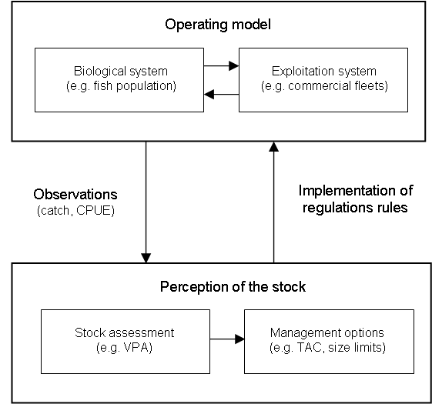

Figure 1. Conceptual framework of the simulation model.

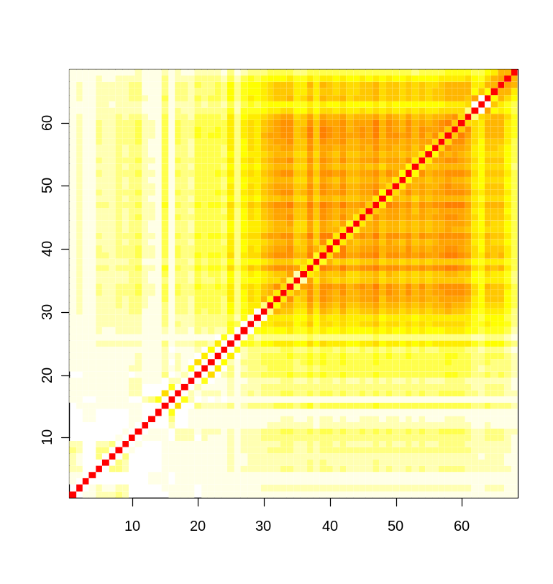
Figure 3. Correlation matrix for estimates of recruitment deviations, axis represent years from start of time series.

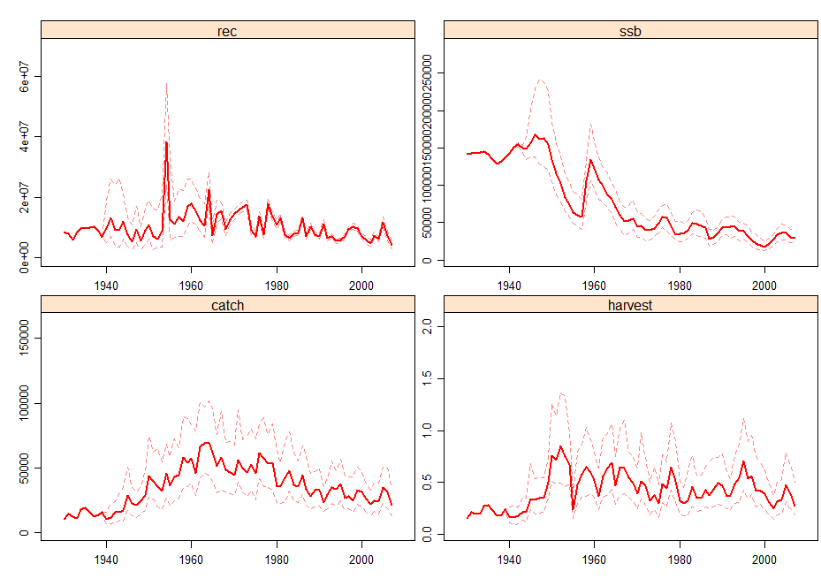
Figure 4. Historic trends in run 4B, assumming historic uncertainty in recruitment and catchability, thick line represents medians, dashed the inter quartile range.

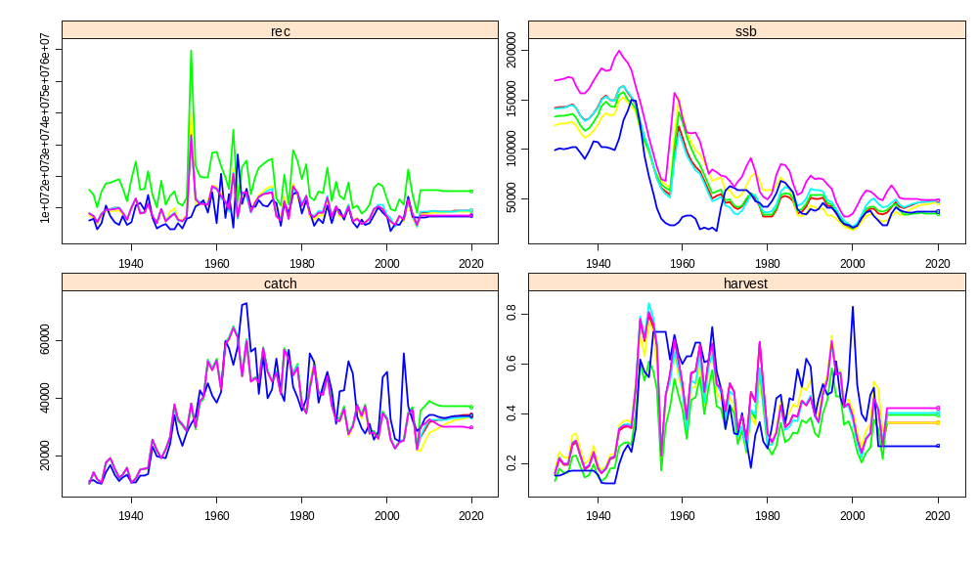Figure 5. Historic stock estimates (prior to 2008) and projections for the six scenarios based upon a fishing mortality of F_{MSY}. Scenarios are 4B (red), 4G (yellow) 4H (green) 4N (cyan), New maturity (blue), 2007 assessment (violet)
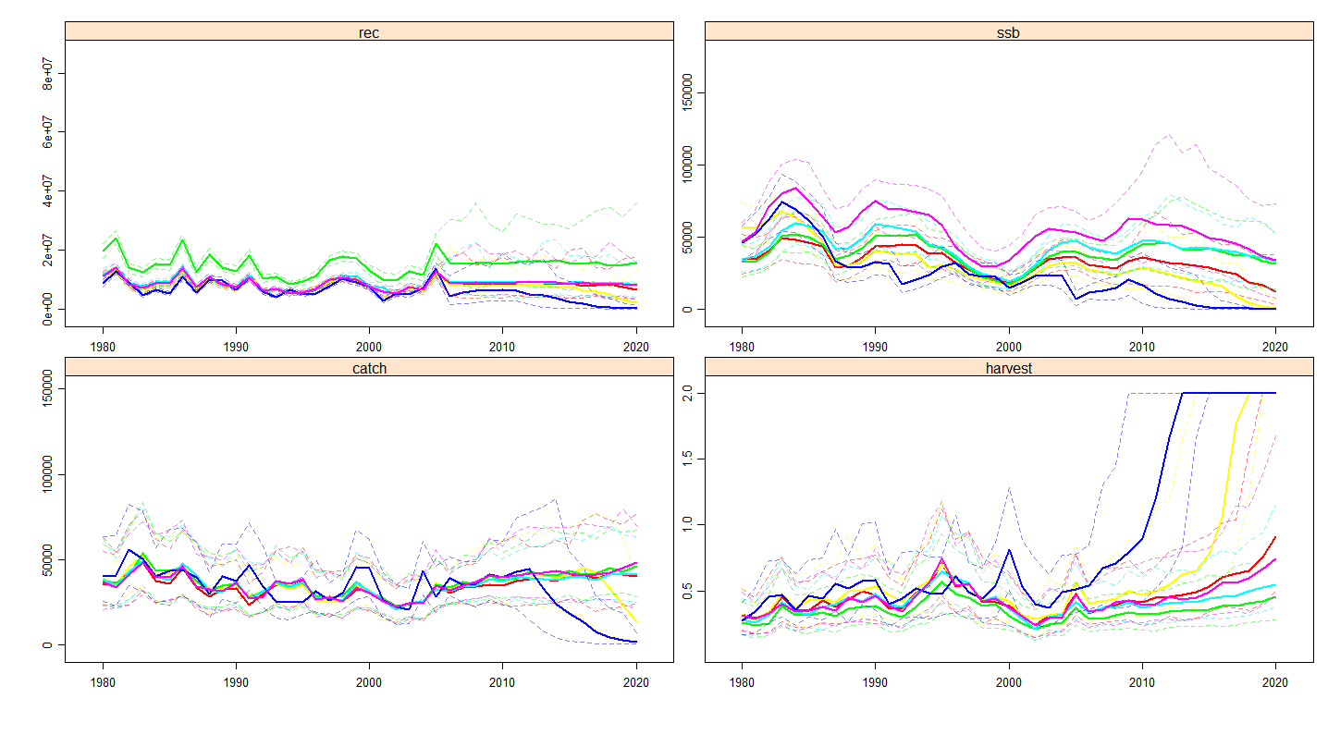 Figure 6. Historic time series (prior to 2006) with projections based upon a TAC equivalent to a fishing mortality of F_{0.1}.as estimated by the management procedure.
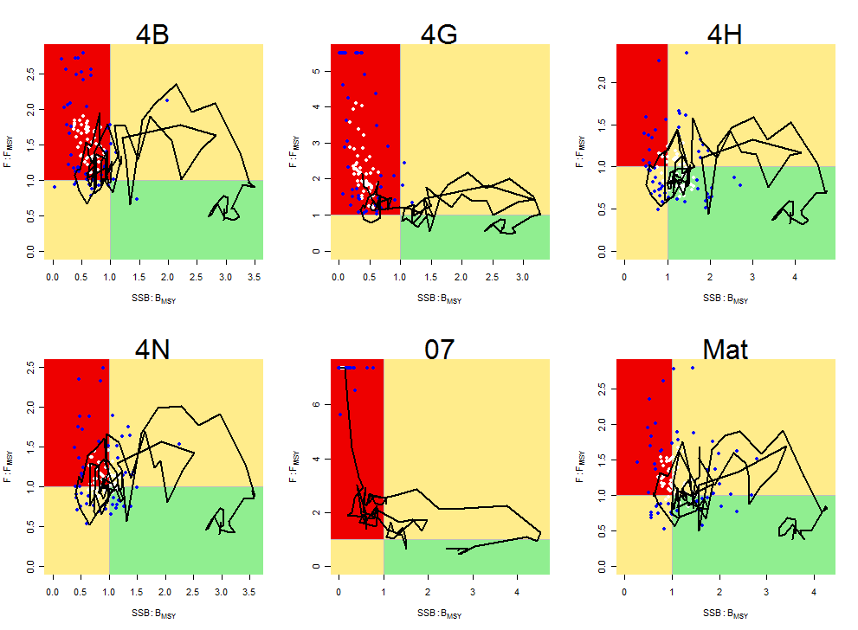
Figure 7. “Kobe plots” by scenario; points show individual realisations in 2015 and lines the median stock trajectories for historic and projected periods (black and grey respectively). Quadrants are defined for the stock amd fishing mortality relative to B_{MSY} and F_{MSY}; i.e. red SSB<B_{MSY} and F>F_{MSY}, green red SSB≥B_{MSY} and F≤F_{MSY} yellow otherwise.

ICCAT Secretariat, C/Corazón de María, 8. 28002 Madrid, Spain; Laurie.Kell@iccat.int; Phone: 34 914 165 600 Fax: 34 914 152 612.
AZTI - Tecnalia / Unidad de Investigación Marina. Herrera kaia portualdea z/g . 20110 Pasaia (Gipuzkoa)
IEO Secretariat, C/Corazón de María, 8. 28002 Madrid, Spain

