My Research Document

Iago Pinal-Fernandez

2024-10-28

## Introduction

This document discusses various experiments and their results. We will refer to several figures and tables throughout the text.

In Experiment 1, we can see the results in Figures 1-4 and Figure 2. Also, here we illustrate an important finding (Figures 1, 3-4, Table 1, Supplementary Figure 1, Supplementary Tables 1-2).

The analysis is summarized in Table 2 and detailed further in Table 3.

Supplementary details can be found in Supplementary Figure 2 and Supplementary Table 3.

In addition to the figures and tables, further reading can be found in references Pinal-Fernandez et al. (2024), and Selva-O’Callaghan et al. (2018). These references discuss the theoretical background and related work in this field.

## Results

The results show a significant improvement when comparing different methods. Figure 1 and Figure 2 highlight the trends observed.

Moreover, Table 2 and Table 3 provide comprehensive data supporting these findings.

See Table 2.

## Conclusion

The figure-tables-formatter filter automatically manages the figures, tables, and supplementary materials. Placeholders are used to insert these elements in the correct order and location:

The filter ensures clear and concise management of references and visual elements.

## Tables and Figures

Table 2. Results.

| Col1 | Col2 | Col3 |
| --- | --- | --- |
| A | B | C |
| E | F | G |
| A | G | G |

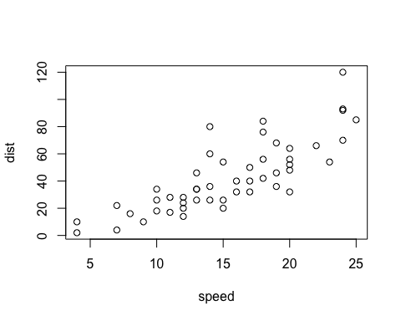

Figure 1. More data.

## Supplementary Figures

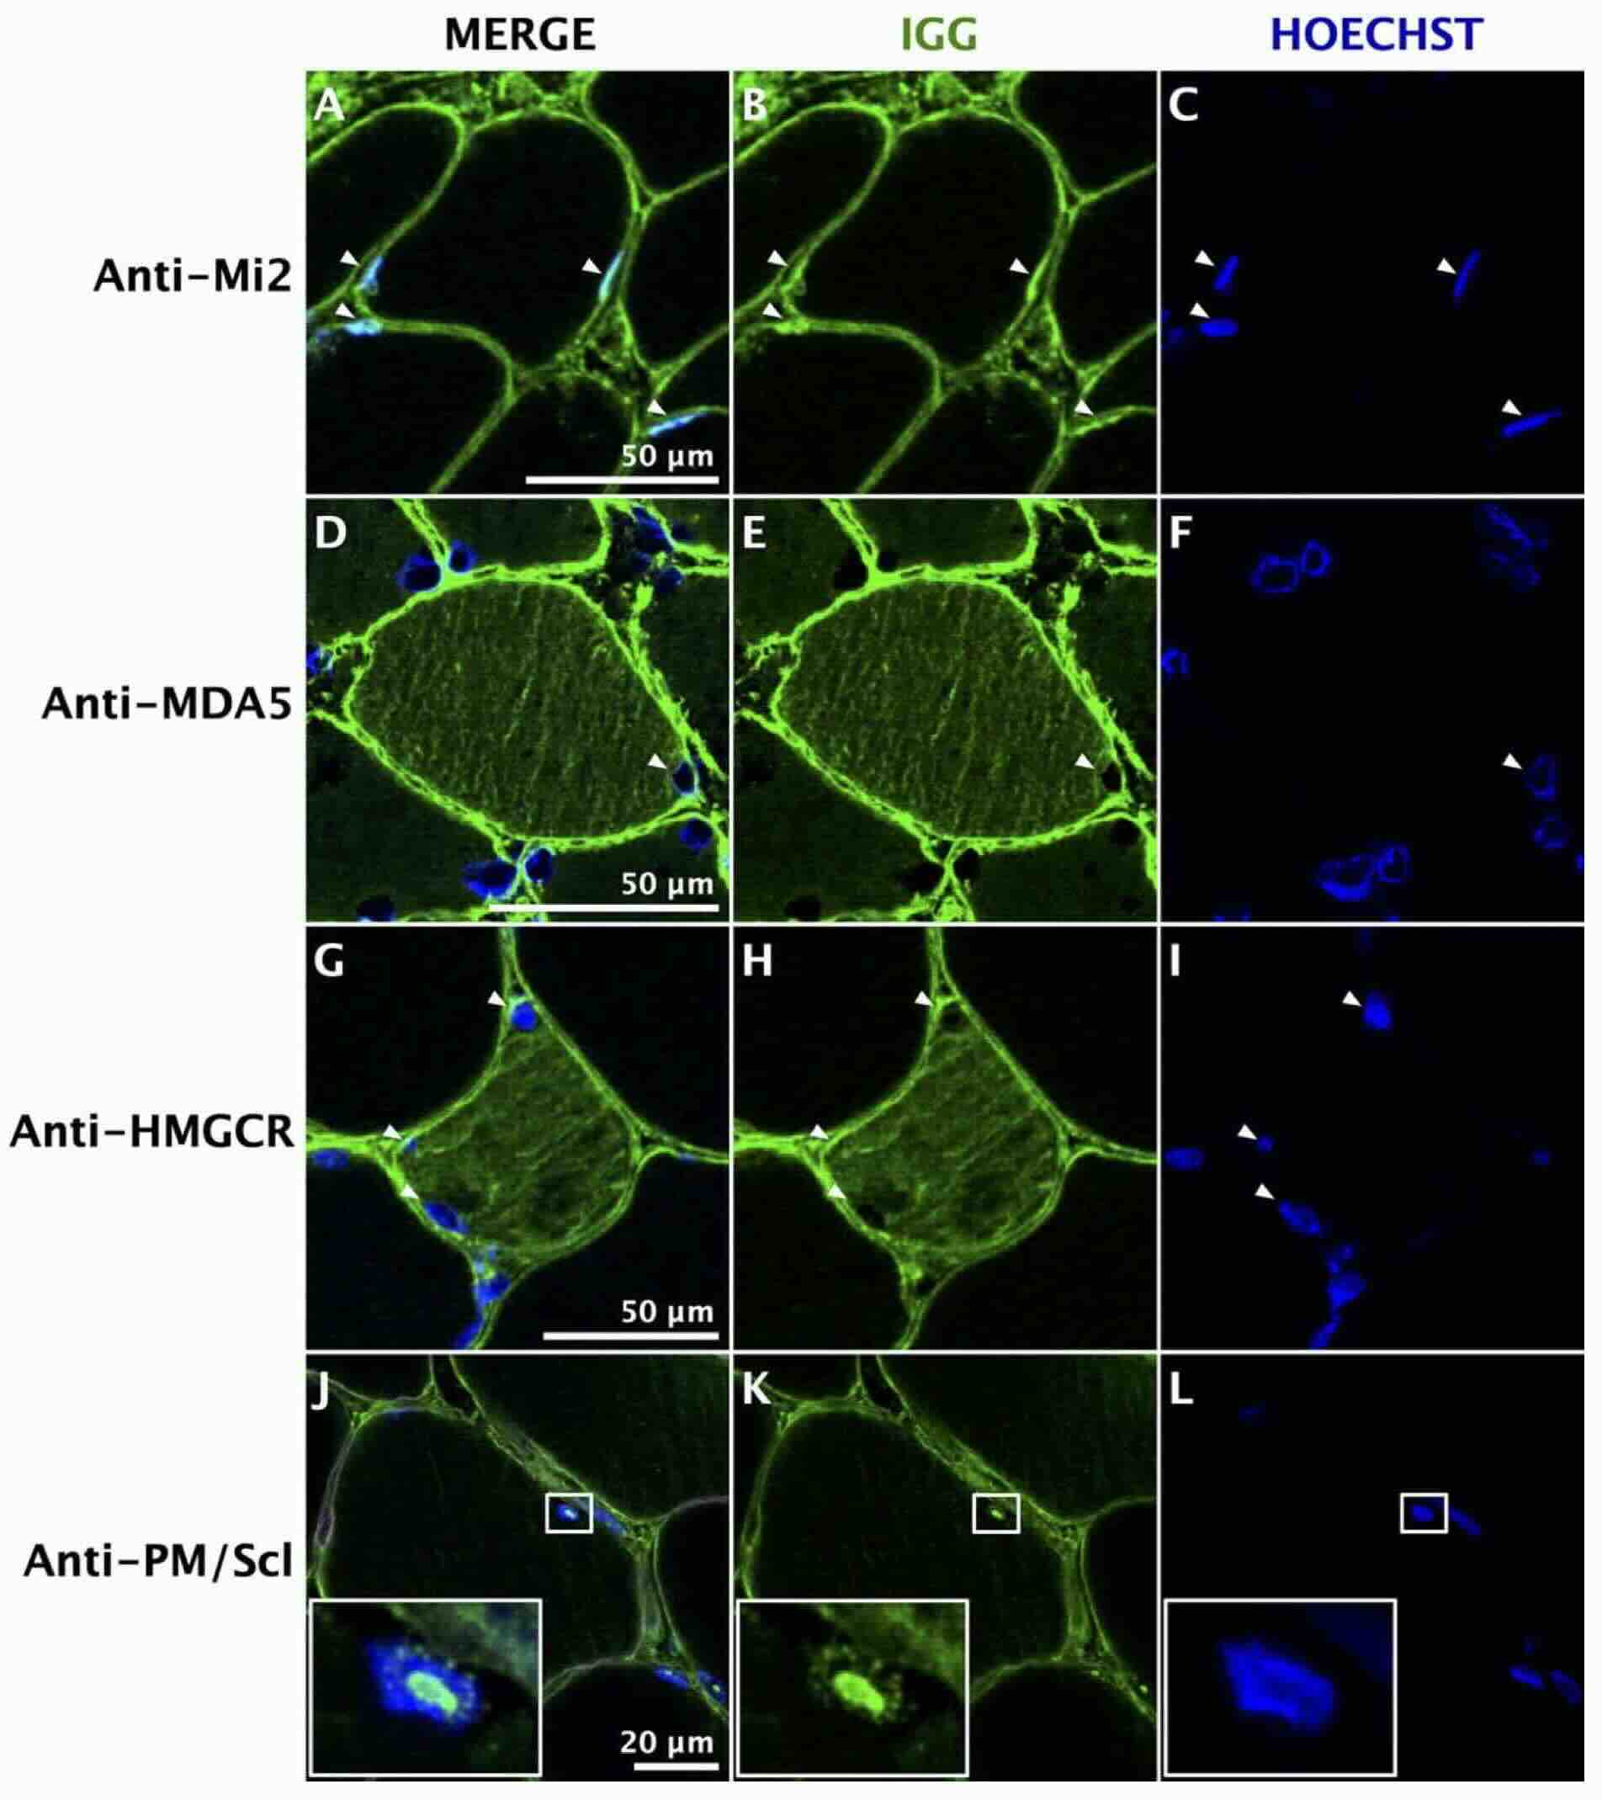

Supplementary Figure 1. Antibodies inside of cells in myositis.

## Supplementary Tables

Supplementary Table 3. More results.

| Col1 | Col2 | Col3 |
| --- | --- | --- |
| A | B | C |
| E | F | G |
| A | G | G |

## References

Pinal-Fernandez, Iago, Sandra Muñoz-Braceras, Maria Casal-Dominguez, Katherine Pak, Jiram Torres-Ruiz, Jon Musai, Stefania Dell’Orso, et al. 2024. “Pathological Autoantibody Internalisation in Myositis.” *Annals of the Rheumatic Diseases*, June. <https://doi.org/10.1136/ard-2024-225773>.

Selva-O’Callaghan, Albert, Iago Pinal-Fernandez, Ernesto Trallero-Araguás, José César Milisenda, Josep Maria Grau-Junyent, and Andrew L Mammen. 2018. “Classification and Management of Adult Inflammatory Myopathies.” *The Lancet Neurology* 17 (9): 816–28. <https://doi.org/10.1016/s1474-4422(18)30254-0>.