**Task Scheduler Configuration**

***Automated Daily Portfolio Update***

**General Tab**: set the task name and set it to run even if the user is not logged in

**Triggers Tab**: daily trigger configured for 6 AM.

**Actions Tab**: task executes the bash.exe with the full path to the script (run_etl.sh).

**Conditions and Settings Tabs**: extra settings like whether the task runs on battery power or waits for the system to be idle.

***Email Teacher***

**General Tab**: set the task name and set it to run even if the user is not logged in

**Triggers Tab**: trigger configured for 6 AM 22/10/2024.

**Actions Tab**: task executes the bash.exe with the full path to the script (run_etl.sh).

**Conditions and Settings Tabs**: extra settings like whether the task runs on battery power or waits for the system to be idle.

***Deadline Submission***

**General Tab**: set the task name and set it to run even if the user is not logged in

**Triggers Tab**: trigger configured for 19 PM 21/10/2024.

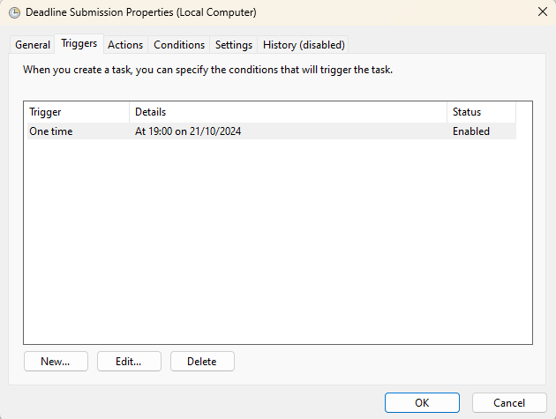

**Actions Tab**: task executes the R script

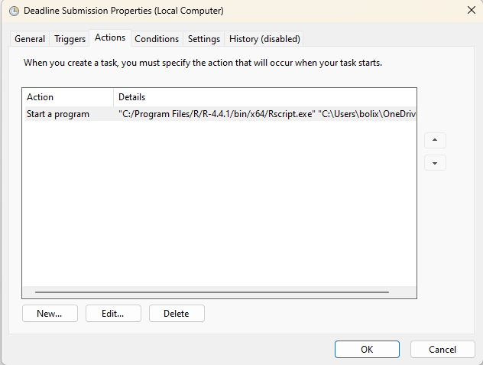

**Conditions and Settings Tabs**: extra settings like whether the task runs on battery power or waits for the system to be idle.

