**LESSON PLAN**

**27th April, 2021(Tuesday)**

**Grade: Seven**

**Subject: Mathematics**

|  |
| --- |
| *QUOTE OF DAY:* |
| Math teaches us that there is every reason to believe that every problem has a solution. |

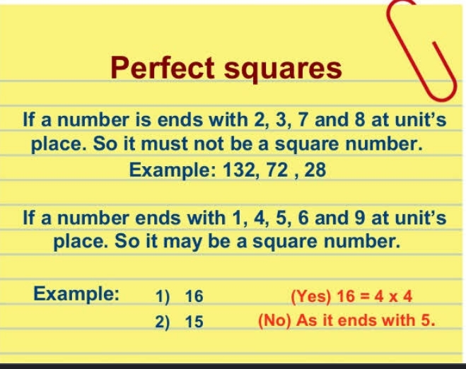

|  |  |
| --- | --- |
| Unit | 04 ( Square and square roots) |
| Topic | **Introduction of Squares and square roots** |
| URL/ Source | <https://youtu.be/9Am6Vnj_fmU> |
| Diary | Read page#47-49. Learn definitions (Square and square roots) + do homework of first table on book (page #51). |

