# Assignment No1

**Question No 1:**

Two different compilers are being tested for a 500 MHz. machine with three different classes of instructions: Class A, Class B, and Class C, which require one, two, and three cycles (respectively). Both compilers are used to produce code for a large piece of software. The first compiler's code uses 5 billions Class A instructions, 1 billion Class B instructions, and 1 billion Class C instructions. The second compiler's code uses 10 billions Class A instructions, 1 billion Class B instructions, and 1 billion Class C instructions.

Which sequence will be faster according to MIPS? Which sequence will be faster according to execution time?

**Question No 2:**

Consider the following performance measurements for a program.

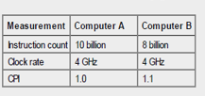

Which sequence will be faster according to MIPS? Which sequence will be faster according to execution time?

**Question No 3:**

The table below describes the performance of two processors, the rAlpha and the c86, and two compilers on a common 'benchmark' program.

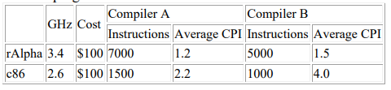

Which is the best compiler-machine combination?

**Question No 4:**

Consider three different processors, P1 P2 and P3, executing the same instruction set. P1 has a 3 GHz clock rate and a CPI of 1.5. P2 has a 2.5 GHz clock rate and a CPI of 1.0. P3 has a 4.0 GHz clock rate and a CPI of 2.2.

1. Which processor has the highest performance expressed in instructions per second?

2. If the processors each execute a program in 10 seconds, find the number of cycles and the number of instructions.

3. We are trying to reduce the execution time by 30% but this leads to an increase of 20% in the CPI. What clock rate should we have to get this time reduction?

**Question No 5:**

Two different compilers are being tested for a 40 MHz. machine with three different classes of instructions: Class A, Class B, and Class C, which require one, two, and three cycles (respectively). Both compilers are used to produce code for a large piece of software. The first compiler's code uses 5 billion Class A instructions, 2 billion Class B instructions, and 3 billion Class C instructions. The second compiler's code uses 5 billion Class A instructions, 6 billion Class B instructions, and 1 billion Class C instructions.

Which sequence will be faster according to MIPS? Which sequence will be faster according to execution time?

**Question No 6:**

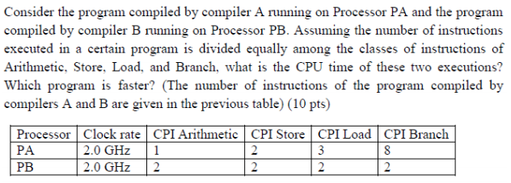

**Question No 7:**

Suppose a program runs in 120 seconds on a machine, with addition operations responsible for 70 seconds of this time. How much do we have to improve the speed of multiplication if we want the program to run 5 times faster?"  
  
How about making it 6 times faster?