**Food Court**



**Project To:** Prof. Haseeb Younis

**Submitted By:**

Sheeza Shahid

Maham Hafeez

Ansa Mumtaz

Laiba Wahid

Hajra Akbar

**University of Management and Technology**

**School of Professional Ad****vancement**

**Contents**

1. INTRODUCTION 4

1.1 Motivations 4

1.2 Project Overview 4

1.3 Problem Statement 5

1.4 Objectives 5

2. DOMAIN ANALYSIS 7

2.1 Affected Groups with social or economic impact 7

3. REQUIREMENTS ANALYSIS 9

3.1 Requirements 9

3.2 List of Actors 9

3.3 List of use cases 9

4. SYSTEM DESIGN 11

4.1 Class Diagram 15

5. CONCLUSION 17

**INTRODUCTION 1**

# INTRODUCTION

## Motivations

My motivation behind choosing this project is restaurant management system. Restaurant is a kind of business that serves people all over world with ready-made food here, during placing orders customers faced many problems and staff too.

In this era where technology leads to a new level, I introduce a desktop application in restaurants. The services that are provided is food ordering management by the customer through the system online, Future scope for the application involves making restaurant even smarter and efficient. This system also greatly lightens the load on the both ends, the customer and the restaurant.

## Project Overview

**Food Court** will be a c++ application. In today’s era of fast food and take-out, many restaurants have preferred to concentration on rapid preparation and speedy delivery of orders so, our system helps the restaurant employee to manage the restaurant more effectively and efficiently by using the smart application for meal ordering and invoicing. Our system is a user friendly, fast and efficient. The principle advantage of our smart application is that it makes the order whole order processing system easier for the staff and customers as well. This application is also designed for the computerized menu of any restaurant. The customers are presented with most innovative and updated menu that contains all available options with parallel display of pricing upon order selection by the customer. After making a selection, final order is presented as preview for customer before proceeding to check out in order for invoicing and order preparation. This provides instant visual confirmation of order as per the final selection of the customer. Moreover, instead of going to the counter, they will places an order on his seat through our application “Food Court”. So it’s beneficial to both customer and manager. Mostly it facilitate the customer because at first the customer had to line up to get his order but now they will get their order just after one click. This automation of the process also reduces the load on the restaurant’s end, as the end to end process of meal ordering is interfaced. Once an order is placed on the webpage, it is restored into the files and retrieving of the data is now possible in real time.

It includes the following Modules as:

* Manager Management
* Customer Management
* Chef Management

## Problem Statement

Nowadays, many restaurants meal ordering is manually managed In traditional booking system, a customer has to go to restaurant or make a phone call in order to get his meal reserved. Today, trained staff (restaurant waiters) takes the customer orders using paper. It consumes five to 10 minutes to book the order using paper so there chance of lost and duplication of customer order. Restaurant management system puts the order in a queue with specific priority according to time and quantity for a cook to prepare the order. Using this order system often makes it difficult for the restaurant management to schedule the orders on time and duplication may be possible. Many people have faced delays in order services and poor customer services by certain waiters.

I introduce this app to resolve this issue. The paper menus can be difficult to manage in case of spike in orders from customers. To leverage the growing Tech industry, the online restaurant proffers solution. I introduce this app to resolve this issue this restaurant menu and management system will replace the paper waste, is more maintainable, and allows for greater customer engagement also improve the efficiency of restaurant staff. Our system is a user friendly, fast and efficient. The main advantage of our system is that it makes the ordering process easier for both the customer and also for the management of the restaurant.

## Objectives

The development of this software is for the satisfaction of the customer that the customer will get their desire menu or cuisine details according to their needs.

* To increase efficiency and improve services provided to the customers through better application of technology in daily operations.
* To be able to stand out from competitors in the food service industry
* Improve effective utilization of the staff.
* Paper work is almost reduced and accuracy in ordering system is also achieved with this smart application.
* Timely delivery of services with higher customer satisfaction level.
* It enables the customers to view the available options at the restaurant for meal ordering and will also show the final selection once choices are made by the customer.

**DOMAIN ANALYSIS 2**

# DOMAIN ANALYSIS

## Affected Groups with social or economic impact

* **Sales Staff**

It will affect the sales as well as the staff of the specific restaurant in the following ways:

* It will save time of staff as they don’t have to go from table to table to show menus and take orders.
* Saving time means more sale as there will be more orders at a time using digital app as compared to manual ordering system.
* There can be increase in the salary of staff if there will be increase in sales.
* **Customers**

It will build the trust of customers as they will get their exact orders in time, time will be saved, and they also will not have to be reluctant in ordering something digitally.

**REQUIREMENT ANALYSIS 3**

# REQUIREMENTS ANALYSIS

## Requirements

* **Functional Requirements:**
* Food Court will take the order from customer and give it to the chef.
* Manager can CRUD items and category using food court.
* **Non-Functional Requirements:**
* Maintainability- will be easy to maintain
* Performance/ response time- fast response
* Usability by target user community- will be easy to use

## List of Actors

Actors used in this system are:

* **Customer**: this person uses the application.
* **Manager**: this person perform reporting and CRUD operations in items of the menu.
* **Chef**: this person prepares order after checking order in screen.

## List of use cases

* **Place Order:** allow customer to add to cart items and then send order
* **Log In:** allow users (Chef, Manager) to access the restricted services
* **Edit Menu:** allow manager to perform CRUD operations.

**SYSTEM DESIGN 4**

# SYSTEM DESIGN

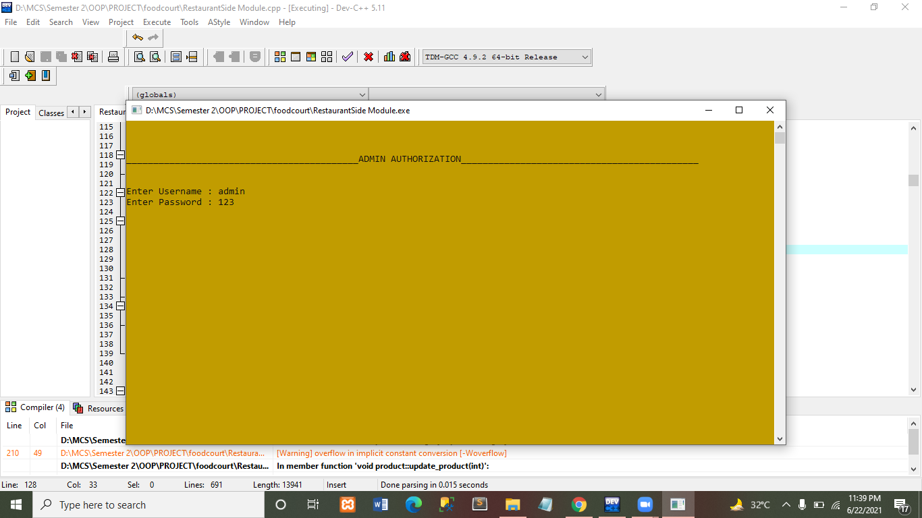

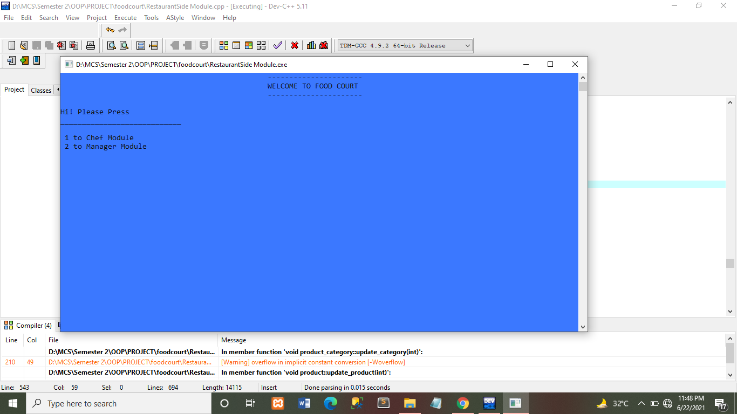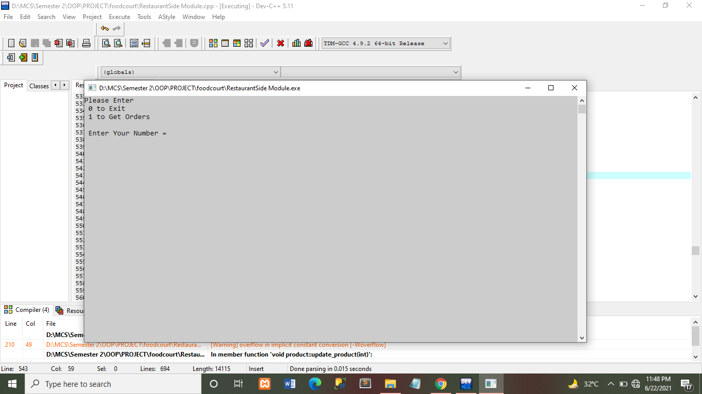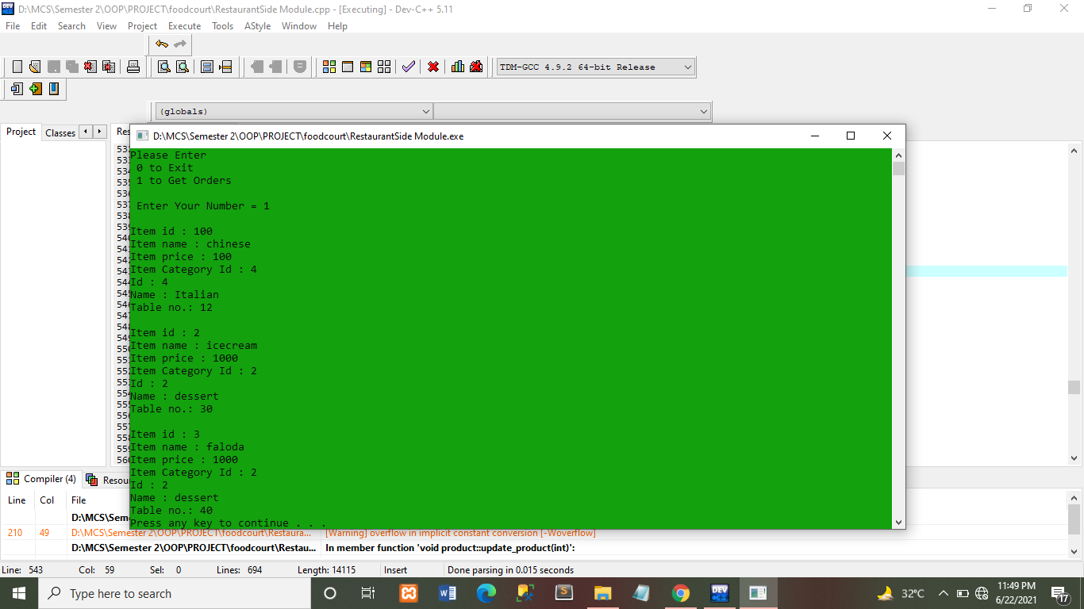

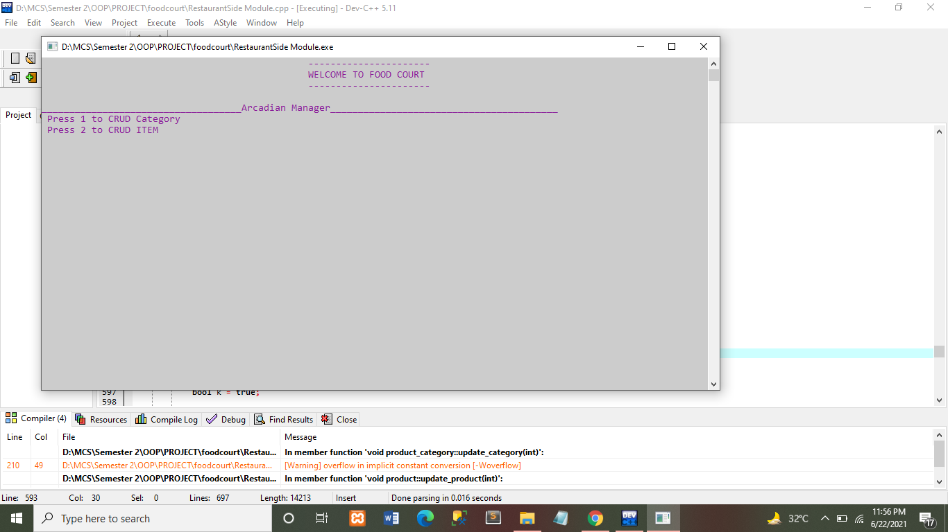

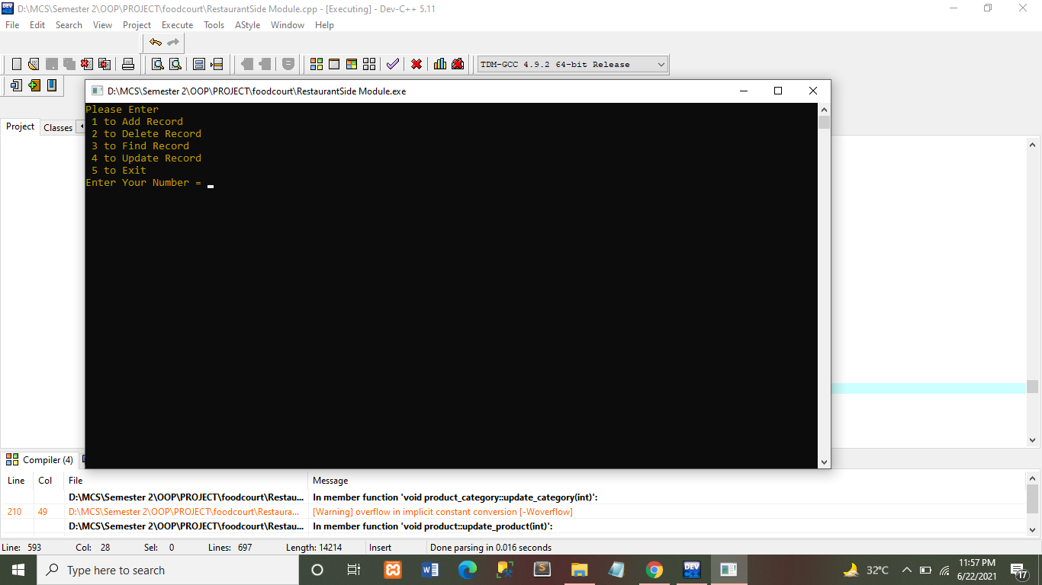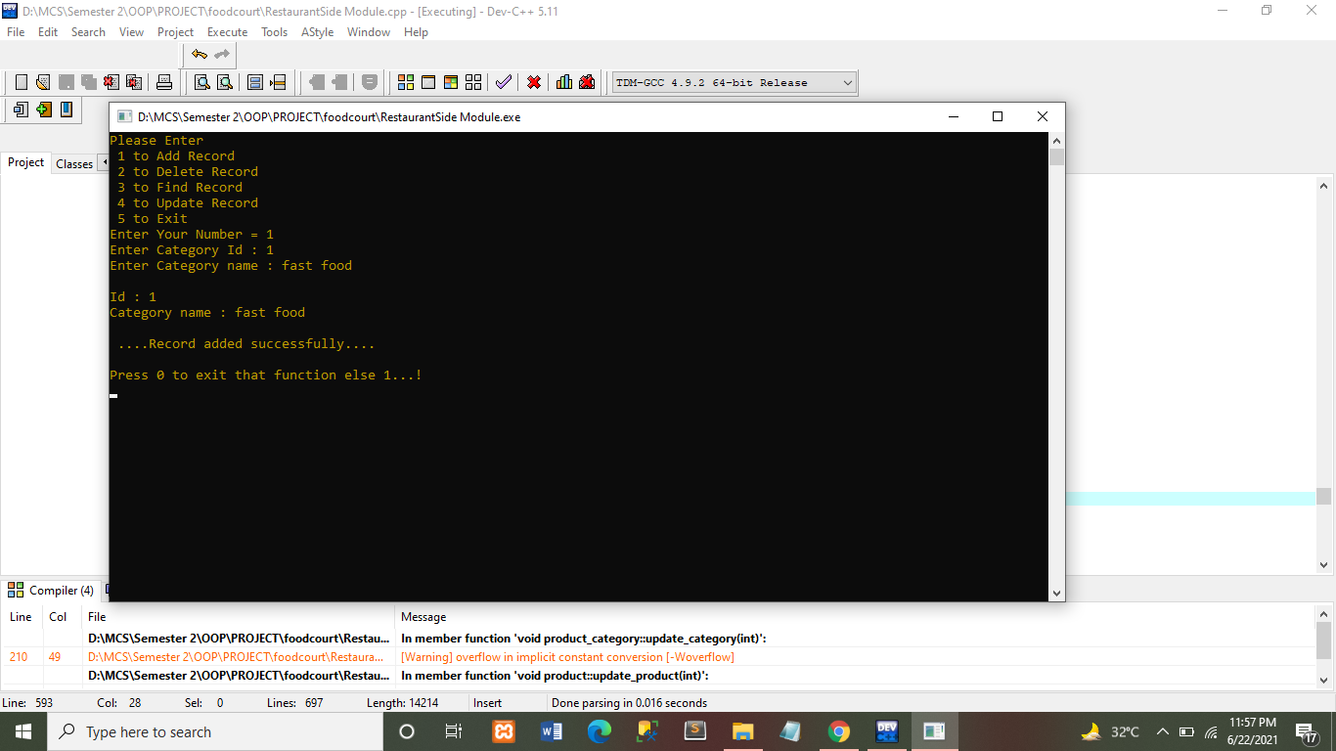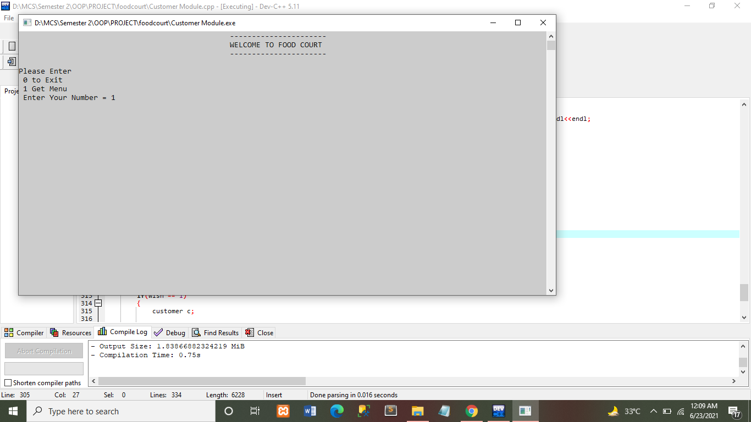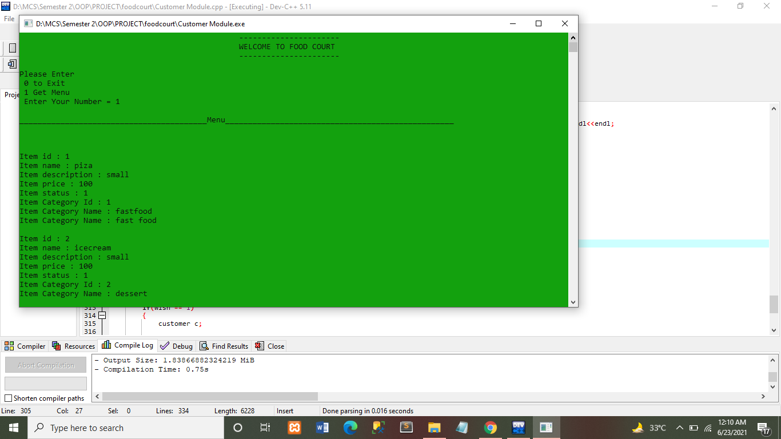

## Class Diagram

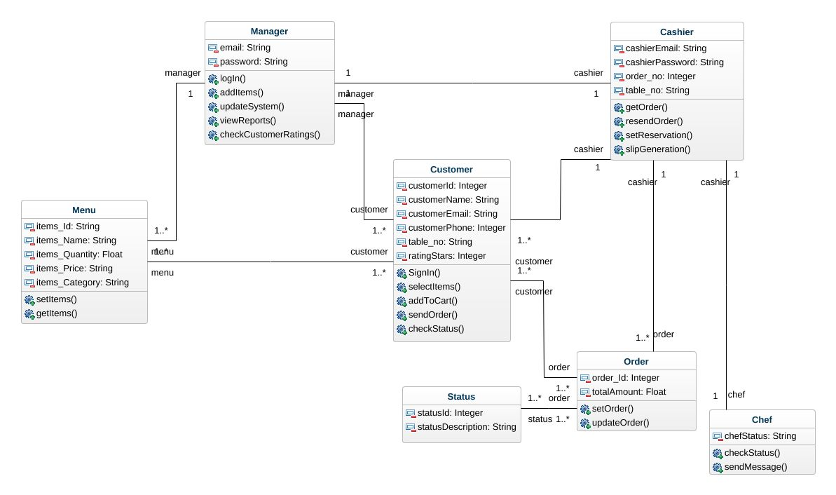

Figure 5.1. : Class Diagram

This Class Diagram illustrates main functions which perform my application, moreover it also explain main attributes which mostly explain that what my application wants from users. For Example: Customer Function is to select items then add to cart items then send order and check status. Manager Function is to login, update menu. Chef function is to update status after making order.

**CONCLUSION**

# CONCLUSION

In this document, we have mentioned the requirements of the project functional, non- functional requirements. We have described how this application works on the admin as well as customer side. This project will be successful and can revolutionize the food ordering system by making it much more convenient for people. It can be expanded further to cafeterias and fast food companies.