Enterprise HR Portal — Workflow Reference
Version: 1.0 | Last Updated: 2026-03-08
1. Leave Request Workflow
Full State Machine
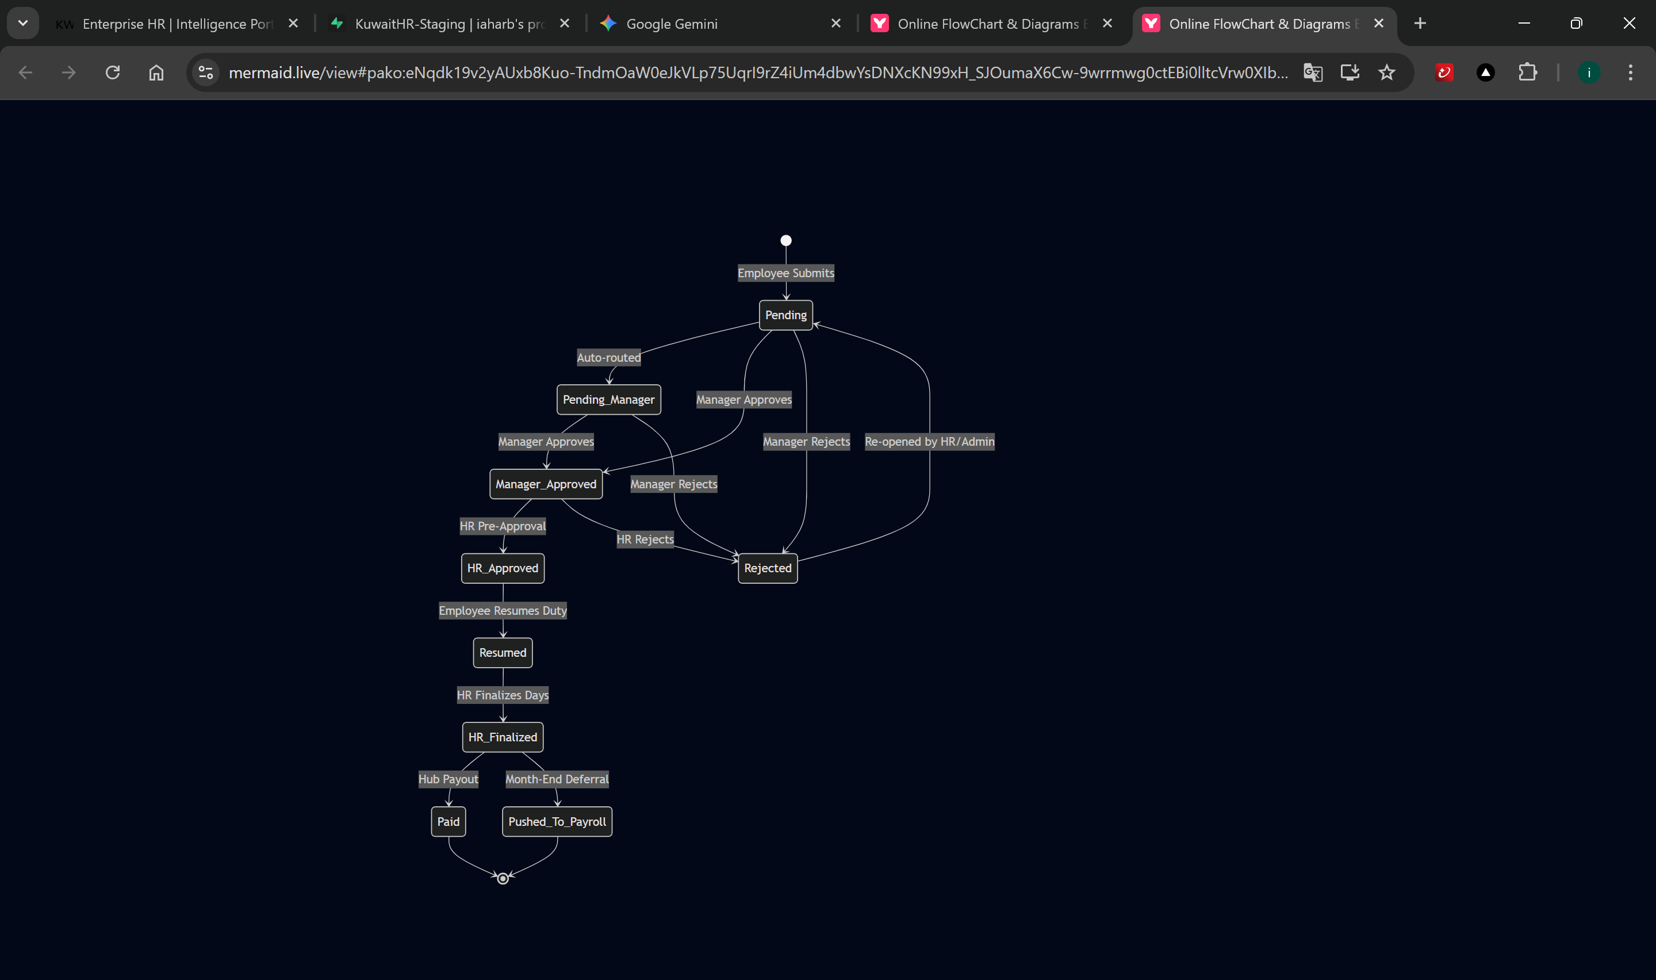
Actors at Each Stage
Stage | Actor | Actions Available
Pending | Manager | Approve → Manager_Approved · Reject → Rejected
Manager_Approved | HR Manager/Officer | HR Pre-Approval → HR_Approved
HR_Approved | Employee | Resume Duty → Resumed
Resumed | HR Manager | Finalize & Sync → HR_Finalized (adjustable days)
HR_Finalized | Payroll Manager | Hub Payout → Paid · Push to Monthly → Pushed_To_Payroll
Rejected | HR/Admin/Manager | Re-open → Pending

2. Leave Payout Calculation Workflow
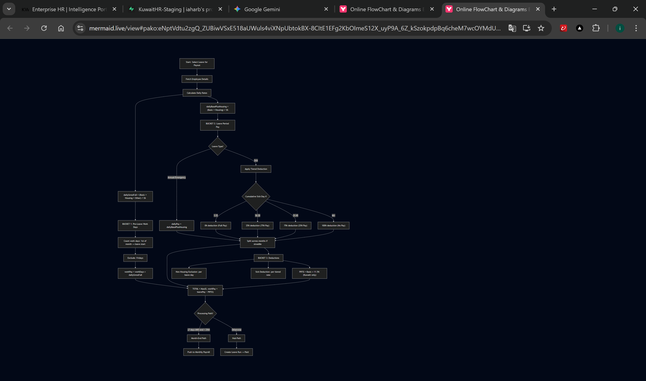
Key Formulas
Daily Gross Full | = (Basic + Housing + All Allowances) / 26
Daily Base + Housing | = (Basic + Housing) / 26
PIFSS Deduction | = Basic × 0.115 (Kuwaiti only)
For Percentage Allowances: | Value = Basic × (Percentage / 100)

3. Monthly Payroll Cycle
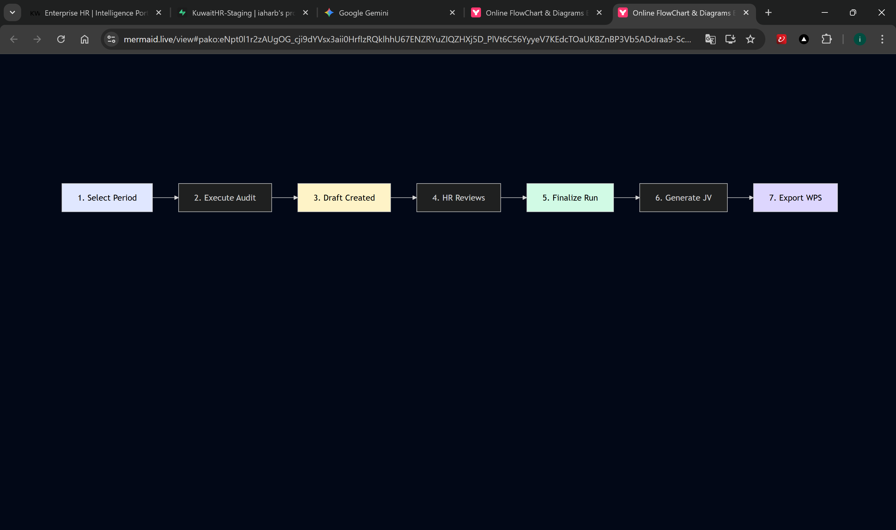
Step Details
Step | Action | System Behavior
1 | Payroll Mgr selects month/year and cycle type | —
2 | Click "Execute Period Audit" | Calls generate_payroll_draft RPC
3 | System creates Draft run + items for all active employees | Items include: salary, allowances, PIFSS, deductions
4 | HR verifies each line item for accuracy | Check variance, verify amounts
5 | Click "Finalize" and confirm | Calls finalize_payroll_run RPC; status →Finalized
6 | Navigate to Finance → Generate JV | Creates GL journal entries per mapping rules
7 | Select bank format → Export WPS | Downloads CSV file for bank submission

Payroll Item Components
Net Salary = Basic Salary
+ Housing Allowance
+ Other Allowances
+ Overtime Amount
+ Annual Leave Pay
+ Sick Leave Pay
+ Performance Bonus
+ Company Bonus
- Leave Deductions
- Short Permission Deductions
- PIFSS Employee Deduction

4. Overtime Processing Workflow
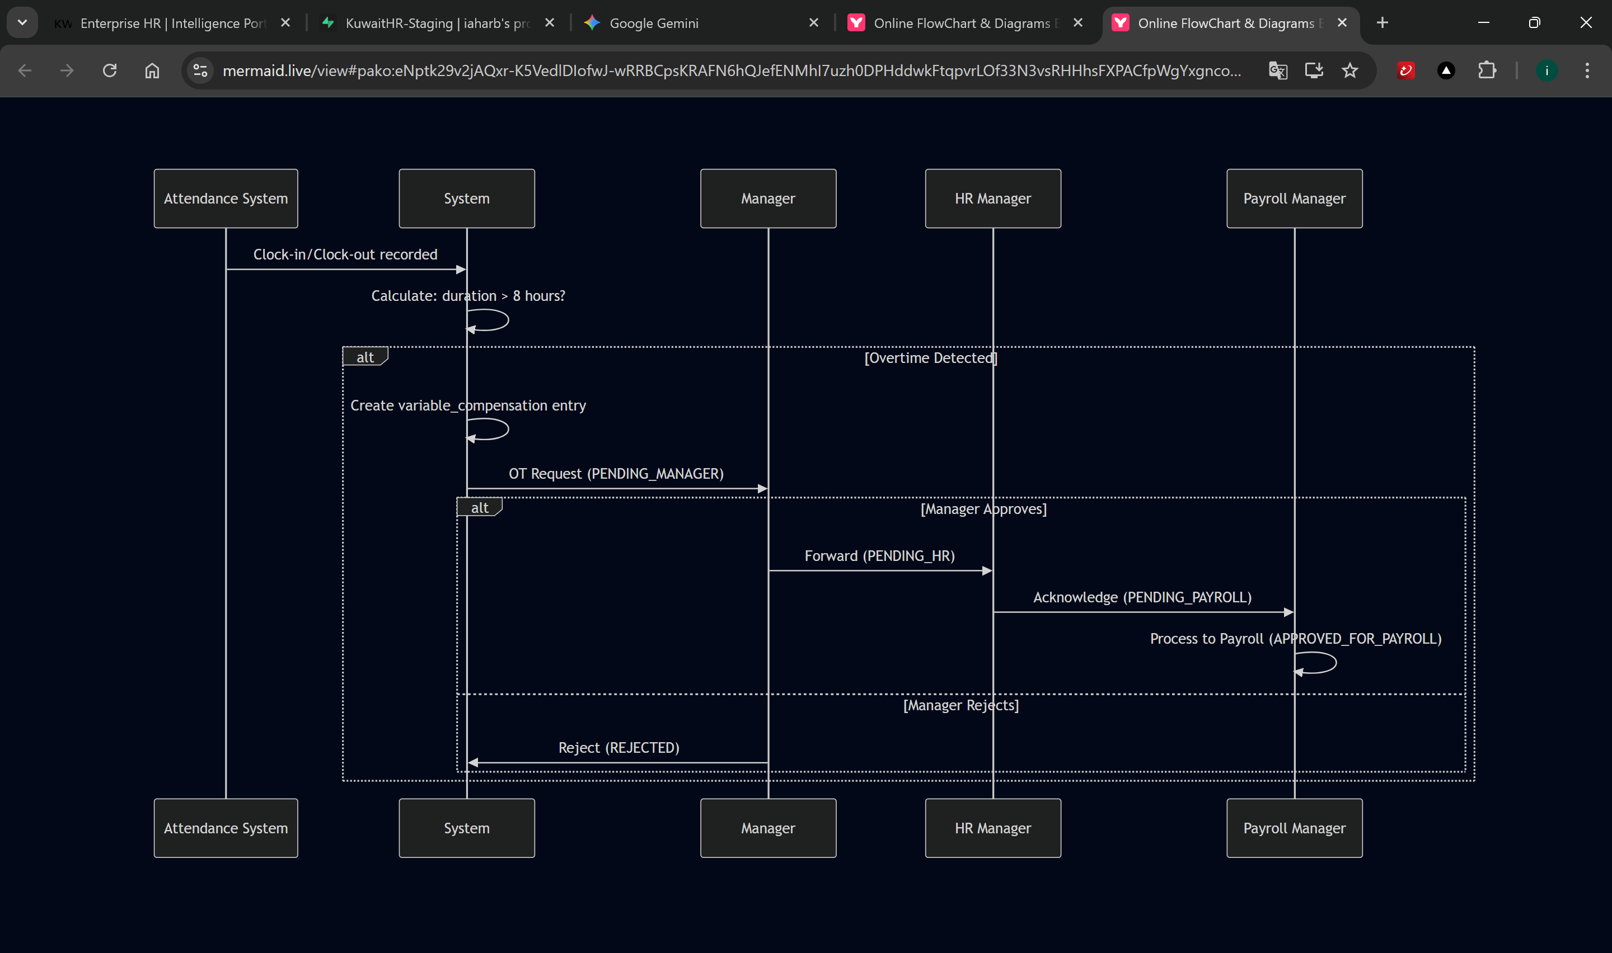
Overtime Calculation
Standard Shift = 8 hours (28,800 seconds)
Clock Duration = clockOut(seconds) - clockIn(seconds)
If Duration > Standard Shift:
OT Hours = (Duration - Standard Shift) / 3600
→ Create entry: comp_type=OVERTIME, sub_type=Workday_OT, amount=OT_Hours

5. Expense Claims Workflow
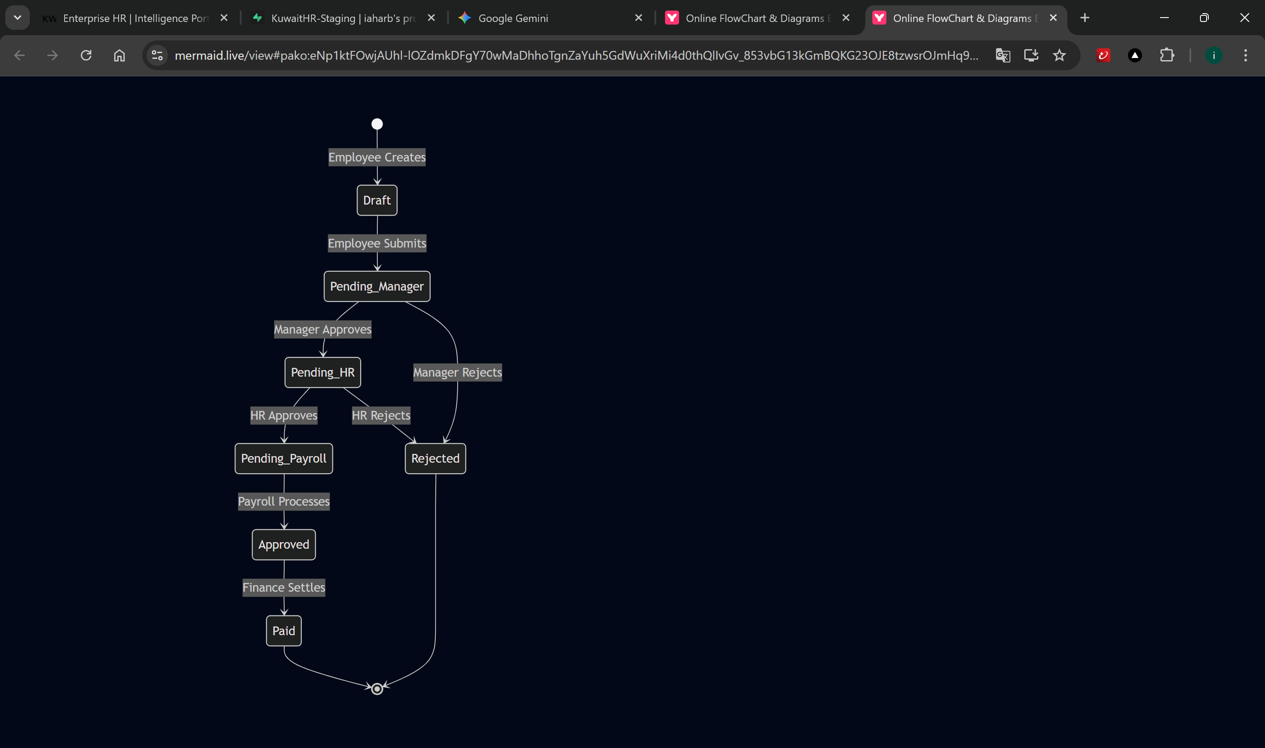

Required Fields
Field | Type | Description
Merchant | Text | Vendor/store name
Amount | Number | Claim amount in KWD
Date | Date | Date of expense
Category | Select | Travel, Meals, Supplies, etc.
Receipt | Image | Uploaded photo/scan

6. Profile Update Workflow
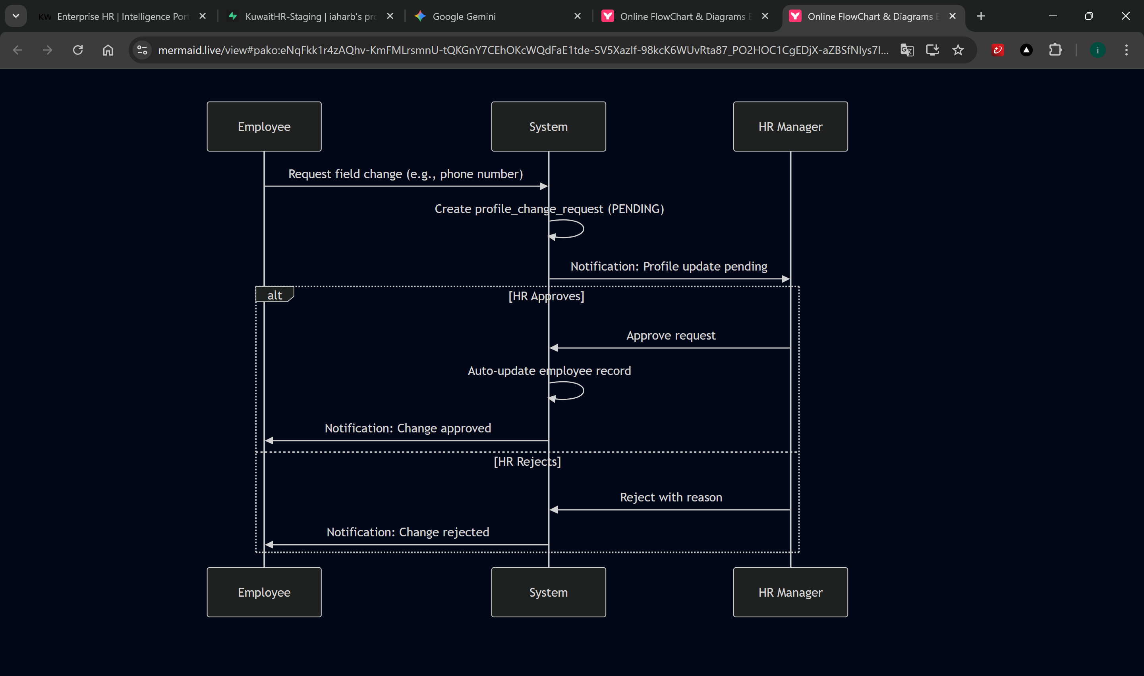

7. Final Settlement (EOSB) Calculation Workflow

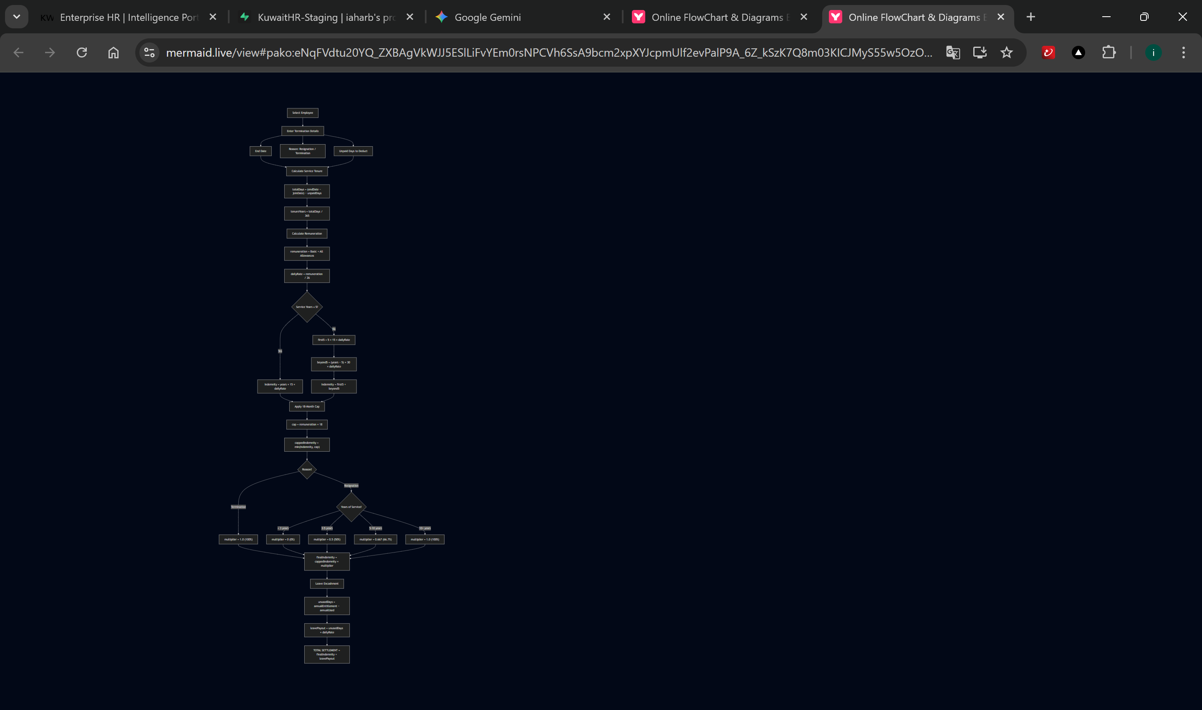

8. Performance Evaluation Workflow
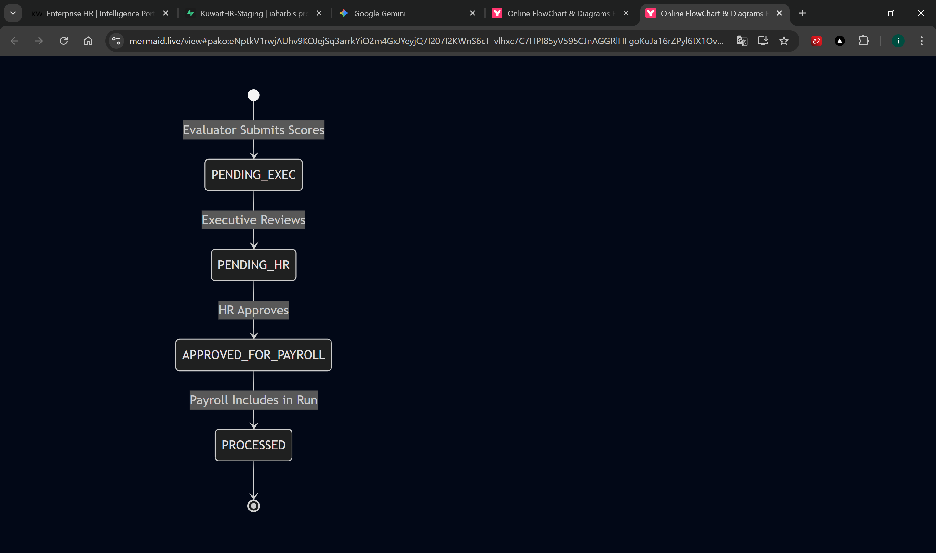

KPI Scoring Formula
For each KPI:
Weighted Score = (Score / 100) × Weight
Total Score = Σ(Weighted Scores)
Pro-rata Factor = (Active Days in Period) / (Total Days in Period) Calculated KWD = Total Score × Pro-rata Factor × Bonus Rate

9. Profit Sharing Bonus Workflow
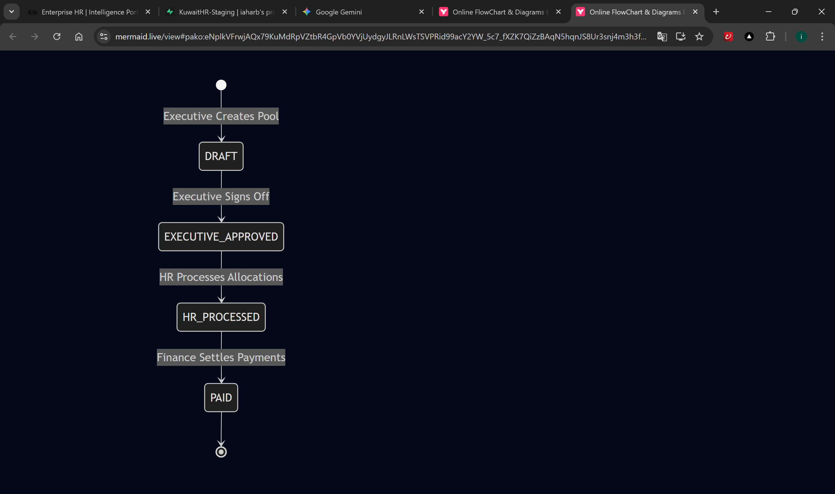
Distribution Methods
Method | Formula
Equal Split | allocation = poolAmount / eligibleCount
Pro Rata Salary | allocation = poolAmount × (empSalary / totalSalaries)

Eligibility
- Employee must be Active on the eligibility cutoff date
- Join date must be on or before the cutoff date

10. Attendance Recording Workflow
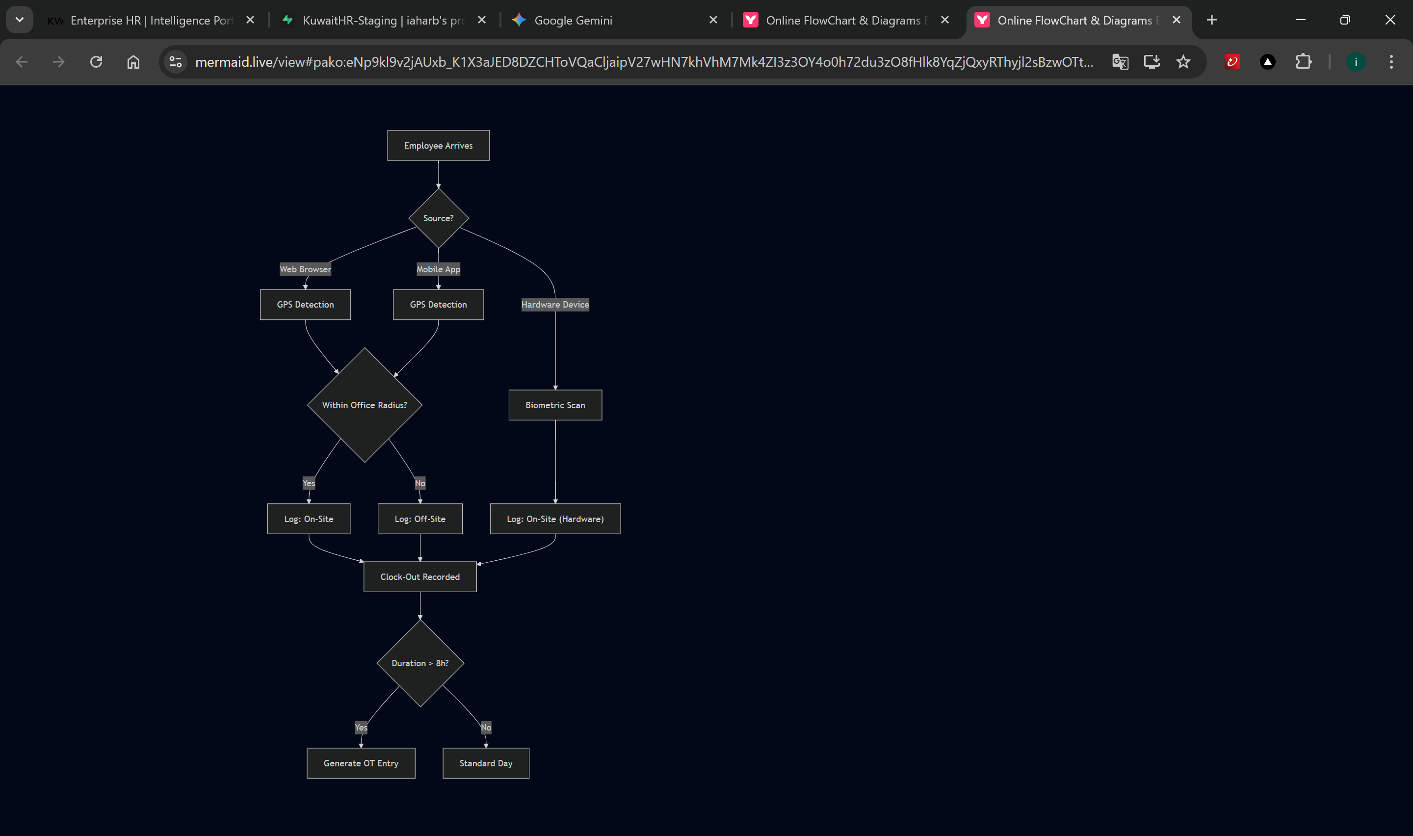

This workflow reference is automatically kept in sync with the portal codebase. For the latest version, consult the system documentation.

