**Lab01: Fault List Generation & Fault Simulation**

**B09901153 胡凱翔**

1. Accumulated fault coverage vs. the number of applied test patterns (fully/partially specified) (35%)

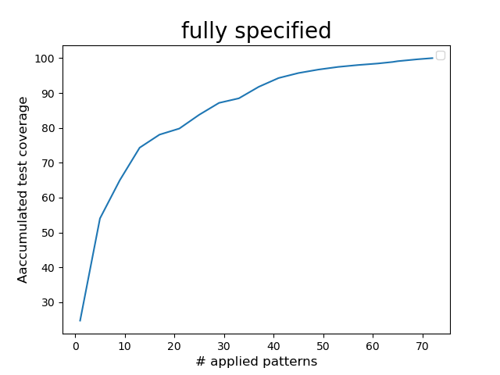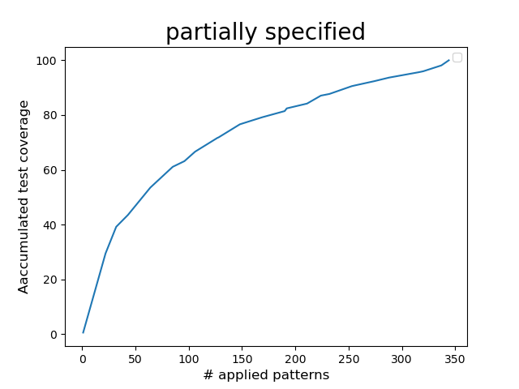

1. A histogram that shows the distribution of the numbers of detected faults (fully/partially specified) (35%)

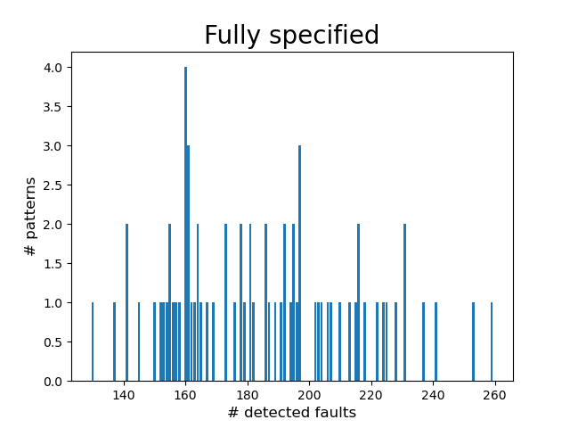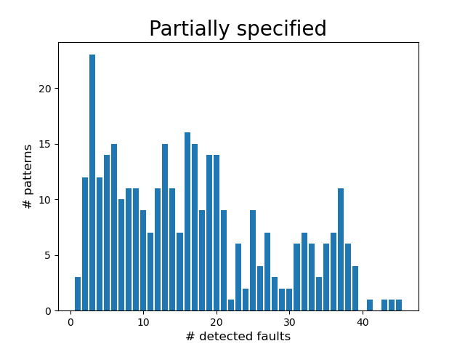

1. What do you observe from the plots?

For both fully and partially specified, as the number of applied test patterns increases, the fault coverage also significantly increases. This is because there are many easy-to-detect faults, and while these easy-to-detect faults are all detected, both of them increase slower as their fault coverage saturate.

And from the histograms, we can see that the number of detected faults of each pattern for fully specified patterns varies a lot, while it does not for partially specified patterns. Also, the number of detected faults of each pattern for fully specified patterns is usually larger than partially specified patterns. These are because there are many ‘X’s in partially specified patterns, and hence the number of faults that can be activated and detected for each pattern would be fewer.