BÁO CÁO THỰC HÀNH LAP 1  
LẬP TRÌNH HƯỚNG ĐỐI TƯỢNG

# Làm việc với github, bitbuket.

Mẫu báo cáo 0.

# The Very First Java Programs

## *2.2.1* Write, compile the first Java application:

*Kết quả*

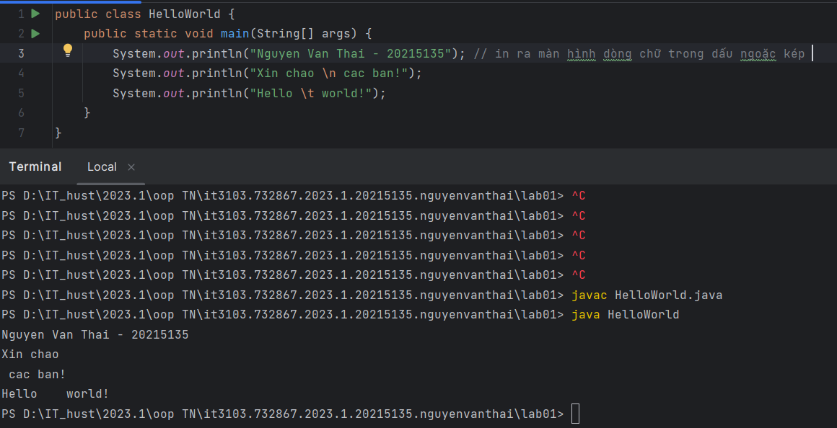

## 2.2.2 Write, compile the first dialog Java program

## 2.2.3 Write, compile the first input dialog Java application

**Kết Quả:**

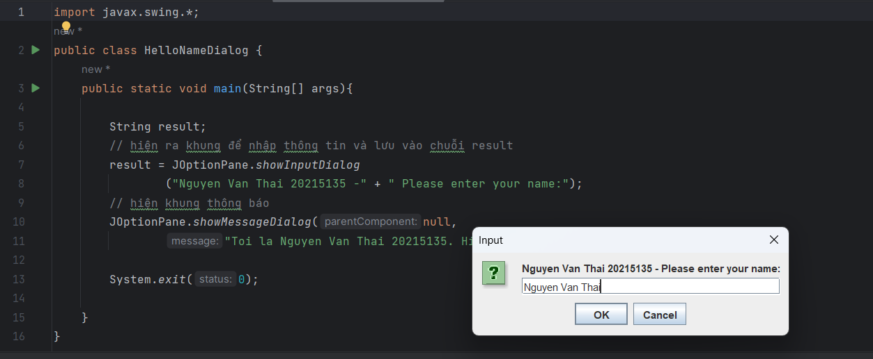

## A screenshot of a computer program Description automatically generated2.2.4 Write, compile, and run the following example:

Kết quả :

## 2.2.5 Write a program to calculate sum, difference, product, and quotient of 2 double numbers which are entered by users.

**Notes**

* To convert from String to double, you can use

**double num1 = Double.parseDouble(strNum1)**

* Check the divisor of the division

Kết quả:

6 Exercises

6.1 Write, compile and run the ChoosingOption program:

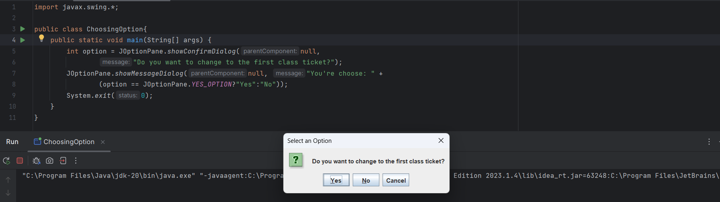

6.2 Write a program for input/output from keyboard

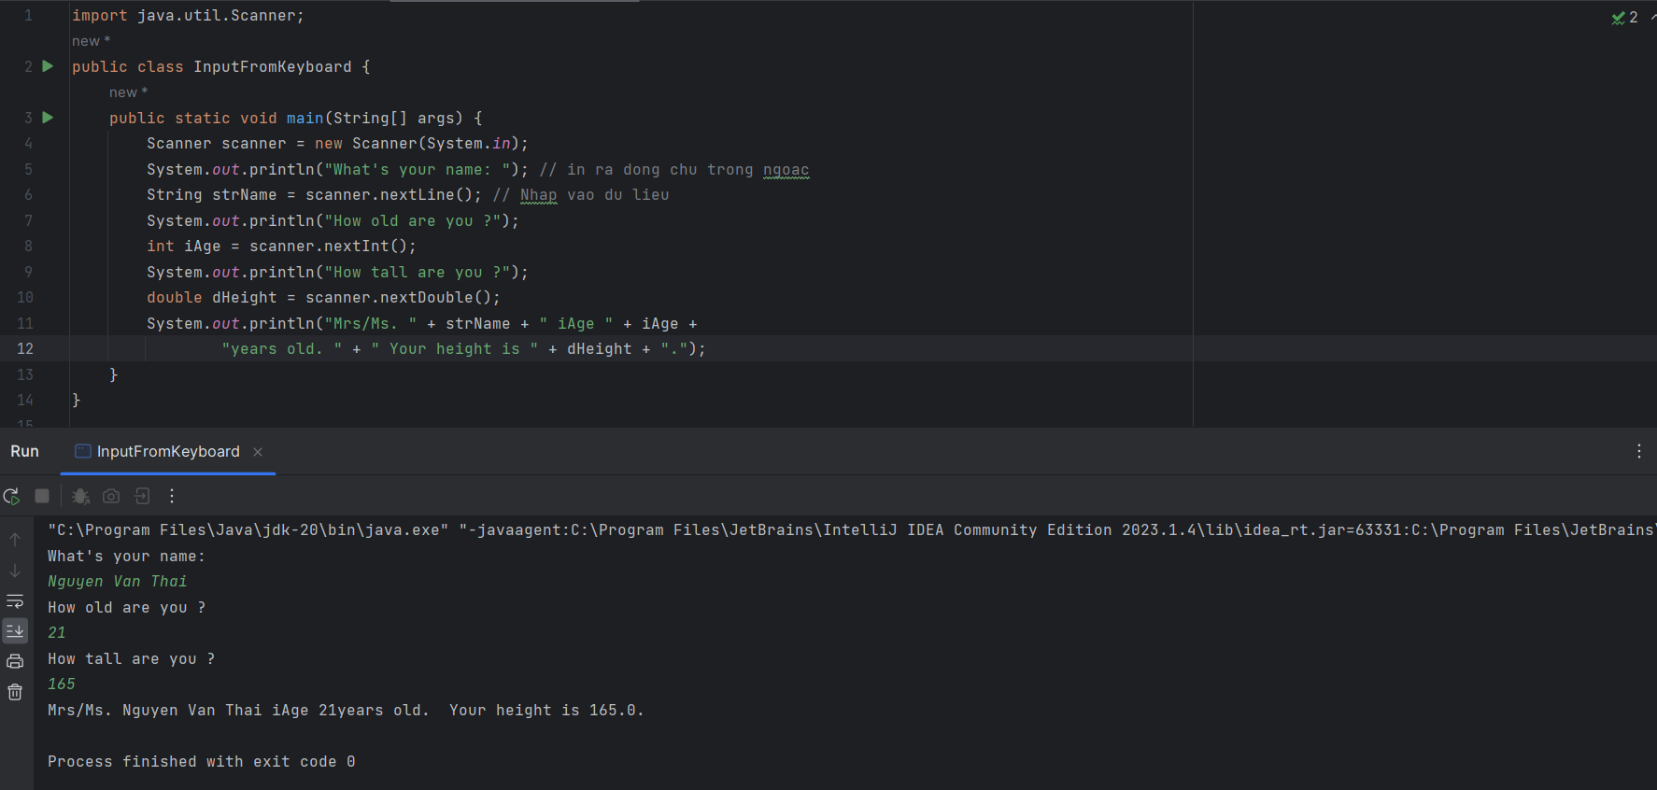

6.3 Write a program to display a triangle with a height of n stars (*), n is entered by users.

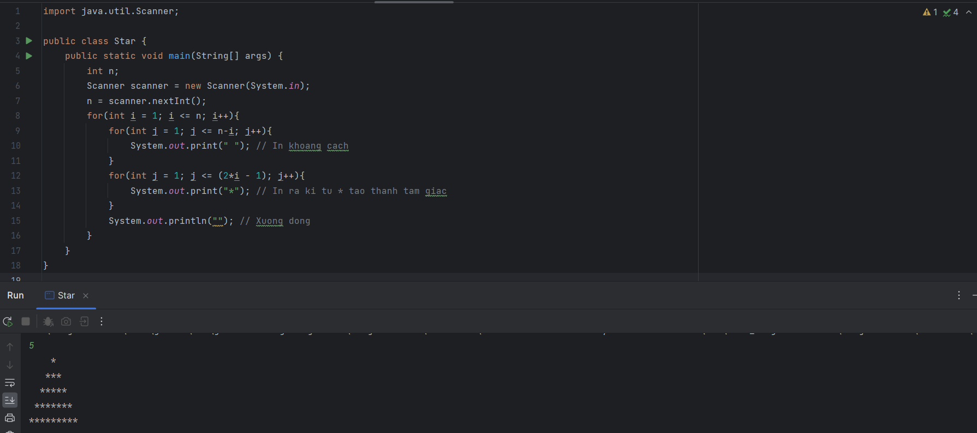

6.4 Write a program to display the number of days of a month, which is entered by users (both month and year). If it is an invalid month/year, ask the user to enter again.

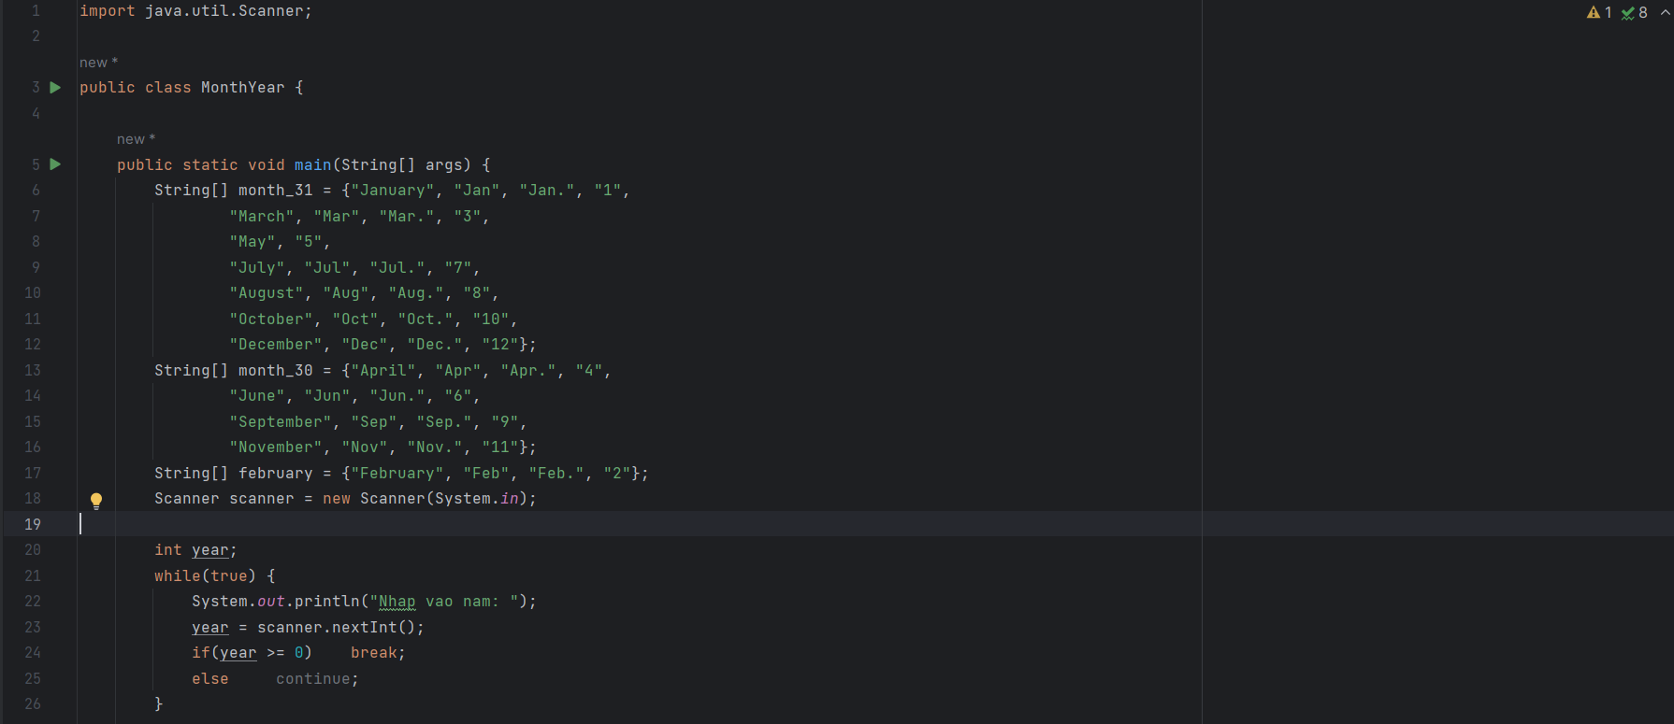



Kết quả:

6.5 Write a Java program to sort a numeric array, and calculate the sum and average value of array elements.

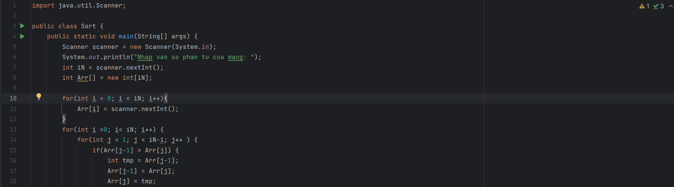

Kết quả :

6.6 Write a Java program to add two matrices of the same size.

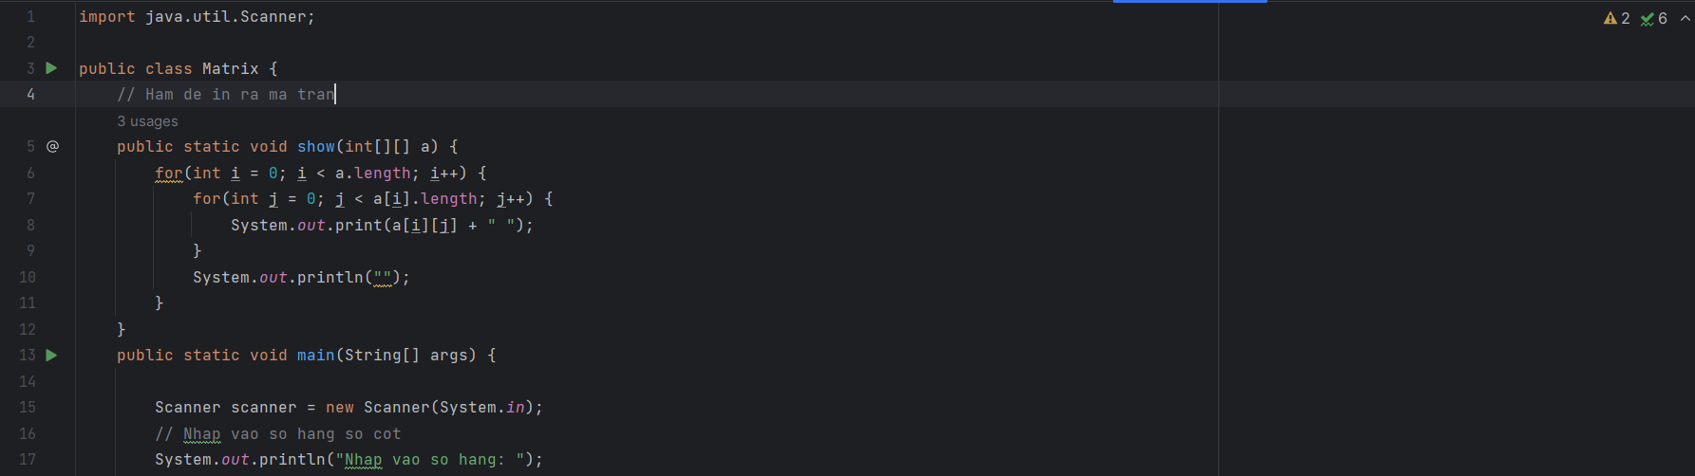

Kết quả:

