# Introduction

## Project Background

The Inventory & Invoicing app that you will build is composed of three entities: the Customer, Inventory & Invoicing. This system has a functionality that can track the records of orders, customer details & stocks of the items. Each entity has a functionality that can generate reports of the records.

|  |  |
| --- | --- |
| **ENTITIES/MODULES** | **Definition/Function** |
| Customer | * Module where the user will encode the data of the customer and the products/items that they will avail. |
| Inventory | * Module where all the stocks will be stored & maintained. |
| Invoice | * This will be the module where the user confirms the transaction for every purchase from the customers.  Important details to include: * Customers Information * Product Information * Computation of the product |

JAKE BRIAN YAP BSIT 3A

Inventory:

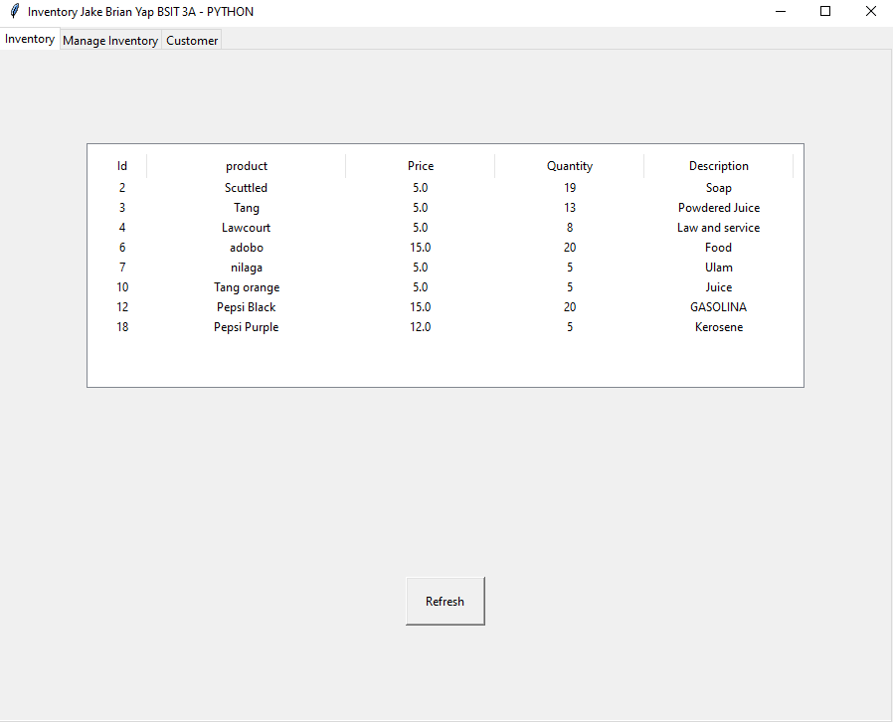

Manage:

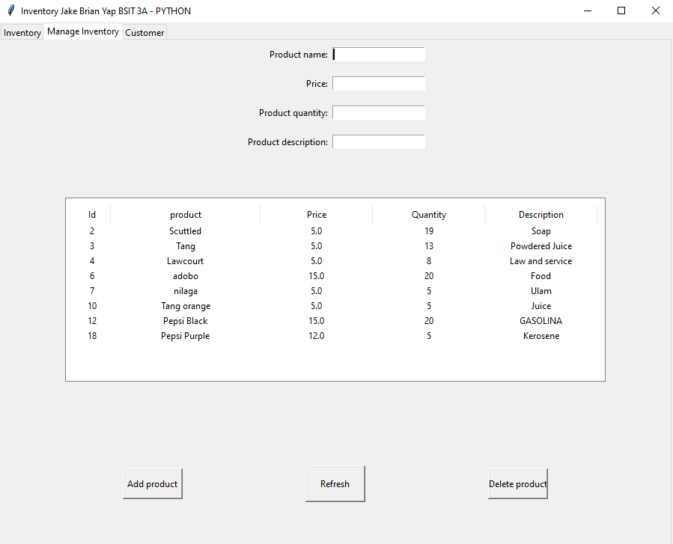

Customer:

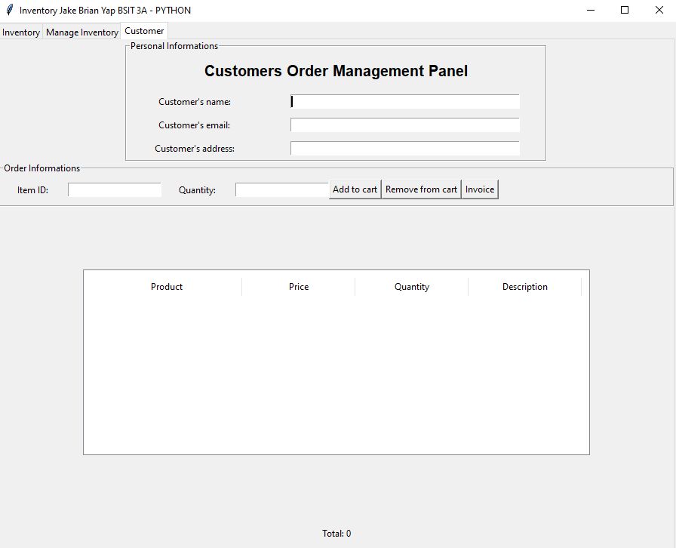

Invoice:

