1
Df - report file system disk space usage
df >> diskUsage.txt

df | awk '{print($1, $5, $6)}' | column -t >> diskUsage.txt

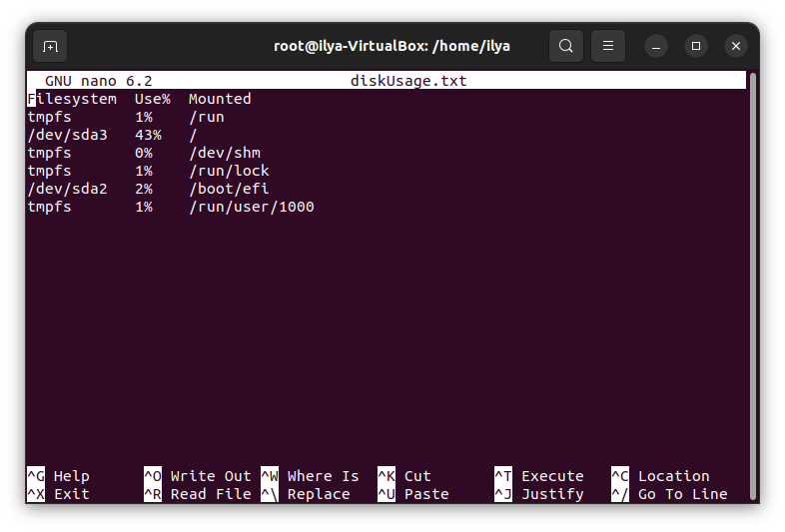
aa

2
du -hs /etc/*

du -hs /etc/* | sort -g -r | head -10

3
nano testFile.txt
awk '! /SD/{print $0}' testFile.txt | awk '! /^A/{print $0}'

sed '/NSD/d' testFile.txt | sed '/D$/d'
4
cp /etc/passwd passwd
grep /bin/bash passwd | awk '{print ((NR-1)%3)+1 $0}' $1 >> newPasswd

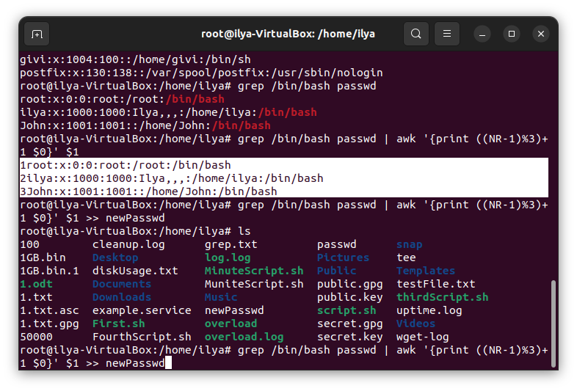
5
grep /bin/sh passwd | sed -i 's/sh/bash/g' passwd

