1
mkdir test
cd test
nano test_123

ln -s test /tmp/soft_link -add soft link from /home/ilya/test to /tmp/soft_link
ls -l /tmp/soft_link – view soft link

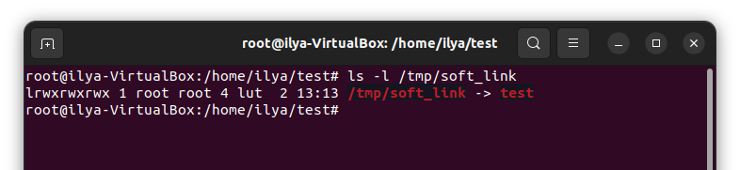
cp /home/ilya/test/test_123 /tmp/
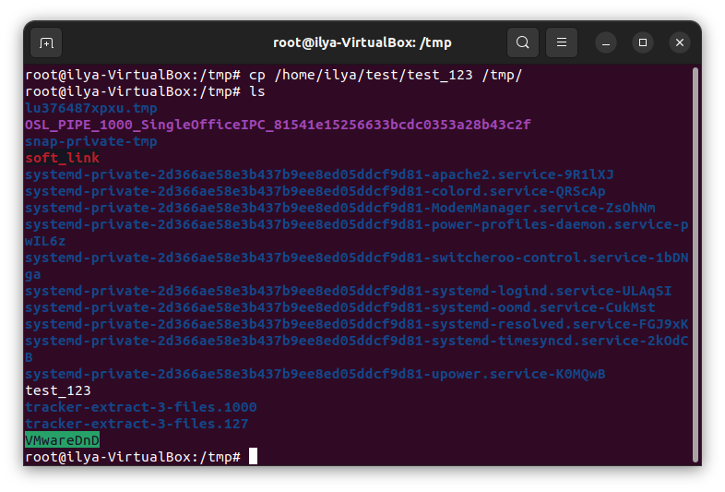

ls test_123 /tmp/test_123

sudo du --inode /tmp – all inodes
sudo df -ih /tmp -userd inodes

2
fdisk -l – list of disks

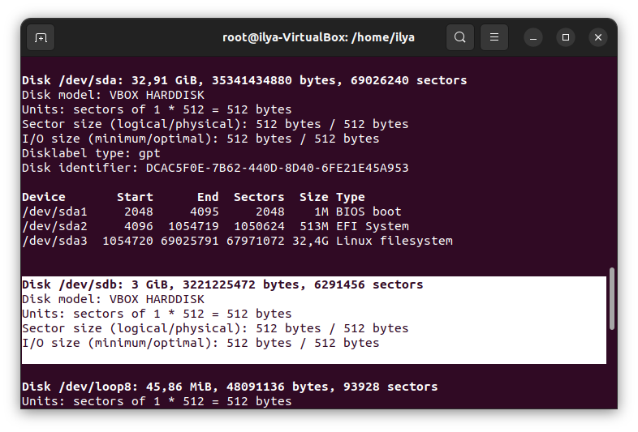
fdisk /dev/sdb – launch fdisk utility

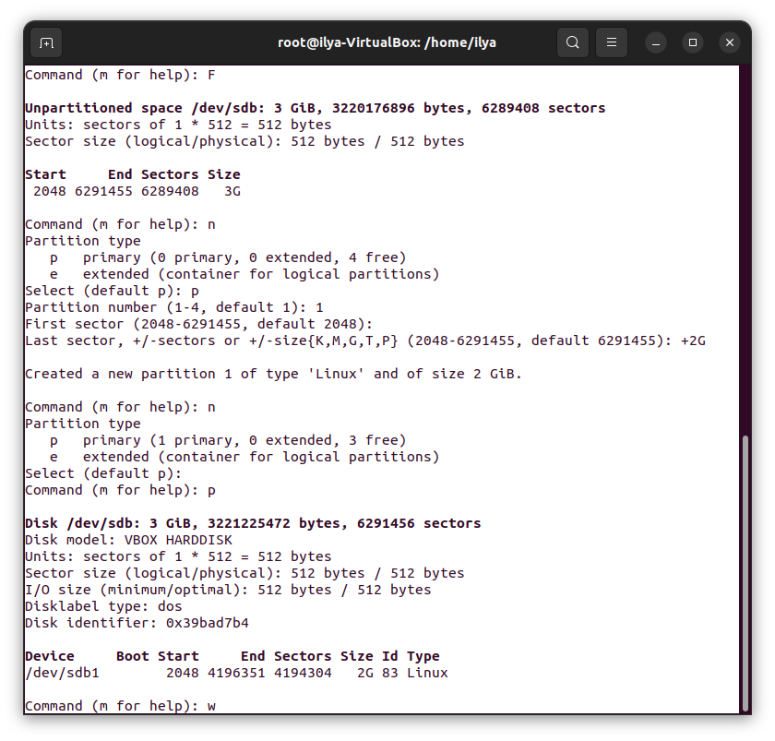
mount -t xfs /dev/sdb1 /mnt – mount device /dev/sdb1 with /mnt

apt install xfsprogs
mount -t xfs /dev/sdb1 /mnt
mkfs.xfs /dev/sdb1 - xfs file system to devsdb1
mount /dev/sdb1 /mnt

cd /mnt
nano TestText

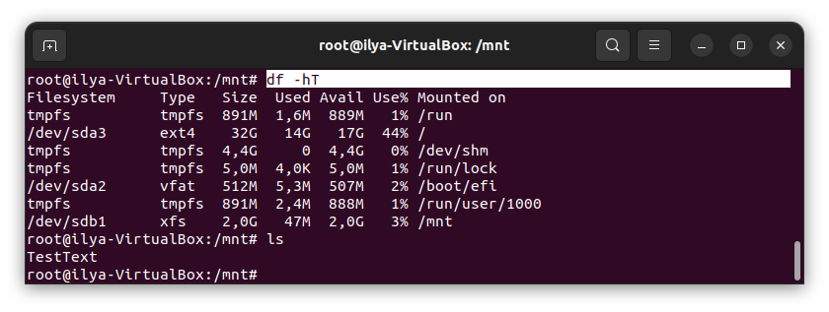
apt -y install cloud-guest-utils
growpart /dev/sdb1

3
nano testFile.txt
awk '! /SD/{print $0}' testFile.txt | awk '! /^A/{print $0}'

sed '/NSD/d' testFile.txt | sed '/D$/d'
4
cp /etc/passwd passwd
grep /bin/bash passwd | awk '{print ((NR-1)%3)+1 $0}' $1 >> newPasswd

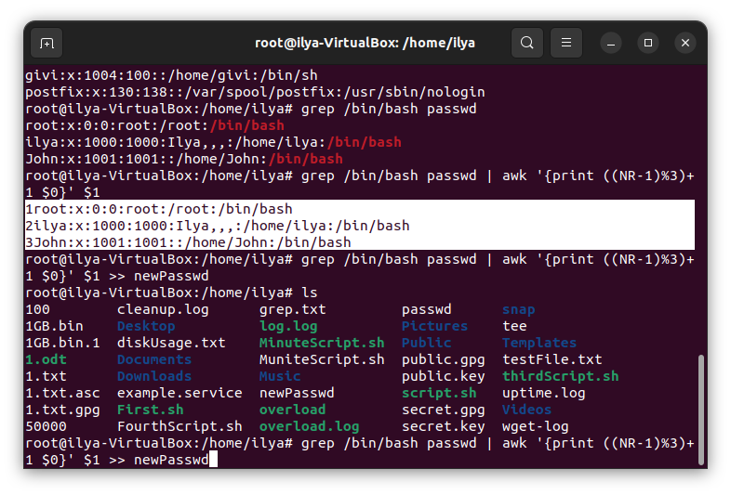
5
grep /bin/sh passwd | sed -i 's/sh/bash/g' passwd

