sudo apt update & upgrade

apt list --upgradable

sudo apt install telnetd -y

systemctl status inetd – to show status
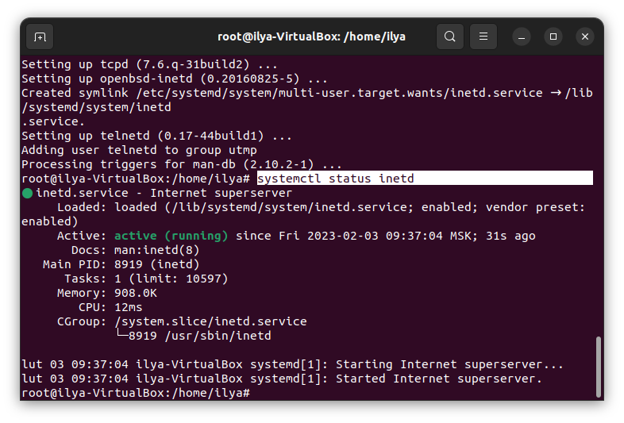
1
ufw allow 23/tcp – to open port23 in the ufw firewall
1
To enable firewall open /etc/ufw/ufw.conf

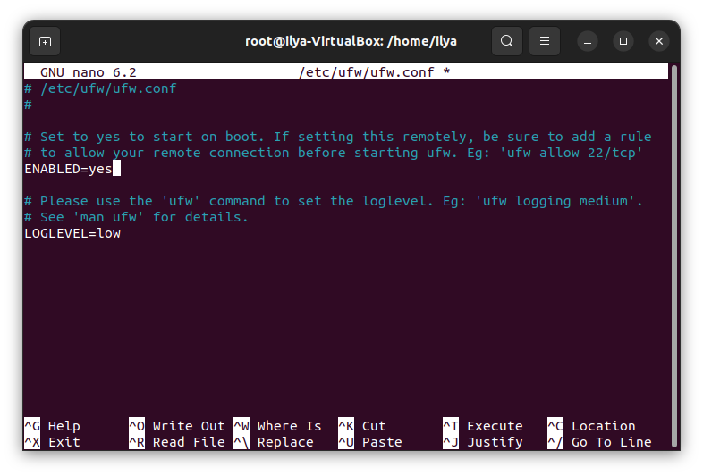
ufw reload – to reload firewall

apt install whois

whois google.com

ping google.com – to get ip adress usind domain name
PING google.com (64.233.164.138) 56(84) bytes of data.
64 bytes from lf-in-f138.1e100.net (64.233.164.138): icmp_seq=1 ttl=108 time=58.8 ms
nslookup google.com

telnet google.com 80

GET /search?q=devops

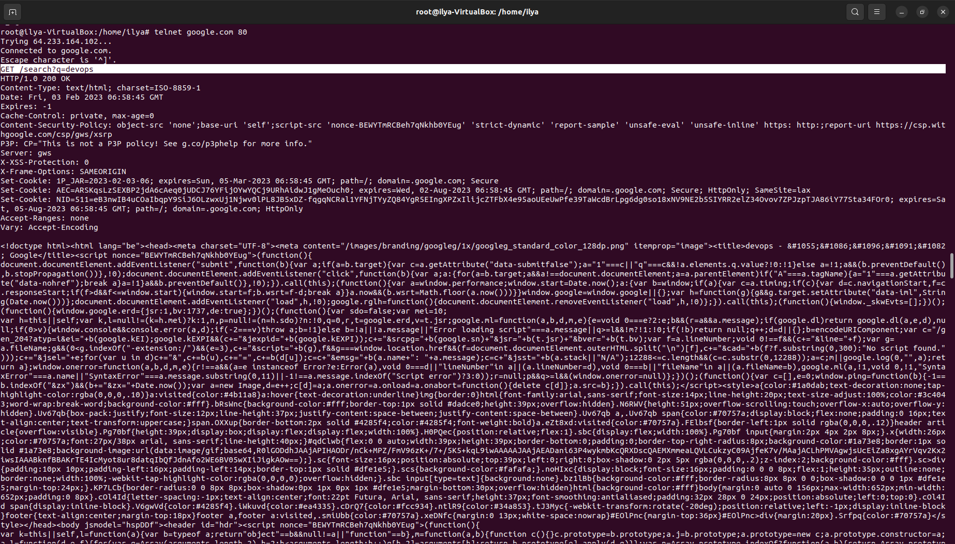
1

apt install curl
curl -k -L -s --compressed -X GET https://api.stackexchange.com/2.3/questions/4495473/answers\?order\=desc\&sort\=activity\&site\=stackoverflow

apt install jq – to work with JSON

curl -k -L -s --compressed -X GET https://api.stackexchange.com/2.3/questions/4495473/answers\?order\=desc\&sort\=activity\&site\=stackoverflow | jq '.items[].owner | {link}'

curl -k -L -s --compressed -X GET https://api.stackexchange.com/2.3/questions/4495473/answers\?order\=desc\&sort\=activity\&site\=stackoverflow | jq '.items[].owner | {link}' >> link

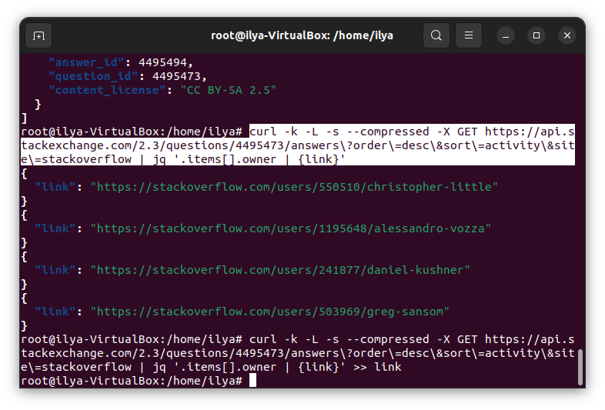
2
25334
https://stackoverflow.com/oauth?client_id=25334&scope=read_inbox,no_expiry,write_access,private_info&redirect_uri=https://stackapps.com

https://stackapps.com/?code=Do*ZfU6OUGpxiCN6jD26mw))

curl -d "client_id=25334&client_secret=9RLSQvbFuVnUyy8o*v7xrQ((&code=Do*ZfU6OUGpxiCN6jD26mw))&redirect_uri=https://stackapps.com" -X POST https://stackoverflow.com/oauth/access_token
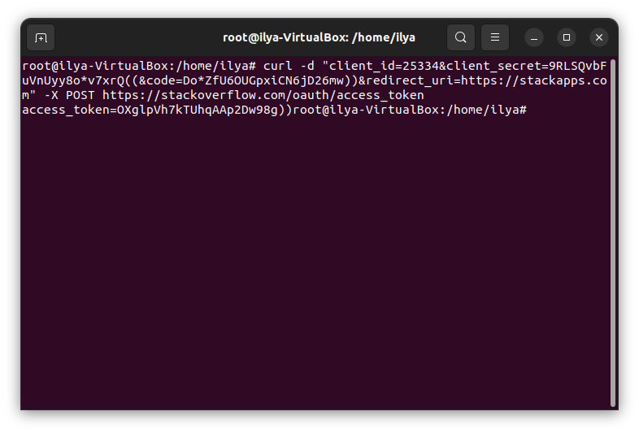
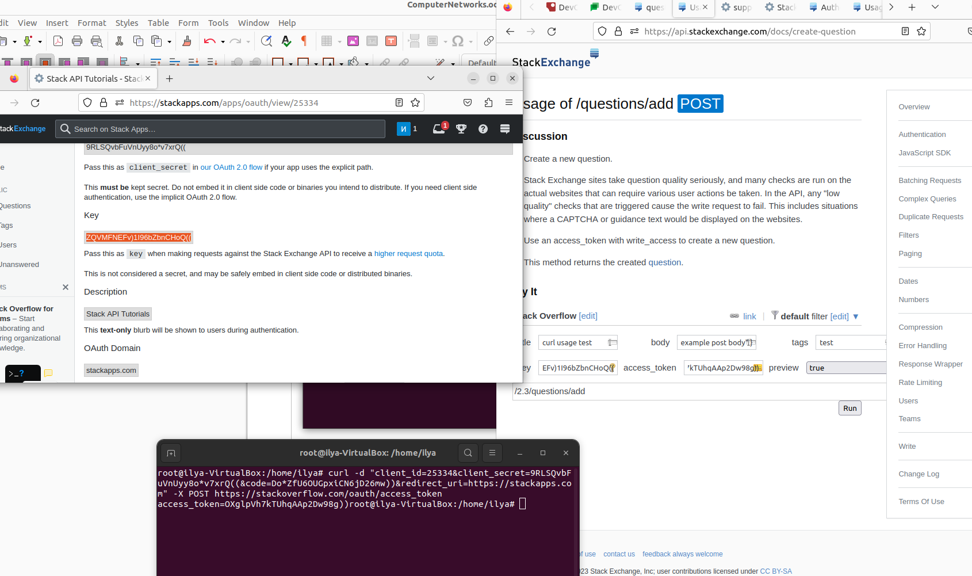
11
