mcedit /etc/systemd/system/example.service

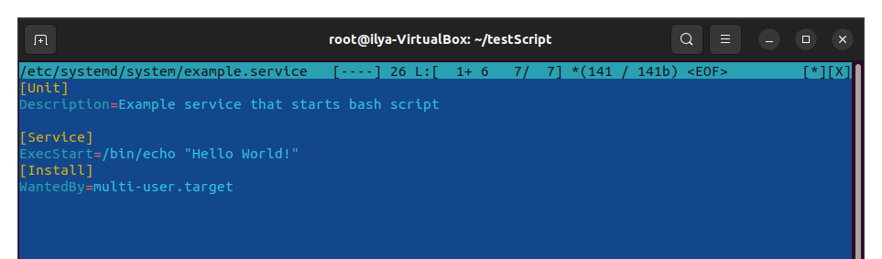
systemctl daemon-reload
systemctl start example.service
systemctl status example.service

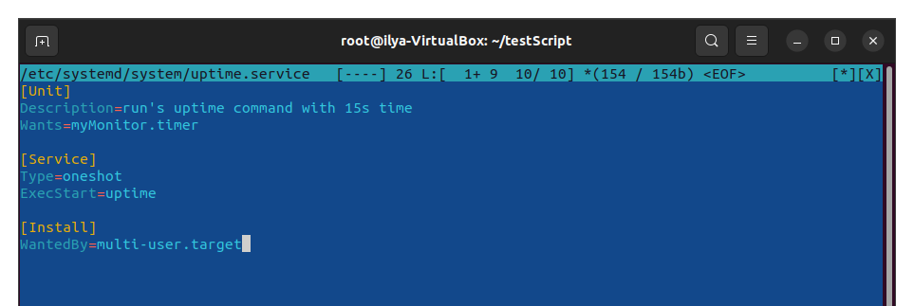
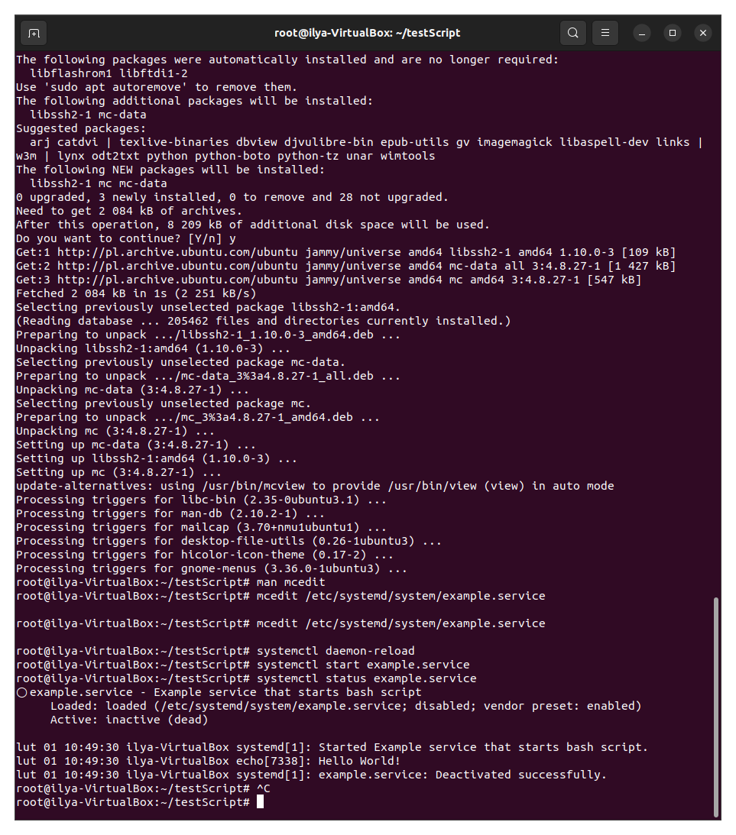
mcedit /etc/systemd/system/uptime.service

systemctl start uptime.service
root@ilya-VirtualBox:~/testScript# systemctl status uptime.service

mcedit /etc/systemd/system/mytimer.timer

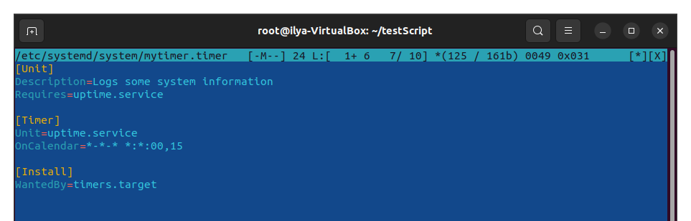
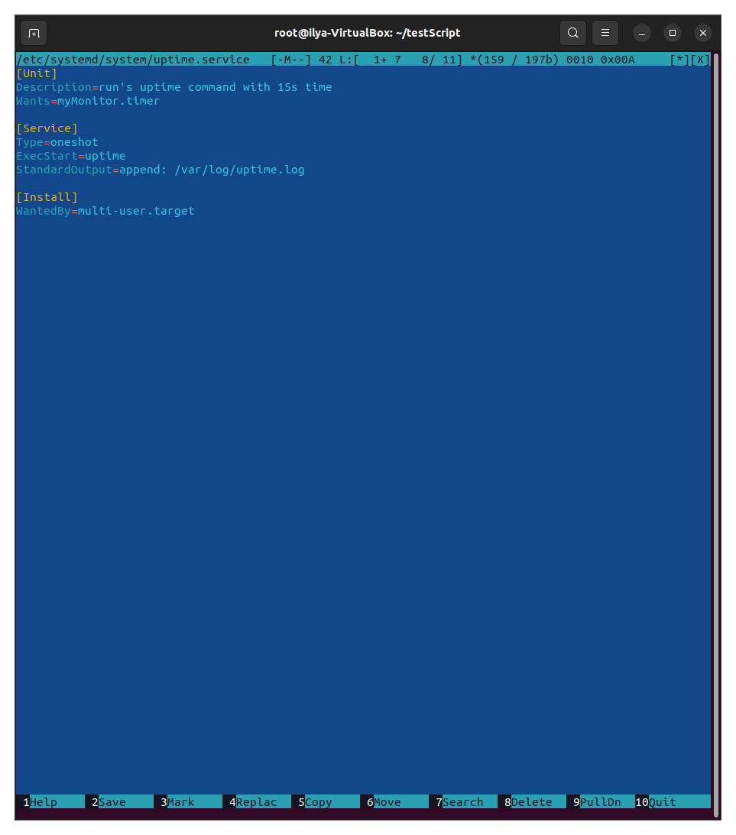
f $programname == 'uptime.service' then /home/ilya/uptime.log & stop
> systemctl restart rsyslog
> touch /home/ilya/uptime.log
> chown syslog /home/ilya/uptime.log
> ls -l /var/log/uptime.log
> systemctl restart rsyslog

date +%M

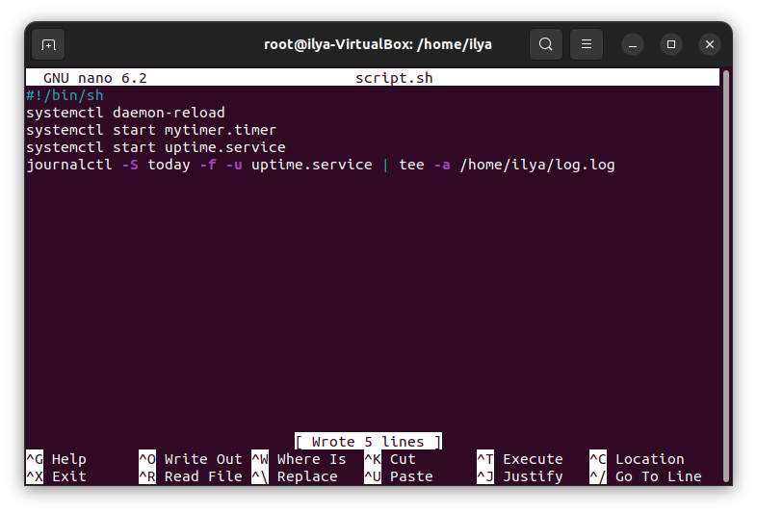
systemctl daemon-reload
systemctl start mytimer.timer
systemctl start uptime.service

journalctl -S today -f -u uptime.service | grep ':'$(date +%M)':'

journalctl -S today -f -u uptime.service | tee -a log.log
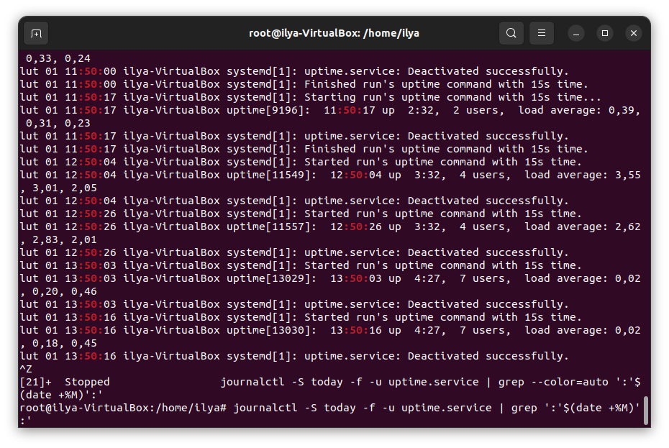
journalctl -S today -f -u uptime.service | tee -a log.log
grep ':'$(date )':'' log.log
grep 'average: 1' grep.txt

wget https://speed.hetzner.de/1GB.bin &
jobs
fg %1

crontab -e

grep CRON /var/log/syslog

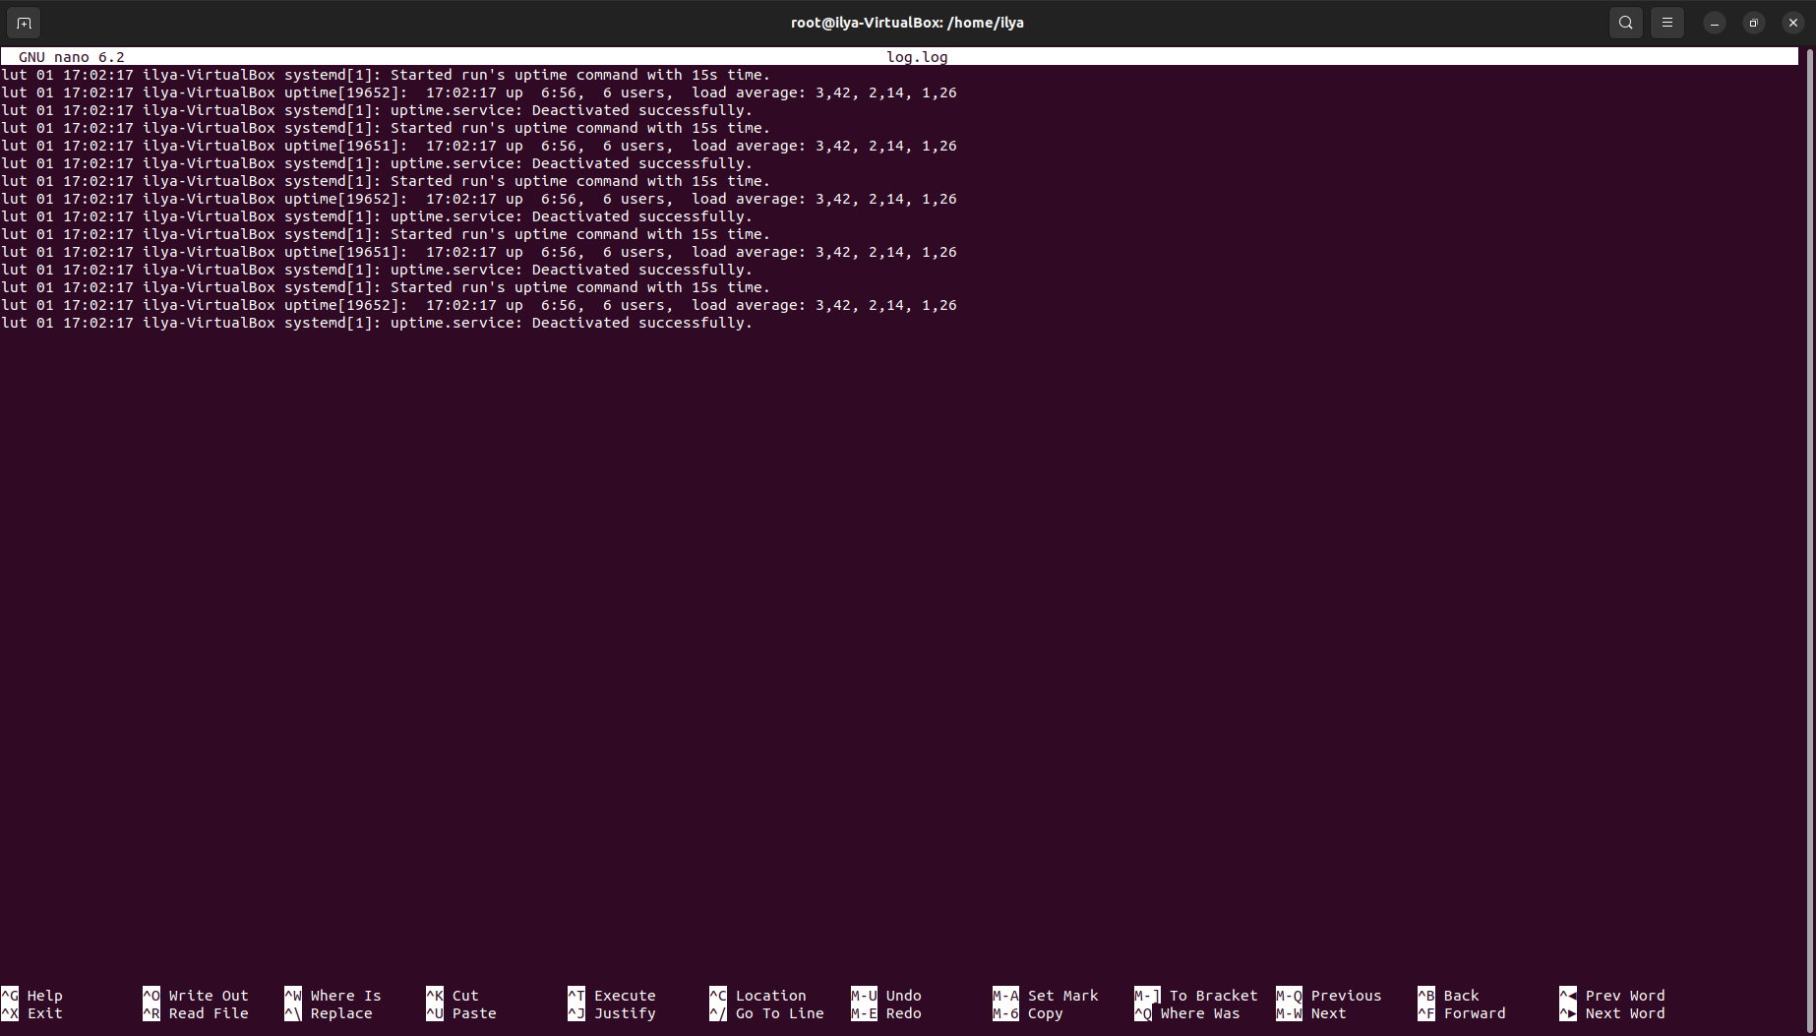
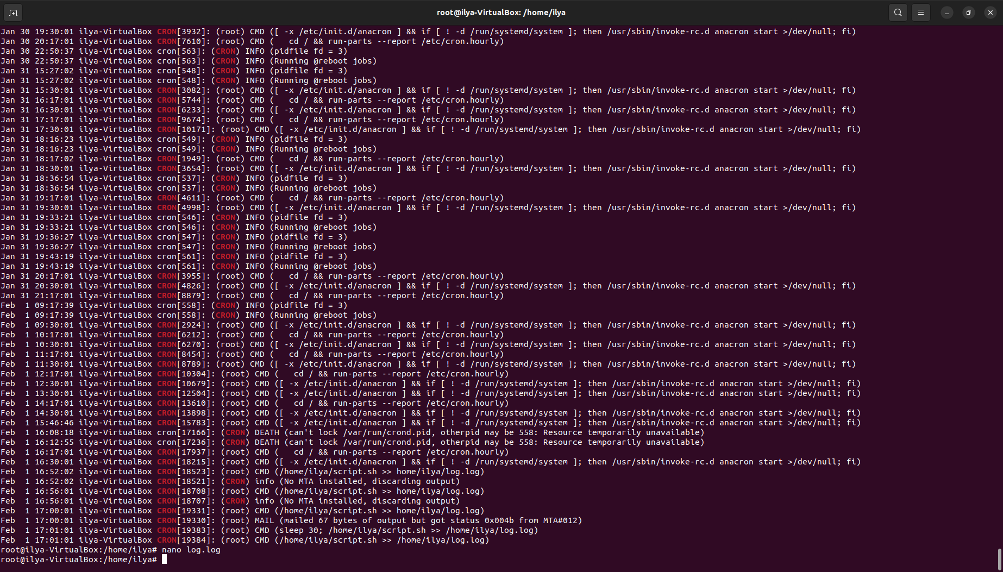
grep CRON /var/log/syslog – показывает все действия крон

записали в crontab -e

* * * * * /home/ilya/script.sh >> /home/ilya/log.log
* * * * * sleep 15; /home/ilya/script.sh >> /home/ilya/log.log

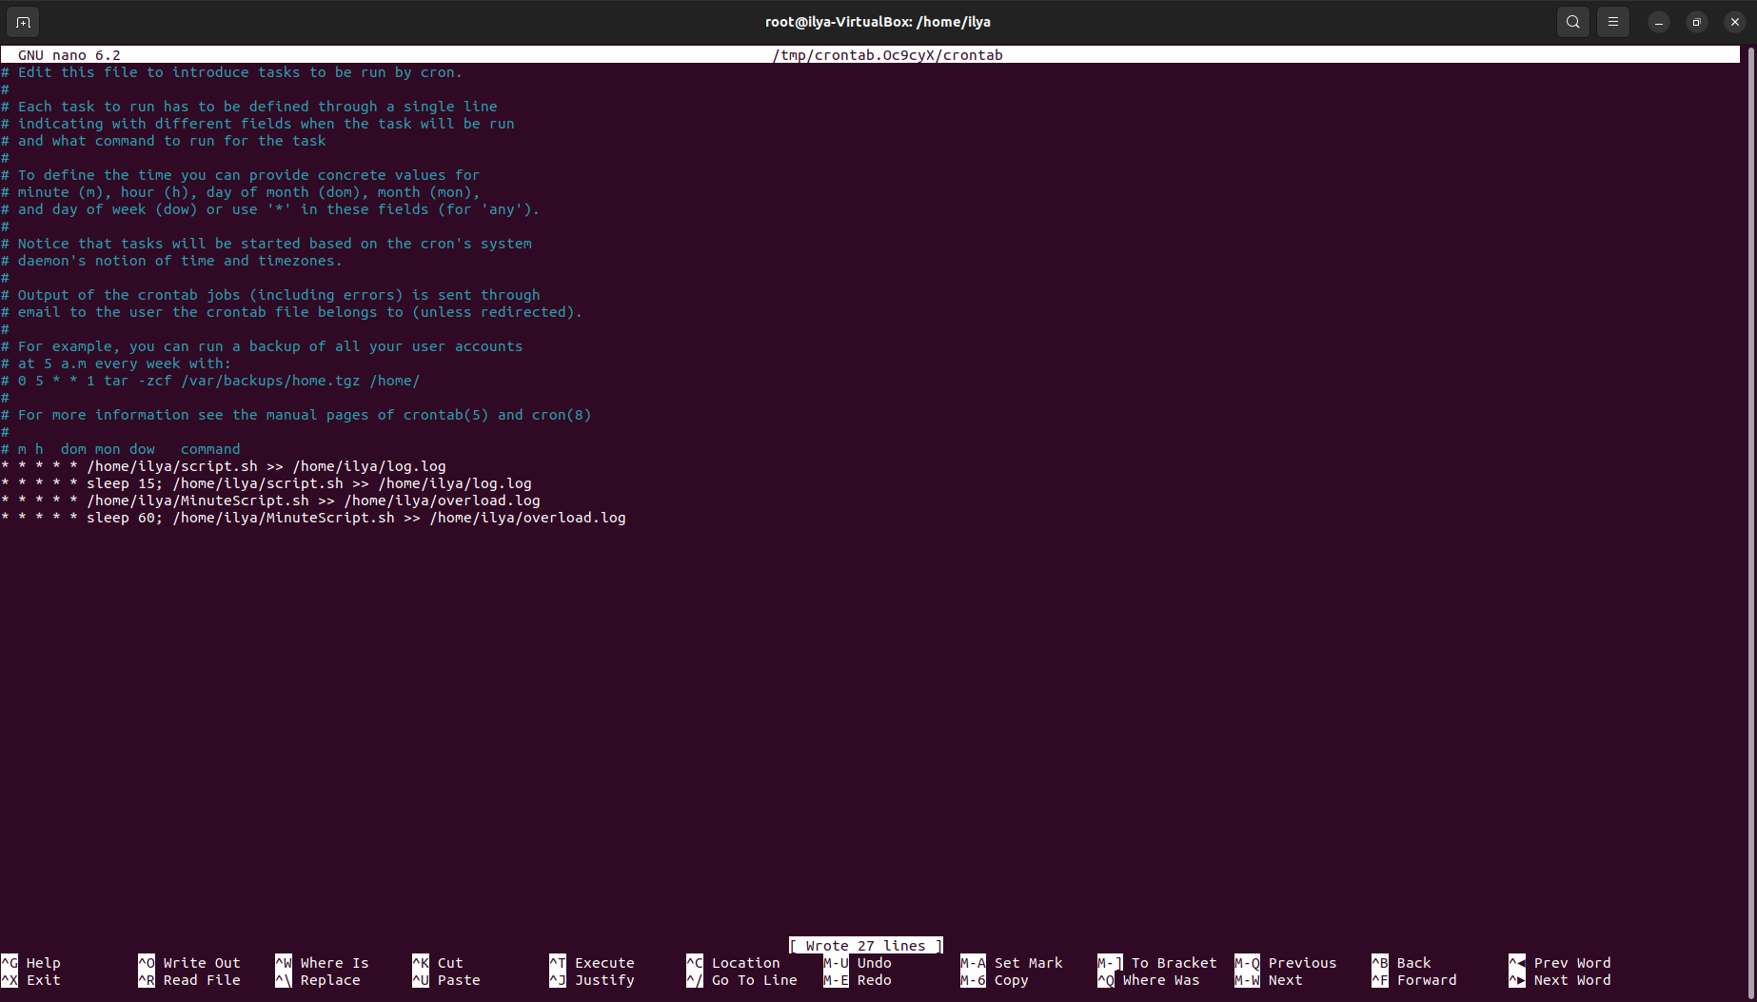
if statement
if [ "(wc -c overload.log > 50000)" ] ; then rm overload.log; echo $(date) >> cleanup.log; fi

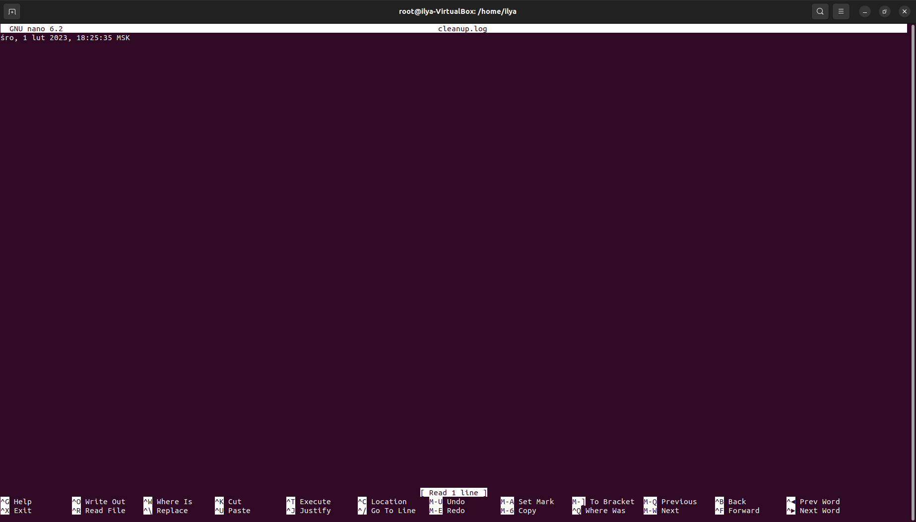
* * * * * /home/ilya/script.sh >> /home/ilya/log.log
* * * * * sleep 15; /home/ilya/script.sh >> /home/ilya/log.log
* * * * * /home/ilya/MinuteScript.sh >> /home/ilya/overload.log
* * * * * sleep 60; /home/ilya/MinuteScript.sh >> /home/ilya/overload.log
* * * * * /home/ilya/thirdScript.sh
* * * * * sleep 60; /home/ilya/thirdScript.sh
*/10 * * * * /home/ilya/FourthScript.sh
total crontab

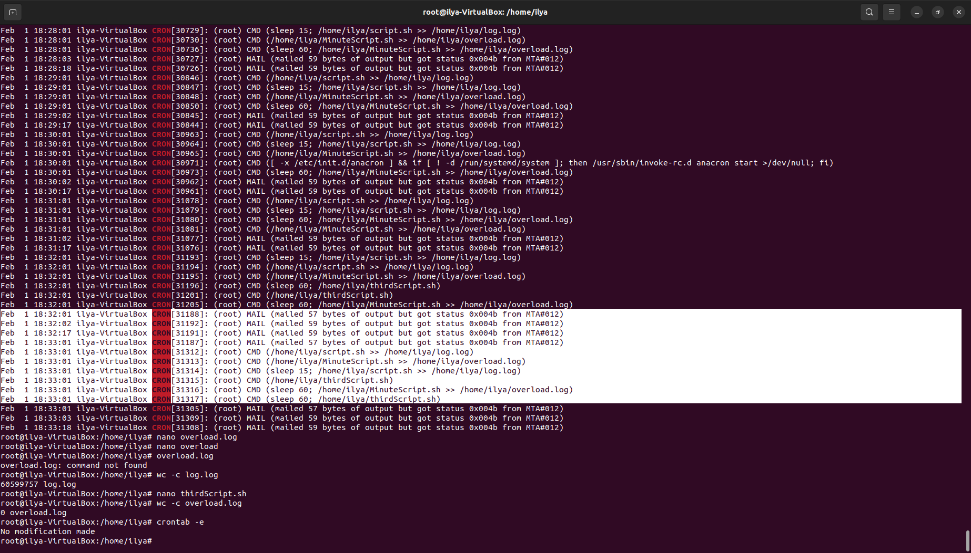
sudo apt install stress

stress --cpu 1 --timeout 10s

ping 8.8.8.8

ping 8.8.8.8 &

jobs
fg %6

kill &6

