Technical Report: Enterprise IoT Fleet Telemetry Integration
1. Executive Summary
This project delivers a robust, scalable middleware architecture designed to process real-time Internet of Things (IoT) fleet telemetry data and integrate it into SAP S/4HANA. The core objective was to ingest high-frequency vehicle coordinates and statuses, route the data intelligently based on real-time vehicle states, batch active records to minimize API calls, and maintain a historical audit trail for inactive vehicles.
Built on SAP Cloud Platform Integration (CPI), the solution handles complex payload transformations, enforces strict XML envelope formatting for SAP Multi-Mapping, and includes a global, automated exception-handling framework to ensure enterprise-grade reliability and proactive alerting.
2. System Architecture
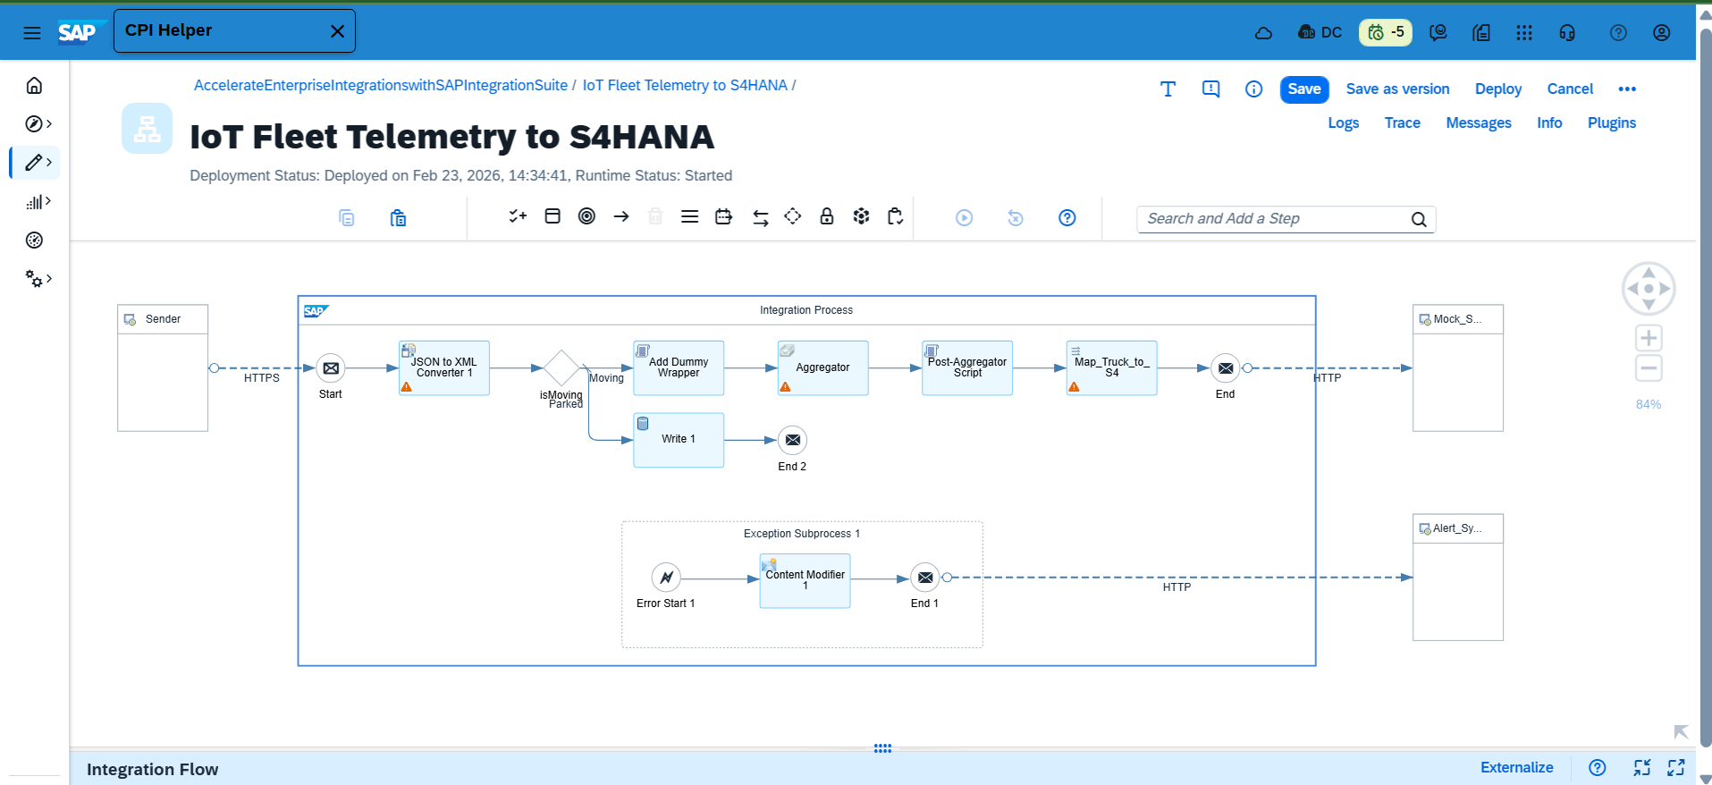
The architecture follows a standard Enterprise Service Bus (ESB) pattern, decoupling the IoT data producers from the ERP consumers.
- Data Producer (IoT Simulator): A customized Node.js application generating real-time JSON payloads containing vehicle coordinates, speeds, and statuses (MOVING, PARKED, END_OF_BATCH).
- Integration Middleware (SAP CPI):
  - Data Formatters: JSON to XML Converter.
  - Routing Engine: Content-Based Router utilizing XPath condition evaluation.
  - Batch Processor: CPI Aggregator step, configured to collect messages dynamically until an END_OF_BATCH trigger is received.
  - Custom Compute: Groovy scripting engine for strict SAP XI payload manipulation.
  - Transformation Engine: SAP Message Mapping for flat XML target generation.
  - Persistence Layer: CPI Data Store Operations for audit logging.
- Data Consumers: * Primary System: Webhook endpoint simulating the S/4HANA FleetUpdate OData/SOAP interface.
  - Alerting System: External HTTP webhook for automated JSON error notifications.
3. Implementation Timeline & Evolution
Phase 1: Initial Approach (ThingsBoard Integration)
The project initially leveraged ThingsBoard, a robust open-source IoT platform, to simulate a massive fleet of trucks. The goal was to test high-volume ingress directly into SAP CPI.
- The Pivot: While ThingsBoard provided excellent scale, generating predictable, deterministic edge-case scenarios (like forcing an exact sequence of specific truck states followed immediately by an end-of-batch trigger) proved overly complex. The middleware testing was bottlenecked by the simulator's rigidity.
Phase 2: Pivot to Deterministic Node.js Simulation
- Trade-offs & Lessons Learned: We traded the massive scale of ThingsBoard for the ultimate control of a custom Node.js script. This taught an important architectural lesson: when building complex integration routing, perfectly controlled test data is far more valuable than sheer volume.
Phase 3: Final Implementation (3-Truck State Routing)
The final architecture standardized around simulating three distinct truck states to test every integration branch simultaneously:
- Truck 1 & 2 (MOVING): Routed to the Aggregator, batched, mapped, and sent to S/4HANA.
- Truck 3 (PARKED): Routed to the Persistence Layer for audit logging.
- Trigger (END_OF_BATCH): Signaled the Aggregator to close the transaction and push the batch forward.
4. Technical Deep Dive
Routing Logic & State Management
The integration uses an intelligent XPath-driven Router immediately after JSON-to-XML conversion:
- //status='MOVING': Directs active telemetry to the Aggregator.
- //status='PARKED': Drops the payload from the active processing queue to preserve downstream bandwidth, routing it directly to a CPI Data Store (Parked_Trucks_Log) with the SAP_MessageTrackingID appended for historical auditing.
Advanced Payload Manipulation (The "Nuclear" Groovy Script)
To utilize SAP's Message Mapping engine for batched arrays (Multi-Mapping), the payload must be wrapped in a strict XI envelope (<ns0:Messages xmlns:ns0="http://sap.com/xi/XI/SplitAndMerge"><ns0:Message1>). However, the CPI Aggregator dynamically wraps batched payloads in its own unpredictable tags (e.g., <multimap:Messages>).
A robust Groovy script was engineered to bypass brittle XML parsing. Using regular expressions (Pattern.compile("<TruckGeo>.*?</TruckGeo>")), the script surgically extracts only the raw data blocks from the Aggregator's output and manually reconstructs a pristine, byte-for-byte compliant SAP XI envelope from scratch, guaranteeing the Message Mapping engine never fails due to malformed root nodes.
Global Exception Handling
A specialized Exception Subprocess was implemented to catch runtime, mapping, and network errors globally. If the downstream system goes offline (simulated via forced HTTP 404/500 errors), the subprocess intercepts the failure, extracts the system error via ${exception.message}, dynamically captures the flow ID (${camelId}), and POSTs a clean, actionable JSON alert to a designated support webhook.
5. Challenges & Solutions
- Challenge: Aggregator vs. Multi-Mapping Envelope Conflicts. The CPI Aggregator step continually stripped, modified, or nested our custom XML envelopes, causing the subsequent Message Mapping to throw IllegalInstanceException errors due to missing target elements.
- Solution: Iterative debugging revealed that standard DOM parsing was too brittle against the Aggregator's native behavior. The solution was the aforementioned Regex-based Groovy script. By treating the Aggregator output as a raw string rather than a strict DOM object, we achieved 100% reliable envelope generation, completely neutralizing the conflict.
- Challenge: Namespace Binding Exceptions. Early attempts to inject the ns0 tags resulted in SAX parser crashes because the namespace was undeclared in the parent wrapper.
- Solution: Hardcoded the xmlns URI directly into the reconstructed payload string prior to mapping evaluation.
6. Key Learnings & Insights
- Defensive Integration Design: Never trust the output of a native integration step (like an Aggregator) to perfectly match the input requirements of another (like Multi-Mapping). Intermediate, defensive compute steps (Groovy/XSLT) are essential.
- Proactive vs. Reactive Support: Implementing a global Exception Subprocess that translates complex Java stack traces into actionable JSON alerts drastically reduces Mean Time to Resolution (MTTR) for production outages.
- Decoupling for Performance: Routing 'Parked' telemetry directly to a database instead of processing it through the main mapping engine proved that optimizing payload traffic at the earliest possible node saves critical system memory and processing power.
7. Portfolio Value Statement
This project demonstrates a senior-level command of enterprise middleware architecture, specifically within the SAP ecosystem. It highlights an ability to go beyond basic API connections to architect complex, state-driven routing and batched data processing. By engineering custom scripts to overcome native system limitations and implementing global, automated error-alerting frameworks, this work proves a capacity to design integrations that are not just functional, but highly resilient, deeply auditable, and production-ready.

Appendix A: Glossary of Key Technical Terms
- Enterprise Service Bus (ESB) A middleware architecture pattern that centralizes and manages communication between disparate software applications. Instead of point-to-point connections, systems interact through the ESB, which handles routing, protocol mediation, and data transformation, thereby decoupling producers from consumers.
- SAP S/4HANA SAP’s flagship Enterprise Resource Planning (ERP) suite, built on an advanced in-memory database. In this architecture, it serves as the ultimate system of record and consumer of the fleet telemetry data.
- SAP Cloud Platform Integration (CPI) SAP's cloud-based enterprise integration middleware (part of the SAP Integration Suite). It provides the execution environment for the ESB pattern, orchestrating the end-to-end data pipeline, API management, and message processing.
- SAP XI Multi-Mapping An advanced message mapping pattern within the SAP ecosystem. It allows a single integration step to process an array of multiple source messages (a batch) and map them into a single target structure. It requires strict adherence to SAP's proprietary XML envelope formats (e.g., ns0:Messages).
- XPath (XML Path Language) A standardized query language used to select and evaluate nodes within an XML document. Within this project, XPath serves as the core evaluation engine for the Content-Based Router, dynamically inspecting vehicle telemetry to determine downstream processing paths.
- Groovy Scripting An agile, dynamic, object-oriented programming language native to the Java Virtual Machine (JVM). SAP CPI leverages Groovy to allow developers to write custom compute logic for scenarios where native UI components are insufficient—utilized in this project for aggressive payload manipulation and dynamic XML reconstruction.
- OData / SOAP interfaces Standardized web service protocols used by SAP to ingest external data. OData represents a RESTful approach based on HTTP and JSON/XML, while SOAP is a highly structured XML-based messaging protocol.
- Content-Based Routing An integration design pattern where a single input channel is intelligently divided into multiple output channels based on the evaluated content (the payload data) of the message itself, rather than just its header or origin.
- Data Store Operations A persistence capability within SAP CPI used to temporarily or permanently write message payloads to the tenant's internal database. In this architecture, it is utilized as an asynchronous audit logging mechanism for low-priority (parked) vehicle data.

