📄 Technical Specification: Sales Order Ingestion Interface
Project Name: Sales Order Ingestion
Developer: Iain Leroy Mphepo
Date: January 16, 2026
Platform: SAP Integration Suite (Cloud Integration)
1. Executive Summary
This interface automates the ingestion of legacy sales data from an on-premise SFTP server. It retrieves bulk CSV files via the SAP Cloud Connector, transforms the data into a standardized Finance XML structure, enforces strict data validation (e.g., numeric checks), and splits the bulk data to distribute individual order notifications to the Finance Department via email. It also features a robust exception handling mechanism that routes system alerts to IT Support and archives processed files for auditability.
2. Integration Flow Diagram
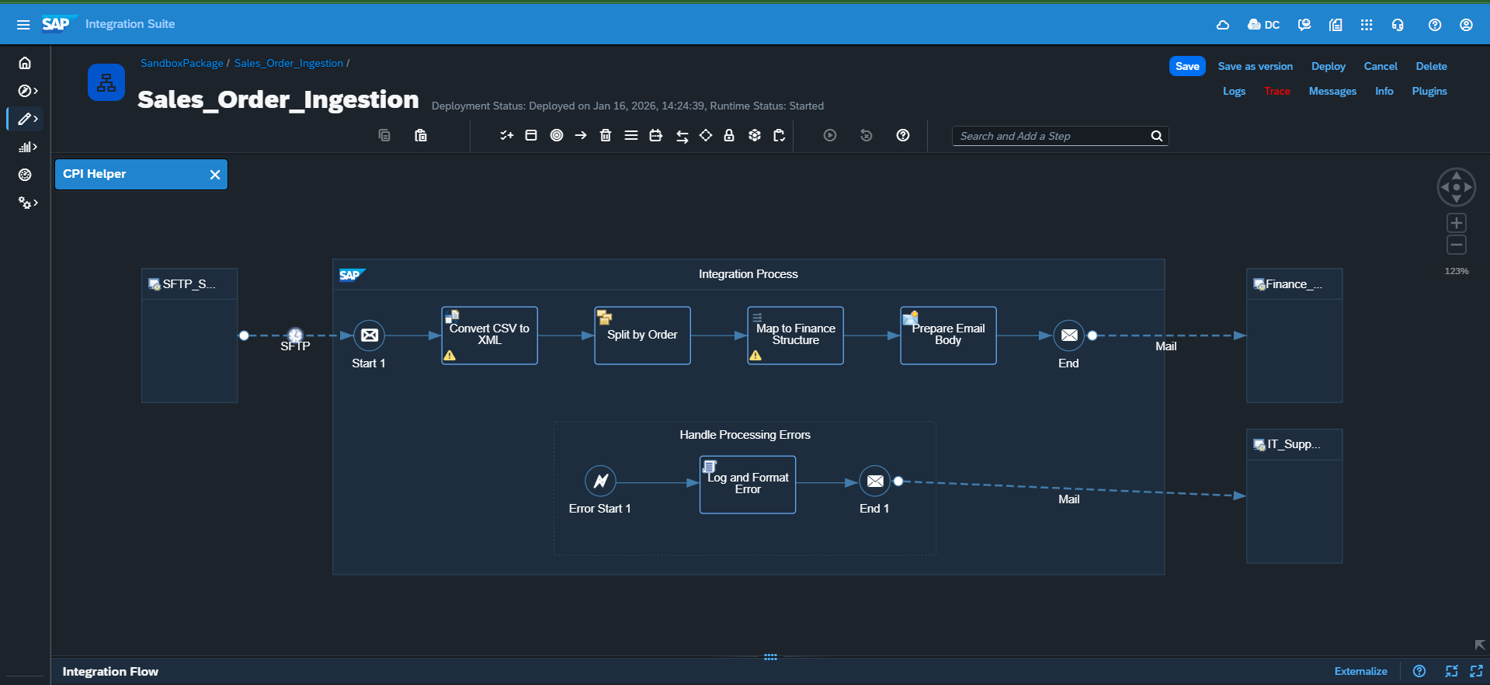
Logic Flow:
Polling (SFTP) → Convert Format (CSV to XML) → Split (Iterating) → Map & Validate → Deliver Order (Email) → Archive File
(Exception Path: Error → Groovy Log → Alert Email)
3. Component Details
A. Sender (Trigger)
- Type: SFTP Adapter
- Directory: /inbox (User Root)
- File Pattern: sales_order.csv
- Post-Processing: Move File (to archive folder)
- Duplicate Handling: Append Timestamp
B. External Service (Source)
- Provider: SFTP Server (Linux/Unix)
- Format: Comma Separated Values (CSV)
- Input Fields: OrderID, Customer, Amount, Currency
C. Transformation & Logic
- Converter: CSV to XML (Root: Orders)
- Splitter: Iterating Splitter (Group: 1, XPath: //Order)
- Message Mapping: Map_to_Finance_Structure
- Validation: Strict formatNumber function on the "Amount" field. Throws java.lang.NumberFormatException if invalid.
- Custom Logic (Groovy Script):
  - Function: Log and Format Error
  - Purpose: Captures raw exception details during a crash and attaches them as a log file (Error Details.txt) to the Message Monitor for forensic analysis.
D. Receiver (Target)
- Adapter: Mail (SMTP)
- Receiver 1 (Success): Finance Team (finance-dept@company.com)
- Receiver 2 (Failure): IT Support (integration-support@company.com)
- Output: HTML Email with dynamic content (Order ID, Total Cost).
4. Challenges & Resolutions
Challenge | Resolution
Infinite Processing Loop | The SFTP adapter repeatedly processed the same file because the "Move" command failed due to absolute path permissions. Resolution: Changed the Archive Directory configuration to use a relative path (archive) and corrected Linux folder permissions.
Data Quality Validation | Non-numeric data in the "Amount" field caused silent failures. Resolution: Implemented a standard formatNumber function in the mapping to force a hard failure, which is then caught by the Exception Subprocess.
Permission Denied (Move) | The SFTP user lacked write access to the archive folder. Resolution: Executed chmod 777 archive via SSH to grant full write permissions¹.
5. Testing Evidence
Status: ✅ Deployed & Verified
Test Tool: SSH / Linux Command Line
Result:
- Permission Fix: Successfully modified folder permissions using chmod 777 archive to ensure writability².
- File Movement: Verified via ls command that sales_orders.csv was successfully processed and moved to the archive directory³.
- Notification: "New Order Processed" emails received in Gmail inbox⁴.

