📄 Technical Specification: Weather-to-Order Interface
Project Name: OpenMeteo Weather Order Generation
Developer: Iain Leroy Mphepo
Date: January 8, 2026
Platform: SAP Integration Suite (Cloud Integration)
1. Executive Summary
This interface automates the creation of a mock "SAP Order" based on real-time weather conditions. It retrieves live weather data for a specific geolocation, transforms the data into an SAP-compliant XML order format, assigns a unique Order ID via custom logic, and routes the final order to an email recipient.
2. Integration Flow Diagram
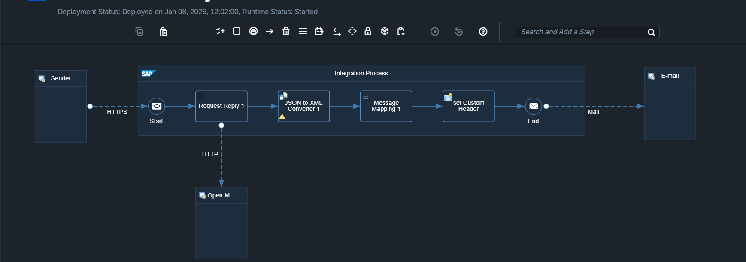
Logic Flow:
External Trigger (HTTP) → Fetch Weather (API) → Convert Format (JSON to XML) → Map Data & Logic → Deliver Order (Email)
3. Component Details
A. Sender (Trigger)
- Type: HTTPS Adapter
- Address: /http/getWeatherForecast
- Method: GET
- Tool Used: Postman
B. External Service (API)
- Provider: OpenMeteo
- URL: https://api.open-meteo.com/v1/forecast
- Query Parameters:
  - latitude: 52.52
  - longitude: 13.41
  - current_weather: true
- Method: GET
C. Transformation & Logic
- Converter: JSON to XML (Root: WeatherReport)
- Message Mapping: WeatherReport_to_SAPOrder
  - Source XSD: Source.xsd (configured with xs:all for flexible validation).
  - Target XSD: SAP_Order.xsd
- Key Mappings:
  - current_weather/temperature → Value
  - current_weather/time → Date
- Custom Logic (Groovy Script):
  - Function: getRandomID
  - Purpose: Generates a unique 6-digit order number (e.g., ORD-84921).
  - Code Snippet:
Groovy
import java.util.Random;
def String getRandomID(String input){
Random rand = new Random();
return "ORD-" + Math.abs(rand.nextInt() % 999999);
}
D. Receiver (Target)
- Adapter: Mail (SMTP)
- Provider: Gmail (smtp.gmail.com:587)
- Security: STARTTLS / App Password Authentication
- Output: Email with XML payload attached.
4. Challenges & Resolutions
Challenge | Resolution
Random Number Generation | Standard palette lacked a random function. Developed a custom Groovy script (java.util.Random) to generate unique IDs.
Strict XML Validation | The Source XSD failed simulation due to field sequence errors. Updated XSD to use xs:all and minOccurs="0" to allow flexible field ordering.
Email Authentication | Standard password auth failed. Implemented Google App Passwords and stored credentials in SAP Security Material.
5. Testing Evidence
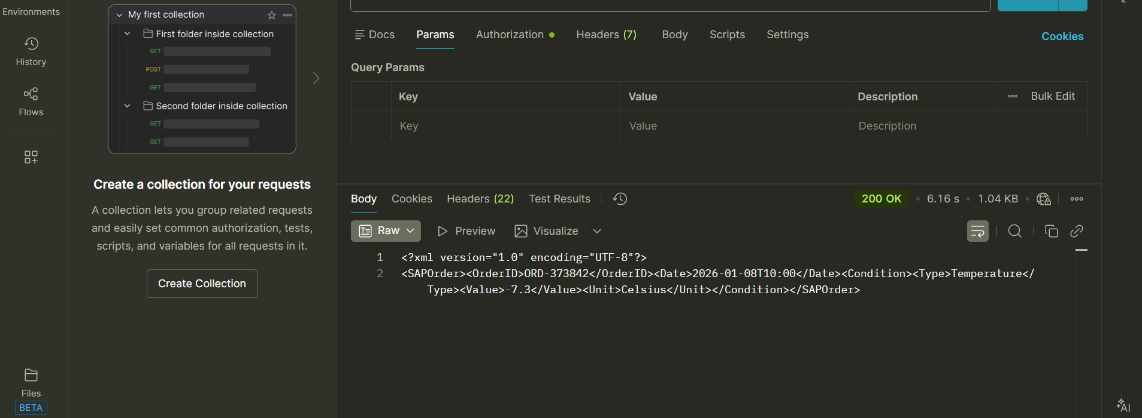
- Status: ✅ Deployed & Verified
- Test Tool: Postman
- Result: HTTP 200 OK
- Verification: Email received with correct Subject Line and XML body containing live temperature data.

