
OurCRMTool

Content
Main Form
1. User Settings Update
2. Security Roles Analyzer
3. Roles Not Assigned
4. Compare Roles
5. Default Team Selector (relevant just for XNES)
6. Re-Set Default Teams (relevant just for XNES)

Main Form
The Main allow the user to connect to the organization wanted, and will show all the tools available in the application.

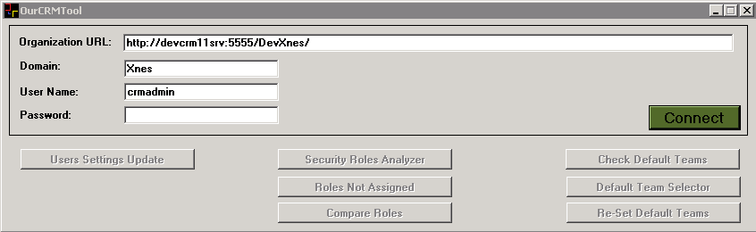

In order to connect, fill the fields as shown in the picture and Press Enter or click in the "Connect" button.
If the connection is successful, will make the tools available for you.

Available tools:
- User Settings Update – Allow bulk update of user settings
- Security Roles Analyzer – Analyze privilege by Entity
- Roles Not Assigned – Show roles that are not assigned to anyone
- Compare Roles – Compare privilege from two roles
- Check Default Teams (relevant just for XNES) – check users that have specific default team
- Default Team Selector (relevant just for XNES) – Assign default team by List of possible default teams
- Re-Set Default Teams (relevant just for XNES) - Delete and re assign default teams for users

General tips:
- In all form's title you can see the organization that you are connected
- In most of the grids, doing DoubleClick will open the record selected

User Settings Update

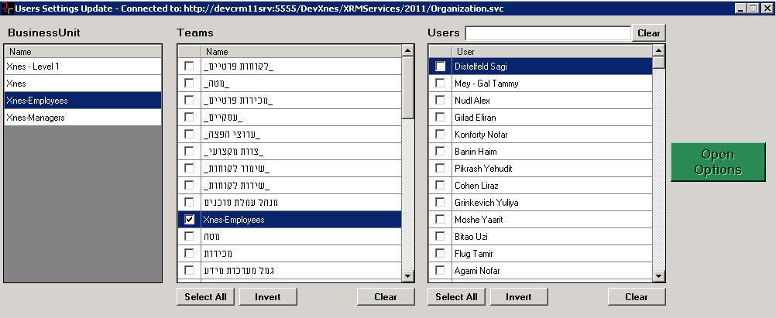

First form when selected "User Settings Update" tool will show 3 grids, to enable the selection of the users to update it's settings.
Choose a Business Unit, then choose a Team and you will get all the users from the selected team.
You can choose more than one team and get the total users from all the checked teams.
You can user the "Select All", "Invert" and "Clear" button in the Team's and User's grid to make the selection.
With the user's search bar you can search for a specific user.
After checked the users where you want to update their settings the "Open Options" button will be enable.
(You can always come back to change the selected users without need to close the second form, the update will occurred to the selected users when press the "Update" button in the second form

Pressing the "Open Options" will open this form:
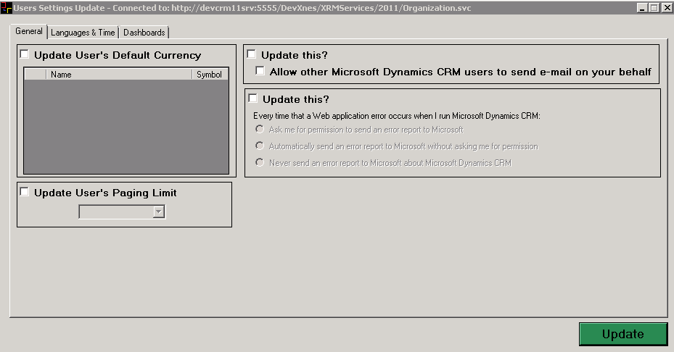
Checking the corresponding checkbox will make enable the wanted section.
The form is divided by Tabs:
- General tab
  - Allow to set the Default User's currency
  - Allow send emails on behalf off
  - How reports errors

- Languages & Time
  - User's Interface language
  - User's time zone
  - Start and Entiy user's time
- Dashboards
  - Set start page the Dashboards
  - Set the default dashboard to show
The options you will get here are all the public dashboards and the private dashboards from the users that is connected to the program.
If you add/remove a dashboard, user the refresh button to refresh the options in this page.

Press the "Update" Button to update the selections in the selected users.

Security Roles Analyzer
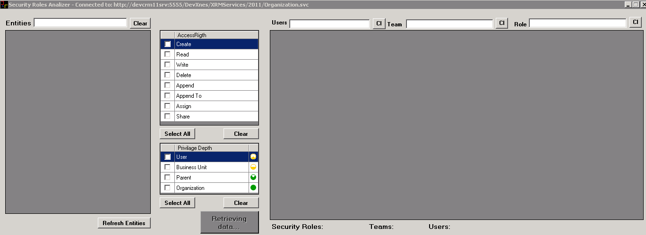

This tools allow the user to analyze the privilege that the users/team have over a selected entity.
(It can take a few second to upload completely, be patient because is retrieving all the entities in the system, when is done you will see the "Retrieving data…" button will change and the grid with the entities will be filled out)

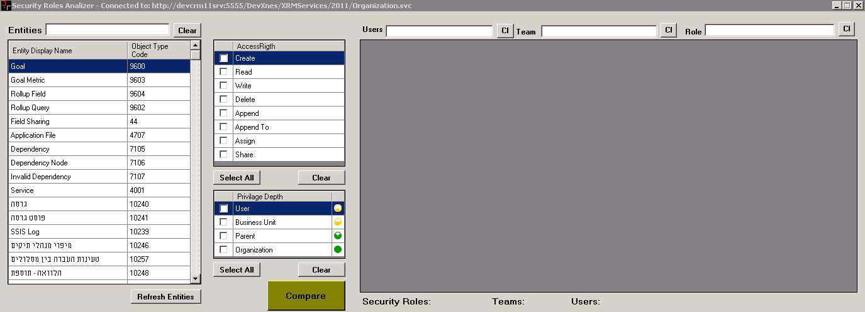

- Select the entity (mark with blue) that you want to know how can access (you can use the Entity search box).
- Then select the Access Rigth that want to check: "Create", "Read", "Write", "Delete", "Append", "AppendTo", "Assign" and "Share" (you can user the "Select All" and "Clear" button)
- You also have to select the Depth of the privilege you want to check: "User", "Business Unit", "Parent", "Organization" (you can user the "Select All" and "Clear" button)
- When press the "Compare" button you will get a list off Users/Teams/SecurityRoles that have the selected access right to the selected entity
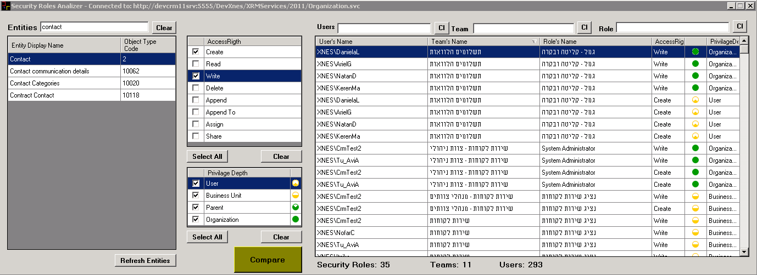

With the searchBoxes you can help yourself to find a specific User/Team/Role.
The "Cl" button next to each searchbar will clear the search.
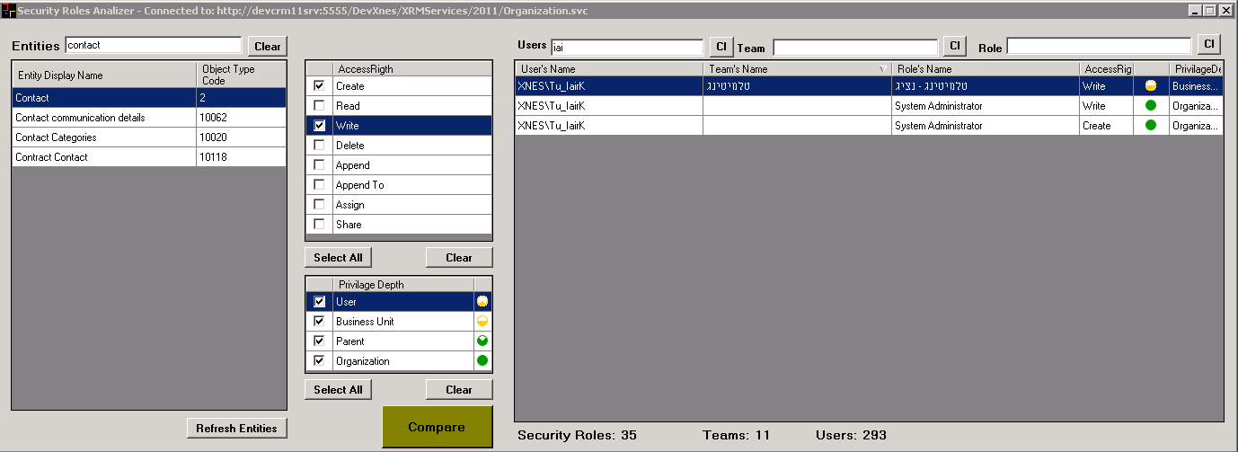

In this example you find out that XNES\Tu_IairK has Write privilege all the contact records in the Business Unit, and he got this privilege because he is part of the team "טלמוטינג".
XNES\Tu_IairK also has "System Administrator" role that give him Write and Create privilege for all the contact records in the organization.

Tip: Sometimes you can find a Team or role that has no User next to it, like in the next picture.
That means that the Team/Role has the asked privilege but is not assigned to anyone
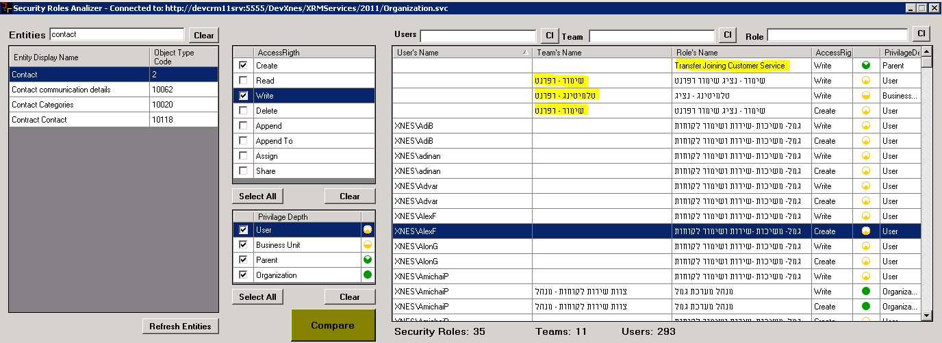

Tip: If you do double click in a specific User/Team/Role cell, it will open the record in the CRM

Roles Not Assigned
This tool will show you all the roles that are not assigned to anyone.
If do double click in a row, it will open the record in the CRM
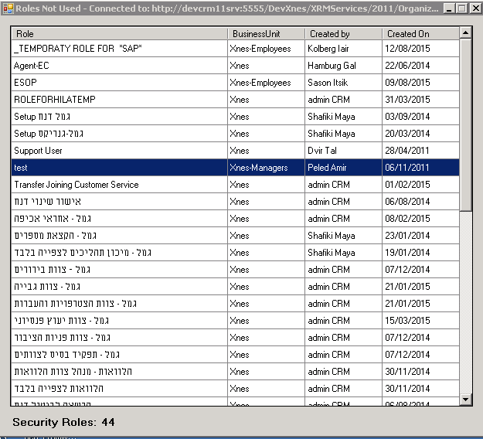

Compare Roles
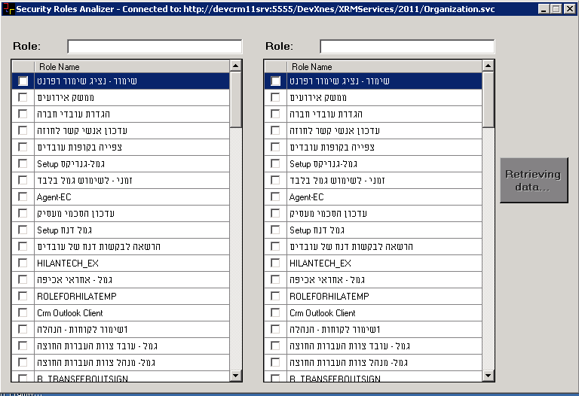

Tool to compare two roles in the system.
The first form showen will show you 2 identical grids with the roles in the system
("Retreving data…" is showen, but you can search for the needed roles in the midle time until all the needed data is retreived)
Check the roles you want to compare (help yourself with the roles search box), after select, if all the data is ready to be used you will be able to press the "Compare" button

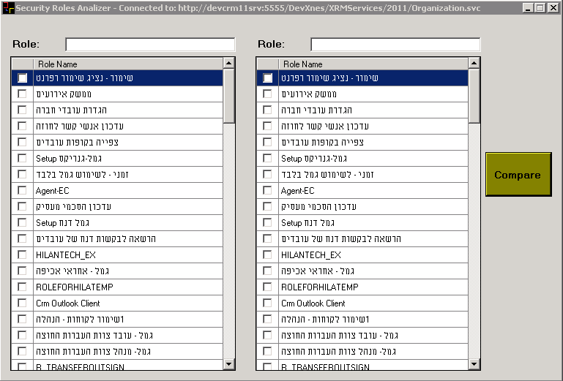

When press the "Compare" button you will get a form to compare the 2 selected roles:
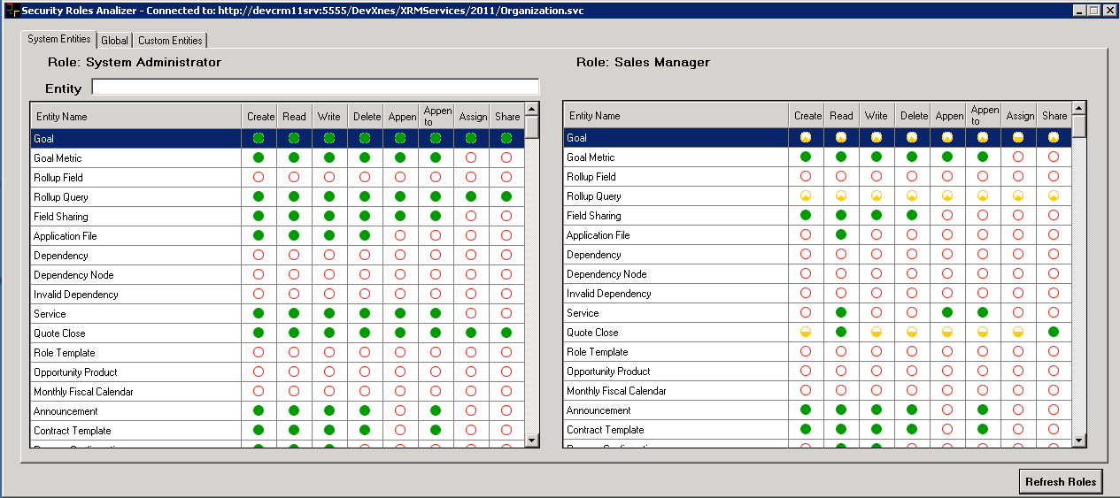

This form is divided on Tabs:
- System Entites – that will show the privilege related to a system entity (as shown in the picture before this)
- Global – Show you the global privilege, that are not related to an entity
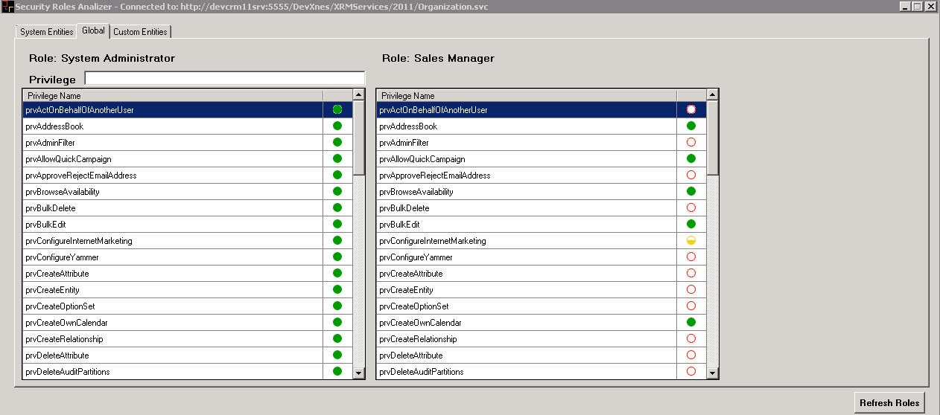
- Customer Entites – Show you the privilege for custom entities as show in the next picture
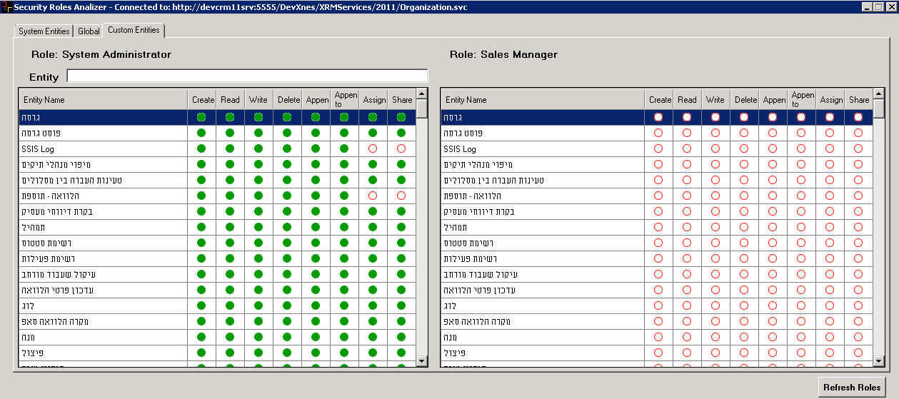
All the tabs are similar:
At the top of each grid you will the name of the role that you are compare
(Do double click to open the role in CRM)
There is also a search box to help you find the wanted privilege.
(The grids are synchronized, to make it easier to compare the two roles)
Tip: If you want to update a role, do double click in the role's name, update the role in the CRM and then press the "Refresh Roles" button to see the changed in the tool

Default Team Selector (relevant just for XNES)

Re-Set Default Teams (relevant just for XNES)

