AMORE Website Guide - Usability Test
  - Testing the Guide Document
Behavioral Neuroendocrinology Lab
2025-11-18
Table of contents

1. Test Objective
This is a usability test to evaluate whether the “Guide for Managing AMORE Website” document is clear and comprehensive enough for lab members to successfully create project pages.
Your task: Create a dummy Living Meta-Analysis (LMA) project page using ONLY the guide document for instructions.

1.1 Purpose
- Test if the guide provides sufficient information
- Identify gaps or unclear sections
- Improve documentation before full rollout

1.2 Important Notes
- The guide is still under development - finding unclear parts helps improve it!
- This is NOT a test of your abilities - it’s a test of the documentation
- If something is confusing, that’s valuable feedback!

2. Before You Begin

2.1 What You’ll Need

2.1.1 Software & Access
- ✅ RStudio installed on your computer
- ✅ Git - You need Git installed locally (not just browser access)
  - Check if installed: Open Terminal/Command Prompt and type git --version
  - If not installed, download from: https://git-scm.com/downloads
- ✅ GitHub account with collaborator access to iaiversen/AMORE-webpage
- ✅ The AMORE Guide PDF (the document is saved in Teams)

2.1.2 Verify Your Access
- Go to: https://github.com/iaiversen/AMORE-webpage
- You should see the repository (not a 404 error)
- You should be able to click on files and see their content
If you cannot access the repository, contact Ingebjørg before starting the test.

3. Test Rules

3.1 ✅ You MAY:
- Use the guide document as much as needed
- Search the guide PDF (Ctrl+F / Cmd+F)
- Use Google for general technical issues (e.g., “how to use git clone”)
- Test and experiment freely

3.2 ❌ You MAY NOT:
- Ask Ingebjørg for help with creating the page (this defeats the test purpose!)

3.3 ⚠️ EXCEPTION:
If you encounter a blocker (something that completely prevents you from continuing), you may:
- Contact Ingebjørg to unblock you

4. Your Assignment

4.1 Task Overview
Create a fictional Living Meta-Analysis project page about oxytocin research.

4.1.1 File Naming Convention
Your file MUST be named:
- Alina: _test_alina.qmd
- Heemin: _test_heemin.qmd
Important: The underscore _ at the beginning prevents the file from going live on the website.

4.1.2 Content Requirements
Use completely fictional data for your dummy project:
- Make up a research question about oxytocin
- Invent plausible metadata (dosage, population, outcomes)
- Create a fictional abstract
- Write example criteria and methodology

4.2 Step-by-Step Tasks

4.2.1 Task 1: Set Up Your Workspace
Using the guide document:
- Clone the AMORE repository to your computer
- Open the project in RStudio
- Verify you can see the project structure
Checkpoint: You should see folders like LMAs/, pages/, assets/

4.2.2 Task 2: Create Your Project File
- Navigate to the LMAs/ folder
- Locate the template file
- Create your new file named _test_[yourname].qmd
- save file to LMAs/ folder
Checkpoint: Your file is in the LMAs/ folder with correct naming

4.2.3 Task 3: Fill in YAML Metadata
Complete YAML metadata fields at the top of your file:
Required fields:
- title
- analytical_framework
- oxytocin section (intervention, assessment_method, route, dosage)
- population section (status, age_group)
- outcomes section (biological, psychological_behavioral, clinical)
Important: Use fictional but plausible values. For example:
- Dosage: Pick from actual options like “24 IU”
- Population: Make up realistic criteria
Checkpoint: YAML fields are filled with valid options (check guide for valid choices)

4.2.4 Task 4: Fill in Content Sections
Complete ALL mandatory sections:

4.2.4.1 Mandatory Sections:
- Title and information container
  - Project hero with title
- Abstract
  - Write a fictional 150-250 word abstract
  - Include: research question, methodology, status
- Resources
  - List fictional resources (e.g., “Fictional Dataset 2024”, “Oxytocin Studies Repo”)

4.2.4.2 Optional Sections:
Choose at least ONE optional section to include:
- Current Results (choose one):
- Inclusion and Exclusion Criteria
- Methodology Summary
- Search Strategy
Checkpoint: All mandatory sections and at least one optional section are present and filled with content

4.2.5 Task 5: Preview Your Page
This part is tricky - you need to preview with styling, but the _ prefix in the file title that keeps the project page from going live also keeps the file from recieving styling commands from the styles.scss when rendering.
The Challenge:
- Files starting with _ are hidden from rendering
- But you need to see styling to verify your page looks correct
Your Task: remove the _ prefix temporarily in the file name to preview with styling, then add it back after verifying. You will find reference images in the appendix to compare your styling against. The reference images are in browser size.
Checkpoint: You can see your page rendered with proper AMORE styling

4.2.6 Task 6: Final Verification
Run through this checklist:
File Structure: - [ ] File is named correctly: _test_[yourname].qmd - [ ] File is in the LMAs/ folder - [ ] File still has the _ prefix (NOT going live)
Content Sections: - [ ] Abstract is written
Rendering: - [ ] Page renders without errors - [ ] Styling looks correct (matches reference) - [ ] No broken links or missing images

4.2.7 Task 7: Save Your Work
- Ensure your file is saved in RStudio
- Do NOT delete your file - it will be reviewed by Ingebjørg

5. What to Submit

5.1 1. Your Project File
- File: _test_[yourname].qmd (add the `_` back before pushing to GitHub after previewing)
- Location: Should remain in LMAs/ folder
- push to Github repository AMORE-webpage

5.2 3. Feedback Form
Complete the feedback form (see next section)

6. Feedback Form
Please provide feedback about using the guide document.

6.1 Part A: Process Questions

6.1.1 1. Time Taken
How long did it take you to complete this task?
Actual time: __________ hours

6.1.2 2. Overall Clarity
How clear was the guide document overall?
- Very clear - I understood everything
- Mostly clear - only minor confusion
- Somewhat clear - needed to search/experiment
- Confusing - struggled to find information
- Very confusing - could not complete without help
If confusing, please explain: text answer:

6.1.3 3. Task Completion
Were you able to complete all tasks?
- Yes, completed everything
- Mostly - skipped optional parts only
- Partially - could not complete some mandatory parts
- No - encountered blockers
If no/partially, what stopped you?

6.2 Part B: Section-Specific Feedback
For each task, rate how well the guide helped you:
Rating Scale: - 5 = Excellent - Found exactly what I needed quickly - 4 = Good - Found information with some searching - 3 = Adequate - Eventually figured it out - 2 = Poor - Information was unclear or incomplete - 1 = Missing - Could not find information

6.2.1 Task 1: Setting Up Workspace (Cloning repository)
Rating: [ ] 1 [ ] 2 [ ] 3 [ ] 4 [ ] 5
What was unclear or missing?

6.2.2 Task 2: Creating Project File
Rating: [ ] 1 [ ] 2 [ ] 3 [ ] 4 [ ] 5
What was unclear or missing?

6.2.3 Task 3: Filling YAML Metadata
Rating: [ ] 1 [ ] 2 [ ] 3 [ ] 4 [ ] 5
What was unclear or missing?

Specific metadata fields that were confusing:

6.2.4 Task 4: Filling Content Sections
Rating: [ ] 1 [ ] 2 [ ] 3 [ ] 4 [ ] 5
What was unclear or missing?

Which sections were most confusing?

6.3 Part C: Content Gaps

6.3.1 What information was completely missing from the guide?

6.3.2 What information was present but not detailed enough?

6.3.3 What information was confusing or contradictory?

6.4 Part D: Suggestions for Improvement

6.4.1 What would have made the guide more helpful?
- More examples
- More screenshots
- Step-by-step checklists
- Troubleshooting section
- Video tutorials
- Quick reference guide
- Better organization
- Other: _______________________________

6.4.2 Specific improvements you recommend:

7. Appendix: Reference Images

7.1 Reference Images: Example Project Page
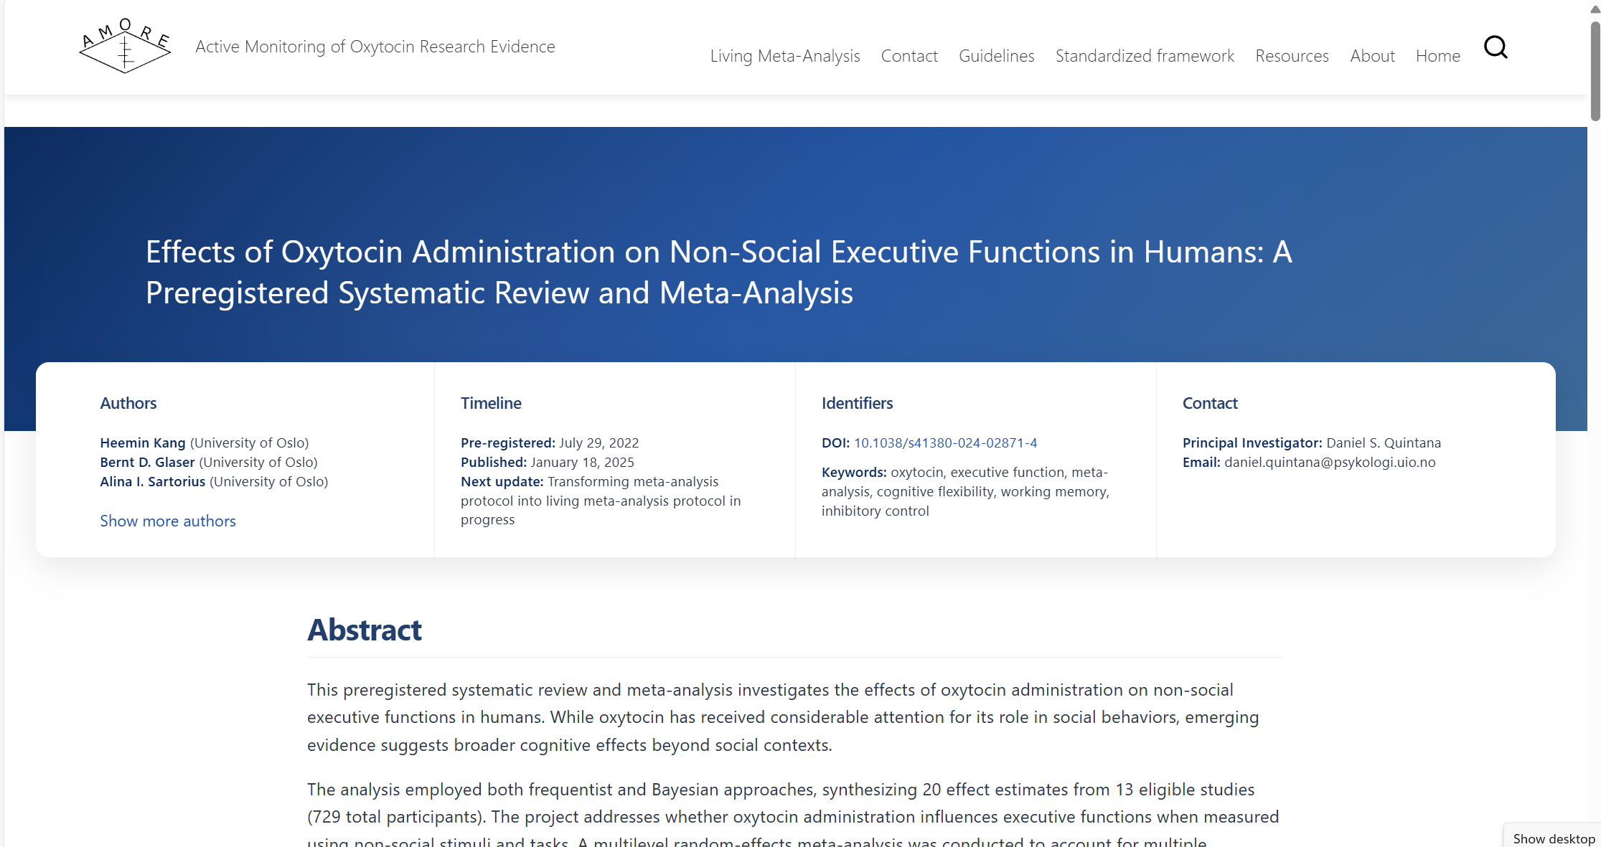
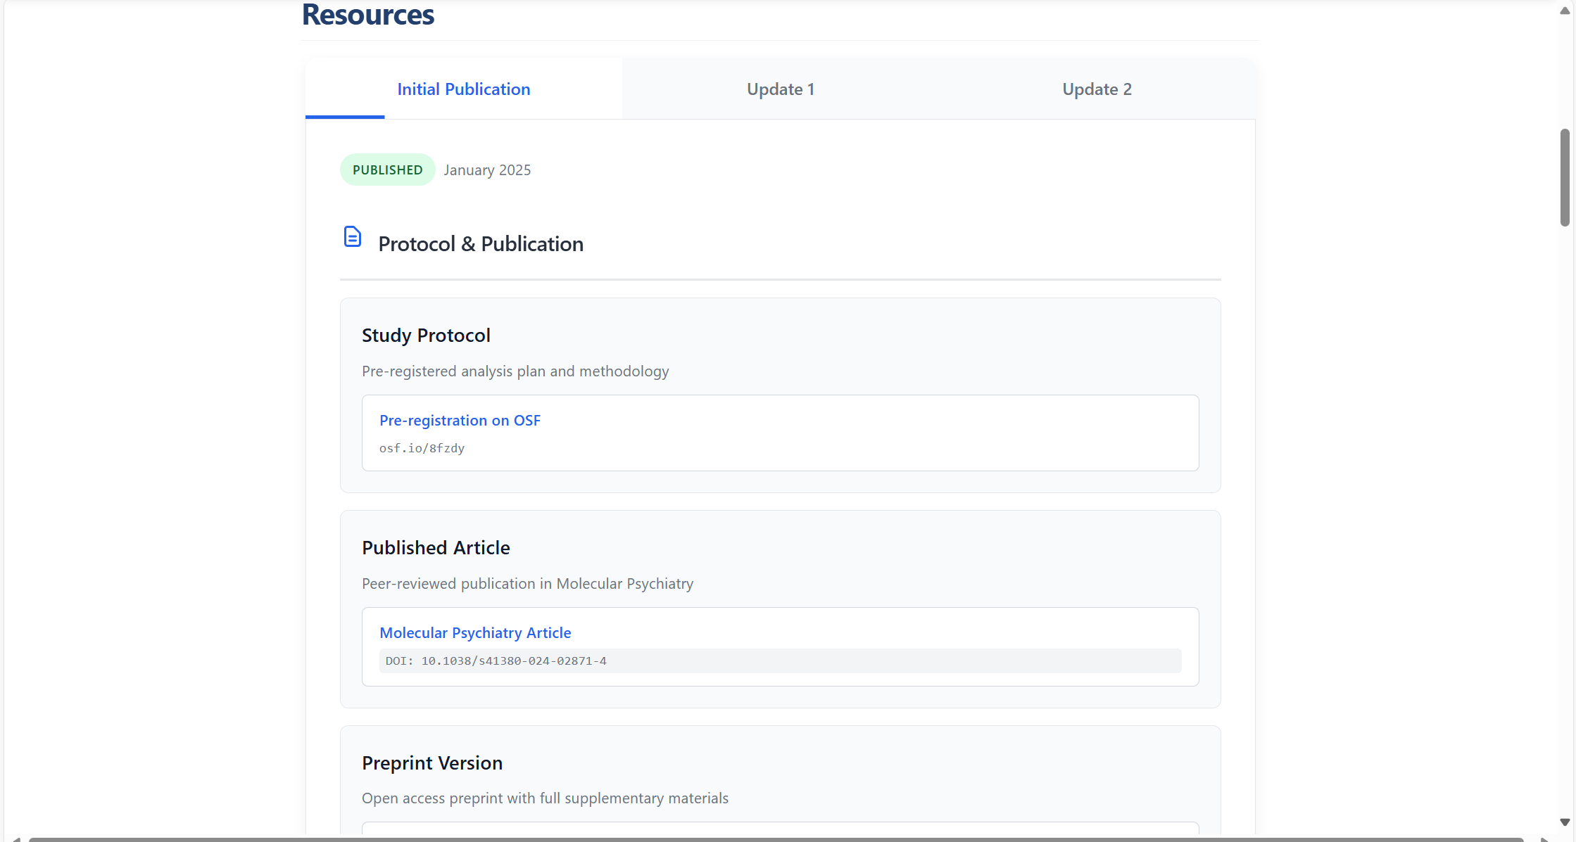
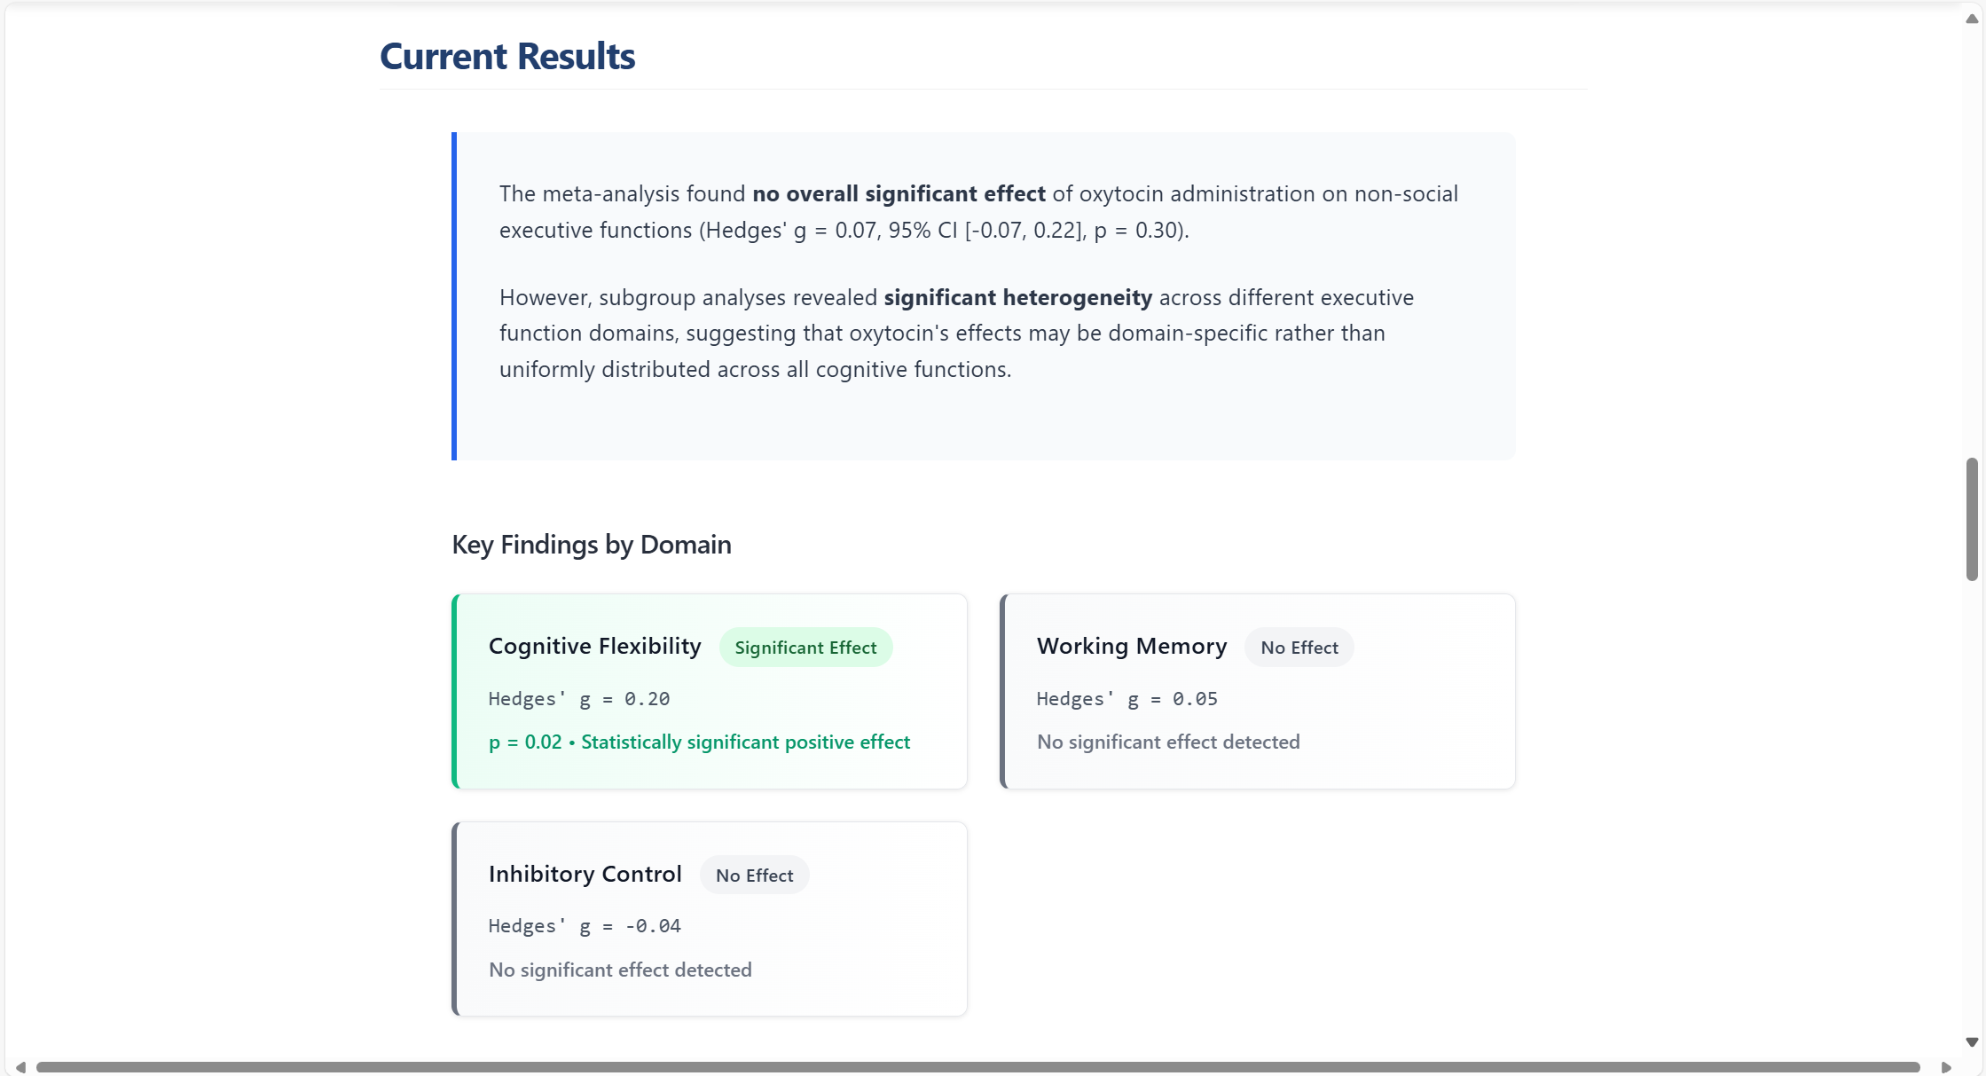
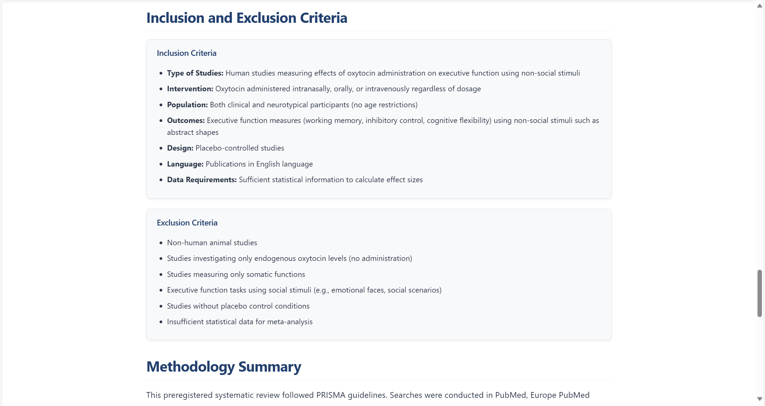

8. Thank You!
Your participation helps make the AMORE website more accessible and the documentation more useful for future lab members and collaborators.
Good luck! 🧪

Version: 2.0
Last updated: {{{<18/11/25>}}}

