CSA1606-DWDM

KNIME Activities
Name: Ajay I
Reg No: 192421147

Activity 1: Sales Analysis Dashboard Problem Statement
A retail company wants to analyze its monthly sales. Task
Build a KNIME workflow that:
- Imports a sales dataset.
- Cleans missing values.
- Calculates monthly sales.
- Identifies the top 10 products.
- Creates bar and line charts.
- Generates a summary report. Expected Outcome:
An interactive sales analysis workflow.

Output:

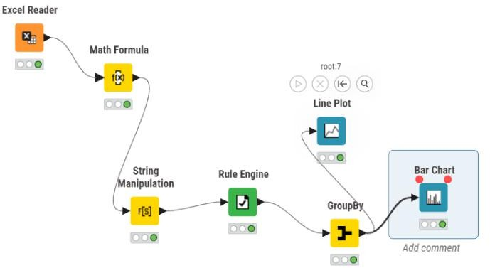

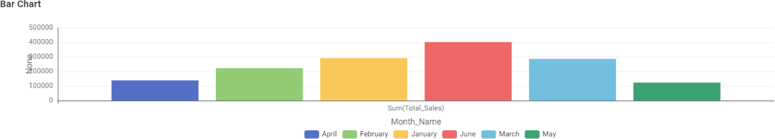
Line Plot:
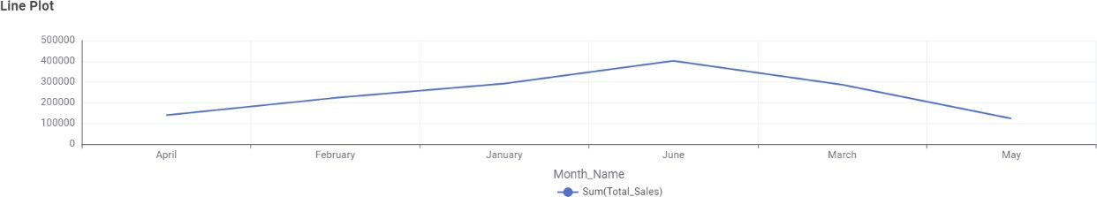

Activity 10: Attendance Monitoring System Problem Statement
Analyze attendance records to identify students with low attendance. Task
Build a workflow that:
- Imports attendance data.
- Calculates attendance percentages.
- Flags students below the attendance threshold.
- Generates a report.

Output:

