Activity: APP BUILDING USING WEKA TOOL

Name: Ajay I
Reg.NO: 192421147

1. Weather-Based Play Prediction
Build a WEKA application that predicts whether a person should play outdoors based on weather conditions.
- Dataset: Outlook, Temperature, Humidity, Windy
- Target: Play (Yes/No)
- Algorithm: J48 Decision Tree
- Tasks:
  - Load the dataset into WEKA.
  - Preprocess the data.
  - Apply J48.
  - Visualize the decision tree.
  - Predict Play for a new weather condition.
2. Flower Species Classification 🌸
Build a WEKA application that identifies the species of a flower from its physical measurements.
- Dataset: Iris dataset
- Attributes: Sepal Length, Sepal Width, Petal Length, Petal Width
- Target: Iris Species
- Algorithm: J48 or Naive Bayes
- Tasks:
  - Load the Iris dataset.
  - Select the classification algorithm.
  - Train the model.
  - Evaluate its accuracy.
  - Classify a new flower.

Answers:
1) Weather-Based Play Prediction
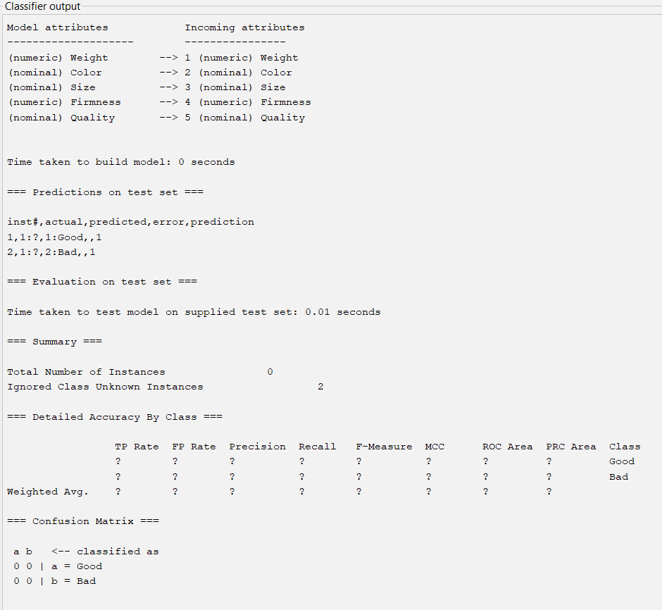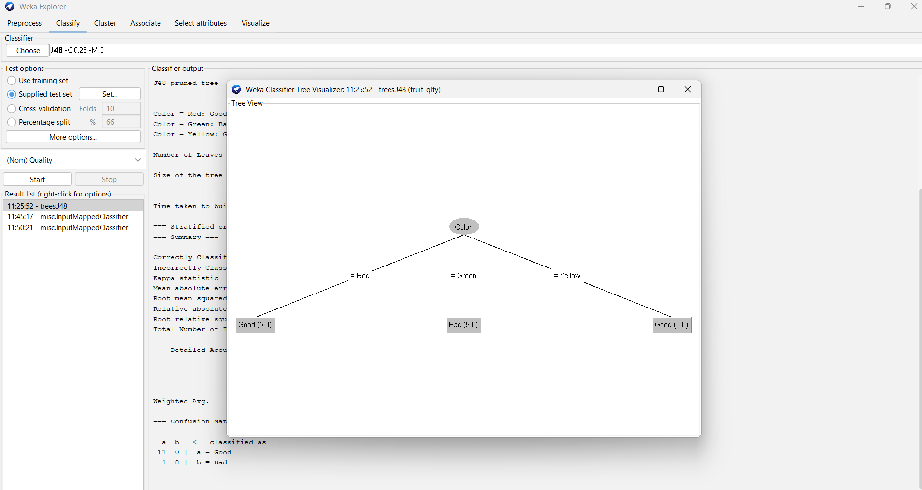
2) Flower Species Classification
