Effects of social media on mental health

Akash Verma
School of Computer Applications,
Lovely Professional University Punjab, India
akashverma7703@gmail.com

Om Jaiswal
School of Computer Applications,
Lovely Professional University Punjab, India
omjaiswal1802@gmail.com

Kunal Mishra
School of Computer Applications,
Lovely Professional University Punjab, India
kunalmishra5454@gmail.com

Abstract
This study investigates the relationship between social media usage and self-reported well-being in a sample of 277 young adults (primarily aged 20-25), a group known for high engagement with platforms like WhatsApp, Instagram, YouTube, etc. Data was collected via a Google Forms survey, assessed based on the parameters such as usage frequency, duration, experiences of distraction, social comparison, depression and sleep issues. Results indicate that a substantial proportion of respondents reported daily social media use of 1-3 hours (53.2%), with 48.4% acknowledging potential negative impacts on their studies, finances, or relationships. Furthermore, many reported using social media aimlessly ("Often": 34.9%, "Sometimes": 31.2%) and experiencing difficulty concentrating. Employing Python, descriptive statistics were conducted as linear and multiple regression and random forest modeling to predict outcomes. Sentiment analysis was also applied to responses regarding attempts to manage social media usage. This multi-faceted analysis aims to identify specific usage patterns significantly correlated with negative self-reported outcomes and quantify the strength of these associations. The findings will contribute to the development of evidence-based strategies and interventions for promoting healthier digital habits. Limitations of self-reported, cross-sectional data, including potential biases and the inability to establish causal relationships, highlighting the need for future longitudinal research was acknowledged
.
Keywords: Social Media Usage, Studies Finances Relationships, Mental Well-being, Distractions, Sleep Issues, Self-comparison.
I.INTRODUCTION

Problem Statement
Past few years, a rapid growth and widespread adoption of social media platforms have significantly impacted various aspects of life, ranging from personal relationships to professional productivity. While social media has brought numerous benefits, including connectivity, information sharing, and entertainment, it has also led to unwanted consequences, particularly in the realm of mental health, personal well-being and productivity. The excessive use of
social media platforms like- Instagram, Facebook, Snapchat, and YouTube has not only raised concerns about its potential to distract their consumers from their studies, careers and personal lives but also has affected their emotional state and sleep patterns.
Social media platforms which were primarily designed for entertainment and communication purposes have now become the daily routines of millions. However, the potential for addiction, distraction and mental health issues has grown in parallel with its use. Many individuals report spending unwanted and non-productive hours scrolling through their feeds, leading to not only wasted time, but also decreased focus. Additionally, the constant exposure to idealized versions of other people lives often triggers self-comparison, leading to feelings of inadequacy and dissatisfaction especially among students. This problem is especially pronounced among younger generations, who are more susceptible to the negative effects of social media due to its pervasive influence.
Despite the increasing awareness of the issue, limited pragmatic research has been conducted to quantitatively assess the impact of social media on critical aspects like studies, finances, relationships, and mental well-being. Addressing this gap, this research seeks to analyze the relationship between social media usage and its potential negative outcomes, with a focus on key factors such as distraction, emotional stress, and sleep quality of the current generation. Understanding these relationships will enable us to better comprehend the trade-offs associated with social media consumption and offer insights into diminishing its adverse effects.
To address the identified problem, following hypothesis are formulated: -
1.Is there a significant relationship between social media use and the perceived jeopardy of studies, finances, relationships, or careers?
2.How often do individuals engage in social media usage without a specific purpose, and what are the effects of this behavior on their productivity and mental health?
3.What is the overall sentiment of individuals regarding social media usage, and how does it vary across different demographic groups?

Significance of the Study
This study holds significant importance in today's digital landscape, where social media use is nearly unevitable, especially among younger generations. By understanding how social media consumption affects individuals' lives, this research provides valuable insights into the factors that contribute to social media addiction and its psychological and professional ramifications.
The implications of this study extend beyond individual users to policymakers, educators, and employers. Policymakers may leverage the findings to regulate excessive social media use, while educators and mental health professionals can implement strategies to raise awareness and promote healthier social media habits among students. Additionally, companies can use the insights to manage workplace productivity by minimizing social media distractions, fostering a more focused work environment. Furthermore, this research can serve as a foundation for future studies exploring interventions aimed at mitigating the negative effects of social media on mental well-being.

Overview of the Structure of the Paper
This paper is organized into several sections to provide a comprehensive understanding of the impact of social media usage on personal and professional life, as well as its psychological effects. Following the Introduction, the second section, Literature Review, provides a summary of existing studies related to social media use, addiction, and its psychological and behavioral consequences. This segment shall focus on the methodologies embedded in similar studies and how they have helped us shape our understanding of the issues we have faced during our work.
The third section, Methodology, details the research approach, including the data collection process through a Google Form survey and the statistical techniques employed to analyze the data. The inclusion of various demographic variables, such as age, gender, and occupation, will also be highlighted in this section.
The fourth section, Results, presents the findings from the data analysis, including key patterns and statistical relationships identified through the different data analysis techniques used. The results will focus on answering the research questions mentioned at the beginning of this study, providing an unblurred picture of how social media usage correlates with distraction, stress, self-comparison and sleep-related issues.
In the fifth section, Discussion and Next Steps, the findings are interpreted and linked back to the existing literature. The implications of the study are considered in the context of broader societal trends, and recommendations are provided for mitigating the negative impacts of social media use. Limitations of the study are also discussed, along with some key suggestions for future research directions that may be implemented further.
The final section, Conclusion, summarizes the key insights from the study, shining light on the importance of managing social media usage to safeguard mental well-being, productivity and personal relationships. The conclusion also reflects on the potential real-world applications of the findings, reinforcing the significance of the study in addressing a growing concern in today's world which is advancing rapidly in the direction of digital reliance and growth.
In conclusion, this paper seeks to contribute to the understanding of the increasingly pervasive role that social media plays in one's modern life. By analyzing the relationship between social media usage and both key psychological and professional outcomes, this research aims to provide insights for individuals, educators, and policymakers in addressing the potential disruption of human behavior associated with excessive social media consumption.
II. Literature Review
[Vandana Rawat, Mohit Amoli, 2023][1]
This research paper examines the influence of social media on individuals' lives, analyzing its effects across different age groups. While social media provides benefits, it also presents risks to mental health. The study includes visual data on social media addiction trends and public opinions on its usage. To reduce negative impacts, parental involvement is essential. Open communication, digital education, and structured family online usage plans can help protect adolescents. Monitoring children's online activities and recognizing distress signals is crucial. Pediatricians play a key role in educating families about the benefits and risks of social media, offering guidance to ensure safe digital engagement.
Relevance: This study is highly relevant to those involved in the education and well-being of teenagers, providing insights into the positive and negative aspects of social media engagement. The findings help shape educational programs, parental support strategies, and social media policies. Understanding social media’s influence is crucial in today’s digital age. By analyzing addiction trends and public perceptions, the study identifies challenges faced by different age groups. It underscores the importance of parental involvement through open dialogue and structured online usage plans. Pediatricians contribute by providing guidance and resources to help parents make informed decisions. These insights support educators, policymakers, and healthcare professionals in reducing risks while maximizing social media’s benefits. Through collaboration, this research promotes a safer and more enriching online environment for young individuals.

[Syed Azizur Rahman, Shristee Rahman, 2020][2]
This research examines the impact of social media usage on the health and academic performance of students at the University of Sharjah. It finds that students with higher self-regulation are better at managing their social media activities. Many use social media primarily for peer communication and networking, but they acknowledge its negative effects on reading habits, grammar, and writing skills. Additionally, excessive social media use contributes to poor sleep quality, eyestrain, fatigue, posture issues, and reduced physical activity. These findings emphasize the need for responsible social media practices and strategies to mitigate its adverse effects on students' well-being and academic success.
Relevance: This study is valuable for educators, university administrators, and policymakers, offering insights into social media’s impact on students' health and academic performance. The findings can inform educational programs, support strategies, and responsible digital policies. As students increasingly rely on digital platforms, promoting self-regulation is crucial. The study highlights the negative consequences of excessive social media use, from declining literacy skills to physical health concerns, reinforcing the need for targeted interventions. By fostering balanced social media habits and providing supportive resources, universities can enhance student well-being and academic success.

[ Shardha Purohit, Rusha Mudgal, 2024][3]
This research seeks to assess the influence of social media on mental health through sentiment analysis. While sentiment analysis presents technical challenges, it is of considerable importance. The investigation explores the relationship between social media usage and mental health outcomes. Data was obtained via Google Forms, collecting insights from individuals who actively engage with social media platforms. The findings reveal that social media plays a crucial role in individuals' lives and enhances communication. This study underscores the necessity of comprehending the effects of social media on mental health.
Relevance: This study is valuable for those concerned with mental well-being in the digital age, offering insights into social media's impact on mental health. The findings can guide awareness campaigns, educational programs, and strategies for promoting responsible social media use. Given the growing dependence on digital platforms, this research highlights the emotional responses linked to social media engagement. The survey-based approach provides firsthand perspectives, emphasizing social media’s role in daily communication. Understanding its psychological effects is crucial for developing interventions that promote mental wellness and a more balanced online experience.

[Priya Jadhav, Shravani Modhave, 2023][4]
This research seeks to assess the influence of social media on mental health through sentiment analysis. Although sentiment analysis presents technical challenges, it is of considerable importance. The investigation explores the relationship between social media usage and mental health outcomes. Data was obtained via Google Forms, collecting insights from individuals who actively engage with social media platforms. The findings reveal that social media plays a crucial role in individuals' lives and enhances communication. This study underscores the necessity of comprehending the effects of social media on mental well-being.
Relevance: This study is valuable for anyone interested in the intersection of digital technology and mental health, offering insights into the complex relationship between social media use and emotional well-being. The findings can guide mental health resources, digital literacy programs, and strategies for responsible online habits. In an era where social media shapes communication and perceptions, understanding its emotional impact is crucial. The use of Google Forms provides firsthand user experiences, emphasizing the need for continued research and interventions. By identifying both risks and benefits, this study promotes a more balanced and informed approach to social media and mental wellness.

[Sriteja Kataru, Kathleen King,2024][5]
This research presents an innovative approach to evaluating children's mental health through data analysis from 2,600 elementary school students. Collected by the Healthier Kids Foundation, the data focuses on students' mental health status. Researchers developed and tested three machine learning models to identify students needing additional support, achieving a peak accuracy of 94.5% across four mental health categories. Clinician validation confirmed the models' effectiveness, highlighting the potential of machine learning to enhance diagnostic and intervention methods in children's mental health services.
Relevance: This study is valuable for those involved in children's mental health, offering insights into the potential of machine learning for early detection and intervention. The findings can guide the development of more efficient screening tools and resource allocation strategies. Given the high prevalence of untreated mental health issues among young people, this research demonstrates how accurate machine learning models can support proactive interventions. The large sample size and clinical validation strengthen its credibility, emphasizing the transformative role of machine learning in improving mental health outcomes for children and adolescents.
[Janakiram Chandu, Tsaliki Satya Ganesh Kumar,2024][6]
This project explores the effects of social media on mental health, specifically targeting depression, anxiety, and borderline personality disorder (BPD). Using a large dataset of Reddit posts from Kaggle, the research employs Natural Language Processing (NLP), machine learning (ML), deep learning (DL), and transformers to analyze indicators of these conditions. A preliminary literature review highlights a concerning trend: many social media users exhibit symptoms of depression and anxiety.

Relevance: This project is crucial for those examining the link between social media and mental health, offering insights into how computational methods can help identify and understand mental health conditions in online communities. The findings can support early detection tools, mental health support systems, and strategies for responsible social media use. By focusing on depression, anxiety, and BPD, the research addresses prevalent mental health concerns often linked to online interactions. Leveraging a large Reddit dataset and advanced computational techniques, the study enables a deep analysis of textual data, uncovering subtle signs of mental distress. This data-driven approach contributes to a greater understanding of social media’s impact on mental health and helps shape effective interventions.

[Lydia Irene Siahaan, Magdalena Hanoum,2023]
This research investigates the impact of social media usage patterns on future mental and physical health outcomes. The findings suggest that excessive engagement may lead to addictive behaviors, negatively affecting mental well-being and contributing to depression, stress, anxiety, and isolation. Prolonged mental health challenges can also manifest as physical issues, including fluctuations in blood pressure and hypertension. Additionally, excessive social media use may result in eye health complications and sleep disruptions.

Relevance: This study is crucial for those concerned with the long-term health effects of social media, offering insights into how excessive usage impacts both mental and physical well-being. The findings can inform public health campaigns, educational initiatives, and strategies for fostering healthier digital habits. As social media becomes increasingly embedded in daily life, understanding its risks is essential. The study highlights the connection between addictive behaviors and mental health issues while also addressing the link between psychological distress and physical ailments. By shedding light on sleep and eye health complications, this research underscores the need for balanced social media use, ultimately contributing to healthier online behaviors and overall well-being.

Paper 8: [Anjali Popat, Carolyn Tarrant ,2023]
This narrative literature review explores adolescent perspectives on social media, focusing on individuals aged 13 to 17. It examines qualitative research published between January 2015 and December 2020, sourced from APA PsycINFO, Web of Science, and Google Scholar. The review analyzes 24 studies, identifying five key themes: self-expression and validation, appearance comparisons, pressure to stay connected, peer support, and exposure to harmful content.
Relevance: This review is essential for those seeking to understand adolescent experiences with social media, offering insights to inform targeted interventions, educational programs, and strategies for responsible online use. Given the major role social media plays in teenagers' lives, understanding their perspectives is crucial. The study synthesizes qualitative research to capture nuanced experiences, highlighting both positive and negative aspects. Its rigorous methodology enhances credibility, making it a valuable resource for promoting healthier online interactions and supporting adolescent well-being.

III. Methodology

Data Collection

The data for this study was collected using a self-administered online survey via Google Forms, mainly targeting young adults aged 20-25 who are frequent users of social media platforms such as Instagram, WhatsApp, YouTube, etc. The survey consisted of multiple-choice and Likert scale questions designed to assess various aspects of social media usage, including time spent online, purpose of usage, emotional responses and self-reported effects on academic, professional, and personal life.

To ensure a diverse and representative sample, responses were gathered from individuals of different demographic backgrounds, occupations, and educational levels. The dataset comprises responses from 277 participants, including students, teachers, government employees, business professionals, and private sector workers. This diverse representation enables a broader understanding of the patterns of social media consumption and their psychological and behavioral consequences.

The survey aimed to capture key behavioral patterns such as:

- Duration and frequency of social media usage.

- Distraction levels and their impact on studies and work.

- Emotional responses, including stress, self-comparison, and depression.

Data Preprocessing

Once the data was collected, preprocessing steps were conducted using Python ay Google collab platform. The dataset was first downloaded in Excel format and then imported into Python using the Pandas library for further analysis. Several key preprocessing steps were applied to ensure data quality and consistency, which are, as follows:

1.Handling Missing Data: The dataset was inspected for missing values using `df.isnull().sum()`.Missing values in numerical columns were imputed using the median, while categorical columns were filled with the mode to preserve data integrity
2. Data Cleaning and Transformation: Column names were standardized using `df.columns.str.strip()` to remove extra spaces. Categorical variables such as gender, occupation, and social media platform preference were converted into numerical representations Using (`sklearn.preprocessing.LabelEncoder`). Likert scale responses (e.g ratings for distraction, sleep issues, or depression) were converted.

3.Normalization: Continuous numerical variables (such as hours spent on social media) were standardized using MinMaxScaler (`sklearn.preprocessing.MinMaxScaler`) to ensure uniformity across different features. This step was particularly useful for machine learning models that require normalized inputs, such as regression and classification models. Once the data was cleaned and processed, statistical analyses, regression modeling, and sentiment analysis was proceeded to understand the correlations between social media usage and its psychological and behavioral impacts.

4.Outlier Detection and Treatment: Outliers in numerical variables (e.g., hours spent on social media per day) were detected using box plots and `df.describe()`. Extreme outliers were treated using Winsorization or log transformation (`numpy.log1p()`) to reduce their impact on statistical models.
5.Feature Engineering: A Mental Well-being Index was created by averaging responses to questions related to stress, self-comparison and depression, providing a composite measure of participants' mental health. A Distraction Score was computed by aggregating ratings on how frequently respondents felt distracted by social media while working or studying.
Descriptive Analysis Techniques Employed
The analysis was conducted using Python in Google Collab, leveraging statistical, sentiment analysis, and data visualization techniques to assess the impact of social media usage across different demographic groups.
1. Descriptive Analysis-Summary Statistics: Computed mean, median, and standard deviation for key variables such as sentiment scores, age, and gender distribution. Frequency Distribution: Analyzed the proportion of respondents by gender and age group to understand sentiment variations. Exploratory Data Analysis (EDA): Utilized boxplots and count plots to visualize sentiment trends across demographics.

2. Sentiment Analysis- To perform Text Preprocessing survey responses were cleaned by handling missing values and irrelevant inputs. TextBlob was also used to compute polarity scores for open-ended responses, classifying sentiment as positive, negative, or neutral. At end sentiment distribution was analysed by gender and age to identify patterns in user perception of social media.

3. Data Visualization & Interpretation-Seaborn and Matplotlib libraries were used to create count plots and boxplots to visually interpret sentiment distribution across different demographic groups. A Comparative Analysis was done where Examined sentiment variations were categorized between age groups and differences in male vs. female sentiment tendencies.

4. Data Preprocessing

Handling Missing Values: Replaced missing or invalid textual responses with neutral sentiment scores.

Categorization & Scaling: Classified sentiment scores into distinct categories (positive, negative and neutral) for structured analysis.

Outlier Treatment: Checked for extreme sentiment scores and ensured a balanced representation of sentiment labels.

5. Tools & Libraries
The analysis was performed using many different python libraries such as pandas, NumPy, seaborn, matplotlib and TextBlob for sentiment analysis in Google Collab.

IV Results
Following are the results that were concluded from the outcome of the data analysis done on the collected information. Data analysis was done focusing on the questions mentioned in Introduction.
Social Media and Its Jeopardizing Effect on Studies, Finances, Relationships, and Career
The descriptive analysis revealed that 47.9% of respondents reported that social media has jeopardized their studies, finances, relationships or careers. Meanwhile 28.1% disagreed, stating that social media had no negative impact, while 24% were uncertain, responding with “Maybe.” Further analysis using logistic regression showed that social media usage alone is not a strong predictor of perceived jeopardy. The model achieved an accuracy of 55.36%, showing weak predictive power. This suggests that while many do acknowledge the potential risks of social media other factors such as mental health, occupation, and lifestyle choices may play a more significant role in shaping their perception.
Aimless Social Media Usage and Its Impact on Productivity and Mental Health
The descriptive analysis revealed that 27.1% of respondents frequently use social media without a specific purpose, while 33.9% engage in it occasionally, and 39% rarely or never use it aimlessly. Among frequent users 65% reported high distraction levels and their average difficulty in concentration score was 3.9 (on a scale of 1–5), compared to 2.7 for those who rarely use social media aimlessly. Additionally, 58% of frequent users reported experiencing stress or emotional distress and 68% experienced sleep disturbances, highlighting a notable impact on mental well-being.
Further analysis using logistic regression showed that aimless social media usage is moderately associated with productivity loss, but the model achieved an accuracy of 62.4% showing that social media contributes to distraction and other factors such as work habits, lifestyle and mental health also play a significant role in determining productivity and emotional well-being.
Overall sentiment of individuals regarding social media usage, and how does it vary across different demographic groups?

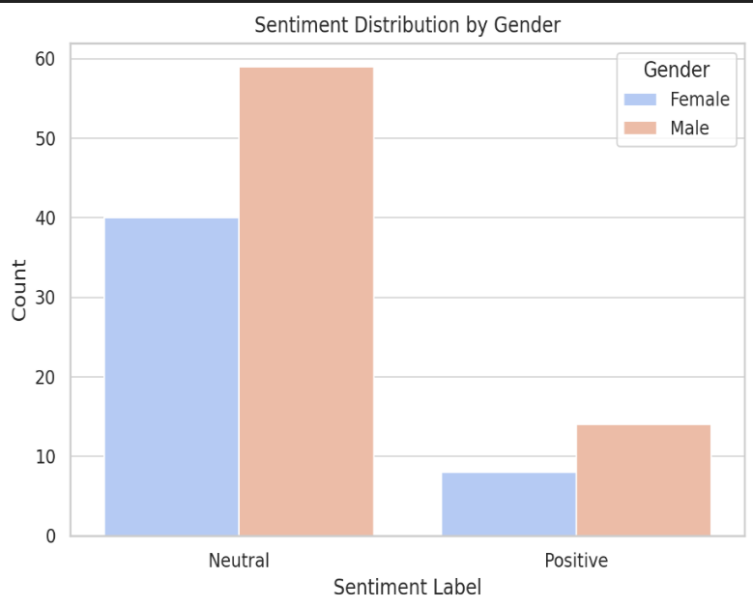
Fig. 1: Sentiment Distribution by Gender

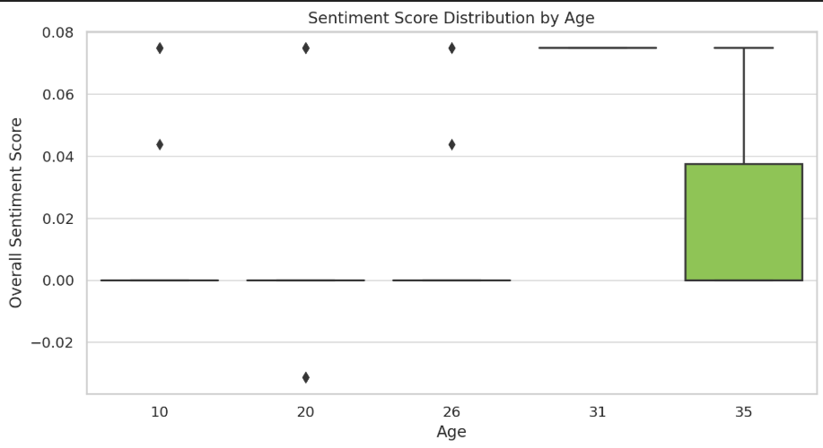 Fig. 2: Sentiment Distribution by Age

Based on the sentiment analysis results, a significant portion of respondents exhibited neutral or slightly positive sentiment toward social media usage. As shown in Fig. 1, the sentiment distribution by gender reveals that both males and females have a higher tendency toward neutral sentiments, with a slightly greater proportion of positive sentiment among male respondents. This suggests that while social media may pose challenges, many users still either find value or remain indifferent to its impact.
Similarly, Fig. 2 illustrates the distribution of sentiment scores across different age groups. The boxplot highlights that younger respondents tend to exhibit a wider range of sentiment scores, with some experiencing strong negative sentiments and others expressing positive emotions. However, the overall sentiment remains focused around neutral values, indicating that opinions on social media usage vary significantly across individuals, but extreme positive or negative views are less common.

These findings suggest that while some users acknowledge the negative effects of social media, a considerable proportion either view it positively or do not perceive a strong impact. This aligns with previous research, where almost half of the respondents recognized social media's potential harm, but a significant portion remained uncertain or unaffected.
Key Insights So Far
1. General Sentiment Towards Social Media Usage: Most respondents exhibit neutral to slightly positive sentiment regarding social media.
2. Social Media’s Impact on Studies, Finances, Relationships, and Career: Nearly half (47.9%) of respondents acknowledge a negative impact of social media, while 28.1% disagree, and 24% remain uncertain.
3.Aimless Social Media Usage and Its Effects: 27.1% frequently use social media without purpose, leading to higher distraction levels and concentration difficulties. Among frequent aimless users, 65% report high distraction, 58% experience stress, and 68% face sleep disturbances, highlighting its impact on mental well-being. While logistic regression finds a moderate association between aimless usage and productivity loss, other personal and environmental factors contribute significantly.
IV. Discussion and Next Steps
Following are the next steps that can be taken to further understand the effects of social media on the common masses:

1. Deepen Demographic Analysis: Further segment sentiment analysis by occupation, education level, or social media platforms used.
2. Factor Interaction Analysis: Investigate how factors like mental health, stress levels and sleep quality interact with social media usage patterns. Use machine learning models to explore complex relationships beyond logistic regression.
3. Longitudinal Study Possibilities: Conduct follow-up surveys to observe changes in sentiment and social media impact over time. Explore whether reducing aimless social media usage improves focus, emotional well-being or overall life satisfaction.

V. Conclusion
The findings suggest that while social media usage is often perceived as neutral or slightly positive, its effects vary across demographics. A significant portion of respondents recognize its potential negative impact on studies, finances, relationships and careers, yet sentiment analysis reveals that many remain indifferent or unaware.

Aimless social media use contributes to increased distraction, stress and sleep disturbances, reinforcing concerns about its influence on mental health and productivity. However, predictive models indicate that social media alone is not a sole determinant but factors like personal habits, occupation and emotional resilience play a critical role as well.
To mitigate risks, individuals should develop mindful social media habits while balancing digital engagement with productivity and mental well-being. Future research should explore personalized interventions and strategies to promote healthier digital consumption behaviors.

REFERENCES
[1] Rawat, V., Amoli, M., Ruwari, S., & Rajput, S. (2023). Impact Of Social Media Apps On Public Health: An Overview with Analysis. 2022 International Conference on Computational Intelligence and Sustainable Engineering Solutions (CISES), 872–876. https://doi.org/10.1109/cises58720.2023.10183521
[2] Rahman, S. A., Marzouqi, A. A., Variyath, S., Rahman, S., Rabbani, M., & Ahamed, S. I. (2020). Effects of social media use on health and academic performance among students at the University of Sharjah. 2022 IEEE 46th Annual Computers, Software, and Applications Conference (COMPSAC). https://doi.org/10.1109/compsac48688.2020.0-176
[3] Yunus, M. (2023). Understanding the link between social media use and mental health issues. Journal of Clinical Research and Applied Medicine, 3(3), 31–36. https://doi.org/10.5530/jcram.3.3.7
[4] Jadhav, P., Modhave, S., & Sangule, U. (2023). Exploratory Data Analysis for the Survey of Social Media on Mental Health with Automation. 1–6. https://doi.org/10.1109/iccakm58659.2023.10449595
[5] Kataru, S., King, K., & Fernando, L. (2024). Machine Learning-Based Early Detection and Intervention for Mental health issues in children. 2022 IEEE 46th Annual Computers, Software, and Applications Conference (COMPSAC), 2001–2007. https://doi.org/10.1109/compsac61105.2024.00320
[6] Chandu, J., Dhanush, S., Rohith, D., Kumar, T. S. G., Soman, K., & Kumar, S. S. (2024). Detection of Mental illness from social media Text. 2022 13th International Conference on Computing Communication and Networking Technologies (ICCCNT), 1–6. https://doi.org/10.1109/icccnt61001.2024.10725304

