Task 1 – AES Encryption

Task 1A: Encrypt a file using AES-128-CBC

Let’s create a file named secret.txt
Encrypt the file with AES-128-CBC pass:mypassword
Task 2
Decrypt the file
Verify it matches the original

Task 2– ECC Signature Verification

Task 2A

Generate a private key

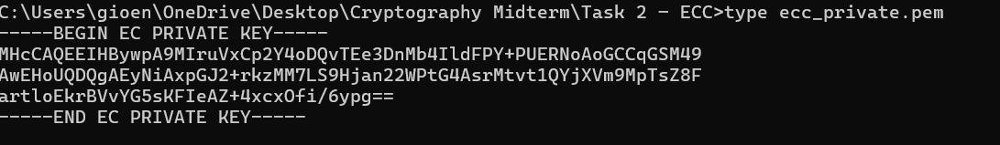

Extract the public key

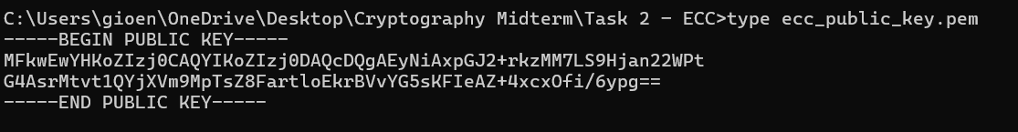

Task 2B

Create a text file

Sign the message using private key

Verify the signature using public key

Task 3– Hashing & HMAC

Task 3A

Creating data.txt

Hash using OpenSSL CLI

Task 3B
Creating HMAC

Task 3C

Changing one letter in data.txt (I change “.”with symbol “!”)

Recomputing HMAC for modified file

conclusion

The original HMAC:
The modified HMAC:
Even though we changed only one character (period to exclamation mark), the entire HMAC output changed completely. This is due to the avalanche effect in cryptographic hash functions.
Why HMAC is important:
- Integrity Verification: HMAC ensures that the message hasn't been tampered with during transmission or storage
- Authentication: Only parties with the secret key can generate valid HMACs
- Security: Even tiny changes in input produce completely different outputs
- Tamper Detection: Any modification of the data or key results in a different HMAC value
- Applications: Used in API security, message authentication, digital signatures, and secure communications
This demonstrates that HMAC provides both authentication and integrity protection, making it essential for secure data transmission and verification.

Task 4– Diffie-Hellman Key Exchange

Task 4A

Lets Generate DH parameters

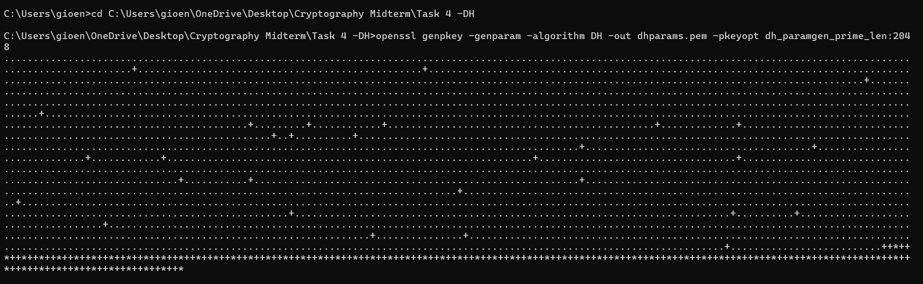

Generating Alice's private/public key pair

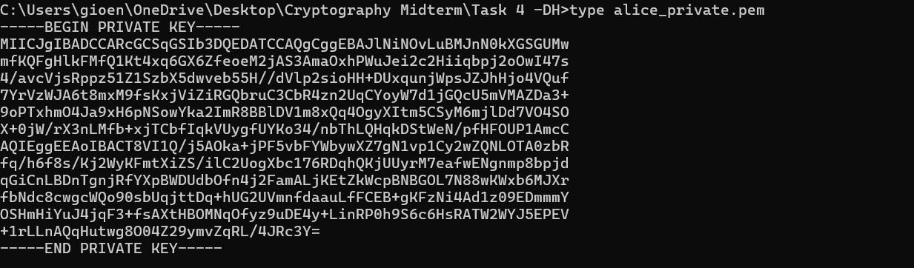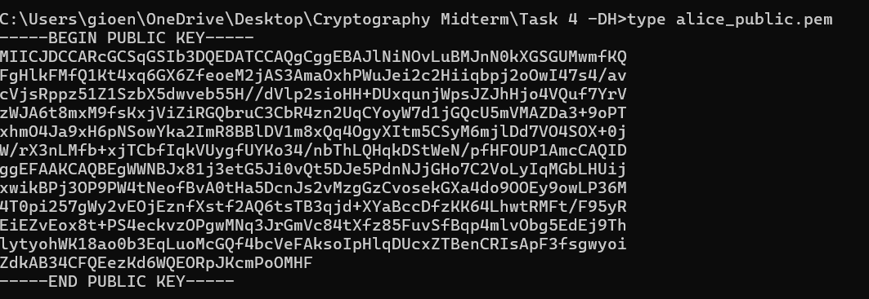

Bob’s private/public key pair

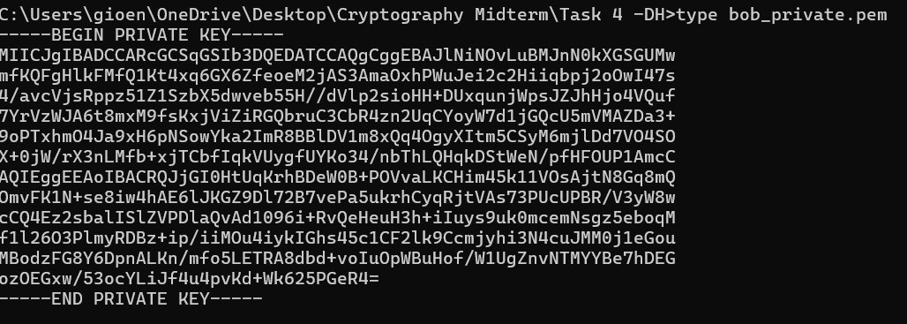
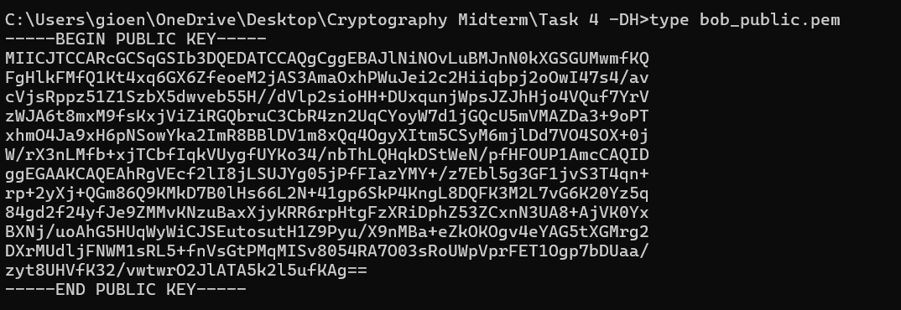

Derive shared secret for Alice

Derive shared secret for Bob

Verifing shared secrets matches

Task 4B
The Diffie-Hellman key exchange is fundamental to modern secure communication and is widely used in practice. In the TLS/SSL handshake that secures HTTPS connections, Diffie-Hellman (specifically in Ephemeral mode as DHE or ECDHE) enables web browsers and servers to establish a shared secret over an insecure channel without pre-shared keys. This provides forward secrecy, meaning even if a server's private key is compromised later, past communications remain secure.
The protocol is also crucial in secure messaging applications like Signal, WhatsApp, and Telegram, where it forms the basis of their end-to-end encryption. In the Signal Protocol, an extended triple Diffie-Hellman (X3DH) handshake allows users to establish secure sessions while providing identity verification and forward secrecy. Additionally, VPN protocols such as IPsec (using IKE) and SSH connections rely on Diffie-Hellman to securely negotiate session keys for encrypted tunnels.

Importance for Secure Communication:
Diffie-Hellman is essential because it solves the key distribution problem - it allows two parties who have never met to establish a shared secret over an insecure channel. This enables perfect forward secrecy, protects against eavesdropping, and forms the foundation for secure symmetric encryption in virtually all modern encrypted communications, ensuring confidentiality and integrity in our digital interactions.

