Task1
Step.1

Step.2
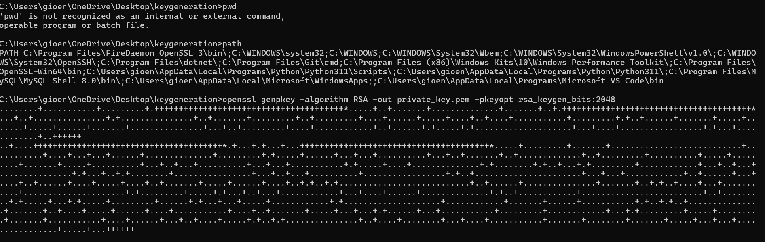
Step.3
Step.4
Step.5
check:


Encryption process with AES
Password:irakli

Step 1
step 2
Step.3


Step 4
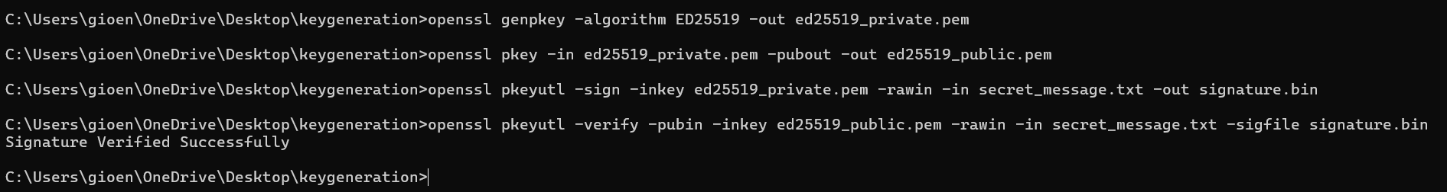


RSA's privileges stem from its use of two mathematically linked keys (Public and Private), allowing for non-repudiation and secure key exchange.
- Secure Key Exchange: RSA's Public Key can be widely shared to encrypt a message (like a small secret, such as an AES key). Only the holder of the matching Private Key can decrypt it. This is its most critical privilege, allowing two parties to securely establish a shared secret over an insecure channel.
- Digital Signatures: Its unique strength is the ability to create Digital Signatures. The sender uses their Private Key to sign data, and anyone can use the sender's Public Key to verify the signature, proving the data's authenticity and integrity (who sent it and that it hasn't been tampered with).
- Non-Repudiation: Because only the legitimate owner possesses the Private Key, a valid signature acts as proof that the owner authorized the transaction, preventing them from later denying it.
- rsa_vs_aes.txt – I’ll write down the answer in the word document:
- These two cryptographic algorithms encrypt the same message using specific keys. Even though the goal is the same — preventing a third party from reading the message —
- their performance and internal logic differ.

AES's Role: The Efficient Data Transport
AES (and other symmetric algorithms like ChaCha20) is fast and efficient because it uses a single, shared secret key.
- Core Privilege: Providing Blazing Speed and Efficiency for Bulk Data Encryption. Once the RSA handshake is complete and the shared AES key is exchanged, AES takes over to encrypt and decrypt the vast majority of the data transfer. Its speed is critical for maintaining high throughput in continuous communications (like streaming video or large file transfers).
- Essential Function: Providing Confidentiality for large datasets with minimal computational overhead.
RSA is an asymmetric algorithm that requires two keys: a private key and a public key. In asymmetric cryptography, each side has its own private and public keys. The private key must be kept secret, meaning only the owner should have access to it, while the public key can be shared openly. The public key is derived from the private key, and it is computationally infeasible to recover the private key from it. To encrypt and decrypt messages, both parties use a combination of their public and private keys. Asymmetric cryptography requires a more intensive computational process.
- AES is a symmetric cryptographic algorithm that is lighter and much faster. Symmetric algorithms use a single shared key for both encryption and decryption, which can be riskier because the key must be securely shared.
- Comparing RSA with AES, both are strong and reliable algorithms that provide confidentiality, but they are used in different contexts due to their performance differences and key-management models.
Task2

Step 1
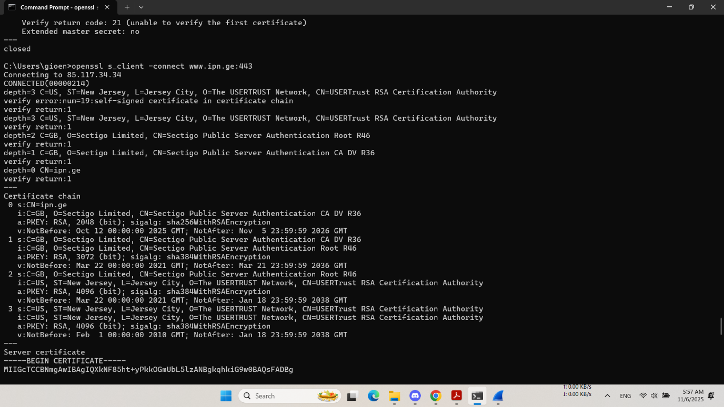
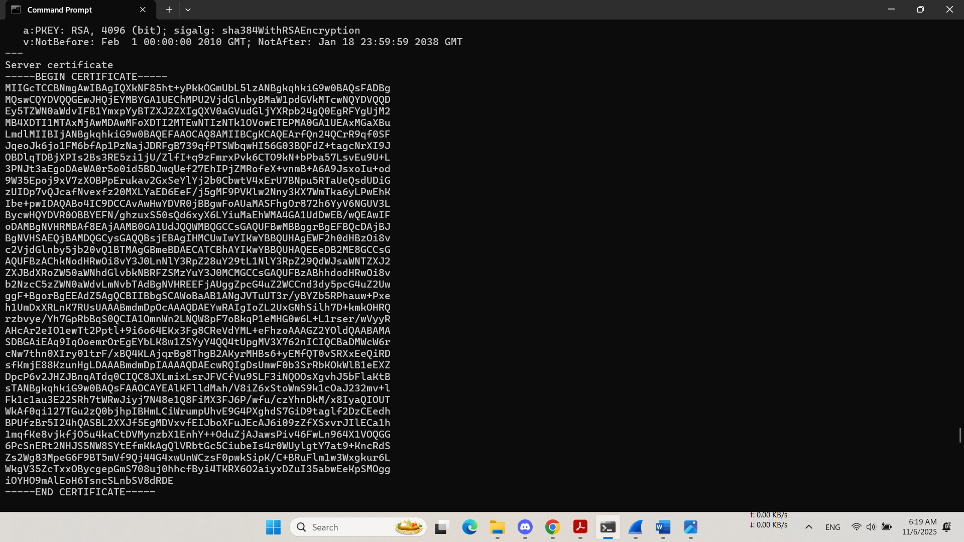

Step 2
